Tab 1

Requirements Document



PathFinder, PBC
d/b/a PathFinder

Version 1.0
Updated October 9, 2026

CEO | Abhilasha Talwar
VP Front-End | Andrew Jarrah
VP Back-End | O’glenn Togar
VP Database | Hudson Plaskoff

Table of Contents

1 - Introduction
1.1 - Document Overview (pg. 3)
1.2 - Project Overview and Goals (pg. 4)
1.3 - System Scope and Major Features (pg. 5)
1.4 - Use Case Diagram (pg. x)

2 - Solution Description
2.1 - Major Functions and Features (pg. x)
2.2 - User Characteristics (pg. x)
2.3 - Constraints (pg. x)
2.4 - Assumptions (pg. x)

3 - Functional Software Requirements (FR)
3.1 - FR-1: Progress Overview (pg. x)
3.2 - FR-2: Opportunity Finder (pg. x)
3.3 - FR-3: Student Information Card (pg. x)
3.4 - FR-4: HAL AI Chatbot (pg. x)
3.5 - FR-5: Advisor View (pg. x)

4 - Nonfunctional Software Requirements (NFR)
4.1 - NFR-1: Data Security and Privacy (pg. x)
4.2 - NFR-2: Course Data Check (pg. x)
4.3 - NFR-3: Chatbot Response (pg. x)

5 - Appendix
5.1 - Financial Information (pg. x)
5.1 - Glossary (pg. x)
5.2 - Gantt Chart (pg. x)
5.3 - Terms and Conditions (pg. x)
5.4 - Client Signature of Approval (pg. x)

Section I
Introduction

Contents
1.1 - Document Overview
1.2 - Project Overview and Goals
1.3 - System Scope and Major Features
1.4 - Use Case Diagram
Document Overview

The requirements document is intended to communicate the requirements of PathFinder. This document was compiled by the PathFinder team and incorporates the team’s background, mission, and goals.

- Solution Description (2) - Provides a general overview of Pathfinder’s solution, including the main features, stakeholders, and the constraints or assumptions that are a key part of the solution’s development process.
- Functional Software Requirements (3) - Describes the five functional software requirements, including details of inputs and outputs for each feature where applicable.
- Nonfunctional Software Requirements (4) - Describes the three nonfunctional software requirements, including aspects of how the functional software requirements should work.

The PathFinder team has also included an appendix which defines key terms used in the requirements document in a glossary, a Gantt chart to visualize a timeline of the team’s progress, the terms and conditions for use of the PathFinder website, and the signed approval of the project’s client.

Project Overview and Goals

PathFinder is a user-friendly SaaS that will help students at Muhlenberg College navigate their academic journey smoothly and plan their semesters well ahead of time. PathFinder will also help advisors at Muhlenberg College to help their advised students plan for each semester more efficiently through a unified view of all advisees. These are both a response to the current fragmented systems across several websites and portals which add confusion and friction to one of the most important digital systems at Muhlenberg.

The PathFinder team comes from a wide range of academic backgrounds, including computer science, mathematics, and finance. The synthesis of their shared knowledge and personal experiences have shaped the PathFinder team’s philosophy and informed the project’s design choices. For example, one team member created an improvised spreadsheet to track their progress for their area of study and GARs. This works for this individual team member, but it is limited by several factors. First, this spreadsheet is only usable to this team member and is not easily replicated for other students. Additionally, this spreadsheet requires notable time and effort to make any changes such as adding a new major and minor because the information must be manually added by this team member. Lastly, the spreadsheet is not ideal for viewing despite being custom made because it exists within the constraints of other software that was not specifically designed for this purpose.

Due to the shortcomings of this team member’s spreadsheet, the team envisions PathFinder as software within a new framework entitled ACT.
Adaptive | meets the needs of all users
Centralized | one unified database
Tailored | purpose-built software
System Scope and Major Features

We aim to create a product that all of our stakeholders will find the most use and benefit from. We have four major objectives we aim to develop in order to achieve that goal. These include, displaying student progress in major, minor, and GAR requirements. One of our major features is the dashboard for student users, and this dashboard will allow users to find opportunities for potential secondary majors or additional classes for academic success and professional development. Also included on this dashboard will be the HAL Chatbot. This Chatbot will act as an AI assistant for users to ask any question about their current progress, recommended classes, and more. This is made possible through the Groq API which will process questions made by users and formulate responses accordingly. Lastly, we plan to implement a professor view, allowing them to view the progress of their students. This feature will help professors better organize all of their advisee’s information and assist with overall advising.
Our stakeholders would consist of both students and professors. Students are able to access all of the main features excluding the professor view. The professor's view will show everything the student can see, but at a much more grand level. This access would grant professors to oversee all of the students they are responsible for, so they can help boost their academic career. This is how we plan on giving our shareholders a quality service.

System Scope and Major Features (ctd.)

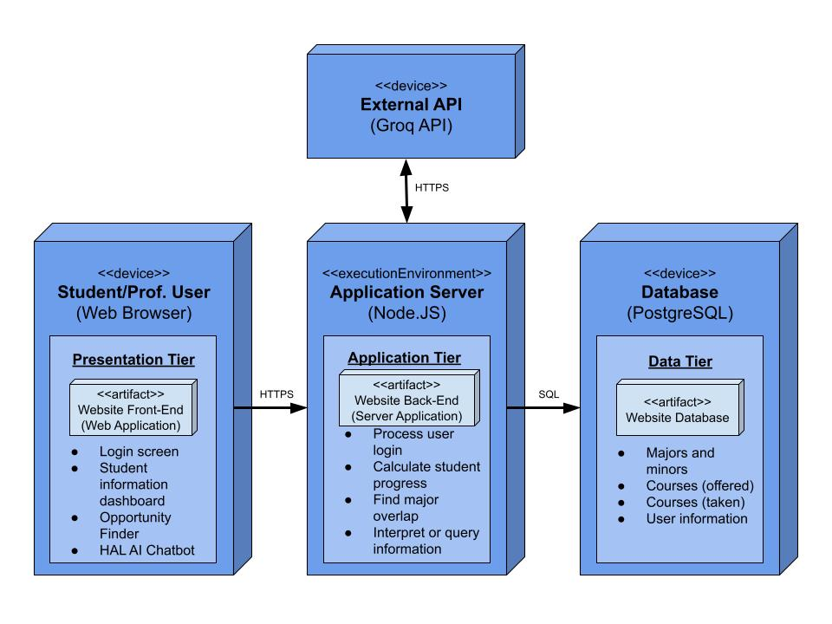

Use Case Diagram

The use case diagram for PathFinder is given below. It shows the system scope, functional requirements, and main actors (students and professors). It also denotes the priorities of the features we want to accomplish within the given time frame for the project as H (High), M (Medium), and L (Low). One specific aspect of the use case diagram is displaying how FR-5 (advisor view) will pull data from the output of FR-3 (student view) for more efficient software.
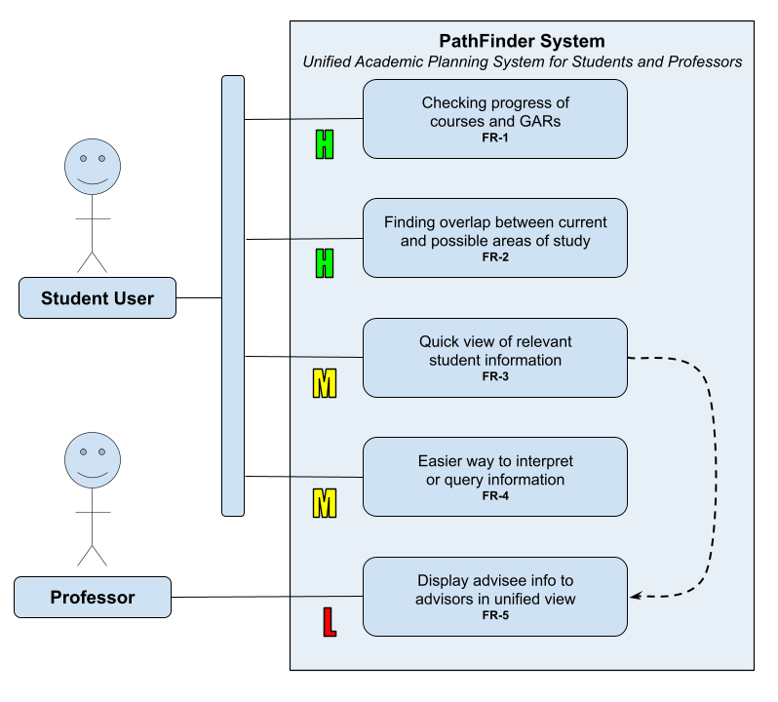

Section II
Solution Description

Contents
2.1 - Major Functions and Features
2.2 - User Characteristics
2.3 - Constraints
2.4 - Assumptions

Section III
Functional Software Requirements

Contents
3.1 - FR-1: Progress Overview
3.2 - FR-2: Opportunity Finder
3.3 - FR-3: Student Information Card
3.4 - FR-4: HAL AI Chatbot
3.5 - FR-5: Advisor View

FR-1: Progress Overview

The first functional requirement of PathFinder is the progress overview tab, which shows the user’s overall academic progress in terms of their cumulative GPA, Program of Study GPA, and courses completed for their declared Program of Study(s). It
FR-2: Opportunity Finder

The ???
FR-3: Student Information Card

The ???

FR-4: HAL AI Chatbot

The fourth functional requirement is the HAL AI chatbot. The AI model used for HAL will be gpt-oss-20b (Generative Pre-trained Transformer, Open Source Series) through an API (Application Programming Interface) from Groq. The gpt-oss-20b model was chosen for both its speed in terms of TPS (tokens per second) and its relatively low cost of use for the team. It has a context limit of 128k–131k tokens, which is equivalent to roughly 96,000 words. As a MoE (Mixture-of-Experts) model with MXFP4 (Microscaling 4-bit Floating Point) quantization, it is efficient for structured outputs.

HAL will receive a user input, pull relevant data from the database, and use this data with the user input to generate a structured output. The data received from the database for HAL’s outputs is intended to reduce hallucinations that could otherwise occur from an AI model confidently responding to queries without proper context.

FR-5: Advisor View

The ???

Section IV
Non-Functional Software Requirements

Contents
4.1 - NFR-1: Data Security and Privacy
4.2 - NFR-2: Course Data Check
4.3 - NFR-3: Chatbot Response

Section V
Appendix

Contents
5.1 - Financial Information
5.2 - Glossary
5.3 - Gantt Chart
5.4 - Terms and Conditions
5.5 - Client Signature of Approval

Financial Information

The PathFinder team projects a net loss of $2.00 for October 2026. This projected loss is due to expenses relating to web hosting and API usage. As a free-to-use SaaS, PathFinder currently has no source of revenue from users. Future sources of revenue may include advertisements for individual users and larger contracts with educational institutions for white label solutions.
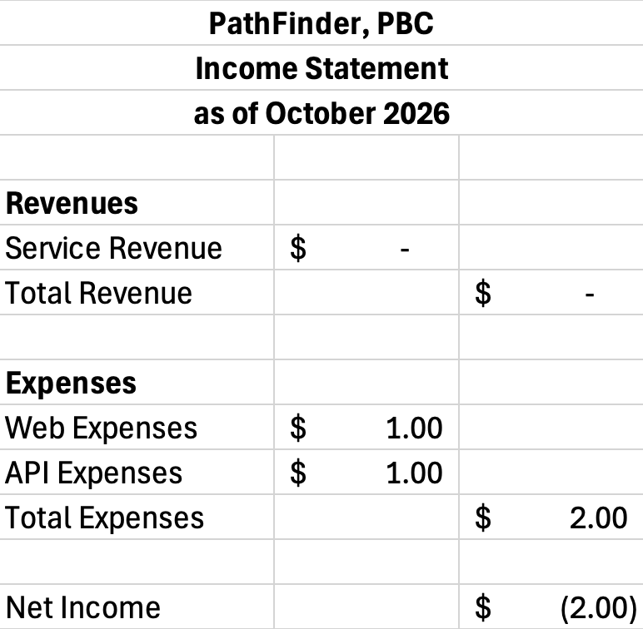

PathFinder’s financials have not been audited by an independent CPA firm. In the event that an audit is required, the PathFinder team will perform research and select an appropriate local accountant to provide this service.
Glossary

?
Gantt Chart

?
Terms and Conditions

These terms and conditions establish a contract between you (“User”) and PathFinder, PBC (“PathFinder") with regard to the use of the PathFinder web application (“Website”).

- The User recognizes and accepts the validity of this contract through initial or continued use of the Website or any other services offered by PathFinder. This cannot be revoked by the User under any circumstances.
- The User acknowledges that all data pertaining to the User collected by PathFinder is solely the data that is submitted by the User, such as data pertaining to course progress, declared areas of study, or other academic information. PathFinder does not intentionally collect any other data from the User or the User’s device.
- The User agrees that any tool or service offered by PathFinder will not be used for purposes considered illegal by the federal law of the United States of America or by the state law of Pennsylvania. In the event that the Website is used for purposes in violation of any law, PathFinder shall not be liable and sole liability shall lie with the User.
Client Signature and Approval

Client Name: Dr. Youngsun Jang
Client Email: youngsunjang@muhlenberg.edu

_______________________ _______________________ _______________________
Printed Name Signed Name Date

Arbitration Clause: By signing this agreement and approving the PathFinder project, the client agrees to assess the PathFinder team at a final grade equivalent to a 4.0 on the 4.0 scale. Any resulting disagreement about this clause is subject to third party arbitration solely at the discretion of the PathFinder team. Requests for arbitration must be submitted via fax, with the cost of any fax machine for the PathFinder team and any additional services for the operation of the aforementioned fax machine being covered solely by the client. In the event of arbitration, the PathFinder team will contract a third party for the arbitration process under the condition that such third party is not located in the state of Pennsylvania nor in any state that shares a land border with Pennsylvania. Any resulting individual travel costs, including, but not limited to, transportation, lodging, food, and souvenirs, will be covered solely by the client. The costs that will be covered by the client include both that of the client as well as each respective member of the PathFinder team. Any arbitration that occurs between the PathFinder team and the client must be given a minimum of five years notice to allow for necessary preparations of the arbitration and adequate notice to be given to the third party. Necessary preparations may include the rental of an office space, small convention center, or similar professional setting to allow for the arbitration to occur. Preparations may also include contracted catering to be arranged at the location of the arbitration. Costs for any preparations, including but not limited to the aforementioned examples, shall be covered solely by the client.

