Abhilasha Talwar, Hudson Plaskoff, Andrew Jarrah, O’glenn Togar

PathFinder: Weekly Report (Week 5)

During the meeting on September 28, the team reviewed the current status of the project. This mainly meant finalizing Presentation #1 during the meeting, which was presented the next day in class. Presentation #1 included the core problem addressed by PathFinder, as well as the key users and stakeholders, the main features, and the team’s current project vision. The presentation also provided time to reflect on what the team’s next steps are. The team also included a snapshot of planning materials, such as meeting minutes, formal weekly reports, and the latest draft of the requirements document. At the conclusion of the meeting on September 28, the team assigned slides to its different members.
During the meeting on September 30, the team discussed the project repository and reviewed all previous commits made. The team also reviewed Git operations and helped each other with the use of GitHub for the project. During class on October 1, the team decided to move from SQLite to PostgreSQL for better scalability in the long-term. The database in SQLite had not been finalized at this point which makes this transition easier, and all future database development will take place in PostgreSQL. Additionally, the team completed the three tier architecture and deployment diagram.
Git Activity
Abhilasha: Created a practice branch for Git assignment, created personal branch
O’glenn: Created personal branch
Andrew: Committed JavaScript and HTML files for front-end, created personal branch
Hudson: Committed course data from registrar to main branch, created personal branch
PathFinder Repository as of September 30 (Wednesday)
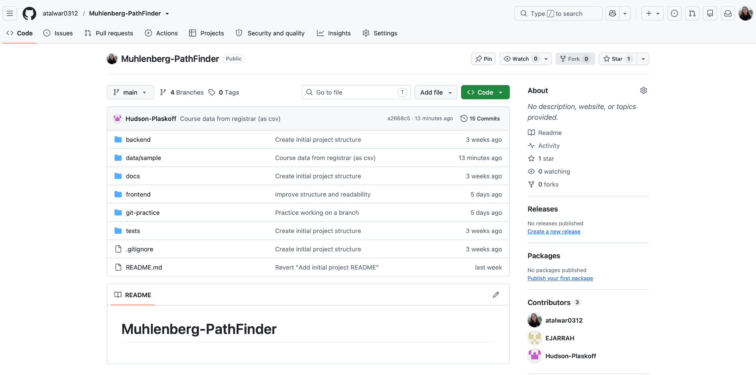
Personal Branches
