Requirements Document



PathFinder, PBC
d/b/a PathFinder

Version 1.4
Updated October 16, 2026

CEO | Abhilasha Talwar
VP Front-End | Andrew Jarrah
VP Back-End | O’glenn Togar
VP Database | Hudson Plaskoff
Table of Contents

1 - Introduction
1.1 - Document Overview (pg. 5)
1.2 - Revision Summary (pg. 6)
1.3 - Project Overview and Goals (pg. 7)
1.4 - System Scope and Major Features (pg. 8)
1.5 - Use Case Diagram (pg. 10)

2 - Solution Description
2.1 - Major Functions and Features (pg. 12)
2.2 - User Characteristics (pg. 13)
2.3 - Constraints and Assumptions (pg. 14)

3 - Functional Software Requirements (FR)
3.1 - FR-1: Progress Overview (pg. 16)
3.2 - FR-2: Opportunity Finder (pg. 18)
3.3 - FR-3: Student Information Card (pg. 20)
3.4 - FR-4: HAL AI Chatbot (pg. 22)
3.5 - FR-5: User Authentication (pg. 24)
3.6 - FR-6: Advisor View (pg. 26)

4 - Nonfunctional Software Requirements (NFR)
4.1 - NFR-1: Secure Login and HTTPS (pg. 29)
4.2 - NFR-2: Authorization (pg. 30)
4.3 - NFR-3: View Response Times (pg. 31)
4.4 - NFR-4: HAL Response Times (pg. 32)
4.5 - NFR-5: Desktop Browser Compatibility (pg. 33)
4.6 - NFR-6: Reliability and Maintainability (pg. 34)

Table of Contents (ctd.)

5 - Appendix
5.1 - Financial Information (pg. 36)
5.2 - Functional Work Breakdown Structure (pg. 37)
5.3 - Glossary (pg. 38)
5.4 - Gantt Chart (pg. 40)
5.5 - Terms and Conditions (pg. 41)
5.6 - Client Signature of Approval (pg. 43)

Section I
Introduction

Contents
1.1 - Document Overview
1.2 - Revision Summary
1.3 - Project Overview and Goals
1.4 - System Scope and Major Features
1.5 - Use Case Diagram
Document Overview

This requirements document defines what PathFinder must do and how well it must do it. It is written for the project’s client by the PathFinder team and incorporates the team’s background, mission, and goals.

- Introduction (1) - Describes the purpose of the document, the project’s goals, the scope of the system and its major features, and a use case diagram showing the system’s actors and feature priorities.
- Solution Description (2) - Provides a general overview of PathFinder’s solution, including the major functions and features, the characteristics of student and advisor users, and the constraints and assumptions that shape development.
- Functional Software Requirements (3) - Specifies what the system must do. Each feature is broken down into numbered requirements, with the expected system behavior, inputs, outputs, and subfunctions for each.
- Nonfunctional Software Requirements (4) - Specifies how well the system must perform, including measurable security, response time, browser compatibility, usability, reliability, and maintainability requirements.
- Appendix (5) - Contains supporting material: financial information, a functional work breakdown structure, a glossary of terms, a Gantt chart showing the project timeline, the terms and conditions for use of the PathFinder website, and the client’s signed approval.

Revision Summary

Following feedback, we expanded the functional and nonfunctional software requirements into hierarchical requirements with inputs, outputs, validation, and error handling. We clarified academic record entry, calculations, recommendations, and role-based access. We made quality targets measurable and added usability, reliability, and maintainability checks. We added an alphabetical glossary, aligned the use case diagram and FWBS with the requirements, and extended the planned timeline through December. However, we removed GARs as an aspect of the project’s requirements due to a constraint relating to limited data from the school. The scope of the project remains limited to available academic data, with email/password authentication.
Project Overview and Goals

PathFinder is a user-friendly, free-to-use software-as-a-service (SaaS) web application that helps students at Muhlenberg College navigate their academic journey and plan their semesters well in advance. It also supports advisors at Muhlenberg in guiding their advisees by providing a unified view of every student they advise. Both are a response to the current fragmented systems which add confusion and friction to one of the most important digital processes at Muhlenberg.

The PathFinder team comes from a wide range of academic backgrounds, including computer science, mathematics, and finance. The synthesis of their shared knowledge and personal experiences has shaped the PathFinder team’s philosophy and informed the project’s design choices. For example, one team member created an improvised spreadsheet to track their progress for their area of study. This works for this individual team member, but it is limited by several factors.

- It is usable only by the team member and cannot easily be replicated.
- It requires significant effort to change, such as adding a new major or minor, because new information must be entered manually.
- It is awkward to view since it lives inside general-purpose software.

Due to the shortcomings of this team member’s spreadsheet, the team envisions PathFinder as software within a new framework entitled ACT.
Adaptive | meets the needs of all users
Centralized | one unified database
Tailored | purpose-built software
System Scope and Major Features

PathFinder is a web application with two user roles: students and advisors. Students use a dashboard to track their academic progress, explore additional majors and minors, and ask questions through an AI chatbot. Advisors use a separate view to monitor the progress of the students they advise.

Feature | Requirement | User | Priority
Progress Overview | FR-1 | Student | High
Opportunity Finder | FR-2 | Student | High
Student Information Card | FR-3 | Student | Medium
HAL AI Chatbot | FR-4 | Student | Medium
User Authentication | FR-5 | Student, Advisor | High
Advisor View | FR-6 | Advisor | Low

PathFinder’s stakeholders are students and advisors at Muhlenberg College:
- Students can use the Progress Overview, Opportunity Finder, Student Information Card, and the HAL AI Chatbot. They can see only their own data and cannot access the Advisor View.
- Advisors (professors and lecturers) can use only the Advisor View. It shows the progress of the students they advise, including the information on each student’s Student Information Card, and lets them open any one student for a detailed look. Advisors cannot see students they do not advise and cannot edit student data.
System Scope and Major Features (ctd.)

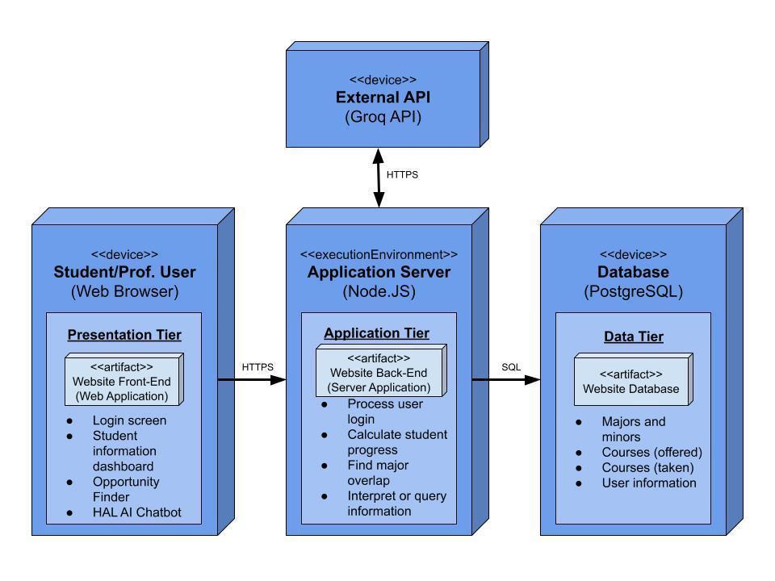
Use Case Diagram

The UML use case diagram shows the complete PathFinder system, its student and advisor roles, and the external Groq service used by HAL. Each use case is linked to its functional requirement number. Academic record entry is a supporting subfunction of FR-1. Students use FR-1 through FR-5; advisors use FR-5 and FR-6. H, M, and L indicate the existing high, medium, and low feature priorities. Data consistency between the card and Advisor View is specified in FR-3 and FR-6 rather than shown as a data-flow relationship.

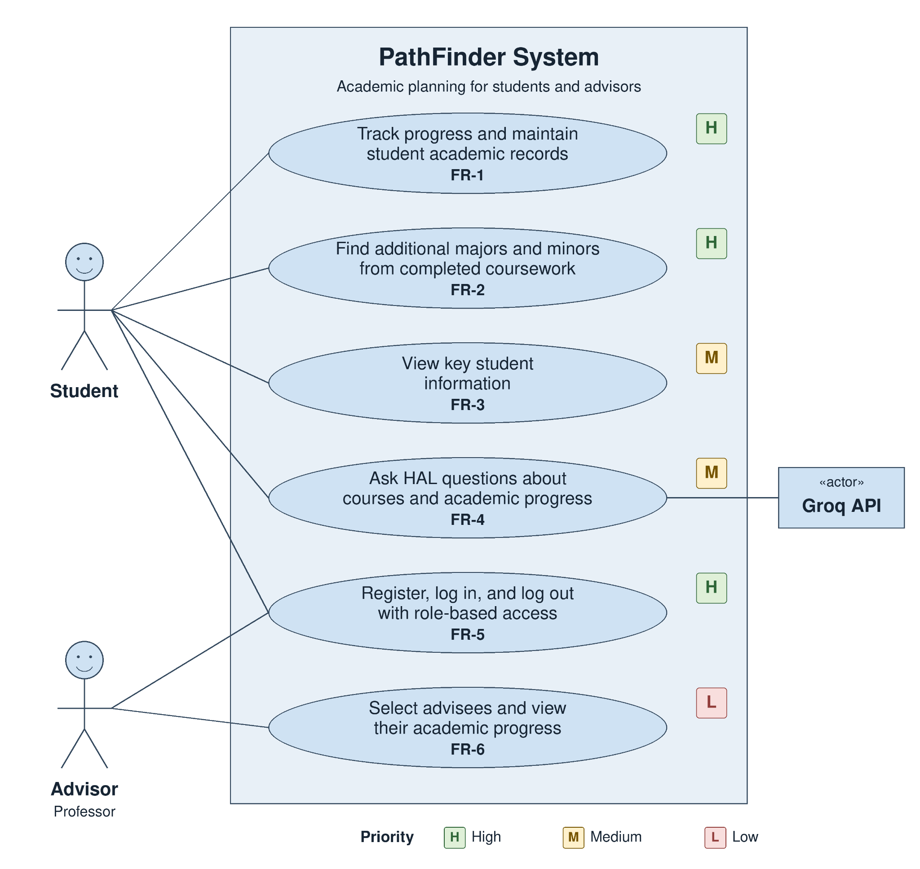

Section II
Solution Description

Contents
2.1 - Major Functions and Features
2.2 - User Characteristics
2.3 - Constraints and Assumptions
Major Functions and Features

The major features of PathFinder include both functional software requirements (FRs) and nonfunctional software requirements (NFRs).

Functional Software Requirements

FR-1: Display student progress and maintain the academic records used to calculate it.
FR-2: Suggest additional majors and minors based on completed courses.
FR-3: Display key student information in a static view.
FR-4: Answer student questions about courses and areas of study with AI.
FR-5: Let users log in and limit each role to its own views and data.
FR-6: Show advisors the progress of their advisees in a separate view.

Nonfunctional Software Requirements

NFR-1: Process user login securely and use HTTPS for all traffic.
NFR-2: Return an authorization error for any request for unauthorized data.
NFR-3: Load main student and advisor views within 2 seconds.
NFR-4: Return AI chatbot responses within 5 seconds.
NFR-5: Work fully on Chrome and Safari for computers.
NFR-6: Preserve saved records and support repeatable maintenance.
User Characteristics

Student

Student users are primarily traditional-age undergraduates at Muhlenberg College. They generally have high technical fluency, are comfortable with a wide range of applications and websites, and prefer to use their phones for most tasks, though they can also use computers in both casual and professional settings. The student interface should be usable on desktop screens.

Students create their own accounts and supply the information PathFinder needs: their name, school ID number, class year, declared major(s) and minor(s), and completed courses with grades. They do not need any training to use the system.

Advisor

Advisor users are Muhlenberg faculty members who serve as academic advisors. Their technical fluency varies from low to high, and they generally prefer computers to phones. Similar to the Student View, the Advisor View should therefore be designed primarily for desktop use and be simple enough to use without training.

Advisors select the students they advise and can view the detailed progress of those students. They cannot view other students’ data and cannot enter or edit student data.
Constraints and Assumptions

The client has set the following constraints for PathFinder:
- The project must be completed by December 2026.
- The team must demonstrate regular progress toward the project’s goals.
- The team must use GitHub to host project files and must demonstrate Git use by all team members.

The PathFinder team makes the following assumptions:
- All users are either students or advisors.
- Students enter their declared areas of study and completed courses truthfully and correctly.
- Students do not have a major and minor in the same area of study.
- Advisors select their role and advisees truthfully. The prototype enforces access against saved selections; it does not independently verify faculty status or official advising assignments. This access model is an explicit assumption for the course prototype, not a verified college authorization process.
- Users have an internet connection and a supported browser.

Section III
Functional Software Requirements

Contents
3.1 - FR-1: Progress Overview
3.2 - FR-2: Opportunity Finder
3.3 - FR-3: Student Information Card
3.4 - FR-4: HAL AI Chatbot
3.5 - FR-5: User Authentication
3.6 - FR-6: Advisor View
FR-1: Progress Overview

The Progress Overview combines cumulative and program GPA, completed and remaining program requirements, and progress toward the thirty-two-credit graduation total. It evaluates the student’s saved records against loaded program requirements. Inputs are completed courses, grades, credits, declarations, and program requirements. Outputs are GPA, satisfied and remaining requirements, completion percentages, and earned and remaining credits.
FR-1.1: The system shall retrieve academic records for the logged-in student and evaluate every declared major and minor against its loaded requirements. Each result shall identify the program to which it applies so that progress in different programs is not combined into one unexplained value.
FR-1.2: The system shall calculate cumulative GPA from all completed courses eligible for GPA calculation using their grade-point values and credit weights. It shall display the result rounded to two decimal places and shall not treat a missing grade as a zero grade.
FR-1.3: The system shall calculate a separate GPA for each declared major and minor using only eligible completed courses that count toward that program. It shall label each program GPA separately from cumulative GPA and round each displayed result to two decimal places.
FR-1.4: The system shall identify the completed courses that satisfy requirements in each declared program and list them with the corresponding satisfied requirements. Courses recorded in the student’s history that do not satisfy a requirement shall not be represented as satisfying that requirement.
FR-1.5: The system shall list every unsatisfied program requirement and the loaded courses that can fulfill it, distinguishing alternative course choices from completed coursework.
FR-1: Progress Overview (ctd.)

FR-1.6: The system shall display each declared program’s completed requirement count, total requirement count, and completion percentage, calculated as 100 times completed count divided by total count and rounded to one decimal place. Counts shall follow the loaded program rules. A missing or unusable program definition shall be shown as unavailable rather than zero-percent completion.
FR-1.7: The system shall display total completed credits and remaining graduation credits. Remaining credits shall equal thirty-two minus completed credits, with a minimum displayed value of zero. Reaching the credit total alone shall not cause unsatisfied major or minor requirements to be marked complete.
FR-1.8: When the student saves an added, edited, or removed course or changes a declared program, the system shall recalculate every affected progress value from the saved record. A rejected or unsuccessful save shall not be displayed as a successful change to academic progress.
FR-1.9: The system shall exclude courses without a valid grade from GPA calculations and identify those courses to the student. It shall distinguish an unavailable GPA from a numerical GPA of zero, and shall identify missing academic data that prevents a program calculation.
FR-1.10: The system shall provide consistent calculated progress to the Student Information Card and the authorized Advisor View. Opening the same saved student record in those views shall not apply different credit totals, grade inputs, or program requirement results.
FR-2: Opportunity Finder

The Opportunity Finder compares completed coursework with additional majors and minors. It presents the closest eligible matches, including possible minor-to-major upgrades, while keeping recommendations separate from the student’s actual declarations. Inputs are completed courses, current declarations, and loaded program requirements. Outputs are up to five ranked programs with counted courses, satisfied requirements, and requirements remaining.
FR-2.1: The system shall compare the student’s completed courses with the loaded requirements for every major and minor offered in the project’s program data. A program without usable requirement information shall not be presented as though it has been fully evaluated.
FR-2.2: For each evaluable candidate, the system shall determine which completed courses satisfy its requirements and calculate the number and percentage of requirements already satisfied. The displayed values shall be based on the candidate’s own requirement definition rather than the totals of the student’s current major.
FR-2.3: The system shall rank candidates from most to least requirements already satisfied and display up to five suggestions. Ties shall be ordered alphabetically by program name, then major before minor for the same name. When fewer than five eligible programs are available, the system shall show those available without duplicates or fabricated candidates.
FR-2.4: For each suggestion, the system shall identify the suggested program and if it is a major or minor. It shall show the completed courses already counted, the number of satisfied requirements, and the number of requirements left.
FR-2.5: The system shall exclude any already declared major or minor and any minor in the same subject as a declared major. The corresponding major remains eligible for a minor-to-major upgrade.
FR-2: Opportunity Finder (ctd.)

FR-2.6: The system shall retain the corresponding major as an eligible candidate when the student has declared only the minor in that area. It shall present that candidate as an upgrade opportunity only when its calculated result places it among the closest eligible matches.
FR-2.7: The system shall base suggestions on the closest calculated matches even when the student has completed only a small number of courses. It shall display the remaining requirement count so that a relatively close match is not misrepresented as an already completed program.
FR-2.8: When no completed courses have been entered, the system shall display a message prompting the student to enter courses instead of displaying ranked suggestions. When program data cannot be evaluated, it shall identify the unavailable result rather than infer a program’s requirements.
FR-2.9: After a course is added, edited, or removed or a declared program is changed and saved, the system shall recompute the suggestions and their supporting course lists. The updated suggestions shall reflect the same saved course record used by the Progress Overview.
FR-2.10: The system shall keep suggestions separate from declared programs. Viewing a recommendation shall not add or remove a declaration, change completed coursework, or change GPA. A newly saved declaration shall instead be reflected through the normal refresh and exclusion rules.
FR-3: Student Information Card

The Student Information Card provides a read-only academic identity reference in an upper corner of every student view. Changes are made through profile and course entry functions rather than the card. Inputs are saved profile fields, declarations, and cumulative GPA. Outputs are the school ID, class year, declared programs, and GPA for the authenticated student.
FR-3.1: The system shall display the student’s class year, declared areas of study, cumulative GPA, and school-assigned ID number. Every displayed value shall belong to the authenticated student record, and the school ID shall not be replaced by an internal database identifier.
FR-3.2: The system shall identify each declared area of study as a major or a minor and display all saved declarations. It shall not infer a declaration from an Opportunity Finder suggestion or from the fact that a student has completed coursework in a subject.
FR-3.3: The system shall display cumulative GPA from the same calculation used by the Progress Overview. It shall preserve the two-decimal presentation used in FR-1 and shall not calculate a separate or differently rounded value solely for the card.
FR-3.4: The system shall place the card in an upper corner of the student interface and keep it visible on every student view. Switching between the progress, opportunity, and chatbot features shall continue to show information for the same authenticated student.
FR-3.5: The system shall present the card without interactive editing elements. Selecting or reading the card shall not change the student’s profile, declarations, grades, or completed courses; those values shall be changed only through their corresponding data-entry functions.
FR-3: Student Information Card (ctd.)

FR-3.6: When a profile field or declaration is changed and saved, the system shall refresh the related card fields from the stored record. An unsuccessful save shall not replace a previously saved card value with a value that was not accepted.
FR-3.7: When a course is added, edited, or removed and saved, the system shall refresh cumulative GPA after the Progress Overview recalculates it. Other card fields shall continue to reflect the saved profile and declarations rather than unrelated course-entry values.
FR-3.8: If a card field has not been entered, the system shall display an explicit placeholder such as “Not entered.” If GPA cannot be calculated from the available coursework, it shall identify that state rather than use a blank field or an invented numerical value.
FR-3.9: The system shall associate the displayed card with the active authenticated record. After logout, access to protected card data shall require a new valid login; a later login by another student shall not continue to display the previous student’s card.
FR-3.10: The system shall provide the same card information in the authorized advisor summary specified in FR-6. The advisor’s copy shall remain read-only and shall agree with the corresponding student’s saved values whenever the information is refreshed.
FR-4: HAL AI Chatbot

HAL uses the student’s question and relevant saved academic records to request a grounded response from gpt-oss-20b through the Groq API. It distinguishes successful answers, unavailable information, and service failures. Inputs are a nonempty question and authorized academic context. Outputs are the question and answer, a validation message, or a service-unavailable message; saved academic records remain unchanged.
FR-4.1: The system shall provide a chat interface on the student dashboard with a question-entry control and an area for the related answer. The student shall be able to distinguish their submitted question from HAL’s generated response.
FR-4.2: The system shall accept a nonempty question from the authenticated student. Empty or whitespace-only input shall produce an input message without making a Groq API request, so a blank submission is not treated as a meaningful academic query.
FR-4.3: When a question is submitted, the system shall retrieve the relevant student information, including declared programs and completed courses, and the loaded requirements for programs referenced by the question. The retrieval shall use the current saved record rather than unsaved form values.
FR-4.4: The system shall retrieve student-specific context only for the account that is logged in. A question containing another student’s name or identifier shall not authorize access to that student’s academic records or change the account used for data retrieval.
FR-4.5: The system shall send the question and retrieved context to the configured AI model through the Groq API. It shall not include account passwords, session tokens, or unrelated student records in the request assembled for the model.
FR-4: HAL AI Chatbot (ctd.)

FR-4.6: The system shall instruct HAL to answer from the retrieved academic data. When that data does not contain the information required for an answer, HAL shall state that the information is unavailable instead of inventing a course requirement or a completed academic result.
FR-4.7: On a successful response, the system shall display the answer with its associated question. Course and program references returned in the answer shall remain readable, and a response to an earlier question shall not be presented as the answer to a different question.
FR-4.8: The system shall show a loading indicator while a submitted request is in progress and remove it when an answer or an error is displayed. The complete response and database lookup shall be assessed against the timing requirements in NFR-4.
FR-4.9: If Groq is unavailable, returns an error, or exceeds the configured request timeout, the system shall stop the affected request and display that HAL is temporarily unavailable. The student shall be able to submit another question or retry without re-entering their academic record.
FR-4.10: The system shall preserve saved academic records while processing questions and handling failures. HAL’s output shall remain planning assistance rather than an edit to coursework, grades, or declarations, and the existing terms shall identify that AI responses are not official academic advice.
FR-5: User Authentication

Authentication establishes the account and role used by protected requests. This version uses the team’s email-and-password method, directs each role to its own view, and applies server-side access checks. Inputs are account fields or login credentials and the saved role. Outputs are an account, valid session and permitted view, or a login or access error.
FR-5.1: The system shall allow a new user to create an account by entering an email address, password, and a role of student or advisor. The account shall retain the chosen role for determining the view and operations available after authentication.
FR-5.2: The system shall validate required account-creation fields before accepting a new account. Missing required values or a login identity already in use shall produce a clear account-creation message without leaving an incomplete account that can be used to access academic data.
FR-5.3: The system shall allow a registered user to submit login credentials and shall verify those credentials against the stored account. User login handling and traffic protection shall comply with NFR-1; a successful authentication shall establish the account identity used by protected requests.
FR-5.4: When login credentials are invalid, the system shall display an error without identifying whether the email address or password was incorrect. It shall not create a valid session, open a protected view, or return student academic records in that failure response.
FR-5.5: After successful login, the system shall direct a student to the Student View and an advisor to the Advisor View. The destination and access rights shall be based on the authenticated account’s stored role rather than an unverified role value sent with a later browser request.
FR-5: User Authentication (ctd.)

FR-5.6: The system shall allow a student to access only their own academic records and shall deny access to records belonging to another student. The same restriction shall apply when a student changes an identifier in a URL or submits a direct data request outside normal navigation.
FR-5.7: The system shall allow an advisor to read only the records of students saved in that advisor’s advisee list. It shall deny an advisor’s request for an unselected student and shall deny advisor attempts to add, edit, or delete student academic data.
FR-5.8: The system shall reject attempts by a student account to open the Advisor View and attempts by an advisor account to open the Student View. Hidden navigation controls alone shall not satisfy this requirement; the server shall enforce the role check for each protected request.
FR-5.9: The system shall require a valid, unexpired login session before returning protected information. A missing or expired session shall produce an authentication error and shall not disclose the requested record while the user is required to authenticate again.
FR-5.10: The system shall allow a logged-in user to log out and shall end access through that session. A later protected request using the ended session shall require authentication again, and a subsequent login shall load the identity, role, and data of the account that actually authenticated.
FR-6: Advisor View

The Advisor View provides a summary roster and detailed read-only progress for an advisor’s selected students. Under the team’s existing assumption, advisors select their advisees truthfully; saved selections define permitted access. Inputs are the advisor’s saved selections and associated student records. Outputs are the advisee summary, individual progress details, an empty-list state, or an access or unavailable-data message.
FR-6.1: The system shall allow an authenticated advisor to select the students they advise from registered students and save those selections to that advisor’s account. Selecting an advisee shall establish a read association without changing the selected student’s profile or coursework.
FR-6.2: The system shall allow an advisor to remove a student from their advisee list. After removal, the student shall no longer appear in the advisor’s saved summary, and a new request for that student’s detailed record shall be denied unless the association is established again.
FR-6.3: The system shall display a summary of all students on the advisor’s saved advisee list. For each student, it shall show the class year, declared programs, cumulative GPA, school-assigned ID, and overall progress information specified for the Advisor View.
FR-6.4: The system shall keep summary information associated with the correct student record and preserve the distinction between major and minor declarations. Missing profile or GPA values shall be identified as unavailable or not entered rather than filled with values from another advisee.
FR-6.5: When the advisor selects an associated student, the system shall open that student’s detailed progress and identity information. The record opened shall correspond to the selected roster entry and shall remain subject to a server-side check of the advisor’s current association.
FR-6: Advisor View (ctd.)

FR-6.6: The detailed view shall show the Progress Overview results from FR-1, including cumulative and program GPA, completed and remaining program requirements, and earned and remaining credits. These values shall use the same saved records and calculations as the student’s own view.
FR-6.7: The system shall present student information without academic editing controls and shall reject an advisor’s direct attempt to add, edit, or delete student profile or course records. Read-only access shall be enforced by the server as well as represented in the interface.
FR-6.8: The system shall display only the signed-in advisor’s selected advisees and shall deny requests for unselected students. Entering a different student identifier outside the roster shall not bypass the association check or expose an unrelated student’s progress.
FR-6.9: When the advisor refreshes the roster or reopens an advisee after that student has saved a change, the system shall retrieve the updated record and recalculate affected summaries. It shall not represent an unsuccessful retrieval as a successful refresh of current information.
FR-6.10: If the advisor has no selected advisees, the system shall display an empty-list message. If an associated student’s progress cannot be retrieved or evaluated, it shall identify the unavailable information and preserve the distinction between missing data and verified zero progress.

Section IV
Non-Functional Software Requirements

Contents
4.1 - NFR-1: Secure Login and HTTPS
4.2 - NFR-2: Authorization
4.3 - NFR-3: View Response Times
4.4 - NFR-4: HAL Response Times
4.5 - NFR-5: Desktop Browser Compatibility
4.6 - NFR-6: Reliability and Maintainability
NFR-1: Process user login securely and use HTTPS for all traffic.

This requirement protects user accounts and keeps data private as it moves between the browser, Google’s sign-in service, the application server, and the external Groq API.

NFR-1.1: The system shall authenticate users only through Google OAuth 2.0 and shall not collect, receive, or store user passwords.

NFR-1.2: The system shall serve all pages and API requests over HTTPS, and shall redirect any HTTP request to HTTPS.

NFR-1.3: The system shall use HTTPS for all communication with Google’s OAuth service and the Groq API, and encrypted TLS connections for all communication with PostgreSQL.

NFR-1.4: The system shall not store the Google OAuth client secret, API keys, or database credentials in client-side code or in the GitHub repository, and shall load them from environment variables or a secrets manager.

NFR-1.5: The system shall not include OAuth tokens, the client secret, or session tokens in application logs or in error messages displayed to the user, and shall not place session tokens in URLs.

NFR-2: Return an authorization error for any request for unauthorized data.

This requirement ensures that students and advisors can retrieve only the data their role permits.

NFR-2.1: The system shall return an authorization error when a student requests any data belonging to another student.

NFR-2.2: The system shall return an authorization error when an advisor requests data for a student they have not selected as an advisee.

NFR-2.3: The system shall return an authorization error when a student attempts to open the Advisor View, or an advisor attempts to open the Student View.

NFR-2.4: The system shall return an authentication error when a request is made without a valid, unexpired login session.

NFR-2.5: The system shall enforce authorization checks on the server for every protected request, regardless of what the front end displays.

NFR-3: Load main student and advisor views within 2 seconds.

This requirement keeps the system responsive so users can view their information without noticeable delay.

NFR-3.1: The system shall display the Progress Overview within 2 seconds of the student opening it, for at least 95% of requests.

NFR-3.2: The system shall display Opportunity Finder suggestions within 2 seconds of the student opening it or updating their courses, for at least 95% of requests.

NFR-3.3: The system shall display the Advisor View summary list within 2 seconds of the advisor opening it, for at least 95% of requests.

NFR-3.4: The system shall meet NFR-3.1 through NFR-3.3 with at least two users logged in and issuing requests concurrently.

NFR-4: Return AI chatbot responses within 5 seconds.

This requirement ensures HAL responds in a reasonable time, including the database lookup and the call to the Groq API.

NFR-4.1: The system shall display HAL’s complete response within 5 seconds of the student submitting a question, for at least 95% of queries. Testing shall measure at least 100 valid queries and record the test conditions.

NFR-4.2: The system shall display a loading indicator from the moment a question is submitted until the response or an error message appears.

NFR-4.3: If HAL has not returned a complete answer within 15 seconds of submission, the system shall stop waiting, remove the loading indicator, and display that HAL is temporarily unavailable. This timeout is a failure-handling limit; it does not replace the 5-second performance target in NFR-4.1.

NFR-4.4: The database-retrieval portion of a successful HAL request shall take less than 2.5 seconds, leaving more than half of the 5-second response budget for the Groq API call and display.

NFR-5: Work fully on Chrome and Safari for computers.

This requirement ensures every feature works correctly for users on the two supported desktop browsers.

NFR-5.1: The system shall support the current stable version of Google Chrome on Windows and macOS with all features working. The tested browser and operating-system versions shall be recorded for each release.

NFR-5.2: The system shall support the current stable version of Safari on macOS with all features working. The tested browser and operating-system versions shall be recorded for each release.

NFR-5.3: At browser zoom of 100%, the system shall display every page without overlapping, cut-off, or unreadable content at viewport sizes of 1280 × 720, 1366 × 768, and 1440 × 900 pixels on each supported browser and operating-system combination.

NFR-5.4: The system shall be tested on Chrome and Safari before each release, with every functional requirement passing on each supported browser and operating-system combination.

NFR-5.5: At least four of five untrained representative users shall finish their role’s tasks within 10 minutes: students add a course, locate remaining requirements, view a suggestion, and ask HAL a question; advisors select an advisee and open progress. The five users shall include both roles.

NFR-6: Preserve saved records and support repeatable maintenance.

This requirement defines observable recovery and maintenance checks for the course prototype. It covers saved academic records, failures in dependent services, and the team’s ability to repeat tests after a change.

NFR-6.1: After an application restart and a new valid login, every successfully saved profile field, declaration, course entry, and advisee association shall match its last confirmed saved value. Testing shall compare all fields for at least ten student accounts and two advisor accounts.

NFR-6.2: During simulated database failure and Groq failure, failed operations shall not alter previously saved academic records. Every simulated failure shall produce an error or unavailable state, and the user shall be able to retry after service recovery without recreating their account or saved coursework.

NFR-6.3: Before each release, the team shall maintain a verification checklist linking every FR and NFR subrequirement to at least one test case or inspection. The recorded result shall identify the requirement, expected outcome, actual outcome, and pass or fail status; no subrequirement shall be left unmapped.

NFR-6.4: The project repository shall include setup and test instructions identifying required configuration names without secret values. A team member other than the author shall use those instructions to start the application and run the documented checks in a clean environment; every missing step shall be corrected before release.

Section V
Appendix

Contents
5.1 - Financial Information
5.2 - Functional Work Breakdown Structure
5.3 - Glossary
5.4 - Gantt Chart
5.5 - Terms and Conditions
5.6 - Client Signature of Approval
Financial Information
The PathFinder team projects a net loss of $5.00 for October 2026. This projected loss is due to expenses from API usage for the HAL AI chatbot. As a free-to-use SaaS, PathFinder currently has no source of revenue from users. Future sources of revenue may include advertisements for individual users and larger contracts with educational institutions for custom solutions. PathFinder’s financials have not been audited by an independent CPA firm nor any other third party. The draft income statement was prepared and reviewed solely by the PathFinder team.
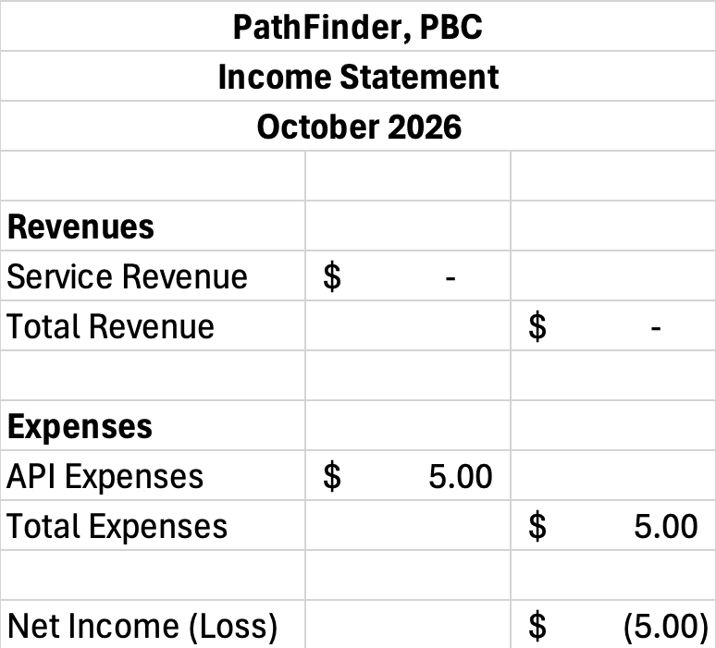
Projections for PathFinder’s future financial information assume a base case where no source of revenue exists and therefore losses accumulate year over year.
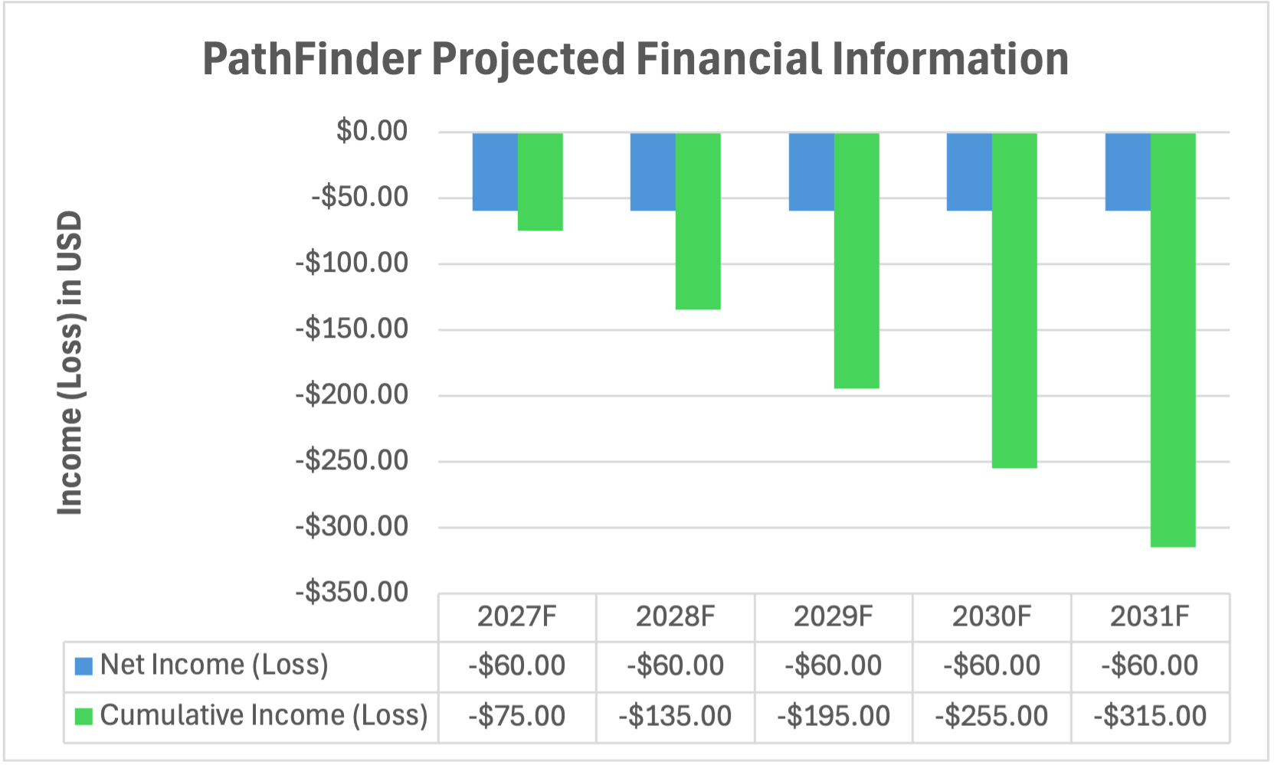
Functional Work Breakdown Structure (FWBS)

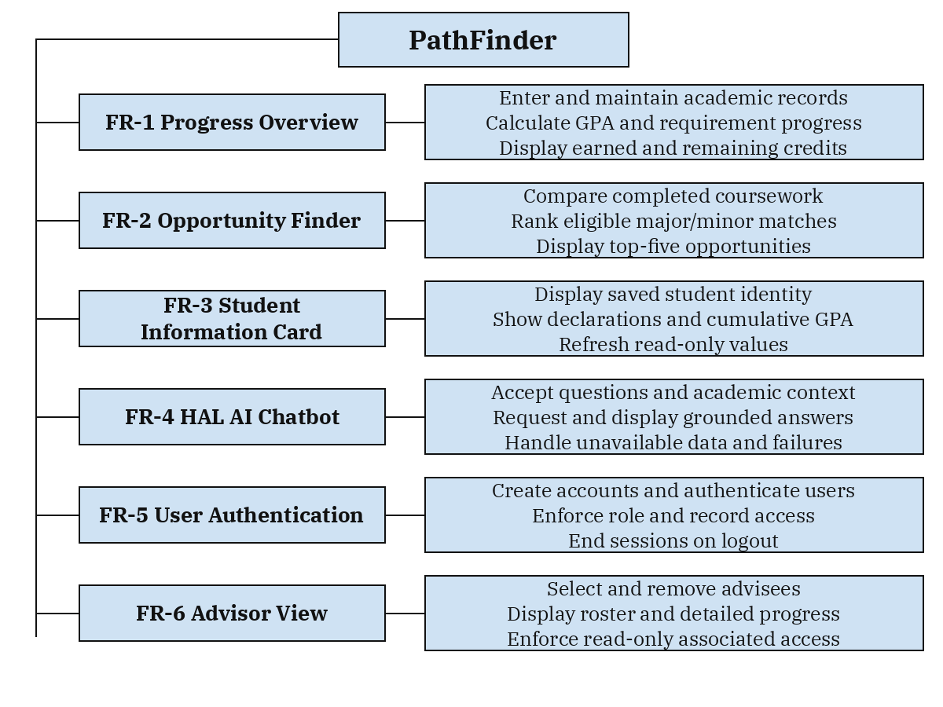
The FWBS decomposes the six functional requirements into their principal subfunctions. Each FR branch corresponds to the same identifier in Section III and the use case diagram. Course and profile entry support FR-1; role restrictions apply throughout the student and advisor functions. Shared quality checks are defined in Section IV.
Glossary

ACT - The PathFinder design framework: Adaptive (meets the needs of all users), Centralized (one unified database), and Tailored (purpose-built software).

Advisor View - The separate view (FR-6) that shows an advisor the progress of their advisees. It is not accessible to students.

API (Application Programming Interface) - A defined way for one software system to request data or services from another. PathFinder uses the Groq API to generate chatbot responses.
Authentication - Verifying a user’s identity before establishing a login session.

Authorization - Checking whether a logged-in user may access a particular view, record, or operation.

FR - Functional Requirement; a statement of behavior the system shall provide.

FWBS - Functional Work Breakdown Structure; a hierarchy of the system’s major functions and their supporting subfunctions.

GPA (Grade Point Average) - A numerical average of a student’s grades, weighted by the credit value of each course.

Groq - The external API service used by HAL to obtain generated responses from the configured AI model.

Glossary (ctd.)

HAL - PathFinder’s AI chatbot (FR-4), which answers student questions about their progress, courses, and areas of study.

HTTPS - Hypertext Transfer Protocol Secure; HTTP communication protected using TLS.

NFR - Nonfunctional Requirement; a measurable quality or constraint the system shall satisfy.

SaaS (Software as a Service) - Software delivered over the internet through a web browser rather than installed on a user’s device.

Student View - The set of PathFinder screens available to student users: the dashboard containing the Progress Overview, Opportunity Finder, Student Information Card, and HAL chatbot. Students see only their own data and cannot access the Advisor View.

TLS - Transport Layer Security; the protocol used to encrypt communication with services such as the database.

UML - Unified Modeling Language; a standard notation for system models, including actors and use cases.
Gantt Chart

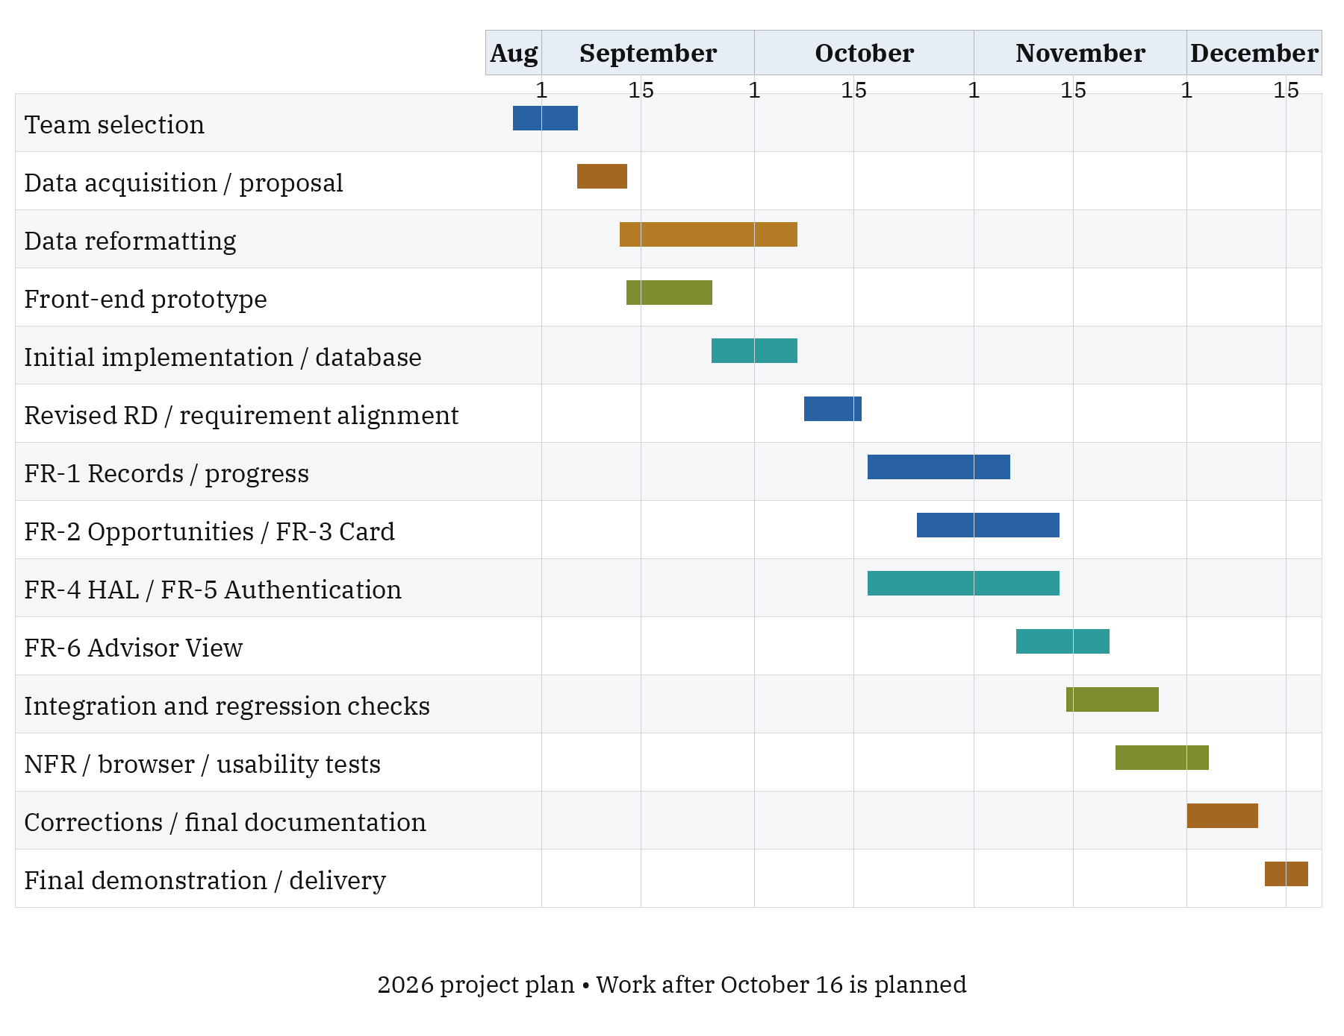

This chart retains the initial project phases and extends the working plan through the December 2026 completion constraint. Dates after October 16 are planning targets, including a December 11 delivery target; they are not claims that work is already complete or an instructor-assigned due date. Each implementation phase maps to the FR identifiers, followed by integration and quality verification.
Terms and Conditions

These terms and conditions establish a contract between you (“User”) and PathFinder, PBC (“PathFinder") with regard to the use of the PathFinder web application (“Website”).

- The User accepts these terms through initial or continued use of the Website or any other services offered by PathFinder. The User may stop using the Website at any time.
- PathFinder may update these terms as needed. Continued use of the Website after an update to these terms means the User accepts the updated terms.
- The User is responsible for keeping their login credentials confidential and for all activity that occurs under their account.
- The User agrees to enter information truthfully and correctly, not to access or attempt to access another user’s data, and not to misuse or interfere with the Website.
- The User agrees that any tool or service offered by PathFinder will not be used for purposes considered illegal under any applicable law. If the Website is used in violation of any law, PathFinder shall not be liable, and sole liability shall lie with the User.
- All academic data pertaining to the User that PathFinder collects is data submitted by the User, such as course progress, declared areas of study, and other academic information, along with the login credentials needed to operate the account. PathFinder does not intentionally collect any other data from the User or the User’s device.
- Student data entered into PathFinder is visible to the advisors who select that student as an advisee. Advisors can view but cannot edit this data. Students should not enter information they do not want their advisors to see.
Terms and Conditions (ctd.)

- When the User asks the HAL chatbot a question, the question and the relevant academic records are sent to a third-party service, the Groq API, to generate a response. PathFinder does not control how Groq handles this data.
- PathFinder’s progress calculations, GPA figures, and major or minor suggestions are based on data entered by the User and on requirement data loaded by the PathFinder team. PathFinder is not the college’s official degree audit or academic record. The User should confirm graduation requirements and course choices with their advisor or the Registrar.
- HAL is an AI chatbot, and its responses may be incomplete or incorrect. HAL’s responses are not official academic advice.
- PathFinder is provided free of charge and “as is,” without warranties of any kind, including accuracy, availability, or fitness for a particular purpose. To the extent permitted by law, PathFinder shall not be liable for any loss arising from the User’s use of, or reliance on, the Website.
- PathFinder may suspend or terminate any account that violates these terms. The User may stop using the Website at any time.
Client Signature and Approval

Client Name: Dr. Youngsun Jang
Client Email: youngsunjang@muhlenberg.edu

_______________________ _______________________ _______________________
Printed Name Signed Name Date

