Abhilasha Talwar, Hudson Plaskoff, Andrew Jarrah, O'glenn Togar
PathFinder: Weekly Report (Week 7)
This week, the team mainly focused on documentation. This included finalizing the Requirements Document (RD), which required substantial revision. Comments on the draft were discussed by the team and implemented into the final draft. A new glossary section was added, and the sections for functional and nonfunctional software requirements were greatly expanded upon.
One major step that occurred this week was the finalization of a PostgreSQL database for testing purposes. It was completed on Supabase and is available to team members working on the back-end team for development use through APIs. It can be used to test basic features such as the opportunity finder or showing how many courses have been completed, which can then be demonstrated on the front-end. Another major step came from the front-end development. New pages for GAR, Major, and Minor tracker have been added to the student progress page.

Git Activity: https://github.com/atalwar0312/Muhlenberg-PathFinder
Abhilasha: n/a (work on RD)
O'glenn: working on connecting frontend, backend, and database (no commits yets)
Andrew: Pushed the new pages talked about above with the GAR, Major, Minor tracking, working on the HAL bot implementation, trying to get that in by 1-2 weeks.
Hudson: n/a (work on Supabase and data)

Supabase Activity:
Hudson: Created initial test PostgreSQL database on Supabase with APIs

PathFinder Supabase as of 10/16/2026
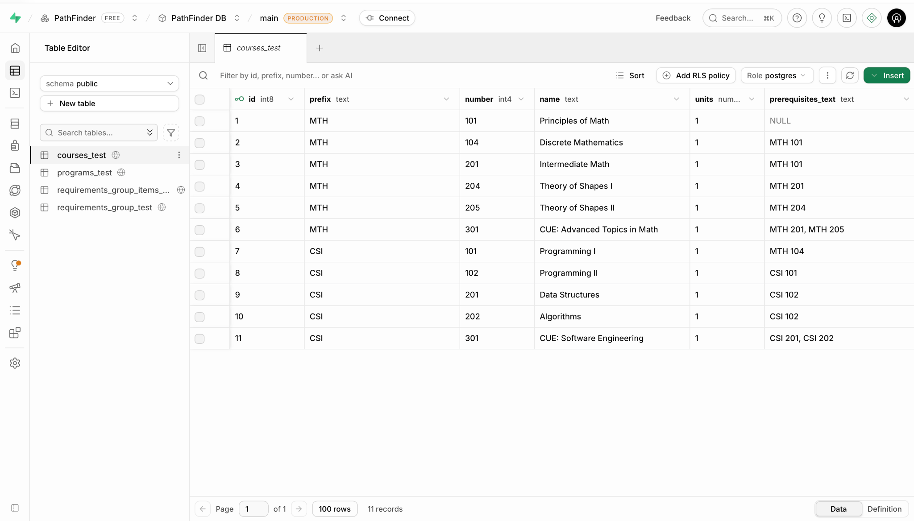
PathFinder Repository as of 10/16/2026
