Lucas Lima

COSC 412

CLASS DIAGRAM

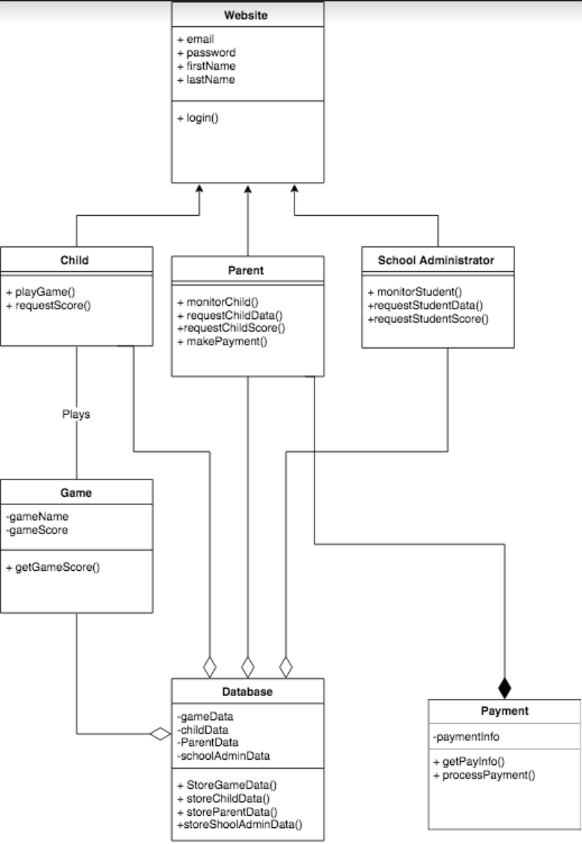

HLA DIAGRAM

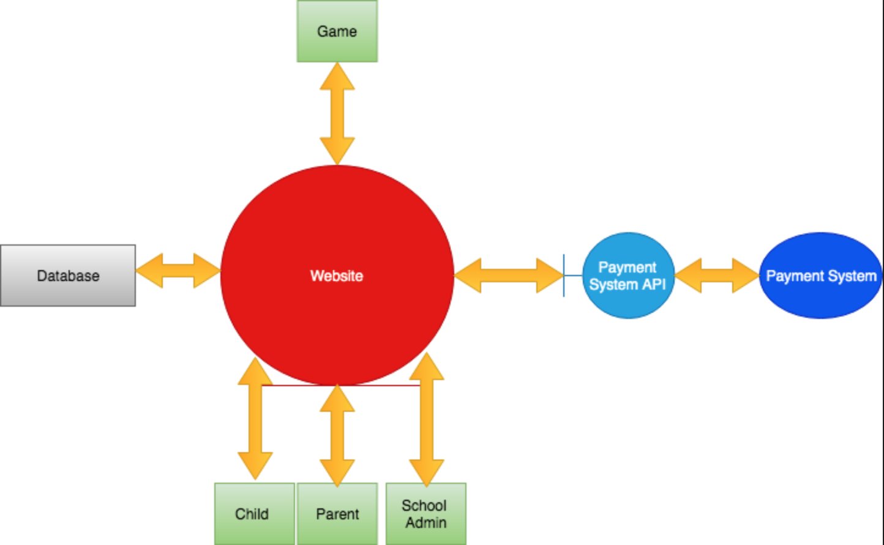

Interface Specifications

