

MiniRT

In this project we are tying to make a program that will render 3d maps with 3d objects and will actually simulate light! By this time im making some headway but its been pretty frustrating and I predict it will get worse so here are my notes for the current point.

Setting things up
typedef structs_vec3
{
float x, y, z;
}t_vec3;

Before we begin we need to create our structs so we can not only hold data but represent the math concepts we will engage with.
t_vec3 – this just represents a vectors that can also be though as a point in space, we will use it a lot.
typedef structs_obj
{
char*type;
t_vec3center;
t_vec3dir;
t_vec3 u;
t_vec3 v;
floatradius;
floatlen;
intcolor;
t_obj*next;
}t_obj;
t_obj – this is the struct that holds the object, I made it general so it can hold any kind of object even if that means some of the info is useless in some objects.
The struct looked like this from the start except that I added and extra t_vec3 u and v that are vectors we use to determine global orientation and enable global rotation.

t_cam – just the cam data. Later I learned that we also need the cam to have extra vectors for it to rotate. So I added t_vec3 right and up
typedef structs_cam
{
t_vec3pos;
t_vec3dir;
t_vec3 up;
t_vec3 right;
Floatfov;
}t_cam;

t_ray – this represents the ray, it needs an origin and a direction and in addition we have to calc some info like tan_half_fov, and view_height which are the same for all rays in the current data state the only ones that change for every ray are u and v its dir components.
Later I found it best to also just put the info about the intersected objects and light in this struct.
typedef structs_ray
{
t_vec3o;
t_vec3dir;
----------------------------
double tan_half_fov;
double view_height;double u;
double v;
----------------------------
double t;
double d;
t_vec3 p;
t_vec3 n;
t_vec3 l;
t_obj *obj;
t_light *lum;
}t_ray;
o – origin;
dir – direction (vector given);
t – distance from o to closest obj or light;
d – distance from hit obj to light;
p – position of obj hit point
n – surface normal vector at point p
l – vector with dir p to light source

The variables in green are the math heavy stuff they are used for the ray direction calculations which will be explained later.
This project is quite math heavy and even though we are not mathematicians we are programmers so we need to understand enough to know what the math concepts and formulas represent, what they mean and how to use them in our code.

Ray-tracing basic explanation

Ray tracing is a technique used to render 3d graphics with realistic lighting and shadows the way it achieves this is by simulating the way light works in the real world.’
In the real world rays of light come out of light sources in every direction then if they hit an objects they are reflected (or refracted, or absorbed) and if some of them reach or eyes we can see the obj.
In ray tracing we do the opposite, computing each rays intersection would be too expensive and unnecessary since only the ones that hit our eyes are seen, we only need to compute the ones that do hit our eyes and the way we do this is by send ind rays not from light to scene but from the cam to the scene and then if they hit and object we trace them to a light source, if the ray can reach the light source them its a visible ray and it carries the color of the obj but if it reach the light then its because there is another obj in front and thus its in shadow, this is how shadows are rendered and how ray-tracing works I a nutshell.

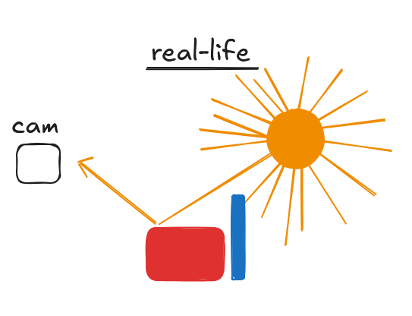
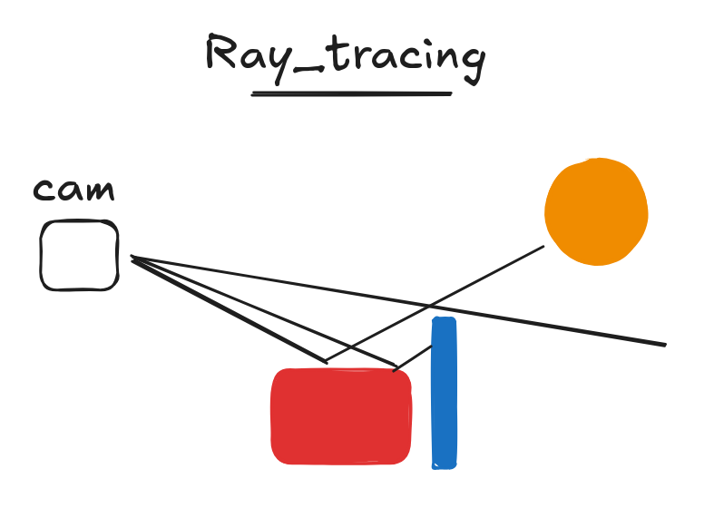

Where to start

Having understood the basics of ray-tracing we need a plan of how to go about coding this. There are probably other way of going about this but I came up with this one:

Print and modify data:
At first we should hard code a scene, essentially just fill the main data structure, init all the graphical library stuff and then just print the values we hard coded and try and change them while running, this is to make sure we can modify the values while running so we don’t just render static scenes that can lead us to think things are working fine when in reality its just working on that one specific perspective.

Send rays
Sending rays really just means calculating their direction and the evaluating their 3d line equation against the 3d obj equation and check for intersections and then returning the distance, its a little math heavy but I will explain in detail in the next section.

Check for intersections
This is the most computationally expensive part, its where we need to check if the ray hit which obj and return the closest.
The most easy and inefficient way of doing this is to just check against every obj its a O(n) solution because it grows linearly as we increases the objs, there are some optimization techniques available but I recommend just using it as is because the focus inst rendering speed. Additionally if it is too slow we can just reduce the img size.

Color pixel using ray info
This is pretty straightforward just color the pixel using the obj color in the ray if there is no obj then color it black, a cool thing we can do is to use ray→t as a factor for the strength of the color so that objs that are closer are very bright and those that are far are darker which gives us a simple idea of how light kinda looks like, though in this case the light source would be the cam itself

So the steps list looks like this:

- print and modify numerical values
  - make hook functions for changing position of camera ,no rotation needed yet
  - print that info so we can see the changing values
- send rays
  - calculate ray direction
  - loop trough all pixels, and send a ray, its a ray per pixel
- check for intersections
  - calculate ray obj intersection and save the closest
- color pixel using ray info
  - For starters just color it with the color of the obj directly if there is any or black is there was no obj intersection

Send rays

The rays are the 3d lines that come out of the cam→o and folow a direction, they are then checked agaist the objs and we save info about the closest one, then we send another ray from that intersection point to the light and check if ts in shadow or not.

Ray_Direction
Understanding this part is crucial to the understanding the project so I will try to be as clear as possible.
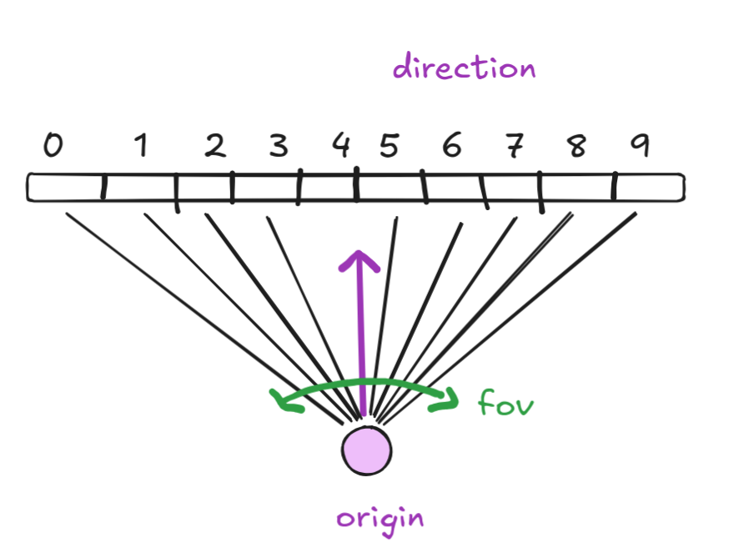
Picture a 2d plane and a point that is our cam center(origin) and a line for cam direction, we need to send rays from the center into the space in an angle interval our field of view and we send as many rays as there are pixels.

Rendering a plane

Lets start with a plane since its a pretty simple object and unlike the sphere it changes depending on the orientation.

To do this we just need to calc a ray which is essentially an origin and a direction then we need to check if it intersects our plane and return the distance and the obj, actually right now we don’t use it but later it will probably be useful.
The ray (line) vector equation is:

p(t) = O + tD where O(origin) and D(direction) are vectors and t is the scalar that gives us the distance but its t for time.

The vector equation of a plane is:

dot(X, N) = dot(C, N) or (X . N = C . N )

where X is the given point, N is the point of the normal Vector, and C a point in the plane.

Now we sub the line equation into the plane equation:

P(t) . N = C . N

(O + tD) . N = C . N

(O . N) + (tD . N) = C . N

(tD . N) = (C . N) - (O . N)

t(D . N) = (C . N) - (O . N)

t = (C . N) - (O . N) / (D . N)

This way we calculate t and if:
- D . N = 0: The ray is parallel to the plane, so no intersection occurs.
- t > 0: The ray intersects the plane at a positive distance (in front of the ray's origin).
- t = 0: The ray's origin lies on the plane or very close.
- t < 0: The ray intersects the plane behind the ray's origin (opposite to the ray's direction).

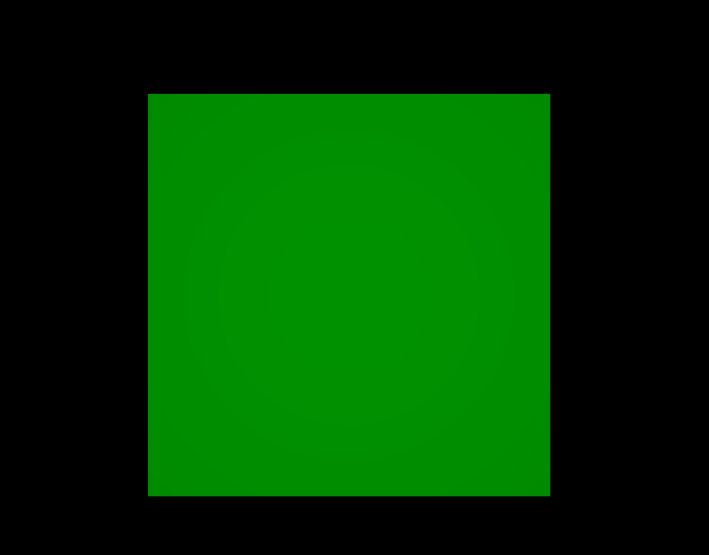
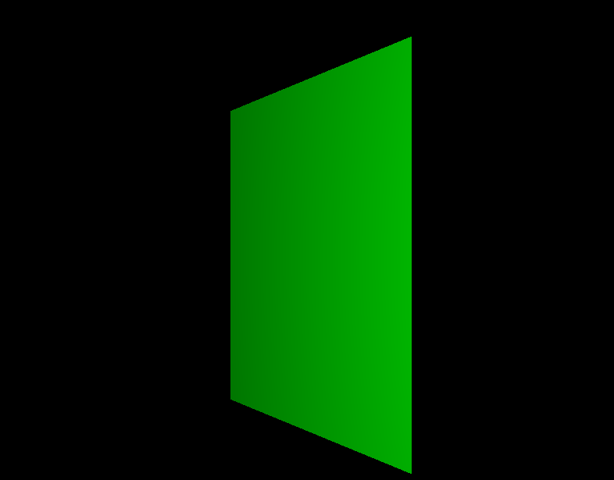
I have added the code bellow its not exactly what I used but its pretty close I skipped the ray color function since it just paints the pixel with the color of the obj, then we just add some key_mappings to change the dir and u of the obj and we get a plane we can rotate.
void ft_render_scene(t_data *data)
{
t_hit *hit;
t_ray ray;
int x;
int y;

y = 0;
ft_init_ray(data, x, y, &ray);
while (y < IM_HEIGHT)
{
x = 0;
while (x < IM_WIDTH)
{
ft_calc_ray(data, x, y, &ray);
if (hit = ft_calc_hit(ray.o, ray.dir, data->obj))
ft_ray_color(hit, data, x, y);
else
ft_pixel_put_img(&data->img, x, y, 0x000000);
x++;
}
y++;
}
mlx_put_image_to_window(data->mlx, data->win, data->img.ptr, 0, 0);
}
float ft_hit_plane(t_vec3 origin, t_vec3 dir, t_obj *obj)
{
float denom, t;
t_vec3 hit, u, v, p;

denom = ft_dot(obj->dir, dir);
if (denom == 0.0)
return (-1);
t = (ft_dot(obj->center, obj->dir) - ft_dot(origin, obj->dir)) / denom;
if (t < 0.0)
return (-1);
if (obj->radius <= 0.0)
return (t);
hit.x = origin.x + t * dir.x;
hit.y = origin.y + t * dir.y;
hit.z = origin.z + t * dir.z;
u = obj->u;
v = (t_vec3){
obj->dir.y * u.z - obj->dir.z * u.y,
obj->dir.z * u.x - obj->dir.x * u.z,
obj->dir.x * u.y - obj->dir.y * u.x
};
ft_normalize(&v);
p.x = ft_dot(hit, u) - ft_dot(obj->center, u);
p.y = ft_dot(hit, v) - ft_dot(obj->center, v);
if (p.x < -obj->radius || p.x > obj->radius || p.y < -obj->radius || p.y > obj->radius)
return (-1);
return (t);
}

From boring MATH to cool visuals…

So getting anything rendered took quite a few prompts and im not ashamed of it, this project is quite math heavy and studing all that is quite time consuming, way better to just have something done and then understand it deeply.
The project involves sending rays (lines, vectors) from the camera into the 3d math space and then checking what was hit the closest and returning that objs color, actually if we just do this we only get a 3d scene no actuall ray tracing since there is no ligh yet, lets keep it this way for now so ‘let there be no light’, for now.

