Group 4: Vector? I Barely Know Her!
Liz Ward, Annie Tan, Daniel Garcia, Araceli Ordaz Zarate
2026-04-29
Processing the CVS file and visualizing the dataset
data<-read.csv("Group4_data.csv", header=T)
str(data)
## 'data.frame': 6 obs. of 15 variables:
## $ Year : int 2026 2026 2026 2026 2026 2026
## $ group : chr "Group 4 / Vector? I Barely Know Her!" "Group 4 / Vector? I Barely Know Her!" "Group 4 / Vector? I Barely Know Her!" "Group 4 / Vector? I Barely Know Her!" ...
## $ date : chr "4/1/2026" "4/1/2026" "4/1/2026" "4/15/2026" ...
## $ Site : chr "Filoli" "Filoli" "Filoli" "Filoli" ...
## $ Habitat : chr "Redwood" "Redwood" "Oak" "Oak" ...
## $ replicate : int 1 2 1 2 3 3
## $ Sample.unit : chr "30meter^2" "30meter^2" "30meter^2" "30meter^2" ...
## $ IpacL : int 2 0 1 27 20 5
## $ IpacN : int 1 1 0 2 3 2
## $ IpacA : int 0 0 2 0 0 1
## $ DermL : int 0 0 0 0 0 0
## $ Dermacentor.nymph: int 0 0 0 0 0 0
## $ Dermacenter.adult: int 0 0 1 0 0 0
## $ juvenile.I.pac : int 3 1 1 29 23 7
## $ Notes : chr "East of Spring Creek" "West of Spring Creek" "Under the big oak tree next to Red's Barn" "Near the entrance trails (west)" ...
head(data)
## Year group date Site Habitat replicate
## 1 2026 Group 4 / Vector? I Barely Know Her! 4/1/2026 Filoli Redwood 1
## 2 2026 Group 4 / Vector? I Barely Know Her! 4/1/2026 Filoli Redwood 2
## 3 2026 Group 4 / Vector? I Barely Know Her! 4/1/2026 Filoli Oak 1
## 4 2026 Group 4 / Vector? I Barely Know Her! 4/15/2026 Filoli Oak 2
## 5 2026 Group 4 / Vector? I Barely Know Her! 4/15/2026 Filoli Oak 3
## 6 2026 Group 4 / Vector? I Barely Know Her! 4/15/2026 Filoli Redwood 3
## Sample.unit IpacL IpacN IpacA DermL Dermacentor.nymph Dermacenter.adult
## 1 30meter^2 2 1 0 0 0 0
## 2 30meter^2 0 1 0 0 0 0
## 3 30meter^2 1 0 2 0 0 1
## 4 30meter^2 27 2 0 0 0 0
## 5 30meter^2 20 3 0 0 0 0
## 6 30meter^2 5 2 1 0 0 0
## juvenile.I.pac Notes
## 1 3 East of Spring Creek
## 2 1 West of Spring Creek
## 3 1 Under the big oak tree next to Red's Barn
## 4 29 Near the entrance trails (west)
## 5 23 Near the entrance (east; near the mulch piles); it was windy
## 6 7 South of barn
A Generalized Linear Mixed Models (GLMMs) “are used to model complex data sets that are non-normal, non-linear, and clustered or longitudinal.”
#for larva
library(glmmTMB)
model<-glmmTMB(IpacL~Habitat, family=nbinom2(), data=data)
summary(model)
## Family: nbinom2 ( log )
## Formula: IpacL ~ Habitat
## Data: data
##
## AIC BIC logLik -2*log(L) df.resid
## 41.0 40.4 -17.5 35.0 3
##
##
## Dispersion parameter for nbinom2 family (): 1.09
##
## Conditional model:
## Estimate Std. Error z value Pr(>|z|)
## (Intercept) 2.7726 0.5712 4.854 1.21e-06 ***
## HabitatRedwood -1.9253 0.8800 -2.188 0.0287 *
## ---
## Signif. codes: 0 '***' 0.001 '**' 0.01 '*' 0.05 '.' 0.1 ' ' 1
#for nymph
library(glmmTMB)
model<-glmmTMB(IpacN~Habitat, family=nbinom2(), data=data)
summary(model)
## Family: nbinom2 ( log )
## Formula: IpacN ~ Habitat
## Data: data
##
## AIC BIC logLik -2*log(L) df.resid
## 22.9 22.3 -8.5 16.9 3
##
##
## Dispersion parameter for nbinom2 family (): 3.86e+08
##
## Conditional model:
## Estimate Std. Error z value Pr(>|z|)
## (Intercept) 0.5108 0.4472 1.142 0.253
## HabitatRedwood -0.2231 0.6708 -0.333 0.739
#for adult
library(glmmTMB)
model<-glmmTMB(IpacA~Habitat, family=nbinom2(), data=data)
summary(model)
## Family: nbinom2 ( log )
## Formula: IpacA ~ Habitat
## Data: data
##
## AIC BIC logLik -2*log(L) df.resid
## 17.2 16.5 -5.6 11.2 3
##
##
## Dispersion parameter for nbinom2 family (): 2.66
##
## Conditional model:
## Estimate Std. Error z value Pr(>|z|)
## (Intercept) -0.4055 0.7908 -0.513 0.608
## HabitatRedwood -0.6931 1.3232 -0.524 0.600
#box plot for larva
library(ggplot2)
p1=boxplot(IpacL~ Habitat, data=data, main="IpacL", ylab="Number of Larva")
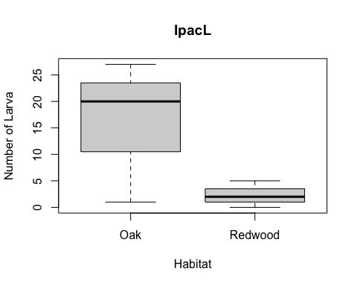
#box plot for nymph
library(ggplot2)
p2=boxplot(IpacN~ Habitat, data=data, main="IpacN", ylab="Number of Larva")
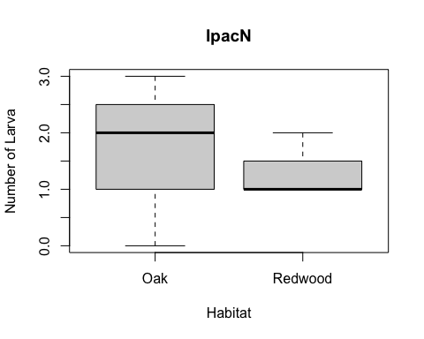
#box plot for adult
library(ggplot2)
p3=boxplot(IpacA~ Habitat, data=data, main="IpacA", ylab="Number of Larva")
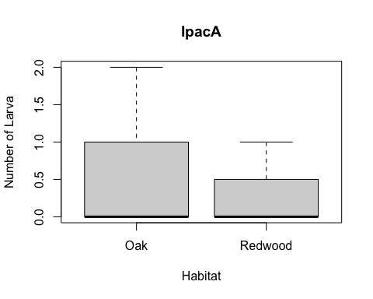
summary(data)
## Year group date Site
## Min. :2026 Length:6 Length:6 Length:6
## 1st Qu.:2026 Class :character Class :character Class :character
## Median :2026 Mode :character Mode :character Mode :character
## Mean :2026
## 3rd Qu.:2026
## Max. :2026
## Habitat replicate Sample.unit IpacL
## Length:6 Min. :1.00 Length:6 Min. : 0.000
## Class :character 1st Qu.:1.25 Class :character 1st Qu.: 1.250
## Mode :character Median :2.00 Mode :character Median : 3.500
## Mean :2.00 Mean : 9.167
## 3rd Qu.:2.75 3rd Qu.:16.250
## Max. :3.00 Max. :27.000
## IpacN IpacA DermL Dermacentor.nymph Dermacenter.adult
## Min. :0.0 Min. :0.00 Min. :0 Min. :0 Min. :0.0000
## 1st Qu.:1.0 1st Qu.:0.00 1st Qu.:0 1st Qu.:0 1st Qu.:0.0000
## Median :1.5 Median :0.00 Median :0 Median :0 Median :0.0000
## Mean :1.5 Mean :0.50 Mean :0 Mean :0 Mean :0.1667
## 3rd Qu.:2.0 3rd Qu.:0.75 3rd Qu.:0 3rd Qu.:0 3rd Qu.:0.0000
## Max. :3.0 Max. :2.00 Max. :0 Max. :0 Max. :1.0000
## juvenile.I.pac Notes
## Min. : 1.00 Length:6
## 1st Qu.: 1.50 Class :character
## Median : 5.00 Mode :character
## Mean :10.67
## 3rd Qu.:19.00
## Max. :29.00
group4_tick_data <- read.csv("Group4_Tick_data.csv", header=T)
hist(group4_tick_data$IpacJuv, breaks=10)
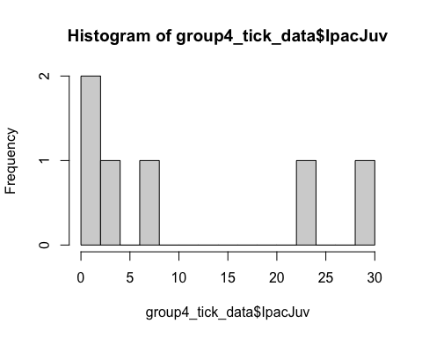
tick_data2 <- read.csv("tick_data2.csv")
tick_data1 <- read.csv("tick_data1.csv")
#download.packages(glmmTMB)
library(glmmTMB)
glm_total <- glmmTMB(TickTotal~habitat, family=nbinom2(), data=tick_data1)
summary(glm_total)
## Family: nbinom2 ( log )
## Formula: TickTotal ~ habitat
## Data: tick_data1
##
## AIC BIC logLik -2*log(L) df.resid
## 43.3 42.7 -18.7 37.3 3
##
##
## Dispersion parameter for nbinom2 family (): 2.4
##
## Conditional model:
## Estimate Std. Error z value Pr(>|z|)
## (Intercept) 2.9267 0.3962 7.387 1.5e-13 ***
## habitatRedwood -1.5404 0.6160 -2.501 0.0124 *
## ---
## Signif. codes: 0 '***' 0.001 '**' 0.01 '*' 0.05 '.' 0.1 ' ' 1
library(ggplot2)
ggplot(tick_data1, aes(x = factor(habitat), y = TickTotal)) +
geom_boxplot(fill = "lightblue")
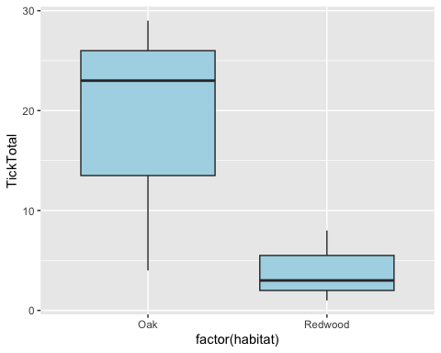
ggplot(tick_data2, aes(x= Life.stage, fill = Habitat,)) +
labs(x = "Life Stage", y = "Tick Number") +
geom_bar(position = "dodge") + scale_fill_manual(values = c("Oak" = "sandybrown", "Redwood" = "forestgreen"))
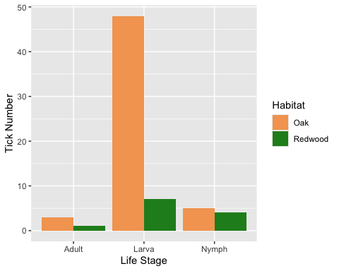
library(glmmTMB)
model<-glmmTMB(TickTotal~habitat, family=nbinom2(), data=tick_data1)
summary(model)
## Family: nbinom2 ( log )
## Formula: TickTotal ~ habitat
## Data: tick_data1
##
## AIC BIC logLik -2*log(L) df.resid
## 43.3 42.7 -18.7 37.3 3
##
##
## Dispersion parameter for nbinom2 family (): 2.4
##
## Conditional model:
## Estimate Std. Error z value Pr(>|z|)
## (Intercept) 2.9267 0.3962 7.387 1.5e-13 ***
## habitatRedwood -1.5404 0.6160 -2.501 0.0124 *
## ---
## Signif. codes: 0 '***' 0.001 '**' 0.01 '*' 0.05 '.' 0.1 ' ' 1

