Jamie Oliver’s cookbook

Table of contents:

1. Skinny carbonara
2. Sesame seared salmon
3. Gluten-free apple
4. Jamie's baked figs

## Skinny carbonara

SMOKY BACON, PEAS, ALMONDS & BASIL

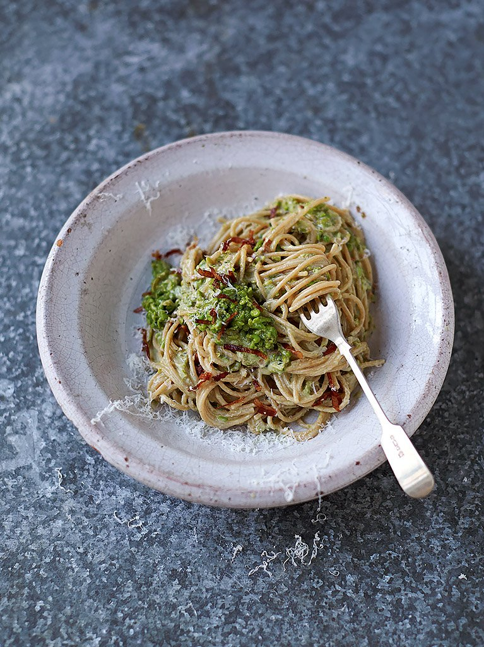

“Humble little peas are a source of nine different micronutrients, and are especially high in thiamin, a B vitamin that helps our hearts to function properly ”

<http://www.jamieoliver.com/recipes/pasta-recipes/skinny-carbonara/#07sJkihvSOZWSfFX.97>

**Serves** - 2

**Cooks In** - 20 minutes

**Difficulty** - Super easy

### Nutrition Per Serving

|  |  |  |  |  |  |  |  |
| --- | --- | --- | --- | --- | --- | --- | --- |
| Calories | Fat | Saturates | Protein | Carbs | Sugar | Salt | Fibre |
| 493 | 16.4g | 5.2g | 27g | 63.6g | 9.2g | 1.3g | 11.5g |
| 25% | 23% | 26% | 60% | 24% | 10% | 22% |  |

### Ingredients

200g freshly podded or frozen peas

1 tablespoon flaked almonds

1 small clove of garlic

½ a bunch of fresh basil, (15g)

15g Parmesan cheese

1 lemon

150g wholewheat spaghetti

1 rasher of higher-welfare smoked streaky bacon

olive oil

1 large free-range egg

100g fat-free natural yoghurt

### Method

Put a pan of boiling salted water on the heat for your pasta, dunk a sieve containing the peas into the water for just 30 seconds, then put aside, leaving the pan on the heat. Very lightly toast the almonds in a dry non-stick frying pan on a medium heat, then blitz until fine in a food processor. With the processor still running, peel and drop in the garlic, a pinch of sea salt, the basil leaves, the finely grated Parmesan and the lemon juice. Blitz until it comes together, then pulse in the peas, to try and keep a bit of texture.

Cook the pasta in the boiling salted water according to the packet instructions. Meanwhile, very finely slice the bacon and fry slowly in the frying pan with 1 teaspoon of oil on a medium-low heat until golden and crispy, then use a slotted spoon to transfer to kitchen paper, so the flavoursome fat stays in the pan. Scoop in three-quarters of your pea mixture to heat through.

Whisk the egg and yoghurt together well. When the pasta’s done, reserving a mugful of cooking water, drain the pasta and toss straight into the pea pan, mixing well, then take the pan off the heat (this is very important, otherwise the egg will scramble when you add it, and we don’t want that). Pour in the egg mixture and toss until evenly coated, silky and creamy, loosening with cooking water if needed. Taste and season to perfection, and serve topped with the remaining pea mixture and the crispy bacon. It might be skinny, but it’s beautifully light and delicious. Enjoy!

## Sesame seared Salmon

TAHINI AVOCADO & SHRED SALAD

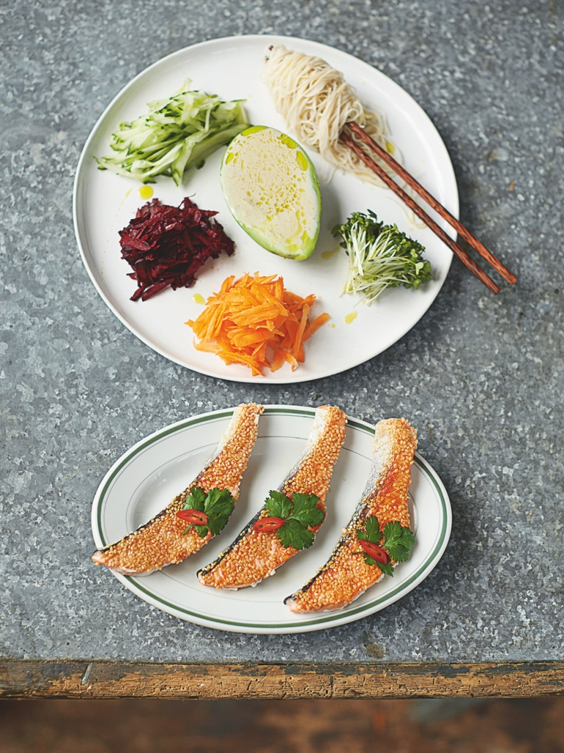

“As well as this delicious dish giving us three of our 5-a-day, salmon is full of vitamin D, which our bodies need for absorbing calcium, keeping our bones and teeth healthy”

<http://www.jamieoliver.com/recipes/fish-recipes/sesame-seared-salmon/#PxUlSW6jc2fjWy83.97>

**Serves** - 2

**Cooks In** - 20 minutes

**Difficulty** - NOT TOO TRICKY

### Nutrition Per Serving

|  |  |  |  |  |  |  |  |
| --- | --- | --- | --- | --- | --- | --- | --- |
| Calories | Fat | Saturates | Protein | Carbs | Sugar | Salt | Fibre |
| 552 | 33.1g | 6g | 28.4g | 35.1g | 8g | 0.8g | 6.2g |
| 28% | 47% | 30% | 63% | 14% | 9% | 13% |  |

### Ingredients

150g brown rice noodles

2 limes

2 x 100 g fillets of salmon, skin on, scaled and pin-boned, from sustainable sources

4 teaspoon sesame seeds

1 clove of garlic

4 teaspoons tahini

8cm piece of cucumber

2 small carrots

2 raw baby beets

1 punnet of cress

1 ripe avocado

extra virgin olive oil

½–1 fresh red chilli

2 sprigs of fresh coriander

### Method

Cook the noodles according to the packet instructions, then drain and toss in a little squeeze of lime juice. Carefully slice each of the salmon fillets lengthways into three. Scatter the sesame seeds over a board and press one side of the salmon slices into the seeds to form a crust. Place a large dry non-stick frying pan over a medium heat, and once hot, add the salmon sesame side down. Leave for 2 to 3 minutes, or until golden, flip over to cook for just 1 more minute, then remove from the heat.

Peel the garlic and pound into a paste with a pinch of sea salt in a pestle and mortar, then muddle in the tahini, the remaining lime juice and a splash of water to make a wicked dressing. Use a box grater to coarsely grate the cucumber, carrots and beets, keeping them in separate piles and dividing between two plates. Snip and divide up the cress, then divide up the noodles.

Halve, peel and destone the avocado and add one half to each plate, then pour the dressing into the wells and add a few drips of oil. Lay the salmon alongside, then finely slice the chilli and scatter over with the coriander leaves. Toss everything together at the table and enjoy.

## Gluten-free apple, almond & cardamom cupcakes

EASY TO MAKE, BUT SUPER IMPRESSIVE

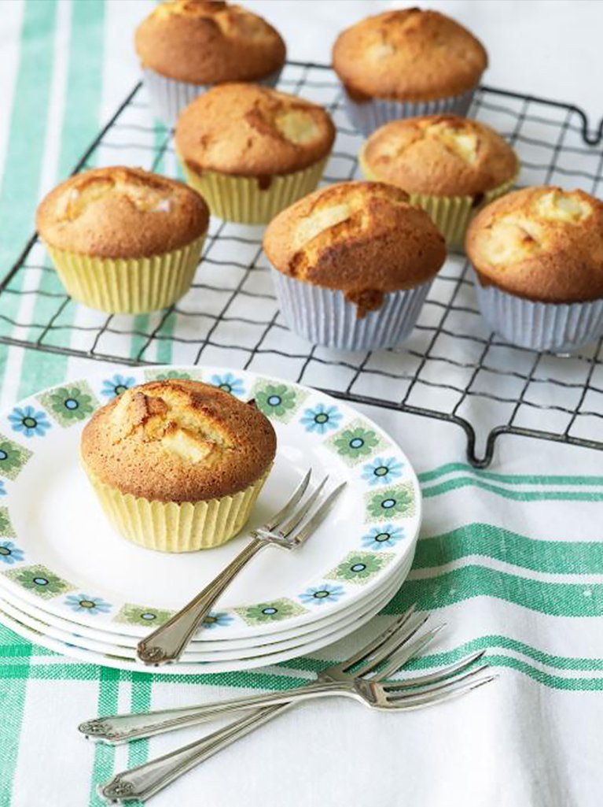

“These gluten-free cakes are so simple to knock up but rammed with flavours – the cardamom really makes them sing ”

<http://www.jamieoliver.com/recipes/recipe/gluten-free-apple-almond-cardamom-cupcakes/#V88d8YXZKAmIpwSi.97>

**Serves** - 20-24

**Cooks In** - 30 minutes

**Difficulty** - Super easy

### Nutrition Per Serving

|  |  |  |  |  |  |  |  |
| --- | --- | --- | --- | --- | --- | --- | --- |
| Calories | Fat | Saturates | Protein | Carbs | Sugar | Salt | Fibre |
| 145 | 5.7g | 0.9g | 3.6g | 20.4g | 12.1g | 0.3g | 0.7g |
| 7% | 8% | 5% | 8% | 8% | 13% | 5% |  |

### Ingredients

200g gluten-free flour

100g ground almonds

1 pinch of salt

2 tsp gluten-free baking powder

1/2 tsp ground cardamom

5 large free-range eggs

2 tbsp vegetable oil

200 g sugar

2 gala apples, cored and chopped

### Method

*Recipe by Cara Hobday*

Preheat the oven to 180C/gas 4 and line two 12-hole muffin trays with cupcake cases.

Combine the dry ingredients in a bowl.

Beat the eggs, vegetable oil and sugar together till light and fluffy. Beat in the dry ingredients then stir in the apple. Spoon the batter into the cupcake cases and bake for 20–30 minutes till firm and lightly golden.

## Jamie's baked figs

Plus a few brilliant ways to enjoy them

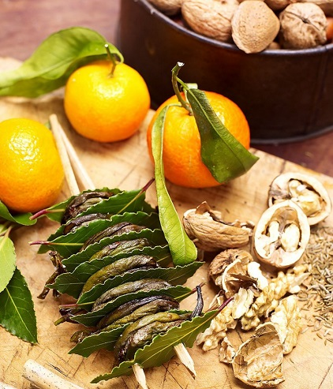

“This baked figs recipe is a festive favourite of mine – incredible on bruschetta with goat's cheese ”

<http://www.jamieoliver.com/recipes/fruit-recipes/jamie-s-baked-figs/#8y7ey3KL0pHpUYWV.97>

**Serves** - 8

**Cooks In** - 4H 5M

**Difficulty** - Super easy

### Nutrition Per Serving

|  |  |  |  |  |  |
| --- | --- | --- | --- | --- | --- |
| Calories | Fat | Saturates | Protein | Carbs | Sugar |
| 199 | 6.8g | 2.7g | 8.3g | 31.4g | 10.0g |
| 10% | 10% | 14% | 18% | 12% | 11% |

### Ingredients

#### **For the baked figs**

24 figs, halved

2 clementines

2 teaspoons ground cinnamon

2 tablespoons caster sugar

#### **For the fig bruschetta**

1 loaf rustic bread, sliced

goat's cheese, hard or soft

1 handful walnuts

runny honey

#### **To store**

1 large jar runny honey

### Method

You should have no problem getting nice figs at Christmas time and they’re wonderful to make in so many ways so when you see them, buy them up! Here’s one really gorgeous way to have them. I promise you won’t get bored of these; there are so many lovely ways of using them up.

Personally, I like to make a sort of bruschetta with them or put them out on a platter with some nice cheese. As it’s Christmas and your kitchen is probably well-stocked, you’ll hopefully have the ingredients for the bruschetta on hand already. If not, you can always improvise with whatever you’ve got in the fridge.

Preheat your oven to 110ºC/225ºF/gas ¼. Lay your figs, cut-side up, in a baking tray. Using a fine grater, zest your clementines over the figs then dust the figs with a sprinkling of cinnamon and a teaspoon of sugar. My flavoured sugar is also great for this so if you’ve made a batch of that, feel free to use that instead.

Pop the figs in the oven to bake for 4 hours, checking on them every hour or so. When they come out of the oven you’ll have semi-dehydrated figs, which will be a bit like wine gums.

#### Fig bruschetta

Get yourself a few slices of nice warm bread, crumble over some lumps of cheese, and a few pieces of walnut then put a few fig halves and a drizzle of runny honey over the top to finish it off. I think the combination of salty goat’s cheese with these figs and a bit of honey is absolute heaven.

#### Figs in honey

You’ll be able to put any leftover figs to good use in all sorts of ways. A really nice way of using them at Christmas is to turn them into a bit of a gift by popping a stack of them in a sterilised jar, covering them completely with honey then sealing the jar with an airtight lid. They’ll be beautiful as part of a cheese platter, baked in a tart, a sticky toffee pud, or even thrown into a roasting tray with some pork or other meat for a bit of added sweetness. Give them to your mates when you go round to theirs for dinner. They’ll love getting something unique, especially when you explain all the different things they can do with them.