Name: Atandrit Chatterjee

Reg. No.: RA2011031010042

**Experiment-1** **Implementation of Lexical Analyzer in CPP**

Aim:

To write a program implementing the Lexical Analyzer using C++.

Procedure:

1. Take the input from the .txt file.
2. Check for keywords present in the input and print it.
3. Using for loop check for the operators present in the input and print it.
4. Using for loop check for all the symbols present in the input and print it.
5. Using for loop check for all the symbols present in the input and print it.
6. Also, check for all the constants and identifiers present in the input and print it.

Code:

#include <bits/stdc++.h>

using namespace std;

int isKeyword(char buffer[]) {

char keywords[32][10] = {"auto", "break", "case", "char", "const", "continue", "default",

"do", "double", "else", "enum", "extern", "float", "for", "goto",

"if", "int", "long", "register", "return", "short", "signed",

"sizeof", "static", "struct", "switch", "typedef", "union",

"unsigned", "void", "volatile", "while"};

int i, flag = 0;

for (i = 0; i < 32; ++i)

{

if (strcmp(keywords[i], buffer) == 0)

{

flag = 1;

break;

}

}

return flag;

}

int main() {

system("cls");

int tk = 0;

char ch, buffer[15], operators[] = "+-*/%=";

ifstream fin("W1.txt");

int i, j = 0;

if (!fin.is_open()){

cout << "error while opening the file\n";

exit(0);

}

while (!fin.eof()) {

ch = fin.get();

for (i = 0; i < 6; ++i) {

if (ch == operators[i]) {

cout << ch << " is operator\n";

tk++;

}

}

if (isalnum(ch) {

buffer[j++] = ch;

}

else if ((ch == ' ' || ch == '\n') && (j != 0)) {

buffer[j] = '\0';

j = 0;

if (isKeyword(buffer) == 10) {

cout << buffer << " is keyword\n";

tk++;

}

else {

cout << buffer << " is indentifier\n";

tk++;

}

}

}

fin.close();

cout << "\nTotal number of tokens present in the 'W1.txt' file is: " << tk << "\n\n";

system("pause");

return 0;

}

Text File:



Output:

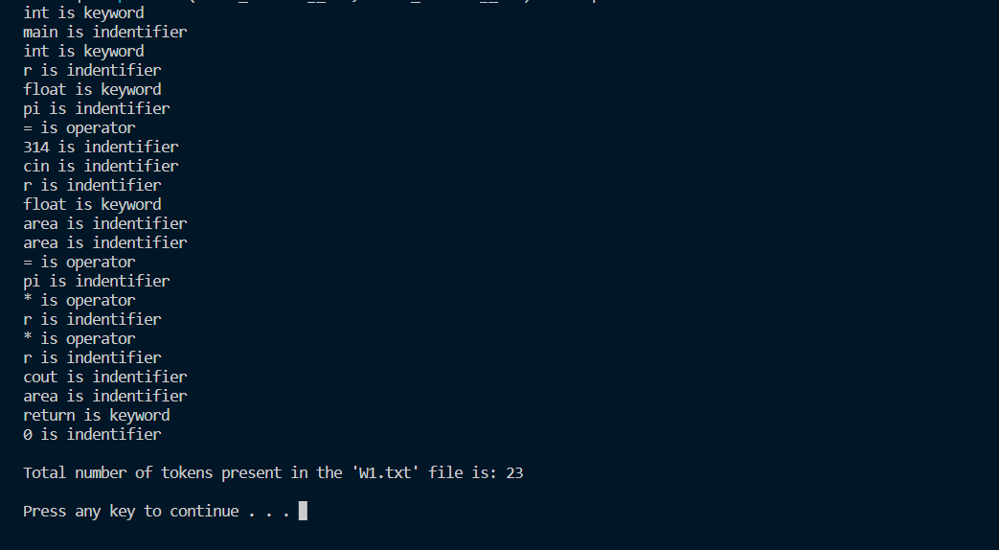

Result:

Implementation of Lexical Analyzer using C++ has been done successfully.