Name: Atandrit Chatterjee

Reg. No.: RA2011031010042

**Experiment-4** **ELIMINATION OF AMBIGUITY**

Aim:

To write a program implementing elimination of ambiguity using Left Recursion and Left Factoring.

Procedure:

1. Elimination of Left Recursion:

1. Start the program.

2. Initialize the arrays for taking input from the user.

3. Prompt the user to input the no. of non-terminals having left recursion and no. of

productions for these non-terminals.

4. Prompt the user to input the production for non-terminals.

5. Eliminate left recursion using the following rules:-

A->Aα1| Aα2 | . . . . . |Aαm

A->β1| β2| . . . . .| βn

Then replace it by

A-> βi A’ i=1,2,3,.....m

A’-> αj A’ j=1,2,3,.....n

A’-> Ɛ

6. After eliminating the left recursion by applying these rules, display the productions

without left recursion.

1. Implementation of Left Factoring:

1. Start

2. Ask the user to enter the set of productions

3. Check for common symbols in the given set of productions by comparing with:

A->aB1|aB2

4. If found, replace the particular productions with:

A->aA’

A’->B1 | B2|ɛ

5. Display the output

6. Exit

Code:

1. Elimination of Left Recursion:

#include <bits/stdc++.h>

using namespace std;

int main()

{

system("cls");

int n;

cout << "\nEnter number of non terminals: ";

cin >> n;

cout << "\nEnter non terminals one by one: ";

int i;

vector<string> nonter(n);

vector<int> leftrecr(n, 0);

for (i = 0; i < n; ++i)

{

cout << "\nNon terminal " << i + 1 << " : ";

cin >> nonter[i];

}

vector<vector<string>> prod;

cout << "\nEnter 'esp' for null";

for (i = 0; i < n; ++i)

{

cout << "\nNumber of " << nonter[i] << " productions: ";

int k;

cin >> k;

int j;

cout << "\nOne by one enter all " << nonter[i] << " productions";

vector<string> temp(k);

for (j = 0; j < k; ++j)

{

cout << "\nRHS of production " << j + 1 << ": ";

string abc;

cin >> abc;

temp[j] = abc;

if (nonter[i].length() <= abc.length() && nonter[i].compare(abc.substr(0, nonter[i].length())) == 0)

leftrecr[i] = 1;

}

prod.push_back(temp);

}

for (i = 0; i < n; ++i)

{

cout << leftrecr[i];

}

for (i = 0; i < n; ++i)

{

if (leftrecr[i] == 0)

continue;

int j;

nonter.push_back(nonter[i] + "'");

vector<string> temp;

for (j = 0; j < prod[i].size(); ++j)

{

if (nonter[i].length() <= prod[i][j].length() && nonter[i].compare(prod[i][j].substr(0, nonter[i].length())) == 0)

{

string abc = prod[i][j].substr(nonter[i].length(), prod[i][j].length() - nonter[i].length()) + nonter[i] + "'";

temp.push_back(abc);

prod[i].erase(prod[i].begin() + j);

--j;

}

else

{

prod[i][j] += nonter[i] + "'";

}

}

temp.push_back("esp");

prod.push_back(temp);

}

cout << "\n\n";

cout << "\nNew set of non-terminals: ";

for (i = 0; i < nonter.size(); ++i)

cout << nonter[i] << " ";

cout << "\n\nNew set of productions: ";

for (i = 0; i < nonter.size(); ++i)

{

int j;

for (j = 0; j < prod[i].size(); ++j)

{

cout << "\n"

<< nonter[i] << " -> " << prod[i][j];

}

}

system("pause");

return 0;

}

Output:

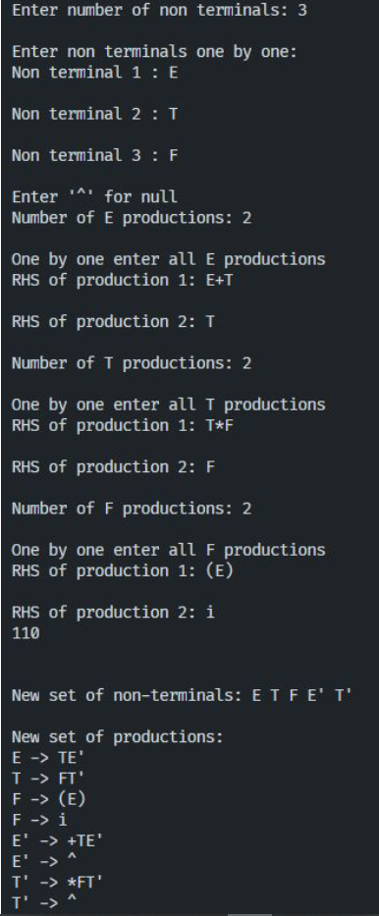

1. Implementation of Left Factoring:

#include <string.h>

#include <stdio.h>

#include <stdlib.h>

#include <conio.h>

int main()

{

system("cls");

char ch, lhs[20][20], rhs[20][20][20], temp[20], temp1[20];

int n, n1, count[20], x, y, i, j, k, c[20];

printf("\nEnter the no. of nonterminals : ");

scanf("%d", &n);

n1 = n;

for (i = 0; i < n; i++)

{

printf("\nNonterminal %d \nEnter the no. of productions : ", i + 1);

scanf("%d", &c[i]);

printf("\nEnter LHS : ");

scanf("%s", lhs[i]);

for (j = 0; j < c[i]; j++)

{

printf("%s->", lhs[i]);

scanf("%s", rhs[i][j]);

}

}

for (i = 0; i < n; i++)

{

count[i] = 1;

while (memcmp(rhs[i][0], rhs[i][1], count[i]) == 0)

count[i]++;

}

for (i = 0; i < n; i++)

{

count[i]--;

if (count[i] > 0)

{

strcpy(lhs[n1], lhs[i]);

strcat(lhs[i], "'");

for (k = 0; k < count[i]; k++)

temp1[k] = rhs[i][0][k];

temp1[k++] = '\0';

for (j = 0; j < c[i]; j++)

{

for (k = count[i], x = 0; k < strlen(rhs[i][j]); x++, k++)

temp[x] = rhs[i][j][k];

temp[x++] = '\0';

if (strlen(rhs[i][j]) == 1)

strcpy(rhs[n1][1], rhs[i][j]);

strcpy(rhs[i][j], temp);

}

c[n1] = 2;

strcpy(rhs[n1][0], temp1);

strcat(rhs[n1][0], lhs[n1]);

strcat(rhs[n1][0], "'");

n1++;

}

}

printf("\n\nThe resulting productions are : \n");

for (i = 0; i < n1; i++)

{

if (i == 0)

printf("\n %s -> %c|", lhs[i], (char)238);

else

printf("\n %s -> ", lhs[i]);

for (j = 0; j < c[i]; j++)

{

printf(" %s ", rhs[i][j]);

if ((j + 1) != c[i])

printf("|");

}

printf("\b\b\b\n");

}

return 0;

}

Output:

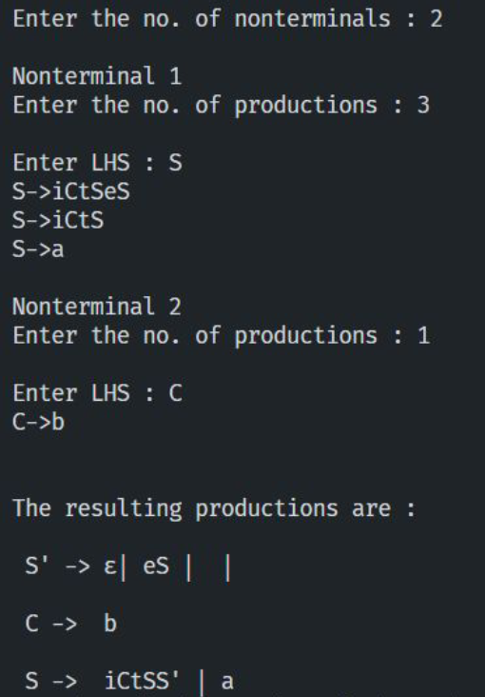

Result:

Elimination of ambiguity using Left Recursion and Left Factoring has been done successfully.