Name: Atandrit Chatterjee

Reg. No.: RA2011031010042

**Experiment-8** **Implement LEADING AND TRAILING**

Aim:

To implement Leading and Trailing for the given grammar in C/C++.

Procedure:

**1. For Leading, check for the first non-terminal.**

**2. If found, print it.**

**3. Look for next production for the same non-terminal.**

**4. If not found, recursively call the procedure for the single non-terminal present before**

**the**

**comma or End of Production String.**

**5. Include its results in the result of this non-terminal.**

**6. For trailing, we compute same as leading but we start from the end of the production to**

**the beginning.**

Code:

#include <iostream>

#include <conio.h>

#include <stdio.h>

#include <string.h>

#include <stdlib.h>

using namespace std;

int vars, terms, i, j, k, m, rep, count, temp = -1;

char var[10], term[10], lead[10][10], trail[10][10];

struct grammar {

int prodno;

char lhs, rhs[20][20];

} gram[50];

void get() {

cout << "\nLEADING AND TRAILING\n";

cout << "\nEnter the no. of variables : ";

cin >> vars;

cout << "\nEnter the variables : \n";

for (i = 0; i < vars; i++)

{

cin >> gram[i].lhs;

var[i] = gram[i].lhs;

}

cout << "\nEnter the no. of terminals : ";

cin >> terms;

cout << "\nEnter the terminals : ";

for (j = 0; j < terms; j++)

cin >> term[j];

cout << "\nPRODUCTION DETAILS\n";

for (i = 0; i < vars; i++)

{

cout << "\nEnter the no. of production of " << gram[i].lhs << ":";

cin >> gram[i].prodno;

for (j = 0; j < gram[i].prodno; j++)

{

cout << gram[i].lhs << "->";

cin >> gram[i].rhs[j];

}

}

}

void leading() {

for (i = 0; i < vars; i++)

{

for (j = 0; j < gram[i].prodno; j++)

{

for (k = 0; k < terms; k++)

{

if (gram[i].rhs[j][0] == term[k])

lead[i][k] = 1;

else

{

if (gram[i].rhs[j][1] == term[k])

lead[i][k] = 1;

}

}

}

}

for (rep = 0; rep < vars; rep++)

{

for (i = 0; i < vars; i++)

{

for (j = 0; j < gram[i].prodno; j++)

{

for (m = 1; m < vars; m++)

{

if (gram[i].rhs[j][0] == var[m])

{

temp = m;

goto out;

}

}

out:

for (k = 0; k < terms; k++)

{

if (lead[temp][k] == 1)

lead[i][k] = 1;

}

}

}

}

}

void trailing() {

for (i = 0; i < vars; i++)

{

for (j = 0; j < gram[i].prodno; j++)

{

count = 0;

while (gram[i].rhs[j][count] != '\x0')

count++;

for (k = 0; k < terms; k++)

{

if (gram[i].rhs[j][count - 1] == term[k])

trail[i][k] = 1;

else

{

if (gram[i].rhs[j][count - 2] == term[k])

trail[i][k] = 1;

}

}

}

}

for (rep = 0; rep < vars; rep++)

{

for (i = 0; i < vars; i++)

{

for (j = 0; j < gram[i].prodno; j++)

{

count = 0;

while (gram[i].rhs[j][count] != '\x0')

count++;

for (m = 1; m < vars; m++)

{

if (gram[i].rhs[j][count - 1] == var[m])

temp = m;

}

for (k = 0; k < terms; k++)

{

if (trail[temp][k] == 1)

trail[i][k] = 1;

}

}

}

}

}

void display() {

for (i = 0; i < vars; i++)

{

cout << "\nLEADING(" << gram[i].lhs << ") = ";

for (j = 0; j < terms; j++)

{

if (lead[i][j] == 1)

cout << term[j] << ",";

}

}

cout << endl;

for (i = 0; i < vars; i++)

{

cout << "\nTRAILING(" << gram[i].lhs << ") = ";

for (j = 0; j < terms; j++)

{

if (trail[i][j] == 1)

cout << term[j] << ",";

}

}

}

int main() {

system("cls");

get();

leading();

trailing();

display();

cout << '\n';

system("pause");

return 0;

}

Output:

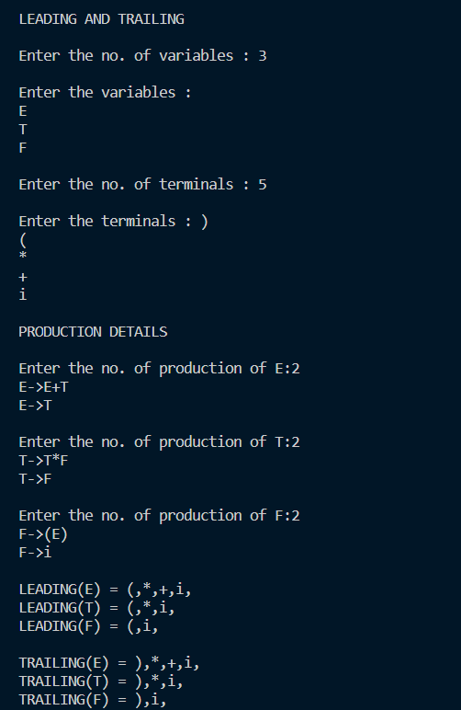

Result:

The implementation of Leading and Trailing was successful.