Name: Atandrit Chatterjee

Reg. No.: RA2011031010042

**Experiment-9** **Implement LR(0) Items**

Aim:

To implement LR(0) items for the given grammar in C/C++.

Procedure:

1. Start.

2. Create structure for production with LHS and RHS.

3. Open file and read input from file.

4. Build state 0 from extra grammar Law S' -> S $ that is all start symbol of grammar and one

Dot ( . ) before S symbol.

5. If Dot symbol is before a non-terminal, add grammar laws that this non-terminal is in Left

Hand Side of that Law and set Dot in before of first part of Right Hand Side.

6. If state exists (a state with this Laws and same Dot position), use that instead.

7. Now find set of terminals and non-terminals in which Dot exist in before.

8. If step 7 Set is non-empty go to 9, else go to 10.

9. For each terminal/non-terminal in set step 7 create new state by using all grammar law that

Dot position is before of that terminal/non-terminal in reference state by increasing Dot point

to next part in Right Hand Side of that laws.

10. Go to step 5.

11. End of state building.

12. Display the output.

13. End.

Code:

#include<iostream>

#include<conio.h>

#include<string.h>

using namespace std;

char prod[20][20],listofvar[26]="ABCDEFGHIJKLMNOPQR";

int novar=1,i=0,j=0,k=0,n=0,m=0,arr[30];

int noitem=0;

struct Grammar

{

char lhs;

char rhs[8];

}g[20],item[20],clos[20][10];

int isvariable(char variable)

{

for(int i=0;i<novar;i++)

if(g[i].lhs==variable)

return i+1;

return 0;

}

void findclosure(int z, char a)

{

int n=0,i=0,j=0,k=0,l=0;

for(i=0;i<arr[z];i++)

{

for(j=0;j<strlen(clos[z][i].rhs);j++)

{

if(clos[z][i].rhs[j]=='.' && clos[z][i].rhs[j+1]==a)

{

clos[noitem][n].lhs=clos[z][i].lhs;

strcpy(clos[noitem][n].rhs,clos[z][i].rhs);

char temp=clos[noitem][n].rhs[j];

clos[noitem][n].rhs[j]=clos[noitem][n].rhs[j+1];

clos[noitem][n].rhs[j+1]=temp;

n=n+1;

}

}

}

for(i=0;i<n;i++)

{

for(j=0;j<strlen(clos[noitem][i].rhs);j++)

{

if(clos[noitem][i].rhs[j]=='.' && isvariable(clos[noitem][i].rhs[j+1])>0)

{

for(k=0;k<novar;k++)

{

if(clos[noitem][i].rhs[j+1]==clos[0][k].lhs)

{

for(l=0;l<n;l++)

if(clos[noitem][l].lhs==clos[0][k].lhs && strcmp(clos[noitem][l].rhs,clos[0][k].rhs)==0)

break;

if(l==n)

{

clos[noitem][n].lhs=clos[0][k].lhs;

strcpy(clos[noitem][n].rhs,clos[0][k].rhs);

n=n+1;

}

}

}

}

}

}

arr[noitem]=n;

int flag=0;

for(i=0;i<noitem;i++)

{

if(arr[i]==n)

{

for(j=0;j<arr[i];j++)

{

int c=0;

for(k=0;k<arr[i];k++)

if(clos[noitem][k].lhs==clos[i][k].lhs && strcmp(clos[noitem][k].rhs,clos[i][k].rhs)==0)

c=c+1;

if(c==arr[i])

{

flag=1;

goto exit;

}

}

}

}

exit:;

if(flag==0)

arr[noitem++]=n;

}

int main()

{

cout<<"ENTER THE PRODUCTIONS OF THE GRAMMAR(0 TO END) :\n";

do

{

cin>>prod[i++];

}while(strcmp(prod[i-1],"0")!=0);

for(n=0;n<i-1;n++)

{

m=0;

j=novar;

g[novar++].lhs=prod[n][0];

for(k=3;k<strlen(prod[n]);k++)

{

if(prod[n][k] != '|')

g[j].rhs[m++]=prod[n][k];

if(prod[n][k]=='|')

{

g[j].rhs[m]='\0';

m=0;

j=novar;

g[novar++].lhs=prod[n][0];

}

}

}

for(i=0;i<26;i++)

if(!isvariable(listofvar[i]))

break;

g[0].lhs=listofvar[i];

char temp[2]={g[1].lhs,'\0'};

strcat(g[0].rhs,temp);

cout<<"\n\n augumented grammar \n";

for(i=0;i<novar;i++)

cout<<endl<<g[i].lhs<<"->"<<g[i].rhs<<" ";

for(i=0;i<novar;i++)

{

clos[noitem][i].lhs=g[i].lhs;

strcpy(clos[noitem][i].rhs,g[i].rhs);

if(strcmp(clos[noitem][i].rhs,"ε")==0)

strcpy(clos[noitem][i].rhs,".");

else

{

for(int j=strlen(clos[noitem][i].rhs)+1;j>=0;j--)

clos[noitem][i].rhs[j]=clos[noitem][i].rhs[j-1];

clos[noitem][i].rhs[0]='.';

}

}

arr[noitem++]=novar;

for(int z=0;z<noitem;z++) {

char list[10];

int l=0;

for(j=0;j<arr[z];j++) {

for(k=0;k<strlen(clos[z][j].rhs)-1;k++) {

if(clos[z][j].rhs[k]=='.') {

for(m=0;m<l;m++)

if(list[m]==clos[z][j].rhs[k+1]) break;

if(m==l) list[l++]=clos[z][j].rhs[k+1]; }

}

}

for(int x=0;x<l;x++)

findclosure(z,list[x]); }

cout<<"\n THE SET OF ITEMS ARE \n\n";

for(int z=0; z<noitem; z++) {

cout<<"\n I"<<z<<"\n\n";

for(j=0;j<arr[z];j++)

cout<<clos[z][j].lhs<<"->"<<clos[z][j].rhs<<"\n"; }

}

Output:

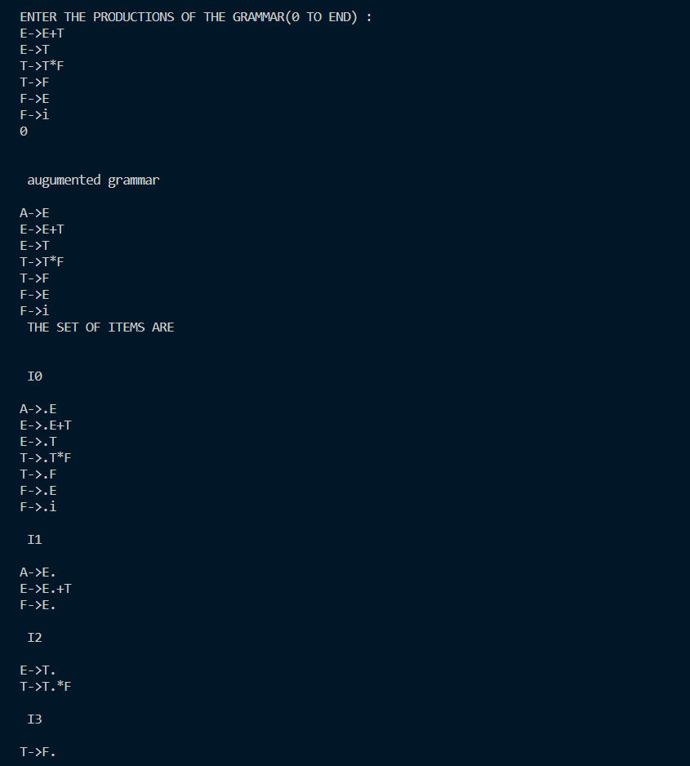

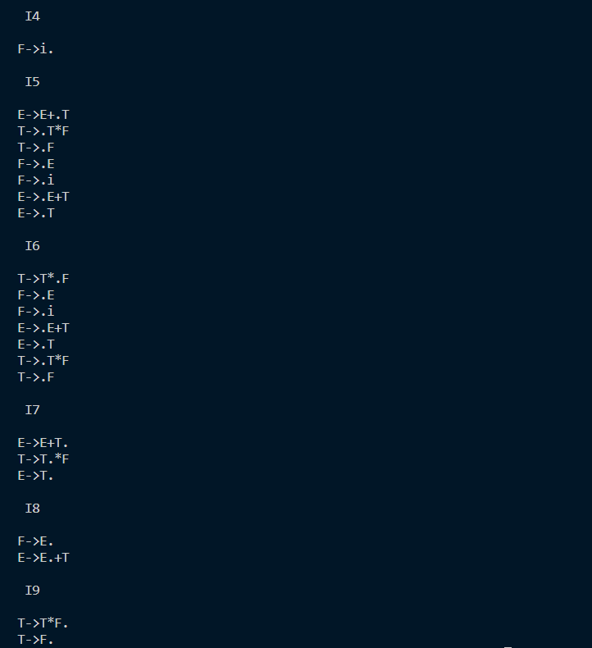

Result:

The implementation of LR(0) items was successful.