1.1 CPU (5) 1.15 Defect (13)

1.2 Abstraction (1) 1.16 Chip (6)

1.3 Bit (3) 1.17 Transistor (24)

1.4 Computer Family (8) 1.18 DVD (12)

1.5 Memory (19) 1.19 Yield (28)

1.6 Datapath (10) 1.20 Complier (7)

1.7 Control (9) 1.21 Operating System (20)

1.8 Desktop/PC (11) 1.22 Assembler (2)

1.9 Embedded System (15) 1.23 VLSI (25)

1.10 Server (22) 1.24 Instruction (16)

1.11 LAN (18) 1.25 Cache (4)

1.12 WAN (27) 1.26 ISA (17)

1.13 Supercomputer (23) 1.27 Semiconductor (21)

1.14 DRAM (14) 1.28 Wafer (26)

1.29 i 1.37 c 1.45 a

1.30 b 1.38 f

1.31 e 1.39 d

1.32 i 1.40 a

1.33 h 1.41 c

1.34 d 1.42 i

1.35 f 1.43 e

1.36 b 1.44 g

1.46

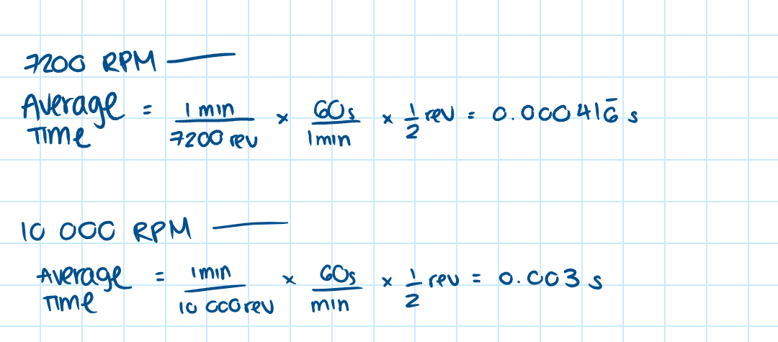

1.52

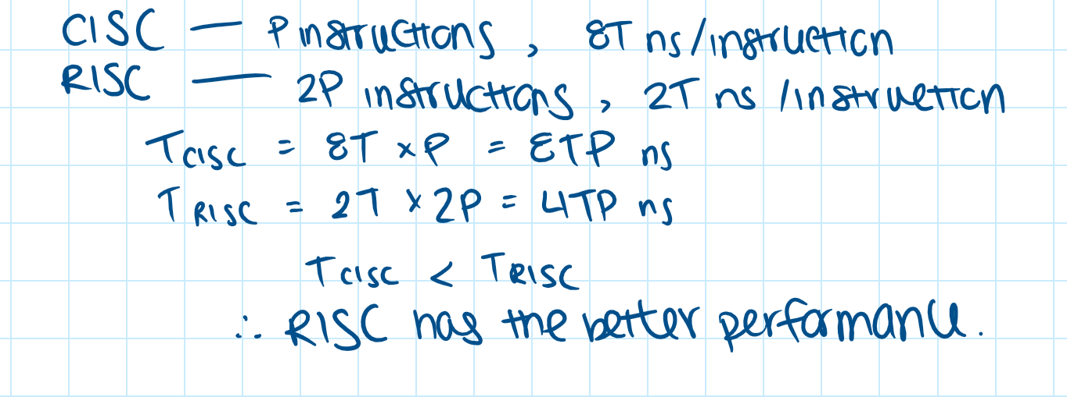

1.54

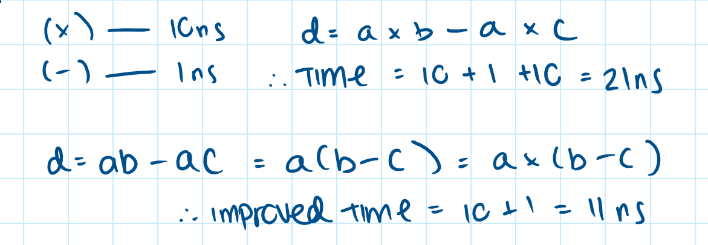

1.55

The Canadian government consists of three main levels; municipal, provincial and Federal. These would be examples of high-level abstractions. Going into detail, the municipal government of a city can be a subset of the provincial government. The municipal government contains the mayor and the elected MPs. The provincial government houses the Lieutenant Governor, Premier, Cabinet, and the different provincial ministries. Lastly, the federal government includes, the Prime Minister, the Senate, Governor General and the national ministries. All these components are examples of the low-level abstractions.