**Computer Organization: MIPS Assembler**

Anna Tang

3180300155

**Introduction**

This program is a command line-based MIPS assembler and disassembler, coded in Python. No executable is generated, and everything runs on the terminal. Please refer to the readme.txt as well.  
  
**Usage**

The user must first specify whether they want to assemble or disassemble a file in the command-line prompt. It then takes in an input file and an output file as the arguments. The input file must be in your **CURRENT** directory for the assembler to detect input. This assembler also supports all file formats (e.g. .txt, .coe, .asm, .hex).

In the case where an input error, an error prompt will appear and terminate the program. If the file successfully assembles or disassembles, the program will terminate. For the following example, user input is bolded to differentiate from program prompts.

*Successful Run:*

C:\Users\Anna\Desktop\Comp Org\Assembler> **python assembler.py**

Welcome to the MIPS assembler and disassembler.

Type A to assemble and D to disassemble: **a**

Input the name of the file to be assembled. For example, test.asm: **t.asm**

Input the name of the file you want the hex code to be outputted in.

If the file does not exist in your directory, a new one will be created: **h.hex**

Assembly successful. Please check h.hex for the assembled instructions.

*Error:*

C:\Users\Anna\Desktop\Comp Org\Assembler> **python assembler.py**

Welcome to the MIPS assembler and disassembler.

Type A to assemble and D to disassemble: **d**

Input the name of the file to be disassembled. For example, test.hex: **file.hex**

Oops! That file does not exist. Please double check the file name and try again.

**Input Specifications**

The input file does not support multiline labels. Please ensure that labels are on the same lines as the instructions. Any white space in the input file will be removed in the output file. Comments are denoted by the ‘**#**’ character, and the end of an instruction is denoted by a semicolon (‘**;**’). For intermediate values, they are to be in decimal format.

*Not Supported: Supported:*

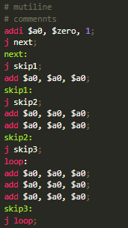 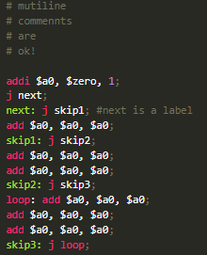

**Output Specifications**

The machine code generated by the assembler will be in hexadecimal format. If the program is in assembler mode, the generated file can be fed back into the disassembler. The disassembler prints out the PC values as comments, next to its respective instruction. Branch and jump addresses are printed in hexadecimal, and intermediate/offset values are preserved in decimal. For reference, the PC addresses start at **0x00000000**. Outputs of the example above are shown below.

*Assembler: Disassembler:*

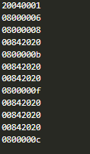 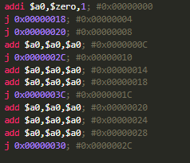

**Supported Instructions for Assembler and Disassembler**

* add
* sub
* and
* or
* addi
* andi
* ori
* lw
* sw
* srl
* sll
* lui
* slt
* slti
* beq
* bne
* j
* jal
* jr
* nor
* xor
* All 32 registers are supported.