

**本科实验报告**

|  |  |
| --- | --- |
| 课程名称： | 计算机组成 |
| 姓 名： | TANG ANNA YONGQI |
| 学 院： | 计算机科学与技术学院 |
| 专 业： | 计算机科学与技术（中加班）留学生 |
| 学 号： | 3180300155 |
| 生活照： |  |
| 指导教师： | 刘海风，洪奇军 |

2020年 6月18日

Final Report– Multi-Cycle CPU Implementation

**Name:** Anna Yongqi Tang **ID:** 3180300155 **Major:** 计算机科学与技术（中加班）留学生

**Course:** Computer Organization

**Date:** 2020-06-18 **Instructor:** 洪奇军

1. **Experiment Objectives and Requirements**

* Understand and implement a multi-cycle CPU design that supports at least the following instructions:
  + R-Type: add, sub, and, or, xor, nor, slt, srl, jr, jalr
  + I-Type: addi, andi, ori, xori, lui, lw, sw, beq, bne, slti
  + J-Type: j, jal
* Datapath Design
  + Mandate memory management and ALU operations
* Controller Design
  + Set to send the appropriate control signals to the datapath for each instruction
* Design testing procedures

1. **Content and Principles of the Experiment**

* **CPU Organization**

The central processing unit (CPU), consist of two main components – the control unit and datapath. As depicted, the datapath follows the program instructions and performs arithmetic operations to get the result. The controller tells the datapath what to do and what components to use, by asserting different control signals.

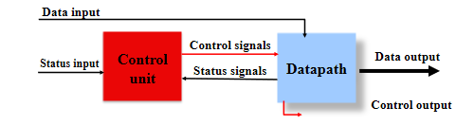

Figure - CPU Organization

* **MIPS Instructions**

A MIPS instruction is broken up into different fields, specifying the registers and operations used for when it is processed. R-type, I-type and J-type do not share the same format. An instruction consists of 32-bits and contains all the information needed to be processed in the CPU.

Note the different destination registers, where R-type would use the rd field and I-type would use the rt field.

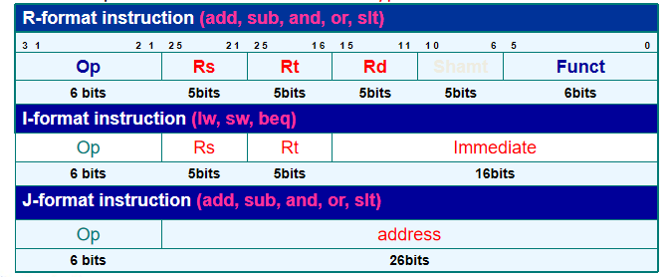

Figure - MIPS Instruction Field

* **Differences Between Multi-Cycle and Single-Cycle**

The multi-cycle CPU is more efficient, because it can work with smaller and multiple clock cycles for each instruction, while the single-cycle implementation only has one set cycle length. Many instructions could finish execution in a shorter clock cycle, and this could potentially build up wasted time. Multi-cycle implementation allows units to be used multiple times, but not always simultaneously in the same clock cycle. Here, we assume that an instruction takes up multiple clock cycles, and each step will take one clock cycle to completion.

Hardware is significantly reduced in the multi-cycle implementation, most noticeably the lack of adders and the memory units. Functional units are now “shared”, but multiplexers are widened to support routing the proper data to other parts of the CPU. Additional registers are added to every major unit, and data is held until used in a subsequent clock cycle.

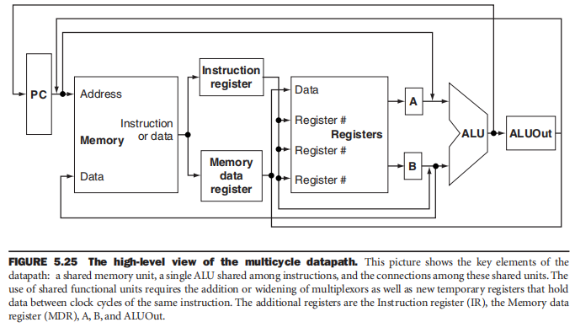

Figure - Top-level of MCPU

* **Instruction and Data Memory**

Unlike the single-cycle CPU, the instruction memory, and data memory units here are merged into one single RAM component. Instructions are still fetched from this unit, and data memory can be accessed and written when necessary signals are asserted. This is solely referred as the memory unit of the multi-cycle CPU.

* **The Datapath**

The datapath implemented in this course has the following components – instruction and data memory, instruction register, memory data register, register file, ALU, program counter, shifters and a 32-bit sign extender.



Figure - Top Diagram of Lab MCPU

* + **Instruction Register (IR)** - The IR is one of the additional temporary registers that are implemented in a multi-cycle CPU. Its purpose is to hold the instruction until completion. It receives the 32-bit instruction as input from the memory unit, and outputs each field needed by the other components.
  + **Memory Data Register (MDR)** - The MDR is one of the additional temporary registers that are implemented in a multi-cycle CPU. It holds data only between a pair of adjacent clock cycles. This is where data from the memory unit gets held, until it gets written into the register file for R-type and memory reference instructions.
  + **ALU Input Registers (A&B)** - Registers A and B store values from the two outputs of register files. These would store the data of registers rs and rt, for a R-type instruction. They only get routed to the ALU for input if permitted by the control signals.

However, the labs do not require ALU input registers to be implemented. Instead, the contents of rdata_A and rdata_B are routed to the ALU if selected by the multiplexer.

* + **ALU Output Register (ALUOut)** - ALUOut simply stores the resulting output produced by the ALU. Depending on what signals are asserted, the data in this register could get routed to memory, the register file or to the PC. It could store an immediate value, an address for the PC or a memory offset.
  + **Program Counter (PC)** – This is where the address of the current instruction is stored. The address gets sent to memory, where the instruction is fetched and processed. In a R-type instruction, the PC gets updated with the next sequential instruction address while a jump or branching instruction would update the PC with another target address.
  + **Arithmetic Logic Unit (ALU)** - All R-type and I-type instructions use the ALU for processing. The memory reference instructions would use it for address calculations, branching for comparisons, and executing arithmetic-logic operations. The type of arithmetic operation is done based on what signal ALU_Control provides.

In a multi-cycle CPU, the ALU takes care of all the tasks that the auxiliary adders are assigned to do. This includes incrementing the PC, and computing the target addresses as well as offsets. Widened multiplexers are used to select the appropriate inputs for the operation.

The overflow signal indicates whether there is an overflow and the zero signal is asserted when a branch is taken by a branching instructed. Lastly, the 32-bit ALU_output contains the address to be written into the data memory or the data to be written into a destination register.

The ALU supports 8 different operations – And, Or, Add, Sub, Slt, Nor, Srl, and Xor.

* + **Register File –** Like the name suggests, this component contains a set of registers that can be read and written by supplying a register number to be accessed. There is a total of 32 32-bit registers in the CPU. The registers are implemented as an array of D flip-flops, decoders and multiplexers are used for reading and writing data. There are four main inputs; R_addr_A, R_addr_B, Wt_addr and Wt_data. The first two are the numbers registers to be read, while the third one provides the number of the destination register and the last one contains the data to be written into the destination. Outputs rdata_A and rdata_B returns the contents of the operand registers and routes them to the ALU. There are three signals used by the register; clk, rst and L_S (asserted if Wt_addr is written with the value on the Wt_data input).

Note that inputs and outputs are 32-bits, while register numbers are 5-bits.

* + **Sign Extender –** A 32-bit sign extender unit is used for branching, memory reference and I-type instructions. Addresses, offsets, and immediate values are given in 16-bit values, so it is necessary to extend them to 32-bits for further processing. The extended output (Imm_32) gets sent to the B input of the ALU, only if selected by a multiplexer to do so.
  + **Multiplexers –** Six multiplexers were used in the single-cycle CPU design, and they all serve the same purpose of selecting one of its inputs to be routed out to another unit as their input.

**MUX1:** Selected the input for the write address for the register file (reg_Wt_addr). It chooses from either the rd field or rt field.

**MUX2:** Selected the input for the write data port of the register file (w_reg_data). It chooses from either the MDR, or ALU_out.

**MUX3:** Selected the input for the B port of the ALU. It chooses from either an immediate value of 4, the branch offset, the B output value from the register file, or jump offset.

**MUX4:** Selected the input for the A port of the ALU. It chooses from either the A output value from the register file or the current PC address.

**MUX5:** Selected the input for the memory unit address (M_addr). It chooses from either the current PC or the contents of ALUOut.

**MUX6:** Selected the input for the PC. It chooses from either the ALU output (res[31:0]), ALUOut or the computed jump address.

* **The Controller**

The controller unit controls the flow of information with the use of several signals. It determines the components that need to be used, and which MUX signals to assert with its own controls. The ALU relies on the ALU_Control signal to determine which operation to execute for a specific instruction.



Figure - Controller of Lab MCPU

|  |  |  |  |
| --- | --- | --- | --- |
| Signal | Function | Asserted | Not Asserted |
| ALUSrc_A | Selects the A input of the ALU | Input comes from rdata_A | Input comes from the PC |
| ALUSrc_B[1:0] | Selects the B input of the ALU | **01** – constant 4  **10** – sign-extended IR[15:0]  **11** - sign-extended IR[15:0] >> 2 | **00** – Input comes from rdata_B |
| RegDst[1:0] | Selects the register write address | **01** – Write to rd | **00** – Write to rt |
| MemtoReg[1:0] | Selects source of the data to be written into the registers | **01** – Use data from MDR | **00** – Use data from ALUOut |
| IorD | Selects source of the address to be sent to the memory | Address comes from memory | Address comes from ALUOut |
| PCSource[3:0] | Selects what overwrites the PC | **01** – ALUOut (branch address)  **10** – Jump target address from ALU | **00** – Default PC + 4 |
| PCWriteCond | Used for conditional instructions | Update PC with branch address if zero == 1 | Branch not taken |
| PCWrite | Determines if PC needs to be written to | PC needs to be written according to PCSource | None. |
| Branch | Used for BNE and BEQ | Branch taken | Branch not taken |
| RegWrite | Determines if a register needs to be written to. | Register indicated by Wt_addr is written with Wt_data | None. |
| MemWrite | Determines if the data memory needs to be written to. | Memory at address Ram_addr is overwritten. | None. |
| MemRead | Determines if the data memory needs to be read. | Memory at address Ram_addr is read. | None. |
| IRWrite | Determines whether if the memory output is written into the IR | Update IR with the newly fetched instruction | None. |
| ALU_Control[2:0] | Sets the appropriate ALU function, using ALU_OP. (Refer to chart) | N/A | N/A |

Table - MCPU Control Signals

* **Main Controller Truth Table**

|  |  |  |  |  |  |  |  |  |  |  |
| --- | --- | --- | --- | --- | --- | --- | --- | --- | --- | --- |
| 状态  输出信号 | 0000 | 0001 | 0010 | 0011 | 0100 | 0101 | 0110 | 0111 | 1000 | 1001 |
| IF | ID | MEM-Ex | MEM-RD | LW_WB | MEM_W | R_Exc | R_WB | Beq_Exc | J |
| PCWrite | 1 | 0 | 0 | 0 | 0 | 0 | 0 | 0 | 0 | 1 |
| PCWriteCond | 0 | 0 | 0 | 0 | 0 | 0 | 0 | 0 | 1 | 0 |
| IorD | 0 | 0 | 0 | 1 | 0 | 1 | 0 | 0 | 0 | 0 |
| MemRead | 1 | 0 | 0 | 1 | 0 | 0 | 0 | 0 | 0 | 0 |
| MemWrite | 0 | 0 | 0 | 0 | 0 | 1 | 0 | 0 | 0 | 0 |
| IRWrite | 1 | 0 | 0 | 0 | 0 | 0 | 0 | 0 | 0 | 0 |
| MemtoReg | 00 | 00 | 00 | 00 | 01 | 00 | 00 | 00 | 00 | 00 |
| PCSource1 | 0 | 0 | 0 | 0 | 0 | 0 | 0 | 0 | 0 | 1 |
| PCSource0 | 0 | 0 | 0 | 0 | 0 | 0 | 0 | 0 | 1 | 0 |
| ALUSrcA | 0 | 0 | 1 | 0 | 0 | 0 | 1 | 0 | 1 | 0 |
| ALUSrcB1 | 0 | 1 | 1 | 0 | 0 | 0 | 0 | 0 | 0 | 0 |
| ALUSrcB0 | 1 | 1 | 0 | 0 | 0 | 0 | 0 | 0 | 0 | 0 |
| RegWrite | 0 | 0 | 0 | 0 | 1 | 0 | 0 | 1 | 0 | 0 |
| RegDst | 00 | 00 | 00 | 00 | 00 | 00 | 00 | 01 | 00 | 00 |
| Branch | 0 | 0 | 0 | 0 | 0 | 0 | 0 | 0 | 1 | 0 |
| ALUOp1 | 0 | 0 | 0 | 0 | 0 | 0 | 1 | 0 | 0 | 0 |
| ALUOp0 | 0 | 0 | 0 | 0 | 0 | 0 | 0 | 0 | 1 | 0 |
| MEM_IO | 0 | 0 | 0 | 1 | 0 | 1 | 0 | 0 | 0 | 0 |

Table - FSM Value Signals Pt.1

|  |  |  |  |  |  |  |  |
| --- | --- | --- | --- | --- | --- | --- | --- |
| 状态  输出信号 | 1010 | 1100 | 1011 | 1101 | 1110 | 1111 | 10000 |
| I_Exc | I_WB | Lui_Exc | Bne_Exc | Jr | Jal | Jalr |
| PCWrite | 0 | 0 | 0 | 0 | 1 | 1 | 1 |
| PCWriteCond | 0 | 0 | 0 | 1 | 0 | 0 | 0 |
| IorD | 0 | 0 | 0 | 0 | 0 | 0 | 0 |
| MemRead | 0 | 0 | 0 | 0 | 0 | 0 | 0 |
| MemWrite | 0 | 0 | 0 | 0 | 0 | 0 | 0 |
| IRWrite | 0 | 0 | 0 | 0 | 0 | 0 | 0 |
| MemtoReg | 00 | 00 | 10 | 00 | 00 | 11 | 11 |
| PCSource1 | 0 | 0 | 0 | 0 | 1 | 1 | 1 |
| PCSource0 | 1 | 0 | 0 | 1 | 1 | 0 | 1 |
| ALUSrcA | 1 | 0 | 1 | 1 | 0 | 0 | 0 |
| ALUSrcB1 | 0 | 0 | 1 | 0 | 0 | 0 | 0 |
| ALUSrcB0 | 0 | 0 | 1 | 0 | 0 | 0 | 0 |
| RegWrite | 0 | 1 | 1 | 0 | 0 | 1 | 1 |
| RegDst | 00 | 00 | 00 | 00 | 00 | 10 | 00 |
| Branch | 0 | 0 | 0 | 0 | 0 | 0 | 0 |
| ALUOp1 | 1 | 0 | 0 | 0 | 0 | 0 | 0 |
| ALUOp0 | 1 | 0 | 0 | 1 | 0 | 0 | 0 |
| CPU_IO | 0 | 0 | 0 | 0 | 0 | 0 | 0 |

Table - FSM Value Signals Pt.2 Extentsion

* **Finite State Machine**

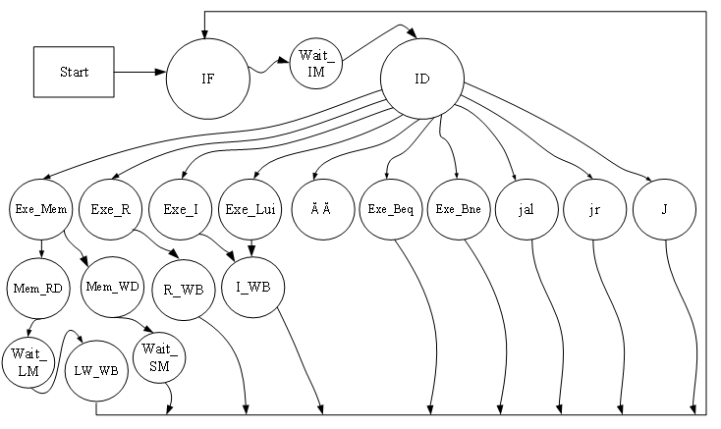

Figure - Extended FSM Diagram

* **ALU Decoder**

The opcode field of an instruction are first decoded and sets the signals for the processes of other units. As for the specified ALU operation, the funct field (instruction[5:0]) is separately decoded to ALU_Control.

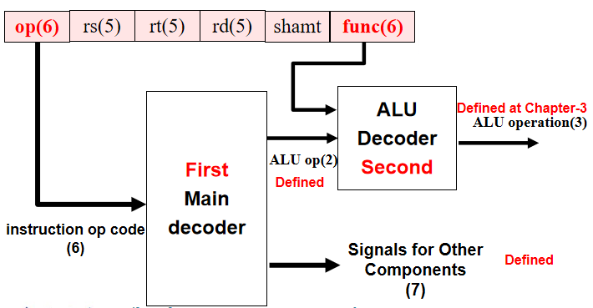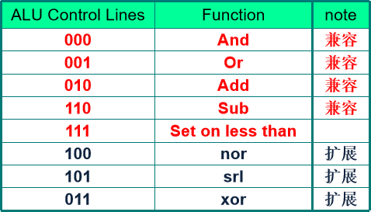

Figure 7 - Decoder Organization Table - ALU Control Signal Values

ALU_Control signals are broken down from ALU_OP, bnegate signal and the instruction funct field, as follows.

Table - ALU Signals and Funct Fields

|  |  |  |  |  |  |
| --- | --- | --- | --- | --- | --- |
| Opcode | ALU_OP | Instruction Operation | Funct | ALU_Control | ALU Operation |
| LW  100011 | 00 | Load word | XXXXXX | 010 | Add |
| SW  101011 | 00 | Store word | XXXXXX | 010 | Add |
| BEQ  000100 | 01 | Branch equal | XXXXXX | 110 | Subtract |
| R-type  000000 | 10 | Add | 100000 | 010 | Add |
| R-type  000000 | 10 | Subtract | 100010 | 110 | Subtract |
| R-type  000000 | 10 | And | 100100 | 000 | And |
| R-type  000000 | 10 | Or | 100101 | 001 | Or |
| R-type  000000 | 10 | Set on less than | 101010 | 111 | SLT |
| J-type  000010 | XX | Jump | N/A | N/A | N/A |

*The J-type instructions do not use the controller.

* **Executing Instructions of All Instruction Classes: Summary**

|  |  |  |  |  |  |  |  |
| --- | --- | --- | --- | --- | --- | --- | --- |
| Step | R-type | Memory Reference | | Branching | | Jumps | |
| Instruction Fetch  **(IF)** | IR = Memory[PC]  PC = PC + 4 | | | | | | |
| Instruction Decode **(ID)**  Register Fetch | A = Reg[rs]  B = Reg[rt]  ALUOut = PC + (sign-extend(instruction[15:0] << 2) | | | | | | |
| Execution  Compute Address  Branch/Jump Finish | ALUOut=A op B | | ALUOut = A + (sign-extend(instruction[15:0]) | | If (A == B):  PC = ALUOut | | PC = address + PC[31:28] + “00” |
| Memory Access  R-Type Completion | Reg(rd)=ALUOUT | | **Load:** MDR = Memory[ALUOut]  OR  **Store:** Memory[ALUOut] <= B | |  | |  |
| Memory Read Finish |  | | **Load:** Reg[rt] = MDR | |  | |  |

Table - MCPU Execution Summary

1. **Equipment**

Instruments:

1. Computer with Xilinx ISE 14.7 1 unit

2. SWORD Experimental Box 1 unit

1. **Methods and Procedures**
2. Construct the top-level of the single-cycle CPU with Verilog.

*topMod.v*

module topMod(

input RSTN,

input [3:0] BTN_y,

input [4:0] BTN_x,

input [15:0] SW,

input clk_100mhz,

output CR,

output RDY,

output readn,

output seg_clk,

output seg_sout,

output seg_clrn,

output SEG_PEN,

output led_clk,

output led_sout,

output LED_PEN,

output led_clrn,

output [7:0] SEGMENT,

output [3:0] AN,

output [7:0] LED,

output Buzzer

);

wire V5, N0;

assign V5 = 1'b1;

assign N0 = 1'b0;

assign Buzzer = 1'b1;

wire Clk_CPU, mem_w, data_ram_we, IO_clk, GPIOE0, GPIOF0, counter0_out, counter1_out, counter2_out, counter_we;

wire[1:0] counter_set;

wire[3:0] BTN_OK, Pulse;

wire[4:0] Key_out, state;

wire[7:0] point_out, LE_out, blink;

wire[9:0] ram_addr;

wire[15:0] SW_OK, LED_out;

wire[31:0] inst, PC, Addr_out, Data_in, Data_out, ram_data_in, ram_data_out, CPU2IO, Counter_out, Div, Disp_num, Ai, Bi;

assign IO_clk = ~Clk_CPU;

Multi_CPU U1(

.clk(Clk_CPU),

.reset(rst),

.inst_out(inst),

.INT(counter0_out),

.PC_out(PC),

.mem_w(mem_w),

.Addr_out(Addr_out),

.Data_in(Data_in),

.Data_out(Data_out),

.state(state),

.CPU_MIO(),

.MIO_ready(V5)

);

RAM_B U3(

.addra(ram_addr),

.wea(data_ram_we),

.dina(ram_data_in),

.clka(clk_100mhz),

.douta(ram_data_out)

);

MIO_BUS U4(

.clk(clk_100mhz),

.rst(rst),

.BTN(BTN_OK),

.SW(SW_OK),

.mem_w(mem_w),

.Cpu_data2bus(Data_out),

.addr_bus(Addr_out),

.ram_data_out(ram_data_out),

.led_out(LED_out),

.counter_out(Counter_out),

.counter0_out(counter0_out),

.counter1_out(counter1_out),

.counter2_out(counter2_out),

.Cpu_data4bus(Data_in),

.ram_data_in(ram_data_in),

.ram_addr(ram_addr),

.data_ram_we(data_ram_we),

.GPIOf0000000_we(GPIOF0),

.GPIOe0000000_we(GPIOE0),

.counter_we(counter_we),

.Peripheral_in(CPU2IO)

);

Multi_8CH32 U5(

.clk(IO_clk),

.rst(rst),

.EN(GPIOE0),

.Test(SW_OK[7:5]),

.point_in({Div, Div[31:13], state, N0, N0, N0, N0, N0, N0, N0, N0}),

.LES(64'b0),

.Data0(CPU2IO),

.data1({N0,N0,PC[31:2]}),

.data2(inst),

.data3(Counter_out),

.data4(Addr_out),

.data5(Data_out),

.data6(Data_in),

.data7(PC),

.point_out(point_out),

.LE_out(LE_out),

.Disp_num(Disp_num)

);

SSeg7_Dev U6(

.clk(clk_100mhz),

.rst(rst),

.Start(Div[20]),

.SW0(SW_OK[0]),

.flash(Div[25]),

.Hexs(Disp_num),

.point(point_out),

.LES(LE_out),

.seg_clk(seg_clk),

.seg_sout(seg_sout),

.SEG_PEN(SEG_PEN),

.seg_clrn(seg_clrn)

);

SPIO U7(

.clk(IO_clk),

.rst(rst),

.Start(Div[20]),

.EN(GPIOF0),

.GPIOf0(),

.P_Data(CPU2IO),

.counter_set(counter_set),

.LED_out(LED_out),

.led_clk(led_clk),

.led_sout(led_sout),

.led_clrn(led_clrn),

.LED_PEN(LED_PEN)

);

clk_div U8(

.clk(clk_100mhz),

.rst(rst),

.SW2(SW_OK[2]),

.clkdiv(Div),

.Clk_CPU(Clk_CPU)

);

SAnti_jitter U9(

.clk(clk_100mhz),

.RSTN(RSTN),

.readn(readn),

.Key_y(BTN_y),

.Key_x(BTN_x),

.SW(SW),

.Key_out(Key_out),

.Key_ready(RDY),

.pulse_out(Pulse),

.BTN_OK(BTN_OK),

.SW_OK(SW_OK),

.CR(CR),

.rst(rst)

);

Counter_x U10(

.clk(IO_clk),

.rst(rst),

.clk0(Div[8]),

.clk1(Div[9]),

.clk2(Div[10]),

.counter_we(counter_we),

.counter_val(CPU2IO),

.counter_ch(counter_set),

.counter0_OUT(counter0_out),

.counter1_OUT(counter1_out),

.counter2_OUT(counter2_out),

.counter_out(Counter_out)

);

SEnter_2_32 M4(

.clk(clk_100mhz),

.BTN(BTN_OK[2:0]),

.Ctrl({SW_OK[7:5],SW_OK[15],SW_OK[0]}),

.D_ready(RDY),

.Din(Key_out),

.readn(readn),

.Ai(Ai),

.Bi(Bi),

.blink(blink)

);

Seg7_Dev U61(

.Scan({SW_OK[1],Div[19:18]}),

.SW0(SW_OK[0]),

.flash(Div[25]),

.Hexs(Disp_num),

.point(point_out),

.LES(LE_out),

.SEGMENT(SEGMENT),

.AN(AN)

);

PIO U71(

.clk(IO_clk),

.rst(rst),

.EN(GPIOF0),

.counter_set(),

.GPIOf0(),

.PData_in(CPU2IO),

.LED_out(LED)

);

endmodule

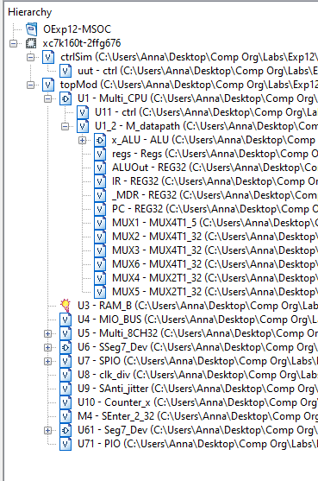

Figure - MCPU file hierarchy

1. SSeg7_Dev, and Seg7_Dev are the seven-segment displays for the SWORD board. They were constructed in the earlier labs (1-4).

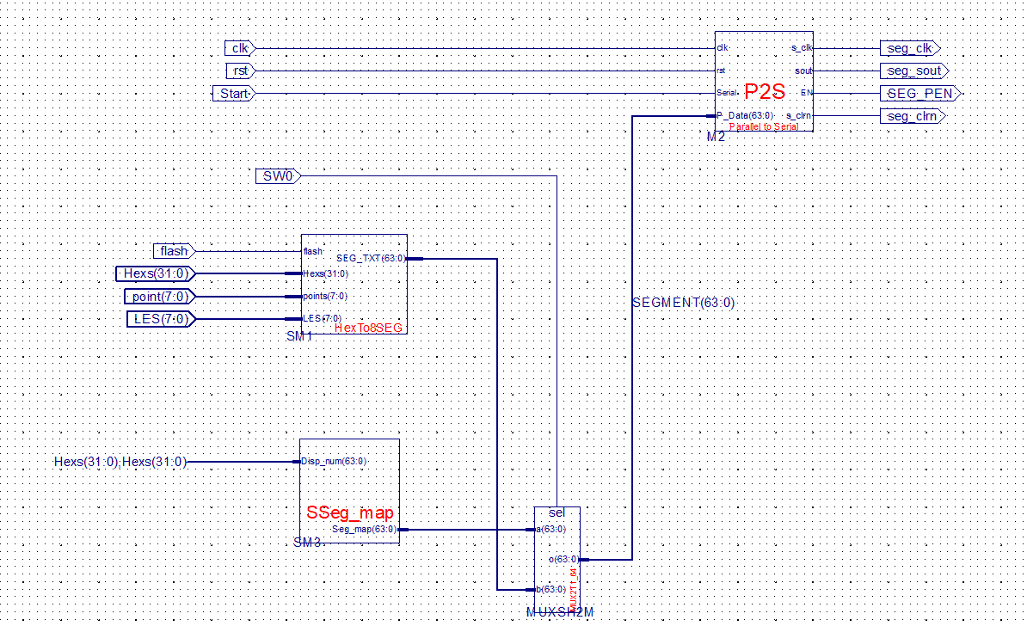

Figure - SSeg7_Dev.sch

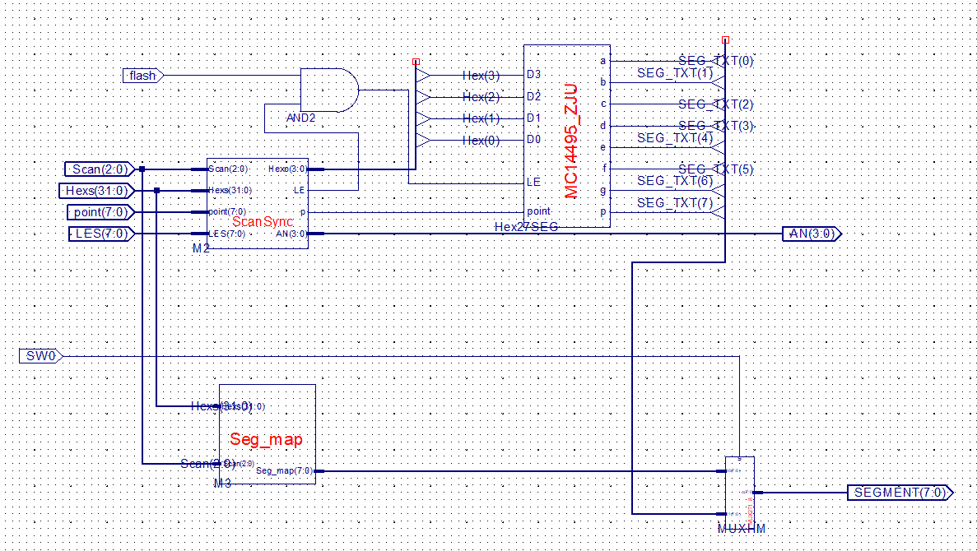

Figure - Seg7_Dev.sch

1. Other than Multi_CPU, the rest of the modules can be directly added as a source and linked to the top-level.
2. Construct the top-level of the CPU with its main two components – the datapath and the controller. Link the components and set the I/Os accordingly as illustrated.

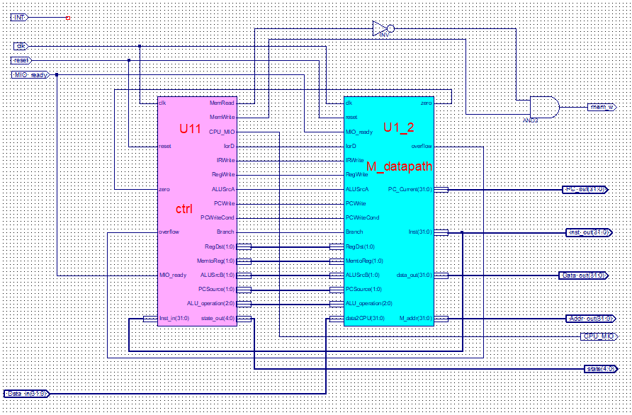

Figure - Multi_CPU.sch

1. Construct the top-level of the datapath using Verilog. The provided schematic in the courseware can be used as a reference. A schematic was used in the first MCPU labs but was later implemented in HDL.

*M_datapath_IO.v*

module M_datapath(input clk,

input reset,

input MIO_ready,

input IorD,

input IRWrite,

input[1:0] RegDst,

input RegWrite,

input[1:0]MemtoReg,

input ALUSrcA,

input[1:0]ALUSrcB,

input[1:0]PCSource,

input PCWrite,

input PCWriteCond,

input Branch,

input[2:0]ALU_operation,

output[31:0]PC_Current,

input[31:0]data2CPU,

output[31:0]Inst,

output[31:0]data_out,

output[31:0]M_addr,

output zero,

output overflow

);

wire [31:0] rdata_A, rdata_B, ALU_Out, MDR, w_reg_data, Alu_A, Alu_B, res, PC_Next;

wire[4:0] reg_Rs_addr_A = Inst[25:21];

wire[4:0] reg_Rt_addr_B = Inst[20:16];

wire[4:0] reg_rd_addr = Inst[15:11];

wire[4:0] reg_Wt_addr;

wire[15:0] imm = Inst[15:0];

wire[31:0] imm_32 = {{16{imm[15]}},imm};

wire N0 = 1'b0, V5 = 1'b1;

wire CE;

assign CE = MIO_ready && (PCWrite || (PCWriteCond && zero&&Branch));

assign data_out = rdata_B;

ALU x_ALU(.A(Alu_A),

.B(Alu_B),

.ALU_operation(ALU_operation),

.res(res),

.zero(zero),

.overflow(overflow)

);

Regs regs(.clk(clk),

.rst(reset),

.R_addr_A(reg_Rs_addr_A), //Inst(25:21)

.R_addr_B(reg_Rt_addr_B), //Inst(20:16)

.Wt_addr(reg_Wt_addr),

.Wt_data(w_reg_data),

.L_S(RegWrite),

.rdata_A(rdata_A),

.rdata_B(rdata_B)

);

REG32 ALUOut(.clk(clk),

.rst(N0),

.CE(V5),

.D(res),

.Q(ALU_Out)

);

REG32 IR (.clk(clk),

.rst(reset),

.CE(V5),

.D(data2CPU),

.Q(Inst)

);

REG32 _MDR(.clk(clk),

.rst(N0),

.CE(V5),

.D(data2CPU),

.Q(MDR)

);

REG32 PC (.clk(clk),

.rst(reset),

.CE(CE),

.D(PC_next),

.Q(PC_Current)

);

MUX4T1_5 MUX1(.I0(reg_Rt_addr_B), //reg addr=IR[21:16]

.I1(reg_rd_addr), //reg addr=IR[15:11]

.I2(5'b11111), // not use

.I3(5'b00000), // not use

.s(RegDst),

.o(reg_Wt_addr)

);

MUX4T1_32 MUX2(.I0(ALU_Out), //ALU OP

.I1(MDR),

.I2(32'h00000000), // not use

.I3(32'h00000000), // not use

.s(MemtoReg),

.o(w_reg_data)

);

MUX4T1_32 MUX3(.I0(data_out), //reg out B

.I1(32'h00000004), //4 for PC+4

.I2(imm_32[31:0]),

.I3({imm_32[29:0],N0,N0}),

.s(ALUSrcB),

.o(Alu_B)

);

MUX4T1_32 MUX6(.I0(res[31:0]),

.I1(ALU_Out[31:0]),

.I2({PC_Current[31:28],Inst[25:0],N0,N0}),

.I3(32'h00000000),

.s(PCSource),

.o(PC_Next)

);

MUX2T1_32 MUX4(.I0(rdata_A), // reg out A

.I1(PC_Current), // PC

.s(ALUSrcA),

.o(Alu_A)

);

MUX2T1_32 MUX5(.I0(PC_Current), //IF

.I1(ALU_Out), //access memory

.s(IorD),

.o(M_addr)

);

endmodule

1. Use the ALU from lab 4.

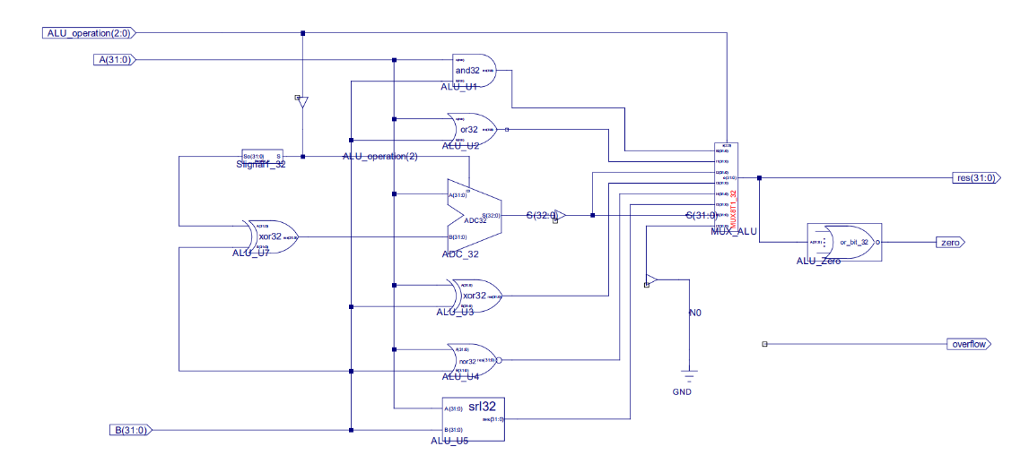

Figure - ALU.sch

1. Implement the register file using Verilog. This was also taken from lab 4 and was provided in the courseware.

*Regs.v*

module Regs(input clk, rst, L_S,

input [4:0] R_addr_A, R_addr_B, Wt_addr,

input [31:0] Wt_data,

output [31:0] rdata_A, rdata_B

);

reg [31:0] register [1:31]; // r1 - r31

integer i;

assign rdata_A = (R_addr_A == 0) ? 0 : register[R_addr_A]; // readassign rdata_B = (R_addr_B == 0) ? 0 : register[R_addr_B]; // read

always @(posedge clk or posedge rst) begin

if (rst == 1) begin

for (i=1; i<32; i=i+1) begin

register[i] <= 0; // reset

end

end else if ((Wt_addr != 0) && (L_S == 1)) begin

register[Wt_addr] <= Wt_data; // write

end

end

endmodule

1. Implement the program counter (PC), ALUOut register, instruction register, and memory data register. These are just 32-bit registers, that holds a value. This was provided in the courseware.

*REG32.v*

module REG32( input clk, rst, CE, [31:0] D,

output reg[31:0] Q

);

always @(posedge clk or posedge rst) begin

if (rst==1) Q <= 32'h00000000;

else if (CE) Q <= D;

end

endmodule

1. Implement the six multiplexers. For the MCPU, we will need one 8-bit 4-1 MUX, two 32-bit 2-1 MUX, and three 32-bit 4-1 MUX. These select the input for the unit, and more detail about their implementation can be found in section 2.
2. Implement the 32-bit signal extender. This was also taken from lab 4 and was provided in the courseware.

*Ext_32.v*

module Ext_32(input [15:0] imm_16,

output[31:0] Imm_32

);

assign Imm_32 = {{16{imm_16[15]}},imm_16};

endmodule

1. Implement the controller using Verilog. Construction started from lab 11 and had extensions added in for lab 12. This was done using the finite state machine as reference.

*mulit_ctrl_IO.v*

module ctrl(input clk,

input reset,

input [31:0] Inst_in,

input zero,

input overflow,

input MIO_ready,

output reg MemRead,

output reg MemWrite,

output reg[2:0]ALU_operation,

output [4:0]state_out,

output reg CPU_MIO,

output reg IorD,

output reg IRWrite,

output reg [1:0]RegDst,

output reg RegWrite,

output reg [1:0]MemtoReg,

output reg ALUSrcA,

output reg [1:0]ALUSrcB,

output reg [1:0]PCSource,

output reg PCWrite,

output reg PCWriteCond,

output reg Branch

);

wire Rtype, LS, IBeq, Jump, Load, Store;

wire[5:0] OP = Inst_in[31:26];

reg[3:0] state;

reg[1:0] ALUop;

parameter IF = 4'b0000, ID = 4'b0001, Mem_Ex = 4'b0010, Mem_RD = 4'b0011, LW_WB = 4'b0100, Mem_W = 4'b0101, R_Exc = 4'b0110, R_WB = 4'b0111,

Beq_Exc = 4'b1000, J = 4'b1001, I_Exc = 5'b01010, I_WB = 5'b01011,

Lui_Exc = 5'b01100, Bne_Exc = 5'b01101, Jr = 5'b01110, Jal = 5'b01111,

Jalr = 5'b10000, Error = 4'b1111;

`define Datapath_signals {PCWrite, PCWriteCond,IorD, MemRead, MemWrite,IRWrite, MemtoReg, PCSource, ALUSrcA, ALUSrcB, RegWrite, RegDst, Branch, ALUop, CPU_MIO}

parameter value0 = 20'b10010100000010000000,

value1 = 20'b00000000000110000000, value2 = 20'b00000000001100000000,

value3 = 20'b00110000000000000001, value4 = 20'b00000001000001000000,

value5 = 20'b00101000000000000001, value6 = 20'b00000000001000000100,

value7 = 20'b00000000000001010000,

value8 = 20'b01000000011000001010,

value9 = 20'b10000000100000000000,

value10 = 20'b00000000001100000110,

value11 = 20'b00000000000001000000,

value12 = 20'b00000010001111000000,

value13 = 20'b01000000011000000010,

value14 = 20'b10000000110000000000,

value15 = 20'b10000011100001100000,

value16 = 20'b10000011110001000000,

value17 = 20'b10000011100001100000;

parameter AND=3'b000, OR=3'b001, ADD=3'b010, SUB=3'b110, NOR=3'b100, SLT=3'b111, XOR=3'b011, SRL=3'b101;

always @ (posedge clk or posedge reset)

if (reset==1) state <= IF;

else

case(state)

IF: if(MIO_ready) state <= ID;

else state <= IF;

ID: case (Inst_in[31:26])

6'b000000:

begin

case(Inst_in[5:0])

6'b001000: state <= Jr; //Jr

6'b001001: state <= Jalr; //Jalr

default: state <= R_Exc; //R-type OP

endcase

end

6'b100011: state <= Mem_Ex; //Lw

6'b101011: state <= Mem_Ex; //Sw

6'b001000: state <= I_Exc; //Addi

6'b001100: state <= I_Exc; //Andi

6'b001101: state <= I_Exc; //Ori

6'b001110: state <= I_Exc; //Xori

6'b001010: state <= I_Exc; //Slti

6'b001111: state <= Lui_Exc; //Lui

6'b000100: state <= Beq_Exc; //Beq

6'b000101: state <= Bne_Exc; //Bne

6'b000010: state <= J; //Jump

6'b000011: state <= Jal; //Jal

default: state <= Error;

endcase

Mem_Ex: if(Inst_in[29]) state <= Mem_W;

else state <= Mem_RD;

Mem_RD: state <= LW_WB;

LW_WB: state <= IF;

Mem_W: state <= IF;

R_Exc: state <= R_WB;

R_WB: state <= IF;

I_Exc: state <= I_WB;

I_WB: state <= IF;

Lui_Exc: state <= IF;

Beq_Exc: state <= IF;

Bne_Exc: state <= IF;

Jal: state <= IF;

Jr: state <= IF;

J: state <= IF;

Error: state <= Error;

default: state <= Error;

endcase

always @ * begin

case(state) //state

IF: `Datapath_signals = value0;

ID: `Datapath_signals = value1;

Mem_Ex: `Datapath_signals = value2;

Mem_RD: `Datapath_signals = value3;

LW_WB: `Datapath_signals = value4;

Mem_W: `Datapath_signals = value5;

R_Exc: `Datapath_signals = value6;

R_WB: `Datapath_signals = value7;

Beq_Exc: `Datapath_signals = value8;

J: `Datapath_signals = value9;

I_Exc: `Datapath_signals = value10;

I_WB: `Datapath_signals = value11;

Lui_Exc: `Datapath_signals = value12;

Bne_Exc: `Datapath_signals = value13;

Jr: `Datapath_signals = value14;

Jal: `Datapath_signals = value15;

Jalr: `Datapath_signals = value16;

default: `Datapath_signals = value0;

endcase

end

always @ * begin

case(ALUop)

2'b00: ALU_operation = 3'b010; //add????

2'b01: ALU_operation = 3'b110; //sub????

2'b10:

case (Inst_in[5:0])

6'b100000: ALU_operation = ADD;

6'b100010: ALU_operation = SUB;

6'b100100: ALU_operation = AND;

6'b100101: ALU_operation = OR;

6'b100111: ALU_operation = NOR;

6'b101010: ALU_operation = SLT;

6'b000010: ALU_operation = SRL; //shfit 1bit right

6'b000000: ALU_operation = XOR;

default: ALU_operation = ADD;

endcase

2'b11:

case (Inst_in[31:26])

6'b001010: ALU_operation = SLT; //slti

6'b001000: ALU_operation = ADD; //addi

6'b001100: ALU_operation = AND; //andi

6'b001101: ALU_operation = OR; //ori

6'b001110: ALU_operation = XOR; //xori

default: ALU_operation = ADD;

endcase

endcase

end

endmodule

1. Implement the memory unit (RAM_B) by generating an IP Core. Load the .coe file provided by the courseware.
2. Attach the provided .ucf file to the top module.
3. Simulate the register file, ALU, datapath, controller, and seven-segment displays.
4. Generate the programmable file (.bit) by synthesizing and implementing the top module design.

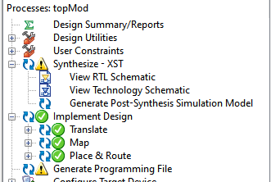 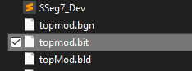

Figure 13 - Successfully generated programming file Figure 14 - .bit file generated

1. Implement .bit file onto the SWORD board and observe results.
2. **Experimental Results and Data Analysis**

Due to the given circumstances of this semester, we were unable to verify the function of these labs and implement it onto the SWORD board. Observations and photos will be omitted. A total of five components in the multi-cycle CPU were simulated – ALU, datapath, controller, register file and 7-segment display. Note that the same ALU and register file simulations were used in the SCPU labs.

* Datapath

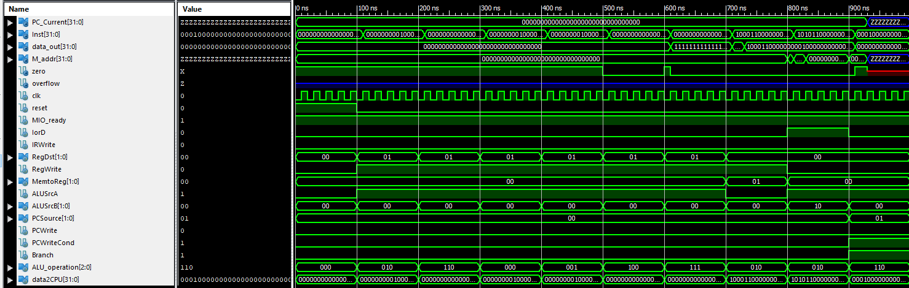

Figure - MCPU datapath simulation

The datapath was simulated by providing the 32-bit instruction (data2CPU) and manually setting the different control signals (`signals) and ALU_Operation for each state represented in the finite state machine. States 0 and 1 are already preinitialized to simulate the instruction decoding, and if we were to simulate the process of a R-type instruction, we would assert the appropriate signals for states 6, 7 and back to 0. I-type, R-type, branch, and memory reference instructions were simulated. Consistent results were produced.

*M_datapathSim.v*

module M_datapathSim;

// Inputs

reg clk;

reg reset;

reg MIO_ready;

reg IorD;

reg IRWrite;

reg [1:0] RegDst;

reg RegWrite;

reg [1:0] MemtoReg;

reg ALUSrcA;

reg [1:0] ALUSrcB;

reg [1:0] PCSource;

reg PCWrite;

reg PCWriteCond;

reg Branch;

reg [2:0] ALU_operation;

reg [31:0] data2CPU;

// Outputs

wire [31:0] PC_Current;

wire [31:0] Inst;

wire [31:0] data_out;

wire [31:0] M_addr;

wire zero;

wire overflow;

// Instantiate the Unit Under Test (UUT)

M_datapath uut (

.clk(clk),

.reset(reset),

.MIO_ready(MIO_ready),

.IorD(IorD),

.IRWrite(IRWrite),

.RegDst(RegDst),

.RegWrite(RegWrite),

.MemtoReg(MemtoReg),

.ALUSrcA(ALUSrcA),

.ALUSrcB(ALUSrcB),

.PCSource(PCSource),

.PCWrite(PCWrite),

.PCWriteCond(PCWriteCond),

.Branch(Branch),

.ALU_operation(ALU_operation),

.PC_Current(PC_Current),

.data2CPU(data2CPU),

.Inst(Inst),

.data_out(data_out),

.M_addr(M_addr),

.zero(zero),

.overflow(overflow)

);

initial begin

// Initialize Inputs

`define signals {PCWrite, PCWriteCond, IorD, IRWrite, MemtoReg, PCSource, ALUSrcB, ALUSrcA, RegWrite, RegDst}

clk = 0;

reset = 1;

MIO_ready = 1;

IorD = 0;

IRWrite = 0;

RegDst = 0;

RegWrite = 0;

MemtoReg = 0;

ALUSrcA = 0;

ALUSrcB = 0;

PCSource = 0;

PCWrite = 0;

PCWriteCond = 0;

Branch = 0;

ALU_operation = 0;

data2CPU = 0;

#100;

reset = 0;

//add r3, r2, r2

data2CPU = 32'b000000_00010_00010_00011_00000_100000;

`signals = 14'b1_00_1000_0010_000;

ALU_operation = 3'b000;

`signals = 14'b0_00_0000_0110_000;

`signals = 14'b0_00_0000_0001_000;

ALU_operation = 3'b010;

`signals = 14'b0_00_0000_0001_101;

#100;

//sub r4, r0, r3

data2CPU = 32'b000000_00000_00011_00100_00000_100010;

`signals = 14'b1_00_1000_0010_000;

ALU_operation = 3'b000;

`signals = 14'b0_00_0000_0110_000;

`signals = 14'b0_00_0000_0001_000;

ALU_operation = 3'b110;

`signals = 14'b0_00_0000_0001_101;

#100;

//and r5, r3, r4

data2CPU = 32'b000000_00100_00011_00101_00000_100100;

`signals = 14'b1_00_1000_0010_000;

ALU_operation = 3'b000;

`signals = 14'b0_00_0000_0110_000;

`signals = 14'b0_00_0000_0001_000;

`signals = 14'b0_00_0000_0001_101;

#100;

//or r6, r2, r4

data2CPU = 32'b000000_00100_00010_00110_00000_010110;

`signals = 14'b1_00_1000_0010_000;

ALU_operation = 3'b000;

`signals = 14'b0_00_0000_0110_000;

`signals = 14'b0_00_0000_0001_000;

ALU_operation = 3'b001;

`signals = 14'b0_00_0000_0001_101;

#100;

//nor r1, r0, r0

data2CPU = 32'b000000_00000_00000_00001_00000_100111;

`signals = 14'b1_00_1000_0010_000;

ALU_operation = 3'b000;

`signals = 14'b0_00_0000_0110_000;

`signals = 14'b0_00_0000_0001_000;

ALU_operation = 3'b100;

`signals = 14'b0_00_0000_0001_101;

#100;

//slt r2, r0, r1

data2CPU = 32'b000000_00000_00001_00010_00000_101010;

`signals = 14'b1_00_1000_0010_000;

ALU_operation = 3'b000;

`signals = 14'b0_00_0000_0110_000;

`signals = 14'b0_00_0000_0001_000;

ALU_operation = 3'b111;

`signals = 14'b0_00_0000_0001_101;

#100;

//lw r1, 4(r0)

data2CPU = 32'b100011_00000_00001_00000_00000_000100;

`signals = 14'b1_00_1000_0010_000;

ALU_operation = 3'b000;

`signals = 14'b0_00_0000_0110_000;

`signals = 14'b0_00_0000_0101_000;

ALU_operation = 3'b010;

`signals = 14'b0_01_0000_0101_000;

`signals = 14'b0_00_0010_0000_100;

#100;

//sw r1, 8(r0)

data2CPU = 32'b101011_00000_00001_00000_00000_001000;

`signals = 14'b1_00_1000_0010_000;

ALU_operation = 3'b000;

`signals = 14'b0_00_0000_0110_000;

`signals = 14'b0_00_0000_0101_000;

ALU_operation = 3'b010;

`signals = 14'b0_01_0000_0101_000;

#100;

//beq r0, r0, 4

data2CPU = 32'b000100_00000_00000_00000_00000_000100;

`signals = 14'b1_00_1000_0010_000;

ALU_operation = 3'b000;

`signals = 14'b0_00_0000_0110_000;

`signals = 14'b0_10_0000_1001_000;

ALU_operation = 3'b110;

Branch = 1;

#100;

end

always begin

clk=0;

#10;

clk=1;

#10;

end

endmodule

* Controller

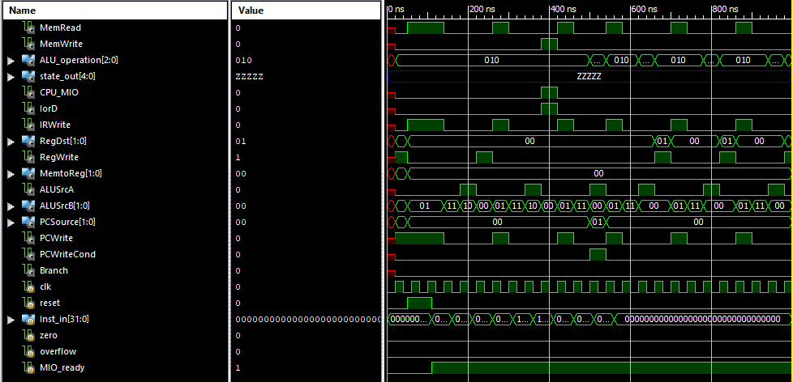

Figure - MCPU controller simulation

The controller input was simulated with 32-bit instructions as input. Several R-type, I-type, branch and jump instructions were used for testing. Consistent results were produced.

*ctrlSim.v*

module ctrlSim;

// Inputs

reg clk;

reg reset;

reg [31:0] Inst_in;

reg zero;

reg overflow;

reg MIO_ready;

// Outputs

wire MemRead;

wire MemWrite;

wire [2:0] ALU_operation;

wire [4:0] state_out;

wire CPU_MIO;

wire IorD;

wire IRWrite;

wire [1:0] RegDst;

wire RegWrite;

wire [1:0] MemtoReg;

wire ALUSrcA;

wire [1:0] ALUSrcB;

wire [1:0] PCSource;

wire PCWrite;

wire PCWriteCond;

wire Branch;

// Instantiate the Unit Under Test (UUT)

ctrl uut (

.clk(clk),

.reset(reset),

.Inst_in(Inst_in),

.zero(zero),

.overflow(overflow),

.MIO_ready(MIO_ready),

.MemRead(MemRead),

.MemWrite(MemWrite),

.ALU_operation(ALU_operation),

.state_out(state_out),

.CPU_MIO(CPU_MIO),

.IorD(IorD),

.IRWrite(IRWrite),

.RegDst(RegDst),

.RegWrite(RegWrite),

.MemtoReg(MemtoReg),

.ALUSrcA(ALUSrcA),

.ALUSrcB(ALUSrcB),

.PCSource(PCSource),

.PCWrite(PCWrite),

.PCWriteCond(PCWriteCond),

.Branch(Branch)

);

initial begin

// Initialize Inputs

clk = 0;

reset = 0;

Inst_in = 0;

zero = 0;

overflow = 0;

MIO_ready = 0;

// Wait 100 ns for global reset to finish

#50;

reset=1;

#60;

reset=0;

MIO_ready=1;

Inst_in = 32'h014B4820; //add t1, t2, t3

#50;

Inst_in = 32'h2014003f; //addi s4, zero, 3f

#50;

Inst_in = 32'h11600005; //beq t3, zero, 5

#50;

Inst_in = 32'h0800000c; //j 12

#50;

Inst_in = 32'h8D69FFFF; //lw t1, 0xffff(t3)

#50;

Inst_in = 32'hAD71FFFF; //sw s1, 0xffff(t3)

#50;

Inst_in = 32'h0C00BFAF; //jal bfaf

#50;

Inst_in = 32'h15700005; //bne s0 5

#50;

Inst_in = 32'h3C0B0001; //lui t3 1

#50;

Inst_in = 32'h00000000;

#50;

end

always begin

clk=0;

#20;

clk=1;

#20;

end

endmodule

* ALU

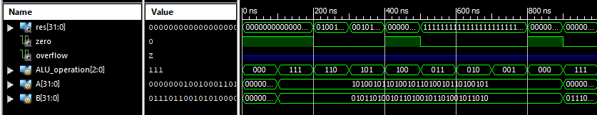

Figure - MCPU ALU simulation

The ALU unit was simulated by setting two arbitrary input values for A and B, and changing the opcodes to toggle the different operations. ALU operations slt, sub, srl, nor, xor, add, or and logical and were simulated. Consistent results were produced in the res output. The Verilog module for this simulation was provided in the courseware.

*aluSim.v*

`timescale 1ns / 1ps

module ALU_ALU_sch_tb();

// Inputs

reg [2:0] ALU_operation;

reg [31:0] A;

reg [31:0] B;

// Output

wire [31:0] res;

wire zero;

wire overflow;

// Bidirs

// Instantiate the UUT

ALU UUT (

.ALU_operation(ALU_operation),

.res(res),

.zero(zero),

.overflow(overflow),

.A(A),

.B(B)

);

// Initialize Inputs

initial begin

A = 0;

B = 0;

ALU_operation = 0;

#100;

// Wait 100 ns for global reset to finish

// Add stimulus here

A=32'hA5A5A5A5;

B=32'h5A5A5A5A;

ALU_operation =3'b111; //slt

#100;

ALU_operation =3'b110; //sub

#100;

ALU_operation =3'b101; //srl

#100;

ALU_operation =3'b100; //nor

#100;

ALU_operation =3'b011; //xor

#100;

ALU_operation =3'b010; //add

#100;

ALU_operation =3'b001; //or

#100;

ALU_operation =3'b000; //and

#100;

A=32'h01234567;

B=32'h76543210;

ALU_operation =3'b111; //slt

end

* Register File

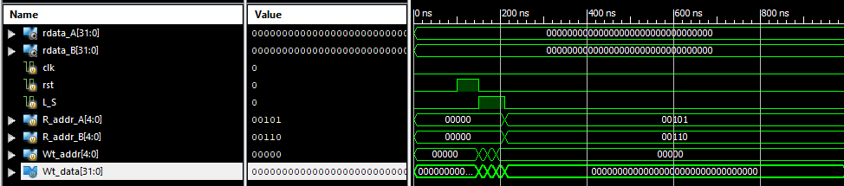

Figure - MCPU Regs simulation

The register file is tested by asserting and deasserting the RegWrite signal, and providing random parameters to all four of its input ports. Either it is given two operand values, or a value and register address to write to.

*regSim.v*

module regsSim;

// Inputs

reg clk;

reg rst;

reg L_S;

reg [4:0] R_addr_A;

reg [4:0] R_addr_B;

reg [4:0] Wt_addr;

reg [31:0] Wt_data;

// Outputs

wire [31:0] rdata_A;

wire [31:0] rdata_B;

// Instantiate the Unit Under Test (UUT)

Regs uut (

.clk(clk),

.rst(rst),

.L_S(L_S),

.R_addr_A(R_addr_A),

.R_addr_B(R_addr_B),

.Wt_addr(Wt_addr),

.Wt_data(Wt_data),

.rdata_A(rdata_A),

.rdata_B(rdata_B)

);

initial begin

// Initialize Inputs

clk = 0;

rst = 0;

L_S = 0;

R_addr_A = 0;

R_addr_B = 0;

Wt_addr = 0;

Wt_data = 0;

// Wait 100 ns for global reset to finish

#100;

// Add stimulus here

rst = 1;

#50;

rst = 0;

L_S = 1;

R_addr_A = 0;

R_addr_B = 0;

Wt_addr = 5;

Wt_data = 32'hA5A5A5A5;

#20;

L_S = 1;

R_addr_A = 0;

R_addr_B = 0;

Wt_addr = 6;

Wt_data = 32'h55AA55AA;

#20;

L_S = 1;

R_addr_A = 0;

R_addr_B = 0;

Wt_addr = 0;

Wt_data = 32'hAAAA5555;

#20;

L_S = 0;

R_addr_A = 5;

R_addr_B = 6;

Wt_addr = 0;

Wt_data = 0;

#20;

end

endmodule

* 7-Segment Display

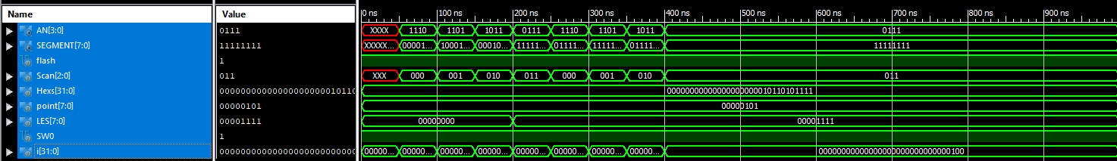

Figure - Seg7Dev simulation

The 7-segment display was simulated back in lab 2. The basic task of this simulation was to traverse each segment of the display. Consistent results were produced.

*Seg7Dev_Sim.v*

`timescale 1ns / 1ps

module Seg7_Dev_Seg7_Dev_sch_tb();

// Inputs

reg flash;

reg [2:0] Scan;

reg [31:0] Hexs;

reg [7:0] point;

reg [7:0] LES;

reg SW0;

// Output

wire [3:0] AN;

wire [7:0] SEGMENT;

// Bidirs

// Instantiate the UUT

Seg7_Dev UUT (

.flash(flash),

.Scan(Scan),

.Hexs(Hexs),

.point(point),

.LES(LES),

.AN(AN),

.SEGMENT(SEGMENT),

.SW0(SW0)

);

// Initialize Inputs

`ifdef auto_init

initial begin

flash = 0;

Scan = 0;

Hexs = 0;

point = 0;

LES = 0;

SW0 = 0;

`endif

integer i;

initial begin

Hexs = 16'h05AF;

point = 4'b0101;

LES = 4'b0000;

SW0 = 1;

flash = 1;

for(i = 0; i < 4; i = i + 1) begin

#50;

Scan = i;

end

LES = 4'b1111;

for(i = 0; i < 4; i = i + 1) begin

#50;

Scan = i;

end

end

endmodule

1. **Discussion and Conclusion**

To modify the simultaneous output of control signals for the finite state machine with HDL, I needed to extend the controller unit of the MCPU processor. Each of the 16 value parameters represented a state of the FSM, and what signals (defined by Datapath_signals) were asserted. Representing the main decoder, a case-switch statement was used and assigned each state a name and its respective opcode. Following that, the ALU decoder (also represented by a case-switch statement) assigned the ALU_Operation signal controls to their respective opcode and ALU operation. Using the FSM to model the controller is how one would expand the different instructions supported. The BNE instruction has different signals than the BEQ instruction because the branch is taken in the event of an inequality. Thus, ALUop = 11 and ALU_Operation = 110. This datapath is modified to support I-type arithmetic instructions, since immediate values are handled before it gets routed to the B input port of the ALU. Secondary decoding has many advantages, such as improving performance and enabling parallel decoding. It can directly and efficiently route the information that the ALU needs to operate. By doing the decoding in a parallel matter, the input values of the ALU would not have to stall and waste clock cycles by waiting for ALU_Operation. The temporary ALU output register is needed to hold the output of a computed value, and route it to another functional unit if needed. Implementing an additional register is more cost-efficient than adding extra adders and reduces clock cycles since the value is immediately available if needed. Having the ALU output register prevents any conflicts, since the output of the ALU could be directly routed from output to the PC or stored for use in the register in the subsequent cycle.

This marks the conclusion of the multi-cycle CPU design labs of the Computer Organization course! Although I am disappointed that I am unable to first-hand experience these labs in person, I still found it to be very rewarding. Not being able to physically do SoC verification made debugging the CPU tricky, because we could not tell what worked what did not work. I am also disappointed that I am unable to run demo MIPS program using this CPU, and this makes the whole lab experience seem incomplete. I think it would have been fun to implement a project, or a game to wrap up all these labs. Doing these labs were not a complete lost though, because it greatly supplemented the material that I learned in the theoretical portion of this course. It helped me better understand how control signals played a role in instruction execution, and how instructions were processed throughout each component. It made learning about the CPU a whole lot easier and I immensely enjoyed doing these labs. These labs have helped me gain confidence with writing testing modules and interpreting simulation results. From this, I had an easier time debugging and it was a way to keep reiterating information. I really liked how these labs were structured because it progressively built up my knowledge by implementing the top module first, then designing each of the components separately. I was able to tell how and why the MCPU was more efficient than the SCPU, by noticing the hardware changes and observing differences in the simulations. I look forward to learning more about computer architecture in the future and exploring its applications.