

**本科实验报告**

|  |  |
| --- | --- |
| 课程名称： | 计算机组成 |
| 姓 名： | TANG ANNA YONGQI |
| 学 院： | 计算机科学与技术学院 |
| 专 业： | 计算机科学与技术（中加班）留学生 |
| 学 号： | 3180300155 |
| 生活照： |  |
| 指导教师： | 刘海风，洪奇军 |

2020年 6月10日

Final Report– Single-Cycle CPU Implementation

**Name:** Anna Yongqi Tang **ID:** 3180300155 **Major:** 计算机科学与技术（中加班）留学生

**Course:** Computer Organization

**Date:** 2020-06-10 **Instructor:** 洪奇军

1. **Experiment Objectives and Requirements**

* Understand and implement a single-cycle CPU design that supports the following instructions:
  + R-Type: add, sub, and, or, xor, nor, slt, srl, jr, jalr
  + I-Type: addi, andi, ori, xori, lui, lw, sw, beq, bne, slti
  + J-Type: j, jal
* Datapath Design
  + Mandate memory management and ALU operations
* Controller Design
  + Set to send the appropriate control signals to the datapath for each instruction
* Design testing procedures

1. **Content and Principles of the Experiment**

* **CPU Organization**

The central processing unit (CPU), consist of two main components – the control unit and datapath. As depicted, the datapath follows the program instructions and performs arithmetic operations to get the result. The controller tells the datapath what to do and what components to use, by asserting different control signals.

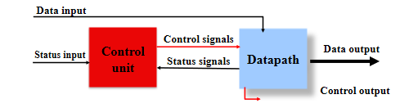

Figure - CPU Organization

* **MIPS Instructions**

A MIPS instruction is broken up into different fields, specifying the registers and operations used for when it is processed. R-type, I-type and J-type do not share the same format. An instruction consists of 32-bits and contains all the information needed to be processed in the CPU.

Note the different destination registers, where R-type would use the rd field and I-type would use the rt field.

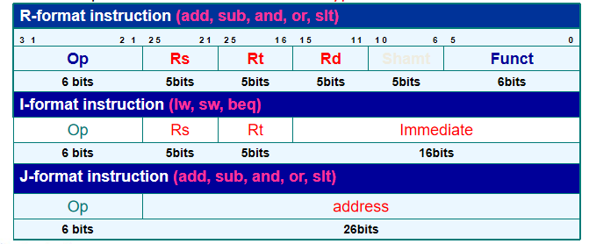

Figure - MIPS Instruction Field

* **Instruction Memory**

For these labs, the instruction memory was implemented as a ROM. Like the name suggests, this was where the instructions where stored. The program counter (PC) would send the address to this component, where the instruction would be fetched, where it would be sent to the datapath for decoding and processing. Simultaneously, the PC would send its current address to an adder and increment it by 4 to the next instruction address, getting it ready to be sent to the instruction memory once again.

* **Data Memory**

The data memory was implemented as a RAM. Typically used in memory access instructions, this is where the datapath would retrieve data and write it to the registers. Similarly, the datapath can overwrite a memory segment with the contents of the register.

* **The Datapath**

The datapath implemented in this course has the following components – program counter, register file, ALU, an adder for the program counter, an adder for branch instructions and a 32-bit sign extender.

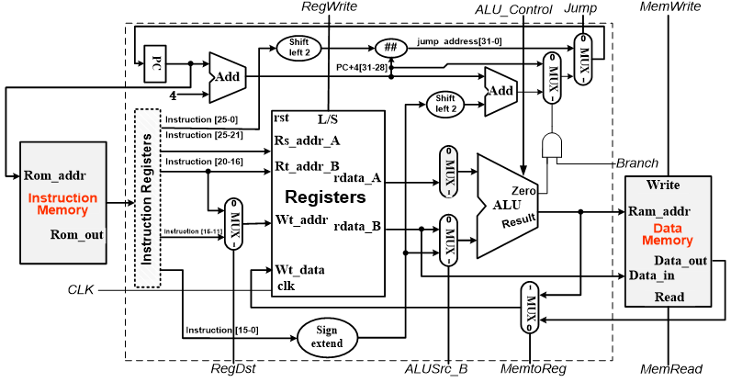

Figure 3 - Top Diagram of Lab MCPU

* + **Program Counter (PC)** – This is where the address of the current instruction is stored. The address gets sent to the instruction memory, where the instruction is fetched and processed. In a R-type instruction, the PC gets updated with the next sequential instruction address while a jump or branching instruction would update the PC with another target address.
  + **Arithmetic Logic Unit (ALU) –** All R-type and I-type instructions use the ALU for processing. The memory reference instructions would use it for address calculations, branching for comparisons, and executing arithmetic-logic operations. The type of arithmetic operation is done based on what signal ALU_operation provides. For lab purposes, the ALU takes in 2 32-bit inputs A and B from the register file, a 3-bit ALU_operation control signal, and 2 signal outputs zero and overflow and finally the output ALU_Out.

The overflow signal indicates whether there is an overflow and the zero signal is asserted when a branch is taken by a branching instructed. Lastly, the 32-bit ALU_output contains the address to be written into the data memory or the data to be written into a destination register.

The ALU supports 8 different operations – And, Or, Add, Sub, Slt, Nor, Srl, and Xor.

* + **Register File –** Like the name suggests, this component contains a set of registers that can be read and written by supplying a register number to be accessed. There is a total of 32 32-bit registers in the CPU. The registers are implemented as an array of D flip-flops, decoders and multiplexers are used for reading and writing data. There are four main inputs; R_addr_A, R_addr_B, Wt_addr and Wt_data. The first two are the numbers registers to be read, while the third one provides the number of the destination register and the last one contains the data to be written into the destination. Outputs rdata_A and rdata_B returns the contents of the operand registers and routes them to the ALU. There are three signals used by the register; clk, rst and L_S (asserted if Wt_addr is written with the value on the Wt_data input).

Note that inputs and outputs are 32-bits, while register numbers are 5-bits.

* + **Sign Extender –** A 32-bit sign extender unit is used for branching, memory reference and I-type instructions. Addresses, offsets, and immediate values are given in 16-bit values, so it is necessary to extend them to 32-bits for further processing. The extended output (Imm_32) gets sent to the B input of the ALU, only if selected by a multiplexer to do so.
  + **Adders –** Only two adders are used in our single-cycle CPU implementation.

One is used to increment the contents of the PC to retrieve the next instruction. It receives the 32-bit current instruction as the input and adds 4 to it. Afterwards, it gets sent to a multiplexer and routes it to the PC.

The other adder is used for branching and jump instructions. This adds the incremented PC and the sign-extended offset and sends the resulting address to the PC if selected by the multiplexer. For jumps, it takes the upper four bits of PC+4, adds it to the 26-bit offset from the instruction, and shifts it left by two.

* + **Multiplexers –** Five multiplexers were used in the single-cycle CPU design, and they all serve the same purpose of selecting one of its inputs to be routed out to another unit as their input.

**MUXD1 & MUXD2:** Selected which segment of the instruction should be interpreted as the destination register; either instruction bits 11-15 or bits 16-20. This then gets sent as the input of the register file, Wt_addr.

**MUXD3:** Selected the input source for B of the ALU; either from rdata_B (register file) or the sign-extended offset.

**MUXD4:** Selected the input source of Wt_data of the register file (data to be written to a register), either from data input, the last 16 bits of the instruction, contents of ALU_Out or the incremented PC.

**MUXD5:** Selected the address source for the next instruction (PC); either from PC+4 adder, branch adder or jump destination.

* **The Controller**

The controller unit controls the flow of information with the use of several signals. It determines the components that need to be used, and which MUX signals to assert with its own controls. The ALU relies on the ALU_Control signal to determine which operation to execute for a specific instruction.

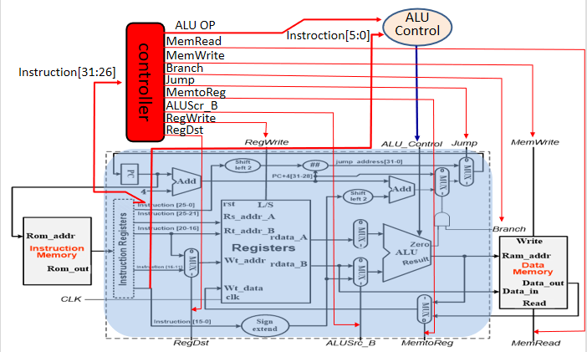

Figure 4 - Controller of Lab MCPU

|  |  |  |  |
| --- | --- | --- | --- |
| Signal | Function | Asserted | Not Asserted |
| ALU_Src_B[1:0] | Determines what goes into the B input of the ALU by controlling MUXD3. | Select sign-extended offset  (Imm_32) | Select register B  (rdata_B) |
| RegDst[1:0] | Determines the destination register for the register file (Wt_addr) by controlling MUXD1. | Choose rd  (inst_field(15:11)) | Choose rt  (inst_field(20:16)) |
| MemtoReg[1:0] | Determines the source of the data to be written into the registers | Data to be written comes from the data memory | Data comes from the ALU (ALU_out) |
| Branch[1:0] | Determines if the branch should be taken (update the PC). | Take branch and update PC with branch address  (zero == 1 as well) | PC = PC + 4 |
| Jump[1:0] | Determines if a jump instruction is present (update the PC). | Update PC with target address. | PC = PC + 4 |
| RegWrite | Determines if a register needs to be written to. | Register indicated by Wt_addr is written with Wt_data | None. |
| MemWrite | Determines if the data memory needs to be written to. | Memory at address Ram_addr is overwritten. | None. |
| MemRead | Determines if the data memory needs to be read. | Memory at address Ram_addr is read. | None. |
| ALU_Control[2:0] | Sets the appropriate ALU function, using ALU_OP. (Refer to chart) | N/A | N/A |

Table 1 - CPU Control Signals

* **Main Controller Truth Table**

|  |  |  |  |  |  |  |  |  |  |  |
| --- | --- | --- | --- | --- | --- | --- | --- | --- | --- | --- |
| OP | RegDst | ALUSrc | MemtoReg | RegWrite | MemRead | MemWrite | Branch | Jump | ALUOp1 | ALUOp0 |
| R | 1 | 0 | 0 | 1 | 0 | 0 | 0 | 0 | 1 | 0 |
| Lw | 0 | 1 | 1 | 1 | 1 | 0 | 0 | 0 | 0 | 0 |
| Sw | X | 1 | X | 0 | 0 | 1 | 0 | 0 | 0 | 0 |
| Beq | X | 0 | X | 0 | 0 | 0 | 1 | 0 | 0 | 1 |
| J | X | X | X | 0 | 0 | 0 | 0 | 1 | X | X |

Table 2 - FSM Value Signals

* **ALU Decoder**

The opcode field of an instruction are first decoded and sets the signals for the processes of other units. As for the specified ALU operation, the funct field (instruction[5:0]) is separately decoded to ALU_Control.

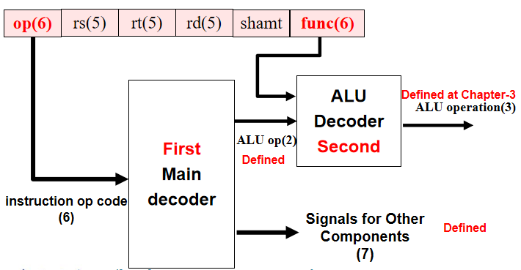 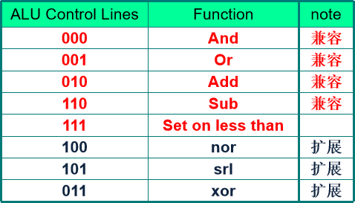

Figure 5 - Decoder Organization Table 3 - ALU Control Signal Values

ALU_Control signals are broken down from ALU_OP, bnegate signal and the instruction funct field, as follows.

Table 4 - ALU Signals and Funct Fields

|  |  |  |  |  |  |
| --- | --- | --- | --- | --- | --- |
| Opcode | ALU_OP | Instruction Operation | Funct | ALU_Control | ALU Operation |
| LW  100011 | 00 | Load word | XXXXXX | 010 | Add |
| SW  101011 | 00 | Store word | XXXXXX | 010 | Add |
| BEQ  000100 | 01 | Branch equal | XXXXXX | 110 | Subtract |
| R-type  000000 | 10 | Add | 100000 | 010 | Add |
| R-type  000000 | 10 | Subtract | 100010 | 110 | Subtract |
| R-type  000000 | 10 | And | 100100 | 000 | And |
| R-type  000000 | 10 | Or | 100101 | 001 | Or |
| R-type  000000 | 10 | Set on less than | 101010 | 111 | SLT |
| J-type  000010 | XX | Jump | N/A | N/A | N/A |

*The J-type instructions do not use the controller.

* **Datapath Operations: R-type Instructions**

|  |  |  |  |  |  |  |  |  |  |  |
| --- | --- | --- | --- | --- | --- | --- | --- | --- | --- | --- |
| OP | RegDst | ALUSrc | MemtoReg | RegWrite | MemRead | MemWrite | Branch | Jump | ALUOp1 | ALUOp0 |
| R | 1 | 0 | 0 | 1 | 0 | 0 | 0 | 0 | 1 | 0 |

Instruction address is first fetched from the PC, and the PC is simultaneously incremented to the next one. The address is used to retrieve the instruction from the instruction memory, where it is then decoded by the main control unit. At the same time, the instruction fields are read and registers rs and rt are accessed. The control unit tells the register file that rd will be used as the destination, with the RegDst signal. ALU detects that rs is one of its inputs, and ALUSrc tells the connecting MUX that it should take rt as the second input. The ALU control unit takes the funct field and ALUOp to determine what operation the ALU needs to perform, and after execution the result gets routed to a MUX and eventually to the input port of the register. The MemtoReg signal tells the MUX to send ALU_Out to the register file, and RegWrite signals that a register needs to be written into.

* **Datapath Operations: Memory Access Instructions**

|  |  |  |  |  |  |  |  |  |  |  |
| --- | --- | --- | --- | --- | --- | --- | --- | --- | --- | --- |
| OP | RegDst | ALUSrc | MemtoReg | RegWrite | MemRead | MemWrite | Branch | Jump | ALUOp1 | ALUOp0 |
| Lw | 0 | 1 | 1 | 1 | 1 | 0 | 0 | 0 | 0 | 0 |
| Sw | X | 1 | X | 0 | 0 | 1 | 0 | 0 | 0 | 0 |

Instruction address is first fetched from the PC, and the PC is simultaneously incremented to the next one. The address is used to retrieve the instruction from the instruction memory, where it is then decoded by the main control unit. At the same time, the instruction fields are read and register rs is accessed.

For the lw instruction, rt is set as destination register since RegDst is deasserted. ALUSrc is asserted to use the sign-extended offset as the B input for the ALU. ALUOp instructs the ALU to compute the sum of the offset and rs and sends ALU_out (memory address) to the data memory. ALU_out contains the address of the data memory, and this is used to retrieve the data and route it to the register file, with the assertion of the MemRead, MemtoReg and RegWrite signals.

No register is written to for the sw instruction, so RegDst is omitted. ALUOp instructs the ALU to compute the sum of the offset and rs and sends ALU_out out (memory address) to the data memory. We are only writing to memory and not reading it, so only the MemWrite signal is asserted. Nothing is written to the register file, so MemtoReg is omitted.

* **Datapath Operations: Branch Instructions**

|  |  |  |  |  |  |  |  |  |  |  |
| --- | --- | --- | --- | --- | --- | --- | --- | --- | --- | --- |
| OP | RegDst | ALUSrc | MemtoReg | RegWrite | MemRead | MemWrite | Branch | Jump | ALUOp1 | ALUOp0 |
| Beq | X | 0 | X | 0 | 0 | 0 | 1 | 0 | 0 | 1 |

Instruction address is first fetched from the PC, and the PC is simultaneously incremented to the next one. The address is used to retrieve the instruction from the instruction memory, where it is then decoded by the main control unit. No destination register is used, so RegDst is omitted. Registers rs and rt are taken as inputs A and B for the ALU, as determined by the ALUSrc signal. The address offset goes through the 32-bit sign extender, and an adder computes the sum of the branch address. ALUOp tells the ALU to subtract A from B and asserts the zero signal if A – B = 0. This indicates that the condition is met, and coupled with the Branch signal, it tells the PC to update its value with the new branch address. Memory and registers are not written to.

* **Datapath Operations: J-Type Instructions**

|  |  |  |  |  |  |  |  |  |  |  |
| --- | --- | --- | --- | --- | --- | --- | --- | --- | --- | --- |
| OP | RegDst | ALUSrc | MemtoReg | RegWrite | MemRead | MemWrite | Branch | Jump | ALUOp1 | ALUOp0 |
| J | X | X | X | 0 | 0 | 0 | 0 | 1 | X | X |

Instruction address is first fetched from the PC, and the PC is simultaneously incremented to the next one. The address is used to retrieve the instruction from the instruction memory, where it is then decoded by the main control unit. For J-type instructions, only the opcode portion is decoded. Registers and memory are not read nor written to, so those respective signals are either deasserted or omitted. ALUOp is also omitted, since the ALU is not used. The adder computes the sum of the target address with the provided 26-bit offset from the instructions. When Jump is asserted, it overwrites the PC with the target address to go to.

1. **Equipment**

Instruments:

1. Computer with Xilinx ISE 14.7 1 unit

2. SWORD Experimental Box 1 unit

1. **Methods and Procedures**
2. Construct the top-level of the single-cycle CPU with a schematic, using the courseware provided.

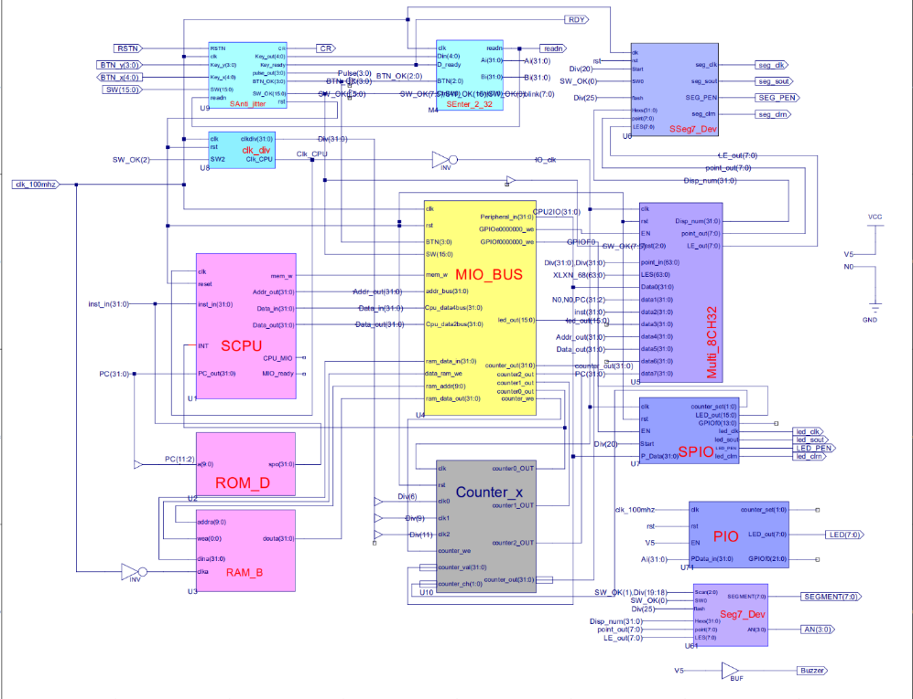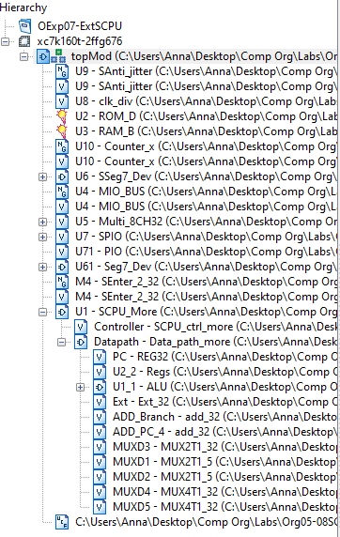

Figure 6 - topMod.sch Figure 7 - SCPU file hierarchy

1. SSeg7_Dev, and Seg7_Dev are the seven-segment displays for the SWORD board. They were constructed in the earlier labs (1-4).

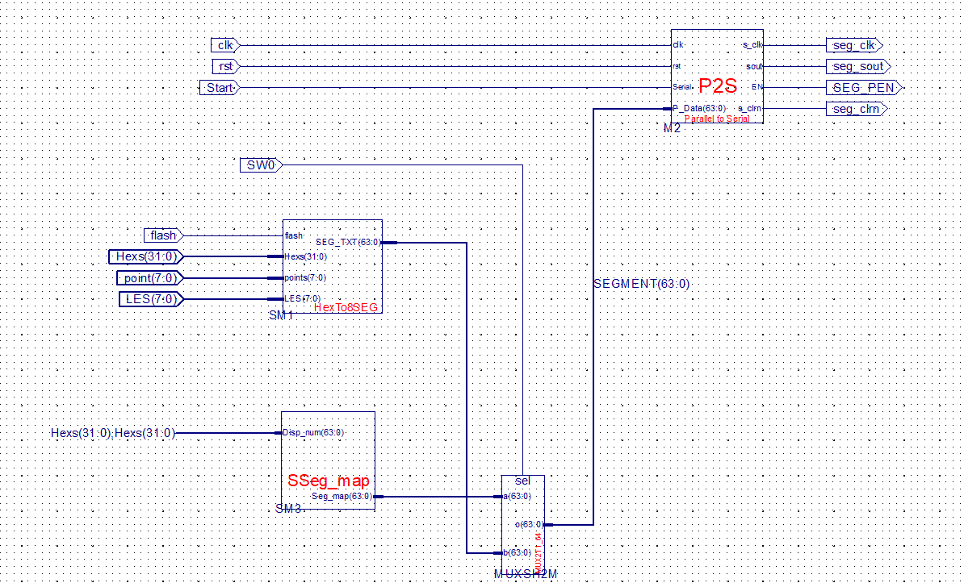

Figure 8 - SSeg7_Dev.sch

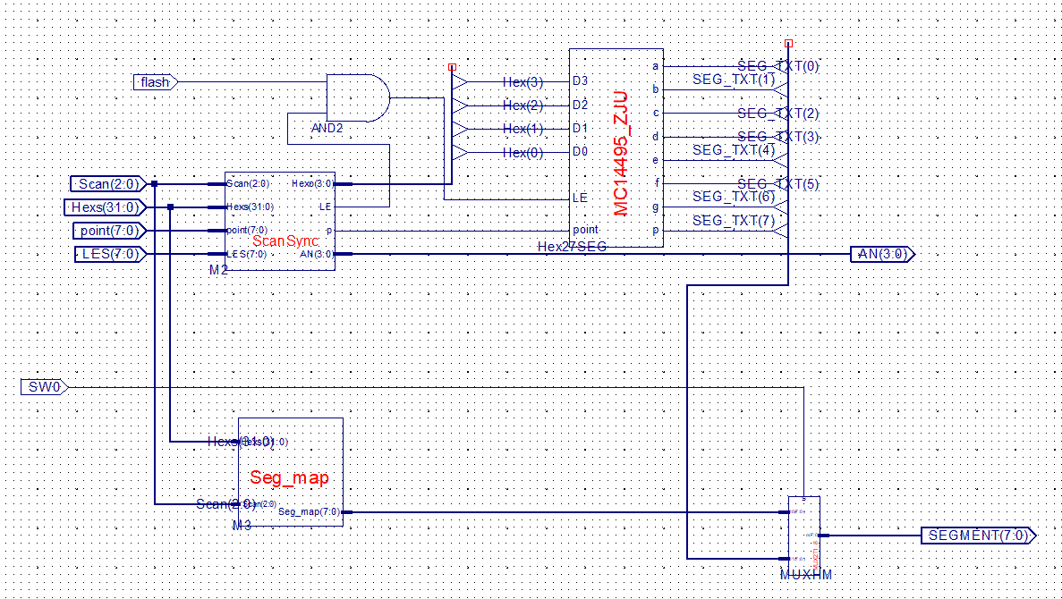

Figure 9- Seg7_Dev.sch

1. Other than SCPU_More, the rest of the modules can be directly added as a source and linked to the top-level.
2. Construct the top-level of the CPU with its main two components – the datapath and the controller. Link the components and set the I/Os accordingly as illustrated.

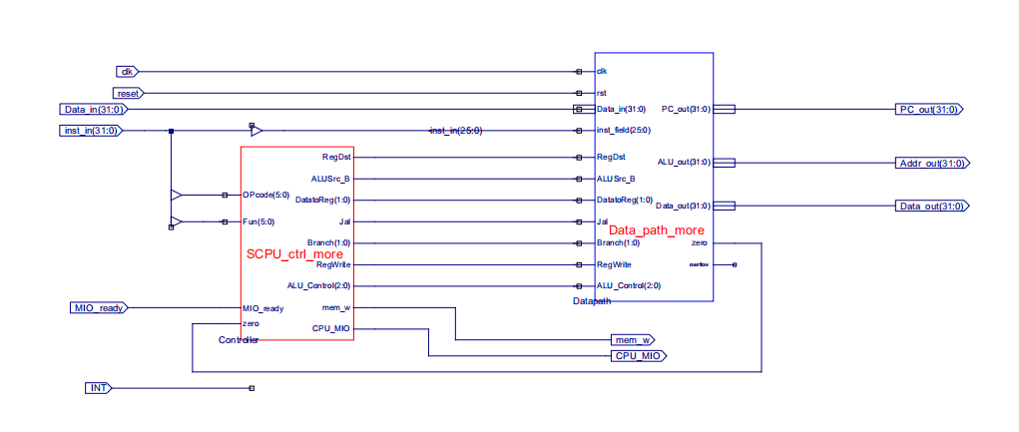

Figure 10 - SCPU.sch

1. Start by constructing the schematic for the datapath. Note the different control signals and components that were discussed in section two. Datapath design begun in lab 4 and was steadily improved to support more instructions.

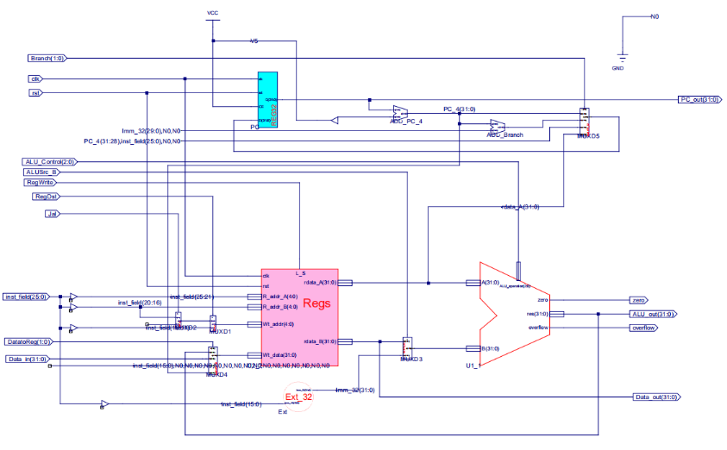

Figure 11 - Data_path_more.sch

1. Design the ALU using a schematic. This step was completed in lab 4.

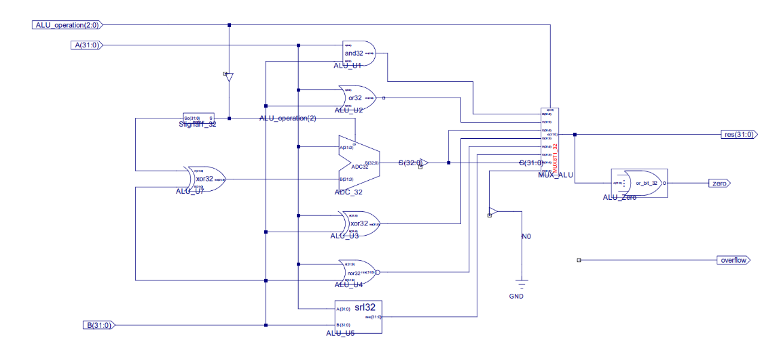

Figure 12 - ALU.sch

1. Implement the register file using Verilog. This was also taken from lab 4 and was provided in the courseware.

*Regs.v*

module Regs(input clk, rst, L_S,

input [4:0] R_addr_A, R_addr_B, Wt_addr,

input [31:0] Wt_data,

output [31:0] rdata_A, rdata_B

);

reg [31:0] register [1:31]; // r1 - r31

integer i;

assign rdata_A = (R_addr_A == 0) ? 0 : register[R_addr_A]; // readassign rdata_B = (R_addr_B == 0) ? 0 : register[R_addr_B]; // read

always @(posedge clk or posedge rst) begin

if (rst == 1) begin

for (i=1; i<32; i=i+1) begin

register[i] <= 0; // reset

end

end else if ((Wt_addr != 0) && (L_S == 1)) begin

register[Wt_addr] <= Wt_data; // write

end

end

endmodule

1. Implement the program counter (PC). This is just a 32-bit register, that holds the address value. This was also taken from lab 4 and was provided in the courseware.

*REG32.v*

module REG32( input clk, rst, CE, [31:0] D,

output reg[31:0] Q

);

always @(posedge clk or posedge rst) begin

if (rst==1) Q <= 32'h00000000;

else if (CE) Q <= D;

end

endmodule

1. Implement the adders for branch addresses and PC incrementing. These are just 32-bit adders that take in two 32-bit inputs and produce a 32-bit sum as an output. This was also taken from lab 4 and was provided in the courseware.

*add_32.v*

module add_32(input [31:0] a,

input [31:0] b,

output [31:0]c

);

assign c=a+b;

endmodule

1. Implement the five multiplexers. For the SCPU, we will need one 32-bit 2-1 MUX, two 5-bit 2-1 MUX, and two 32-bit 4-1 MUX. These select the input for the unit, and more detail about their implementation can be found in section 2.
2. Implement the 32-bit signal extender. This was also taken from lab 4 and was provided in the courseware.

*Ext_32.v*

module Ext_32(input [15:0] imm_16,

output[31:0] Imm_32

);

assign Imm_32 = {{16{imm_16[15]}},imm_16};

endmodule

1. Implement the controller using Verilog. This was completed in lab 7.

*SCPU_ctrl_more.v*

module SCPU_ctrl_more(

input[5:0]OPcode, //Opcode

input[5:0]Fun, //Function

input MIO_ready, //CPU Wait

input zero,

output reg RegDst,

output reg ALUSrc_B,

output reg [1:0]DatatoReg,

output reg Jal,

output reg [1:0]Branch,

output reg RegWrite,

output reg [2:0]ALU_Control,

output reg mem_w,

output reg CPU_MIO

);

`define CPU_ctrl_signals {RegDst,ALUSrc_B,DatatoReg,Jal,Branch,RegWrite,ALU_Control,mem_w,CPU_MIO}

always @* begin

case(OPcode)

6'b000000: begin

case(Fun)

6'b100000: `CPU_ctrl_signals = 13'b1000000101000; //add

6'b100010: `CPU_ctrl_signals = 13'b1000000111000; //sub

6'b100100: `CPU_ctrl_signals = 13'b1000000100000; //and

6'b100101: `CPU_ctrl_signals = 13'b1000000100100; //or

6'b100110: `CPU_ctrl_signals = 13'b1000000101100; //xor

6'b100111: `CPU_ctrl_signals = 13'b1000000110000; //nor

6'b101010: `CPU_ctrl_signals = 13'b1000000111100; //slt

6'b000010: `CPU_ctrl_signals = 13'b1100000110100; //srl

6'b001000: `CPU_ctrl_signals = 13'b1000011000000; //jr

6'b001001: `CPU_ctrl_signals = 13'b1011111100000; //jalr

endcase

end

6'b100011: begin `CPU_ctrl_signals = 13'b0101000101000; end //load

6'b101011: begin `CPU_ctrl_signals = 13'b0101000001010; end //store

6'b000100: begin

if (zero == 1'b1) `CPU_ctrl_signals = 13'b0000001011000; //beq

else `CPU_ctrl_signals = 13'b0000000011000;

end

6'b000101: begin

if (zero == 1'b0) `CPU_ctrl_signals = 13'b0000000011000; //bne

else `CPU_ctrl_signals = 13'b0000001011000;

end

6'b000010: begin `CPU_ctrl_signals = 13'b0000010000000; end //jump

6'b001010: begin `CPU_ctrl_signals = 13'b0100000111100; end //slti

6'b001110: begin `CPU_ctrl_signals = 13'b0100000101100; end //xori

6'b000011: begin `CPU_ctrl_signals = 13'b0011110100000; end //jal

default: begin `CPU_ctrl_signals = 13'b0000000000000; end

endcase

end

endmodule

1. Implement ROM_D and RAM_B by generating an IP Core. Load the .coe file provided by the courseware.
2. Attach the provided .ucf file to the top module.
3. Simulate the register file, ALU, datapath, controller, and seven-segment displays.
4. Generate the programmable file (.bit) by synthesizing and implementing the top module design.

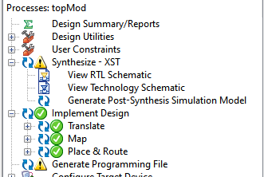 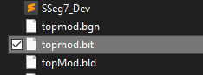

Figure 3 - Successfully generated programming file Figure 4 - .bit file generated

1. Implement .bit file onto the SWORD board and observe results.
2. **Experimental Results and Data Analysis**

Due to the given circumstances of this semester, we were unable to verify the function of these labs and implement it onto the SWORD board. Observations and photos will be omitted. A total of five components in the single-cycle CPU were simulated – ALU, datapath, controller, register file and 7-segment display.

* ALU

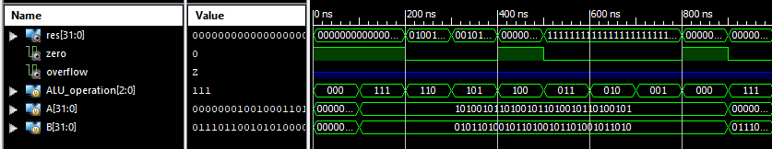

Figure 5 – ALU simulation

The ALU unit was simulated by setting two arbitrary input values for A and B, and changing the opcodes to toggle the different operations. ALU operations slt, sub, srl, nor, xor, add, or and logical and were simulated. Consistent results were produced in the res output. The Verilog module for this simulation was provided in the courseware.

*aluSim.v*

`timescale 1ns / 1ps

module ALU_ALU_sch_tb();

// Inputs

reg [2:0] ALU_operation;

reg [31:0] A;

reg [31:0] B;

// Output

wire [31:0] res;

wire zero;

wire overflow;

// Bidirs

// Instantiate the UUT

ALU UUT (

.ALU_operation(ALU_operation),

.res(res),

.zero(zero),

.overflow(overflow),

.A(A),

.B(B)

);

// Initialize Inputs

initial begin

A = 0;

B = 0;

ALU_operation = 0;

#100;

// Wait 100 ns for global reset to finish

// Add stimulus here

A=32'hA5A5A5A5;

B=32'h5A5A5A5A;

ALU_operation =3'b111; //slt

#100;

ALU_operation =3'b110; //sub

#100;

ALU_operation =3'b101; //srl

#100;

ALU_operation =3'b100; //nor

#100;

ALU_operation =3'b011; //xor

#100;

ALU_operation =3'b010; //add

#100;

ALU_operation =3'b001; //or

#100;

ALU_operation =3'b000; //and

#100;

A=32'h01234567;

B=32'h76543210;

ALU_operation =3'b111; //slt

end

* Datapath

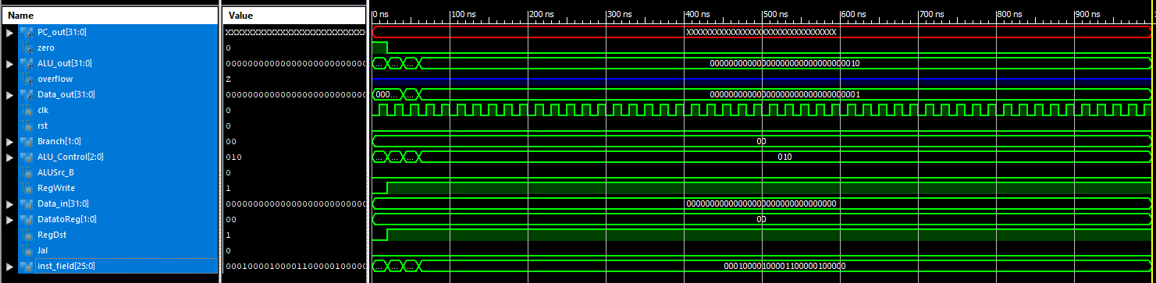

Figure 16- SCPU datapath simulation

The datapath was simulated by providing an instruction (without the opcode) for it to be processed. A simple simulation was done, where two R-type instructions (nor and slt) and beq is tested. The register fields (last 26 bits of an instruction) are provided, and the control signals are manually put into the testing module. Consistent results were produced.

*datapath_moreSim.v*

`timescale 1ns / 1ps

module Data_path_more_Data_path_more_sch_tb();

// Inputs

reg clk;

reg rst;

reg [1:0] Branch;

reg [2:0] ALU_Control;

reg ALUSrc_B;

reg RegWrite;

reg [31:0] Data_in;

reg [1:0] DatatoReg;

reg RegDst;

reg Jal;

reg [25:0] inst_field;

// Output

wire [31:0] PC_out;

wire zero;

wire [31:0] ALU_out;

wire overflow;

wire [31:0] Data_out;

// Bidirs

// Instantiate the UUT

Data_path_more UUT (

.PC_out(PC_out),

.clk(clk),

.rst(rst),

.Branch(Branch),

.ALU_Control(ALU_Control),

.zero(zero),

.ALU_out(ALU_out),

.overflow(overflow),

.Data_out(Data_out),

.ALUSrc_B(ALUSrc_B),

.RegWrite(RegWrite),

.Data_in(Data_in),

.DatatoReg(DatatoReg),

.RegDst(RegDst),

.Jal(Jal),

.inst_field(inst_field)

);

// Initialize Inputs

initial begin

clk = 0;

rst = 0;

Branch = 0;

ALU_Control = 0;

ALUSrc_B = 0;

RegWrite = 0;

Data_in = 0;

DatatoReg = 0;

RegDst = 0;

Jal = 0;

inst_field = 0;

#20

rst = 0;

ALU_Control = 3'b100;

RegWrite = 1;

RegDst = 1;

inst_field = 26'b00000_00000_00001_00000_100111;

#20;

ALU_Control = 3'b111;

inst_field = 26'b00000_00001_00010_00000_101010;

#20;

Branch = 0;

ALU_Control = 3'b010;

ALUSrc_B = 0;

RegWrite = 1;

RegDst = 1;

inst_field = 26'b00010_00010_00011_00000_100000;

#20;

end

always begin

clk=0;#10;

clk=1;#10;

end

endmodule

* Controller

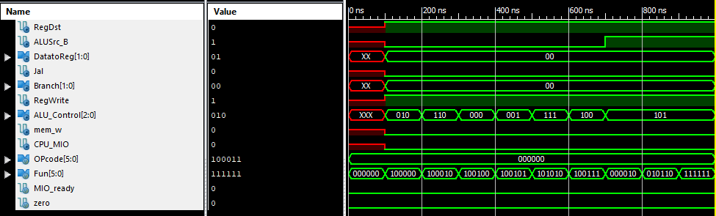

Figure 17 - SCPU controller simulation

The Fun input is the funct field of a R-type instruction, and it aids in determining the ALU operation to be used. The OPcode input is as the name suggests. All the supported ALU operations are simulated. Consistent results were produced. The Verilog module for this simulation was provided in the courseware.

*SCPU_ctrl_moreSim.v*

module SCPU_ctrl_moreSim;

// Inputs

reg [5:0] OPcode;

reg [5:0] Fun;

reg MIO_ready;

reg zero;

// Outputs

wire RegDst;

wire ALUSrc_B;

wire [1:0] DatatoReg;

wire Jal;

wire [1:0] Branch;

wire RegWrite;

wire [2:0] ALU_Control;

wire mem_w;

wire CPU_MIO;

// Instantiate the Unit Under Test (UUT)

SCPU_ctrl_more uut (

.OPcode(OPcode),

.Fun(Fun),

.MIO_ready(MIO_ready),

.zero(zero),

.RegDst(RegDst),

.ALUSrc_B(ALUSrc_B),

.DatatoReg(DatatoReg),

.Jal(Jal),

.Branch(Branch),

.RegWrite(RegWrite),

.ALU_Control(ALU_Control),

.mem_w(mem_w),

.CPU_MIO(CPU_MIO)

);

initial begin

// Initialize Inputs

OPcode = 0;

Fun = 0;

MIO_ready = 0;

zero = 0;

// Wait 100 ns for global reset to finish

#100;

// Add stimulus here

OPcode = 6'b000000; //ALU??,?? ALUop=2'b10; RegDst=1; RegWrite=1

Fun = 6'b100000; //add,??ALU_Control=3'b010

#100;

Fun = 6'b100010; //sub,??ALU_Control=3'b110

#100;

Fun = 6'b100100; //and,??ALU_Control=3'b000

#100;

Fun = 6'b100101; //or,??ALU_Control=3'b001

#100;

Fun = 6'b101010; //slt,??ALU_Control=3'b111

#100;

Fun = 6'b100111; //nor,??ALU_Control=3'b100

#100;

Fun = 6'b000010; //srl,??ALU_Control=3'b101

#100;

Fun = 6'b010110; //xor,??ALU_Control=3'b011

#100;

Fun = 6'b111111; //??

#100;

OPcode = 6'b100011;//load??,?? ALUop=2'b00, RegDst=0,

#100; // ALUSrc_B=1, MemtoReg=1, RegWrite=1

OPcode = 6'b101011;

#100; //store??,??ALUop=2'b00, mem_w=1, ALUSrc_B=1

OPcode = 6'b000100;//beq??,?? ALUop=2'b01, Branch=1

#100;

OPcode = 6'b000010;//jump??,?? Jump=1

#100;

OPcode = 6'h3f; //??

Fun = 6'b000000; //??

end

endmodule

* Register File

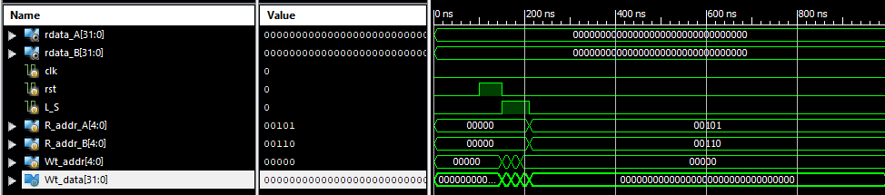

Figure 6 - SCPU Regs simulation

The register file is tested by asserting and deasserting the RegWrite signal, and providing random parameters to all four of its input ports. Either it is given two operand values, or a value and register address to write to.

*regSim.v*

module regsSim;

// Inputs

reg clk;

reg rst;

reg L_S;

reg [4:0] R_addr_A;

reg [4:0] R_addr_B;

reg [4:0] Wt_addr;

reg [31:0] Wt_data;

// Outputs

wire [31:0] rdata_A;

wire [31:0] rdata_B;

// Instantiate the Unit Under Test (UUT)

Regs uut (

.clk(clk),

.rst(rst),

.L_S(L_S),

.R_addr_A(R_addr_A),

.R_addr_B(R_addr_B),

.Wt_addr(Wt_addr),

.Wt_data(Wt_data),

.rdata_A(rdata_A),

.rdata_B(rdata_B)

);

initial begin

// Initialize Inputs

clk = 0;

rst = 0;

L_S = 0;

R_addr_A = 0;

R_addr_B = 0;

Wt_addr = 0;

Wt_data = 0;

// Wait 100 ns for global reset to finish

#100;

// Add stimulus here

rst = 1;

#50;

rst = 0;

L_S = 1;

R_addr_A = 0;

R_addr_B = 0;

Wt_addr = 5;

Wt_data = 32'hA5A5A5A5;

#20;

L_S = 1;

R_addr_A = 0;

R_addr_B = 0;

Wt_addr = 6;

Wt_data = 32'h55AA55AA;

#20;

L_S = 1;

R_addr_A = 0;

R_addr_B = 0;

Wt_addr = 0;

Wt_data = 32'hAAAA5555;

#20;

L_S = 0;

R_addr_A = 5;

R_addr_B = 6;

Wt_addr = 0;

Wt_data = 0;

#20;

end

endmodule

* 7-Segment Display

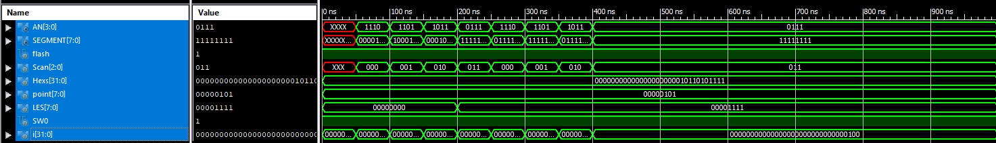

Figure 7 - Seg7Dev simulation

The 7-segment display was simulated back in lab 2. The basic task of this simulation was to traverse each segment of the display. Consistent results were produced.

*Seg7Dev_Sim.v*

`timescale 1ns / 1ps

module Seg7_Dev_Seg7_Dev_sch_tb();

// Inputs

reg flash;

reg [2:0] Scan;

reg [31:0] Hexs;

reg [7:0] point;

reg [7:0] LES;

reg SW0;

// Output

wire [3:0] AN;

wire [7:0] SEGMENT;

// Bidirs

// Instantiate the UUT

Seg7_Dev UUT (

.flash(flash),

.Scan(Scan),

.Hexs(Hexs),

.point(point),

.LES(LES),

.AN(AN),

.SEGMENT(SEGMENT),

.SW0(SW0)

);

// Initialize Inputs

`ifdef auto_init

initial begin

flash = 0;

Scan = 0;

Hexs = 0;

point = 0;

LES = 0;

SW0 = 0;

`endif

integer i;

initial begin

Hexs = 16'h05AF;

point = 4'b0101;

LES = 4'b0000;

SW0 = 1;

flash = 1;

for(i = 0; i < 4; i = i + 1) begin

#50;

Scan = i;

end

LES = 4'b1111;

for(i = 0; i < 4; i = i + 1) begin

#50;

Scan = i;

end

end

endmodule

1. **Discussion and Conclusion**

The multi-level decoding scheme has the advantage of reduced hardware cost (several smaller units instead of one big decoder) and improves the performance of the controller. Having a separate decoder for the ALU may be a hardware disadvantage as well though, with the fact that another functional unit needs to be managed. The BNE instruction has different signals than the BEQ instruction because the branch is taken in the event of an inequality. Thus, ALUop = 11 and ALU_Operation = 110. Regarding andi and other I-type instructions, this can be easily implemented with 16-bit to 32-bit sign-extenders and routed to the B port of the ALU via multiplexer. Support for other instructions can be done by extending the controller’s function by adding in extra cases for the decoder. Single-cycle CPU is not very efficient and generates a lot of potentially wasted clock cycles. Compared to multi-cycle CPU, it takes more time and hardware and it enforces a single clock cycle length to be used.

This marks the conclusion of the single-cycle CPU design labs of the Computer Organization course! Although I am disappointed that I am unable to first-hand experience these labs in person, I still found it to be very rewarding. I am also disappointed that I am unable to run demo MIPS program using this CPU, and this makes the whole lab experience seem incomplete. Doing these labs were not a complete lost though, because it greatly supplemented the material that I learned in the theoretical portion of this course. It helped me better understand how control signals played a role in instruction execution, and how instructions were processed throughout each component. Overall, it made learning about the CPU a whole lot easier and I immensely enjoyed doing these labs. These labs have helped me gain confidence with writing testing modules and interpreting simulation results. From this, I had an easier time debugging and it was a way to keep reiterating information. I really liked how these labs were structured because it progressively built up my knowledge by implementing the top module first, then designing each of the components separately.