

**本科实验报告**

|  |  |
| --- | --- |
| 课程名称： | 计算机组成 |
| 姓 名： | TANG ANNA YONGQI |
| 学 院： | 计算机科学与技术学院 |
| 专 业： | 计算机科学与技术（中加班）留学生 |
| 学 号： | 3180300155 |
| 生活照： |  |
| 指导教师： | 刘海风，洪奇军 |

2020年 3月 6日

Lab 2 – 7-Segment Display Module

**Name:** Anna Yongqi Tang **ID:** 3180300155 **Major:** 计算机科学与技术（中加班）留学生

**Course:** Computer Organization

**Date:** 2020-03-06 **Instructor:** 洪奇军

1. **Method and Experimental Steps**

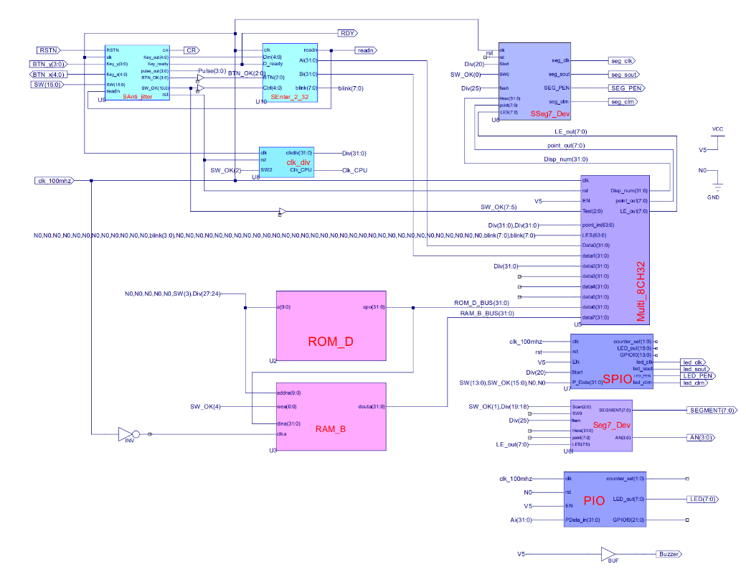

Figure 1 - top.sch

This depicts the completion of lab 2. Lab 2 was a reiteration of lab 1, but with improvements to the SSeg7_Dev module, Seg7_Dev module and the SPIO module. The ucf for this program came from the courseware and is linked to the top module of this project. Synthesis had minimal warnings, and implementation was successful. A programmable file has been generated and is ready for testing.



Figure - TANGANNAYONGQI3180300155_02

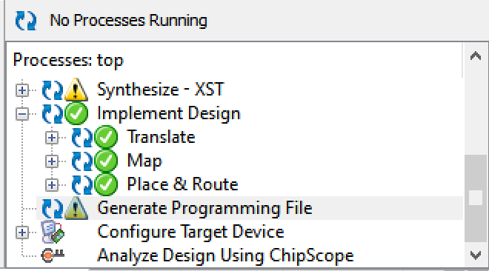 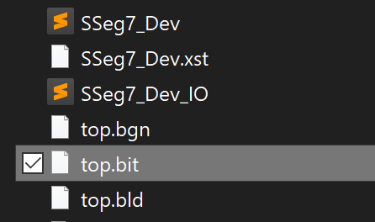

Figure 3 - .bit file generation Figure 4 - .bit file found in direction

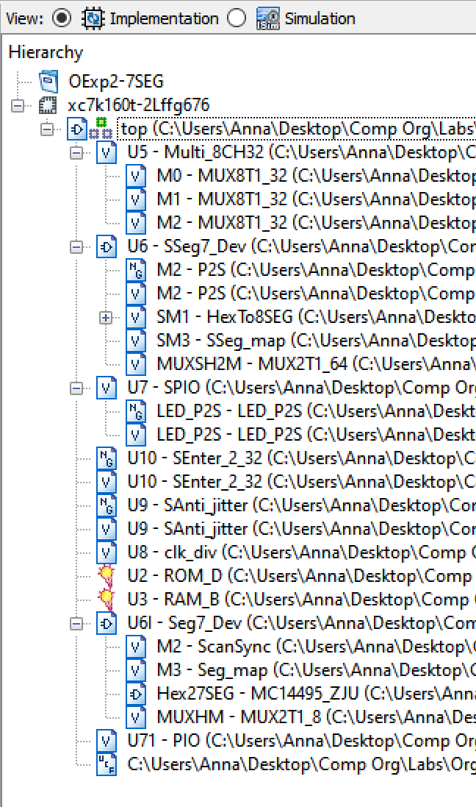

Figure 5 - file hierarchy

Most of the modules and the .ucf file that were used for this lab came from lab 1. Source code for the modules that have not been updated can be found in the lab report for lab 1. Modules that have been changed will be included in this report. Code for submodules can be found at the end of the report.

*SSeg7_Dev (U6)*

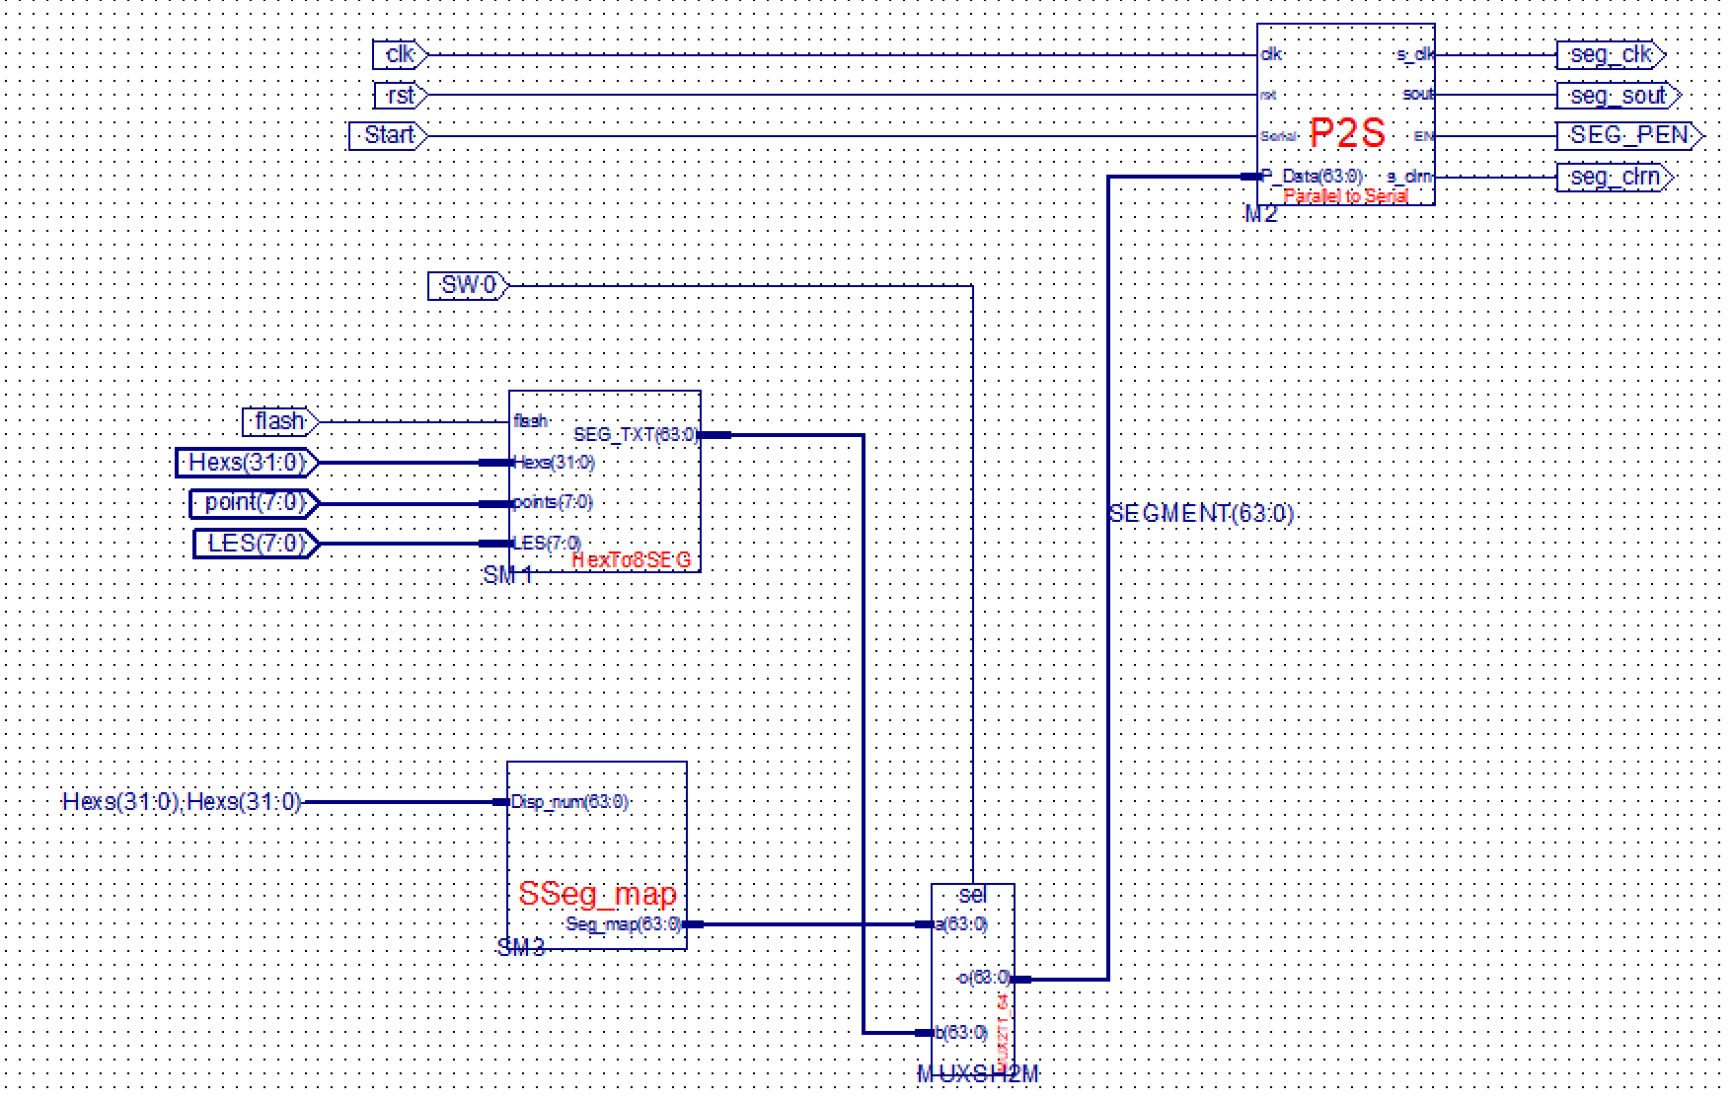

*SPIO Code (U7)*

module SPIO(input clk,

input rst,

input Start,

input EN,

input [31:0] P_Data,

output reg[1:0] counter_set,

output [15:0] LED_out,

output wire led_clk,

output wire led_sout,

output wire led_clrn,

output wire LED_PEN,

output reg[13:0] GPIOf0

);

reg [15:0] LED;

assign LED_out = LED;

always @(negedge clk or posedge rst) begin

if (rst) begin

LED <= 8'h2A;

counter_set <= 2'b00;

end else begin

if (EN) begin

{GPIOf0[13:0], LED, counter_set} <= P_Data;

end else begin

LED <= LED;

counter_set <= counter_set;

end

end

end

LED_P2S LED_P2S(clk, rst, Start,

{~{LED[0], LED[1], LED[2], LED[3], LED[4], LED[5], LED[6], LED[7],

LED[8], LED[9], LED[10], LED[11], LED[12], LED[13], LED[14], LED[15]}},

led_clk,

led_clrn,

led_sout,

LED_PEN

);

endmodule

*Seg7_Dev Code (U6l)*

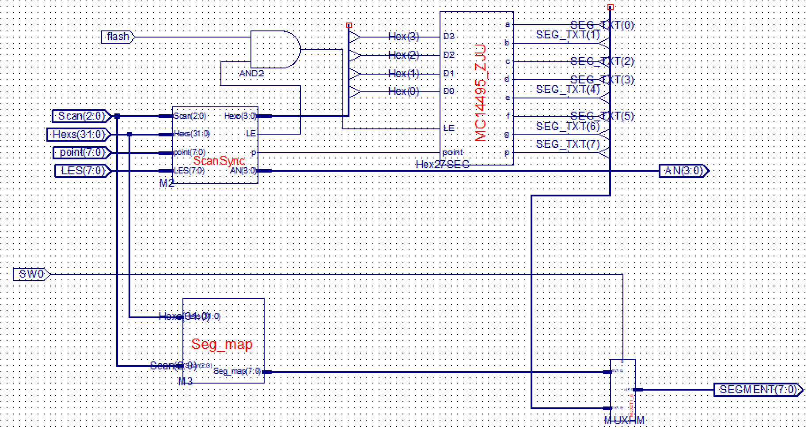

*PIO Code (U7)*

module PIO(input wire clk,

input wire rst,

input wire EN,

input wire[31:0] PData_in,

output reg[1:0] counter_set,

output[7:0] LED_out,

output reg[21:0]GPIOf0

);

reg [7:0] LED;

assign LED_out = LED;

always @(negedge clk or posedge rst) begin

if (rst) begin

LED <= 8'h2A;

counter_set <= 2'b0;

end else begin

if (EN) begin

{GPIOf0, LED, counter_set} <= PData_in;

end else begin

LED <= LED;

counter_set <= counter_set;

end

end

end

endmodule

1. **Simulations and Observations**

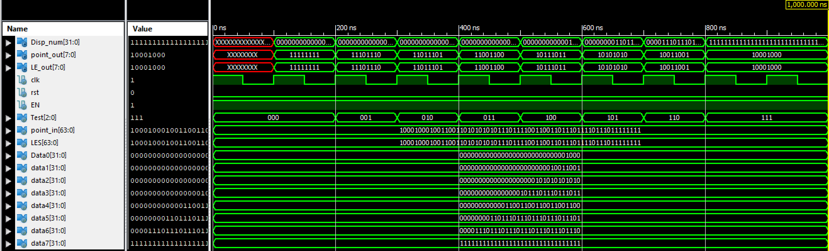

Figure 6 - Multi_CH32 module

I used the same simulation file from lab 1 to simulate this module. As expected, the results are the same and the simulation passed.

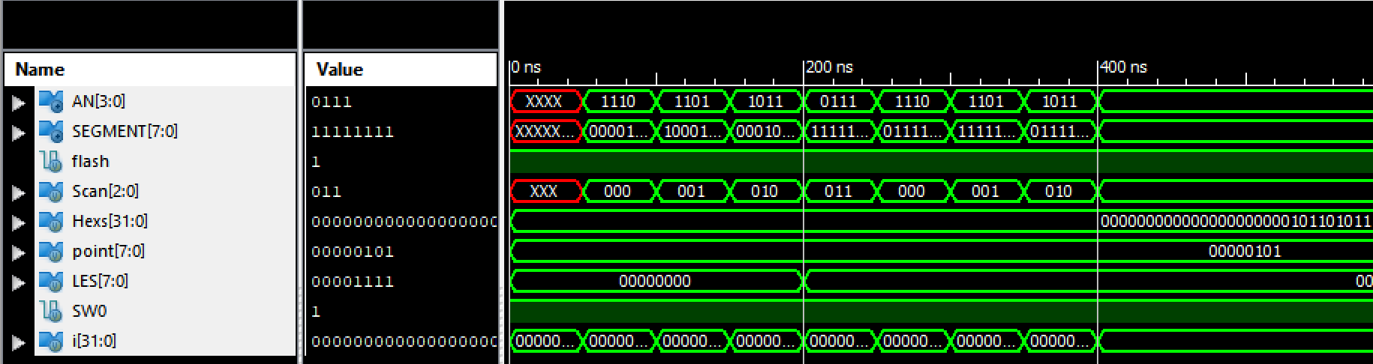

Figure 7 - Seg7_Dev module

The above picture is a simulation of the enhanced seven-segment display module (Seg7_Dev). It is not consistent with the sample provided in the PowerPoint, but it gives the expected results from the programmed parameters.

*Verilog Test Module for Simulation*

module Seg7_Dev_Seg7_Dev_sch_tb();

// Inputs

reg flash;

reg [2:0] Scan;

reg [31:0] Hexs;

reg [7:0] point;

reg [7:0] LES;

reg SW0;

// Output

wire [3:0] AN;

wire [7:0] SEGMENT;

// Bidirs

// Instantiate the UUT

Seg7_Dev UUT (

.flash(flash),

.Scan(Scan),

.Hexs(Hexs),

.point(point),

.LES(LES),

.AN(AN),

.SEGMENT(SEGMENT),

.SW0(SW0)

);

// Initialize Inputs

`ifdef auto_init

initial begin

Scan = 0;

Hexs = 0;

point = 0;

LES = 0;

flash = 0;

SW0 = 0;

`endif

integer i;

initial begin

Hexs = 16'h05AF;

point = 4'b0101;

LES = 4'b0000;

SW0 = 1;

flash = 1;

for(i = 0; i < 4; i = i + 1) begin

#50;

Scan = i;

end

LES = 4'b1111;

for(i = 0; i < 4; i = i + 1) begin

#50;

Scan = i;

end

end

endmodule

1. **Conclusion**

This week’s lab was more confusing than hard, because I struggled to understand the purpose of changing the module’s source files to improve functionality. The information provided in the slides were not helpful and caused much confusion. I still struggle to understand the use of a .ngc file, and what purpose they provide when implemented in a program. Developing a simulation file for the seven-segment display was also not easy, because I did not quite understand what each input was and what role they played. I overcame this difficulty by refreshing what I learned in my Logic course and by playing around with the input parameters. Overall, this was a straightforward lab and I look forward to implementing this onto the SWORD board.

1. **Source Code**

*SSeg7_Dev Code (U6) – P2S (M2)*

module P2S(input wire clk, //parallel to serial

input wire rst,

input wire Serial,

input wire[DATA_BITS-1:0] P_Data,

output reg s_clk,

output wire s_clrn,

output wire sout,

output reg EN

);

DATA_BITS = 64,

DATA_COUNT_BITS = 6;

endmodule

*SSeg7_Dev Code (U6) – Hex28SEG (SM1)*

module HexTo8SEG(input [31:0] Hexs,

//input [2:0] Scan,

input [7:0] points,

input [7:0] LES,

input flash,

output[63:0] SEG_TXT

);

Hex2Seg M0(.Hex(Hexs[3:0]),

.LE(LES[0] & flash),

.point(points[0]),

.flash(flash),

.Segment(SEG_TXT[63:56])

);

Hex2Seg M1(.Hex(Hexs[7:4]),

.LE(LES[1] & flash),

.point(points[1]),

.flash(flash),

.Segment(SEG_TXT[55:48])

);

Hex2Seg M2(.Hex(Hexs[11:8]),

.LE(LES[2] & flash),

.point(points[2]),

.flash(flash),

.Segment(SEG_TXT[47:40])

);

Hex2Seg M3(.Hex(Hexs[15:12]),

.LE(LES[3] & flash),

.point(points[3]),

.flash(flash),

.Segment(SEG_TXT[39:32])

);

Hex2Seg M4(.Hex(Hexs[19:16]),

.LE(LES[4] & flash),

.point(points[4]),

.flash(flash),

.Segment(SEG_TXT[31:24])

);

Hex2Seg M5(.Hex(Hexs[23:20]),

.LE(LES[5] & flash),

.point(points[5]),

.flash(flash),

.Segment(SEG_TXT[23:16])

);

Hex2Seg M6(.Hex(Hexs[27:24]),

.LE(LES[6] & flash),

.point(points[6]),

.flash(flash),

.Segment(SEG_TXT[15:8])

);

Hex2Seg M7(.Hex(Hexs[31:28]),

.LE(LES[7] & flash),

.point(points[7]),

.flash(flash),

.Segment(SEG_TXT[7:0])

);

endmodule

module Hex2Seg(input[3:0]Hex,

input LE,

input point,

input flash,

output[7:0]Segment

);

MC14495_ZJU MSEG(.D0(Hex[0]),

.D1(Hex[1]),

.D2(Hex[2]),

.D3(Hex[3]),

.LE(LE & flash),

.point(point),

.a(Segment[7]),

.b(Segment[6]),

.c(Segment[5]),

.d(Segment[4]),

.e(Segment[3]),

.f(Segment[2]),

.g(Segment[1]),

.p(Segment[0])

);

//assign Segment = {a,b,c,d,e,f,g,p}; //p,g,f,e,d,c,b,a

endmodule

*SSeg7_Dev Code (U6) – SSeg_map (SM3)*

module SSeg_map(input[63:0]Disp_num,

output[63:0]Seg_map

);

assign Seg_map = {Disp_num[0], Disp_num[4], Disp_num[16], Disp_num[25], Disp_num[17], Disp_num[5], Disp_num[12], Disp_num[24],Disp_num[1], Disp_num[6], Disp_num[18], Disp_num[27], Disp_num[19], Disp_num[7], Disp_num[13], Disp_num[26],Disp_num[2], Disp_num[8], Disp_num[20], Disp_num[29], Disp_num[21], Disp_num[9], Disp_num[14], Disp_num[28],Disp_num[3], Disp_num[10], Disp_num[22], Disp_num[31], Disp_num[23], Disp_num[11], Disp_num[15], Disp_num[30], Disp_num[0], Disp_num[4], Disp_num[16], Disp_num[25], Disp_num[17], Disp_num[5], Disp_num[12], Disp_num[24],Disp _num[1], Disp_num[6], Disp_num[18], Disp_num[27], Disp_num[19], Disp_num[7], Disp_num[13], Disp_num[26], Disp_num[2], Disp_num[8], Disp_num[20], Disp_num[29], Disp_num[21], Disp_num[9], Disp_num[14], Disp_num[28], Disp_num[3], Disp_num[10], Disp_num[22], Disp_num[31], Disp_num[23], Disp_num[11], Disp_num[15], Disp_num[30]};

endmodule

*SSeg7_Dev Code (U6) – MUX2T1_64 (MUXSH2M)*

module MUX2T1_64(input[63:0]a,

input[63:0]b,

input sel,

output[63:0]o

);

assign o = sel? a : b;

endmodule

*SPIO Code (U7) – LED_P2S*

Same as SSeg7_Dev Code (U6) – P2S (M2).

*Seg7_Dev Code (U6l) – ScanSync(M2)*

module ScanSync(Hexs,Scan,point,LES,Hexo,p,LE,AN);

input [31:0] Hexs;

input [2:0] Scan;

input [7:0] point;

input [7:0] LES;

output reg [3:0] Hexo;

output reg p,LE;

output reg [3:0] AN;

always@* begin

case(Scan)

3'b000:begin Hexo<=Hexs[3:0]; AN<=4'b1110; p<=point[0]; LE<=LES[0];end

3'b001:begin Hexo<=Hexs[7:4]; AN<=8'b1101; p<=point[1]; LE<=LES[1];end

3'b010:begin Hexo<=Hexs[11:8]; AN<=8'b1011; p<=point[2]; LE<=LES[2];end

3'b011:begin Hexo<=Hexs[15:12]; AN<=8'b0111; p<=point[3]; LE<=LES[3];end

3'b100:begin Hexo<=Hexs[3:0]; AN<=4'b1110; p<=point[0]; LE<=LES[0];end

3'b101:begin Hexo<=Hexs[7:4]; AN<=8'b1101; p<=point[1]; LE<=LES[1];end

3'b110:begin Hexo<=Hexs[11:8]; AN<=8'b1011; p<=point[2]; LE<=LES[2];end

3'b111:begin Hexo<=Hexs[15:12]; AN<=8'b0111; p<=point[3]; LE<=LES[3];end

endcase

end

endmodule

*Seg7_Dev Code (U6l) – SegMap(M3)*

module Seg_map(Hexs,Scan,Seg_map);

input [31:0] Hexs;

input [2:0] Scan;

output reg[7:0] Seg_map;

always@* begin

case(Scan)

3'b000:Seg_map={Hexs[24],Hexs[12],Hexs[5],Hexs[17],Hexs[25],Hexs[16],Hexs[4],Hexs[0]};

endcase

end

endmodule

*Seg7_Dev Code (U6l) – SegMap(M3)*

module MUX2T1_8(input[7:0]I0,

input[7:0]I1,

input s,

output[7:0]o

);

assign o = s ? I1 : I0;

endmodule

*Testing Constraints File (UCF)*

Please refer to the UCF that was provided in the courseware.