**CIS 285**

**Tanim Ahmed**

**Lab 4**

**09/29/2020**

**Screenshot of review change**

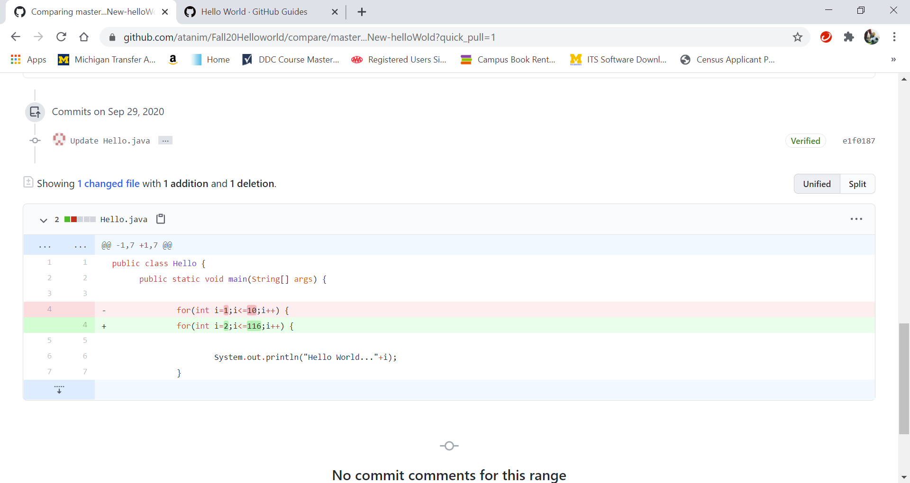

**Screenshot of Merge request page**

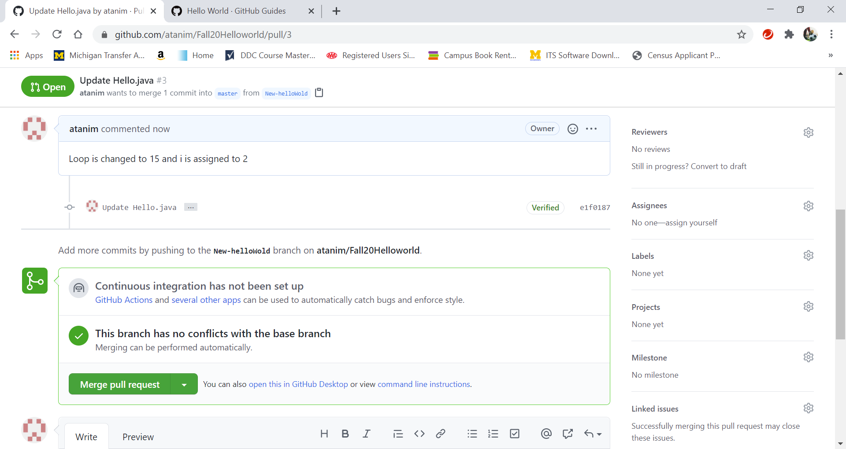

**Screenshot of Jenkins Console Output:**

