**BananaDrone:**

**The Bug-free Buggy**

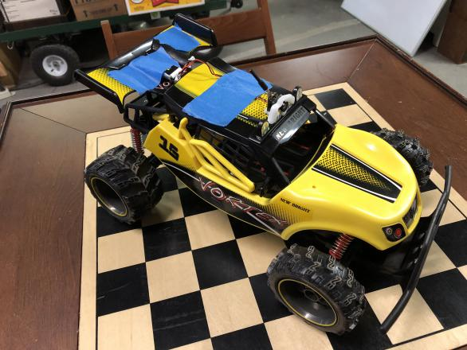 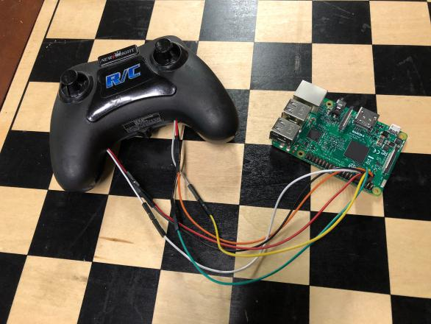

**BananaDrone** is a low-cost autonomous vehicle project by Adam Tannir. The project started in late November 2017 with the purchase of a remote control car on sale. Other components were added to provide first-person views from the vehicle. A Raspberry Pi is configured to control the vehicle using software.

**Hardware:** The car is an off-the-shelf New Bright brand Baja Vortex RC car. This model of car is yellow, hence the name. A drone camera and battery was added to the top of the vehicle. In order to record from the drone camera, a video receiver and EasyCap device are used to provide a video feed to the Raspberry Pi. The EasyCap device appears as a normal video camera to the Linux operating system. Wires were soldered to the remote to provide control and record human-directed driving. An external video receiver is used to drive the car in real time. A series of wires and connectors were soldered together to provide power to both the Pi and the video receiver from a set of three 18650 cells. Battery life under full load should exceed 2.5 hours, greater than most of the other batteries in the system.

**Software:** Python is used to control the hardware pins connected to the remote and therefore control the vehicle. The system can create training data by recording the actions of a human driver. OpenCV is used to capture and save images but will provide more advanced features in the future. Every captured video frame also contains the state of the buttons when it was recorded, thereby creating a compact and portable data set. A multi-layer convolutional neural network (CNN) will take an image from camera or disk and produce a button state as output. The CNN will use Keras and TensorFlow and be trained on a more powerful machine but run in real time on the Raspberry Pi. The network will also respond properly to the loss of power to the transmitter (static) or the receiver (no signal) by stopping the vehicle.

(This project is not yet bug-free.)

**Follow my progress at https://github.com/atannir/autonomous_rc/**

**Special thanks to the members of FUBAR Labs in New Brunswick, NJ**