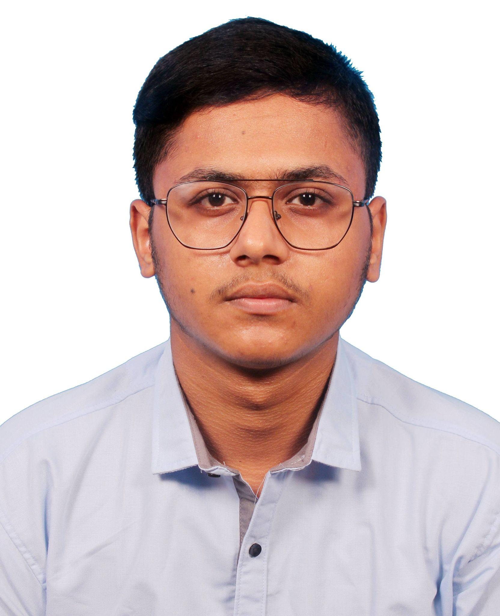**RESUME**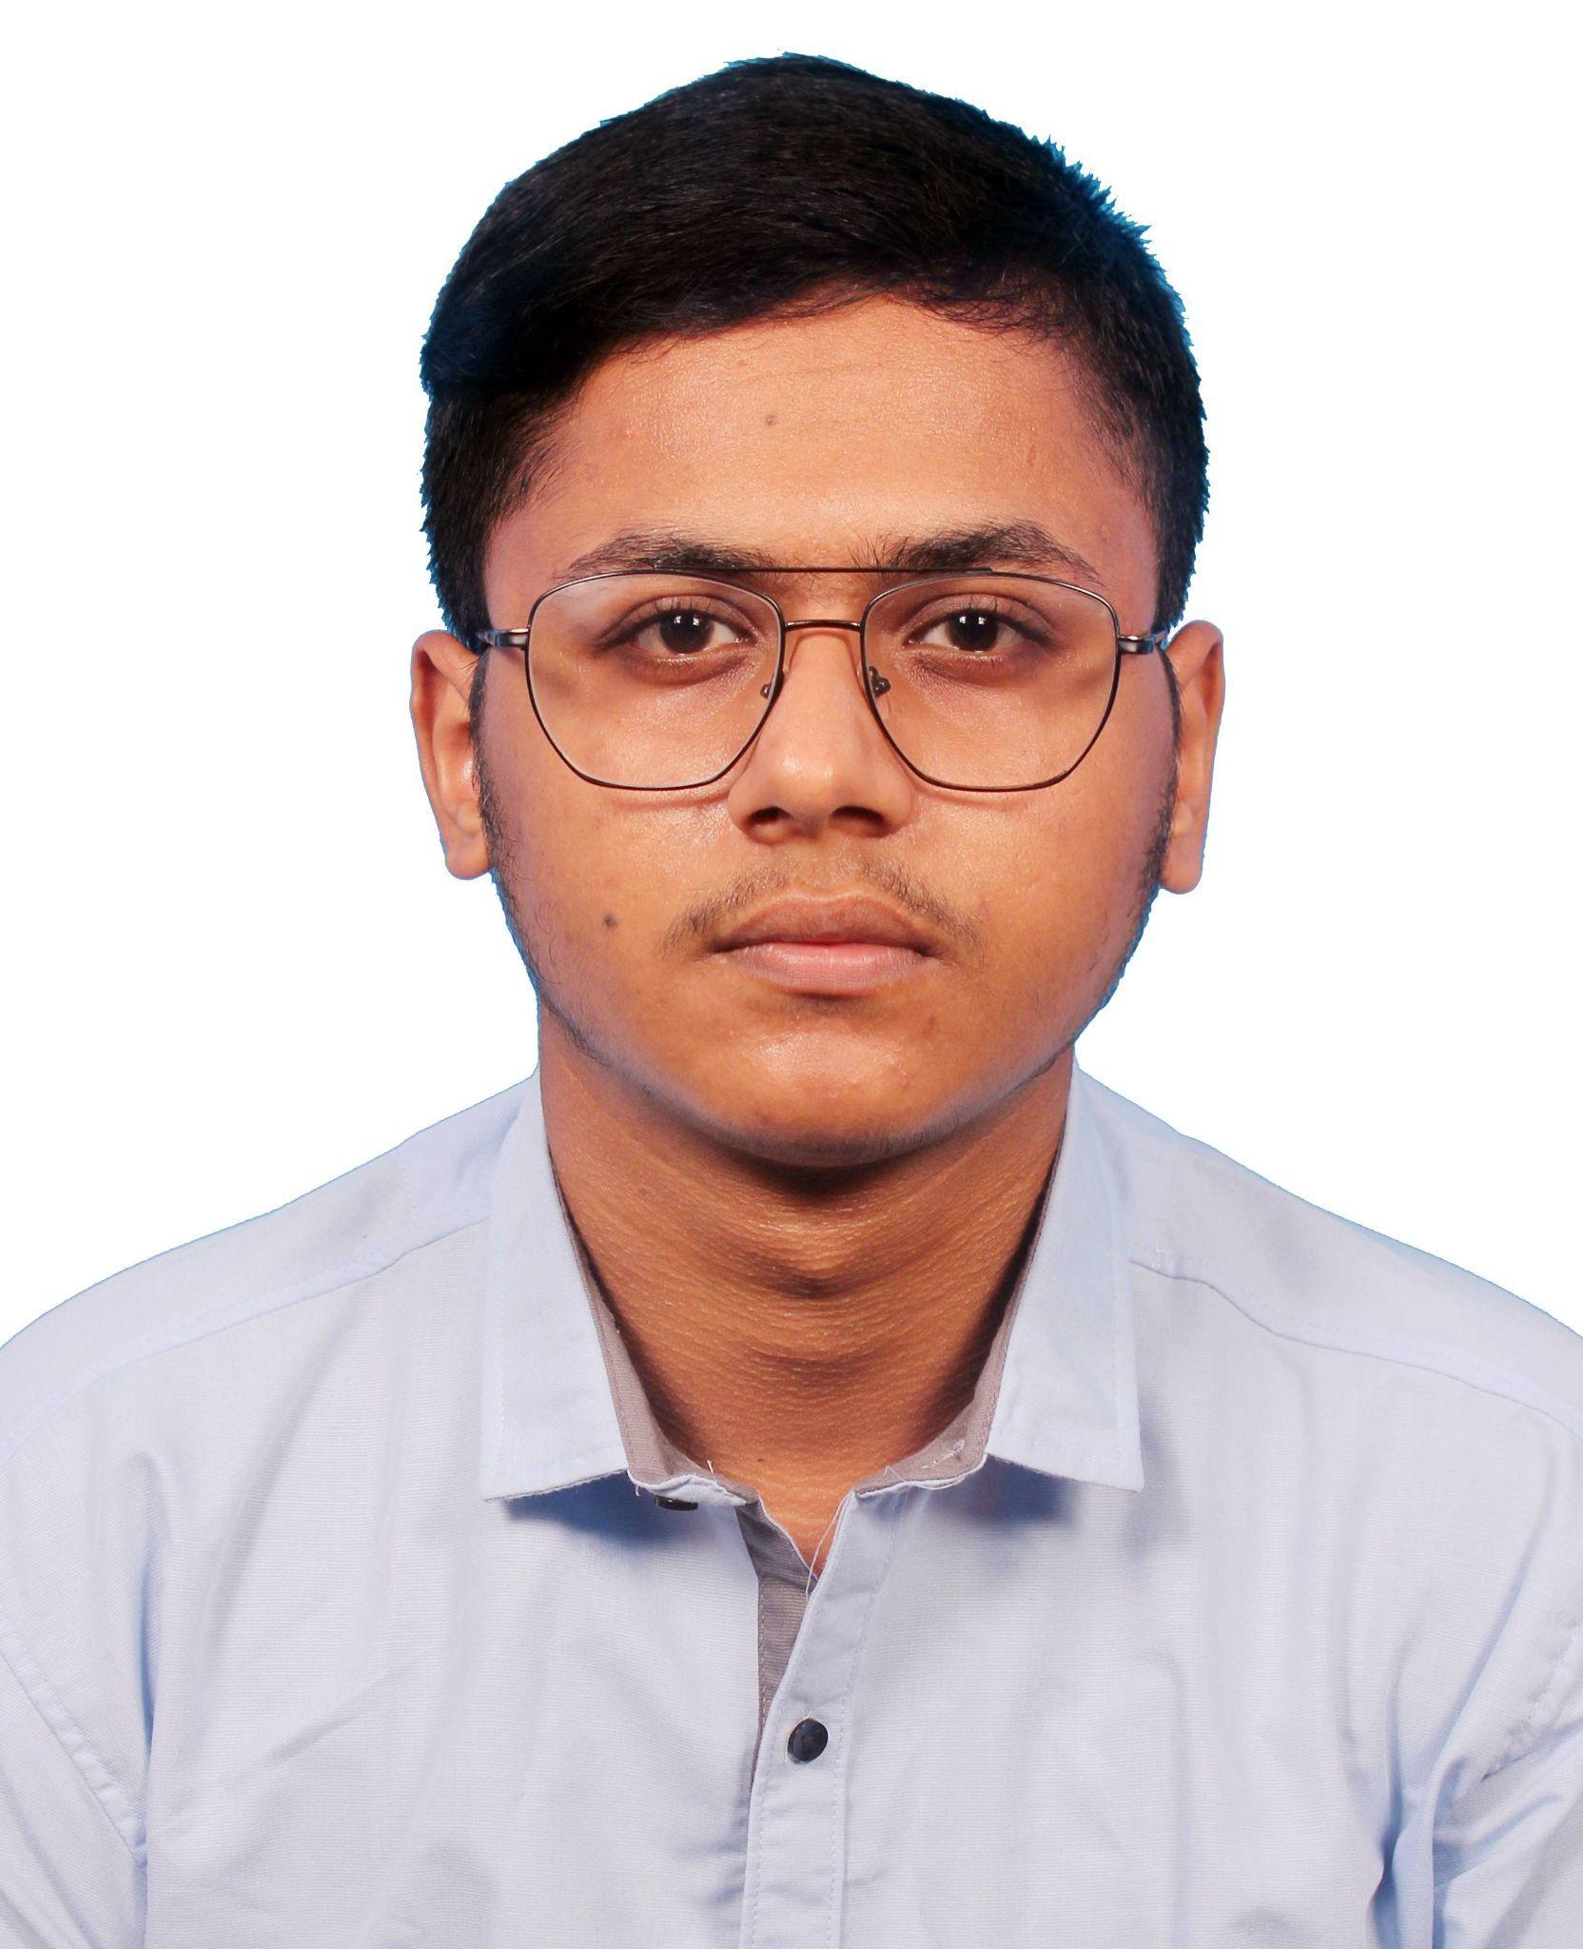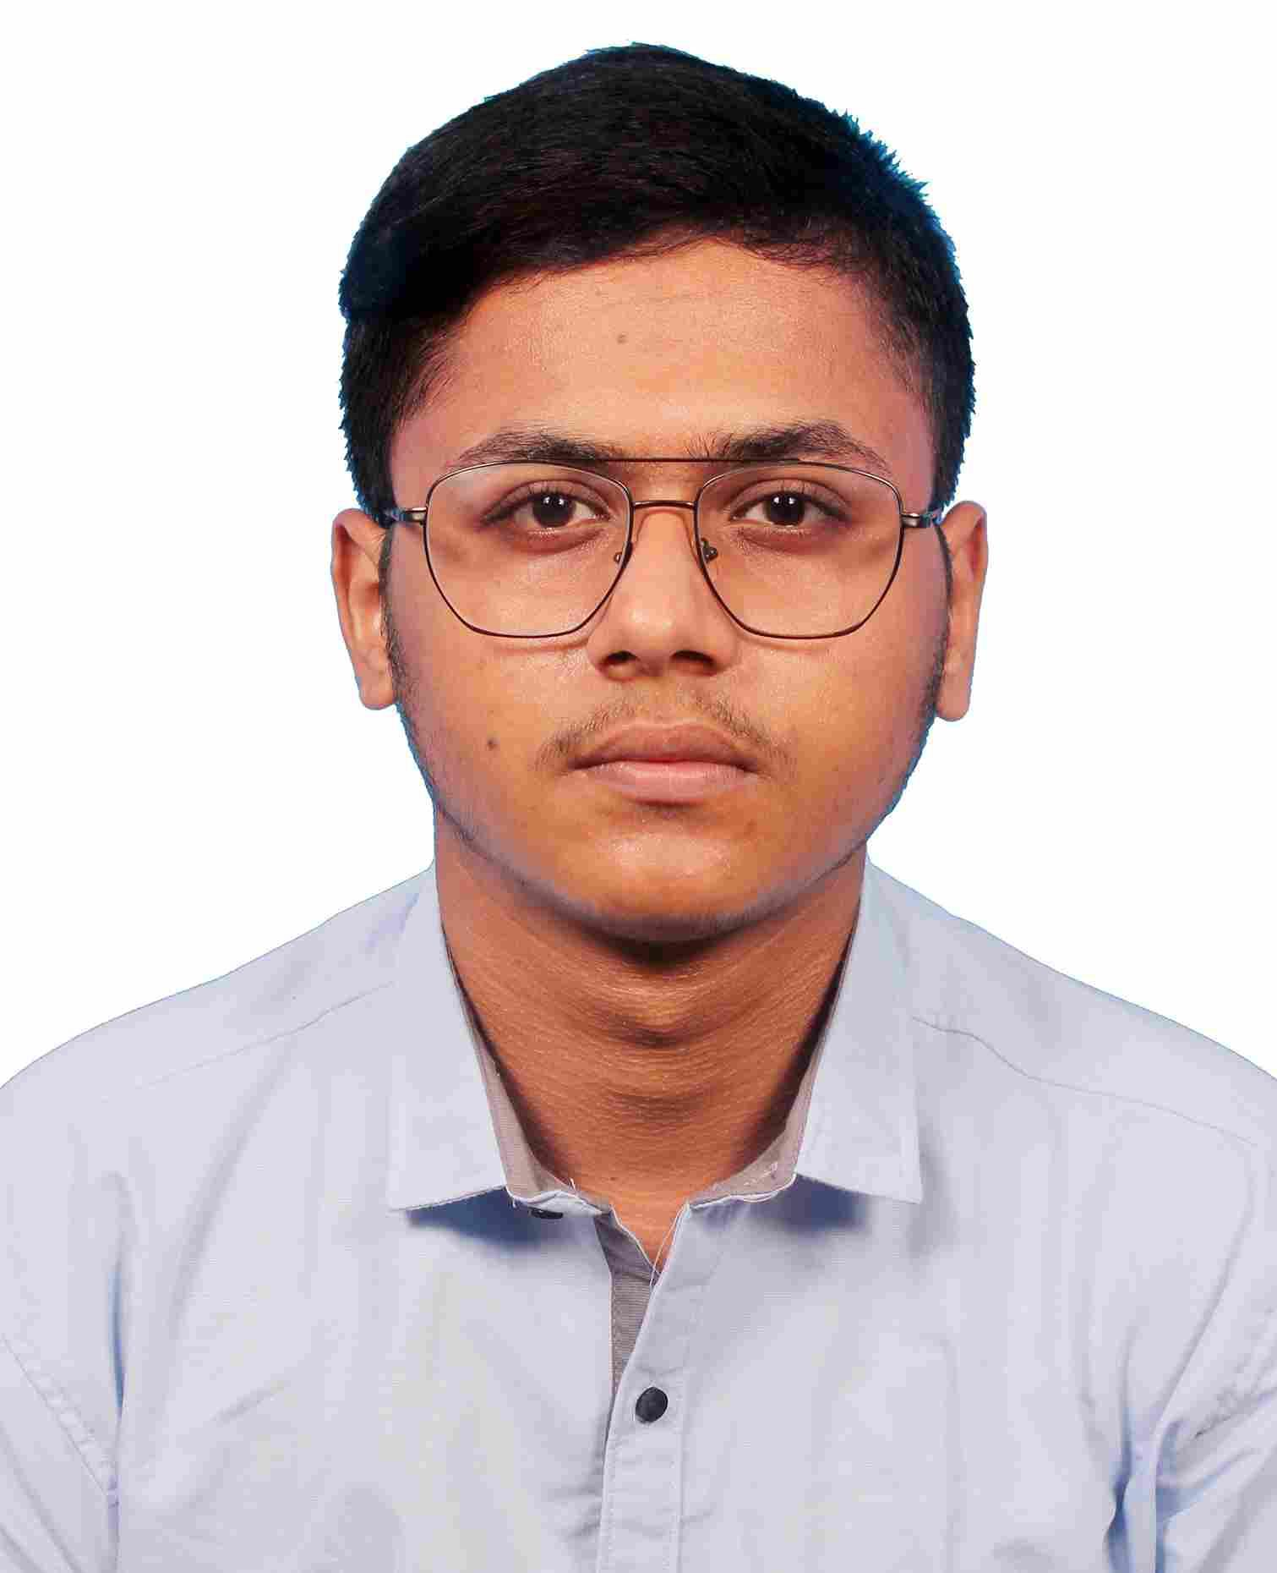

| **Name (in full & in block letters)** | : | ATANU CHAKRABORTY |
| --- | --- | --- |
| **Department** | : | INFORMATION TECHNOLOGY |
| **College Roll No.** | : | IT/21/T72 |

| Father's Name | | | : | PULAKESH CHAKRABORTY | | | | | |
| --- | --- | --- | --- | --- | --- | --- | --- | --- | --- |
| Residential Address | | | : | SILDA,JHARGRAM | | | | | |
| Mobile No. (Personal) | | | : | 8001408829 | | | | | |
| E-mail Address (*Only one)* | | | : | atanuchakraborty831@gmail.com | | | | | |
| Date of Birth | | | : | 08/09/2003 | | | | | |
| Caste | | | : | General | | | | | |
| **Educational Qualification** | | | : |  | | | | | |
|  | **Examination, Board** | **School / College, Place** | | | | **Year of Passing** | **Total Marks obtained** | | **Percentage** |
|  | **WBBSE** | SILDA RADHA CHARAN INSTITUTIONS | | | | 2019 | 460 | | 65 |
|  | **H.S.(WBCHSE)** | BINPUR HIGH SCHOOL | | | | 2021 | 368 | | 73.6 |
|  | **Diploma Marks** |  | | | |  |  | |  |
|  | **WB J.E.E. Rank** | 32500 | | | | | | | |
|  | **B.Tech.( Information Technology)** | **Semesters** | | | **Year of Passing** | | **SGPA** | **Average B.Tech SGPA (Till Date)** | |
|  | 1st | | | 2022 | | 9.37 | 8.512 | |
|  | 2nd | | | 2022 | | 9.2 |
|  | 3rd | | | 2023 | | 8.14 |
|  | 4th | | | 2023 | | 7.43 |
|  | 5th | | | 2024 | | 8.42 |
|  | 6th | | |  | |  |
|  | 7th | | |  | |  |
|  | 8th | | |  | |  |

**Computer Proficiency:**

| Language | : | , JAVA,C,HTML,CSS ,OBJECT ORIENTED PROGRAMMING,DATA STRUCTURES AND ALGORITHMS |
| --- | --- | --- |
| DBMS | : | MYSQL, MongoDb |
| Operating Systems | : | Windows, Ubuntu (Linux) |

**Additional Classes Attended:**  HTML,CSS from Codecademy ,Core Java Specialization from pw skill ,Soft Skill from NPTEL ,Python from NPTEL (IIT MADRAS) .

**Extra-Curricular Activities:** Tree plantation , Blood Donation Camp Organize

**Hobbies:** competitive programming, Listening songs,Learn new technology,Playing Cricket,

| **Date:** 25.06.2024 | **Signature:** (*not necessary for soft copy*) |
| --- | --- |