ASSIGNMENT 4

Atanu Basak

2022-04-19

# Markdown Basics

## Favorite Foods

## Images

## Add a Quote

## Add an Equation

## Add a Footnote

This is a footnote

## Add Citations

* R for Everyone
* Discovering Statistics Using R

# Inline Code

## NY Times COVID-19 Data

## date state fips cases deaths  
## 1 2020-01-21 Washington 53 1 0  
## 2 2020-01-22 Washington 53 1 0  
## 3 2020-01-23 Washington 53 1 0  
## 4 2020-01-24 Illinois 17 1 0  
## 5 2020-01-24 Washington 53 1 0  
## 6 2020-01-25 California 6 1 0

## R4DS Height vs Earnings

setwd("C:\\Users\\atanu\\Documents\\BellevueUniversity_MSDS\\DSC520\\Repository\\dsc520")  
heights_df <- read.csv("data\\r4ds\\heights.csv")  
head(heights_df)

## earn height sex ed age race  
## 1 50000 74.42444 male 16 45 white  
## 2 60000 65.53754 female 16 58 white  
## 3 30000 63.62920 female 16 29 white  
## 4 50000 63.10856 female 16 91 other  
## 5 51000 63.40248 female 17 39 white  
## 6 9000 64.39951 female 15 26 white

plot(heights_df$height,heights_df$earn)

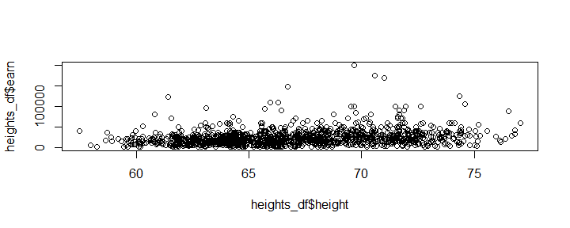

# Tables

## Knitr Table with Kable

| earn | height | sex | ed |
| --- | --- | --- | --- |
| 50000 | 74.42444 | male | 16 |
| 60000 | 65.53754 | female | 16 |
| 30000 | 63.62920 | female | 16 |
| 50000 | 63.10856 | female | 16 |
| 51000 | 63.40248 | female | 17 |
| 9000 | 64.39951 | female | 15 |

## Pandoc Table

##   
##   
## earn height sex ed   
## ------- -------- -------- ----  
## 50000 74.42 male 16   
## 60000 65.54 female 16   
## 30000 63.63 female 16   
## 50000 63.11 female 16

# References

#<https://cran.r-project.org/web/packages/pander/readme/README.html>