ARRAY

Question1 :

Find the sum of submatrix of M

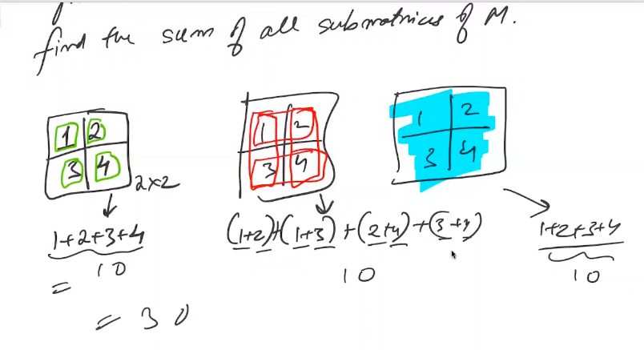

Brute force

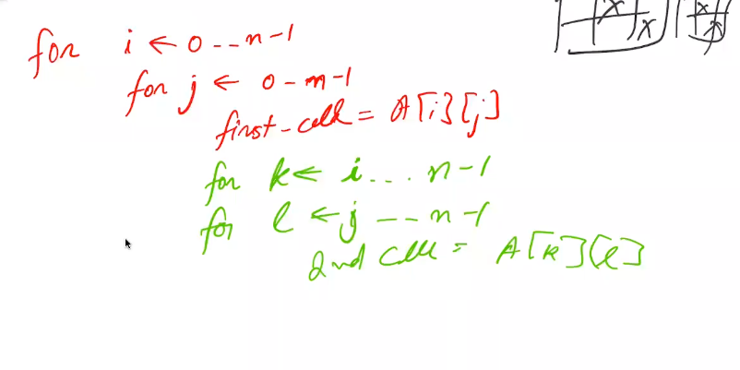

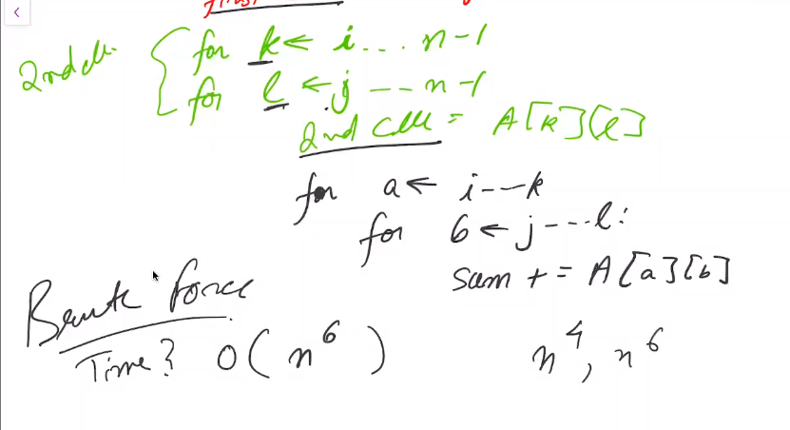

Prefix sum Program

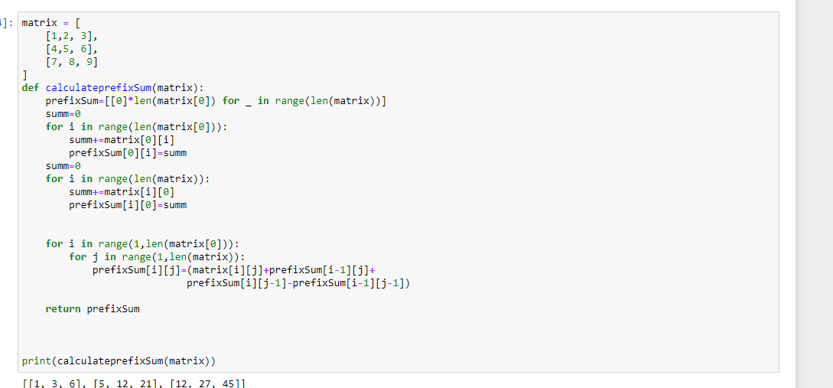

Question 2:

If there is a possibility of finding out the sum of lany submatrix in O(1)

Given a matrix mX n and q queries . query will be (top left and bottom right).

Each query will uniquely charecterize a rectangle. You have to find the sum of all elements in the submatrix

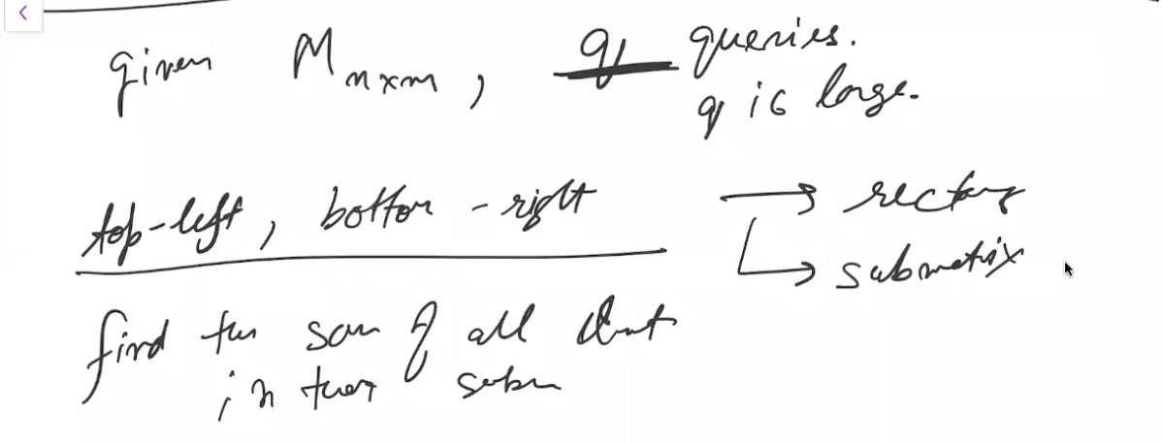

1st solution :

Brurte force:

For each query

For I in ran(o,row):

For j in range(0,col_number):

O (q.n^2) q is very large and n can also be large

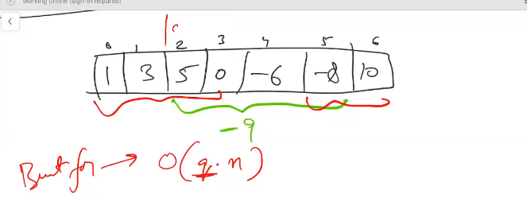

I can create Prefix sum

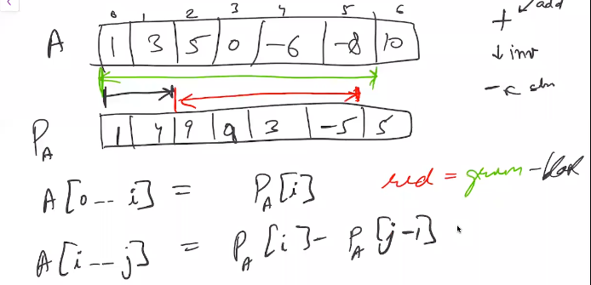

Now for this sum I only take O(1)

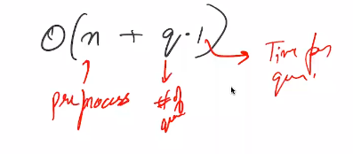

So What about the 2D array:

One cell I,j store prefix sum upto I,j

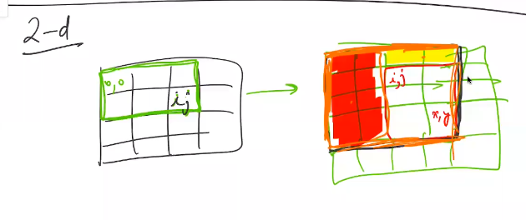

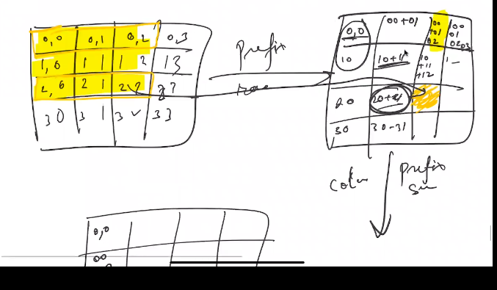

First row sum then column sum will give prefix sum

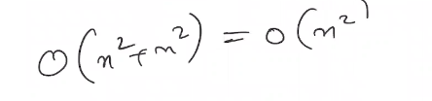

After this We have the prefix sum

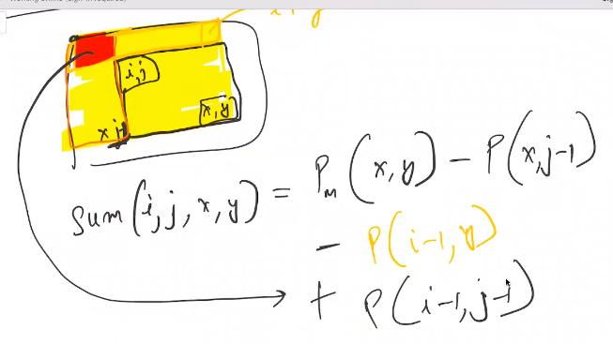

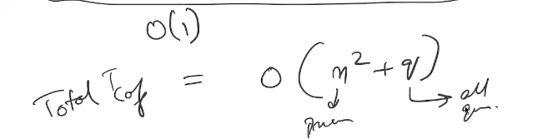

1;10 HR

Question 3 :

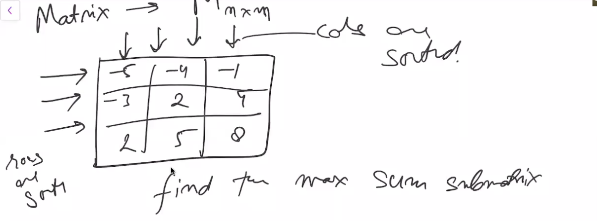

Rows and columns are sorted find the maximum sum submatrix

1. Brute Force

for finding gthe submatrix O(n^4) for calculating the Sum O(n^2)

total O(n^6) . but we ahave prefix sum matrix

that will make it O(n^4.1)

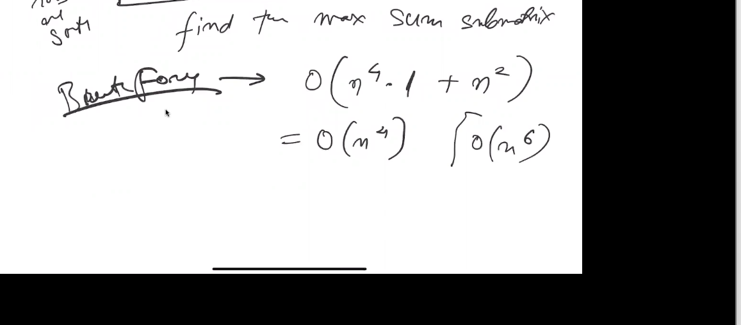

Optimized solution :

Bo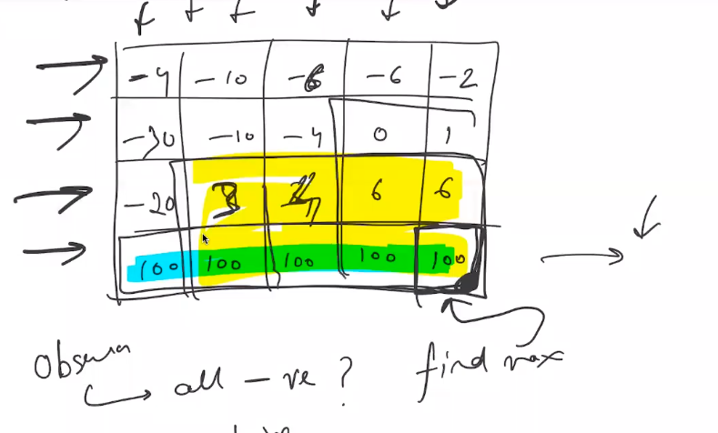

Observation has to be a part : We just have to find the top left :

We go over each possible top left

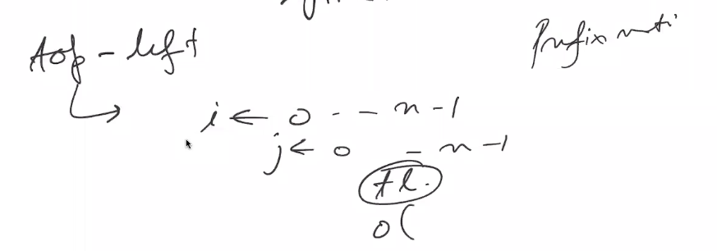

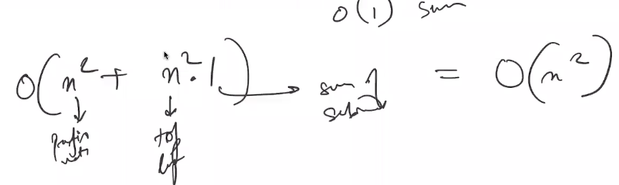

1:25 Hr

## Question 4

You have matrix with columns and rows are all sorted. And a target is goiveen you have to find the position of the number in the matrix

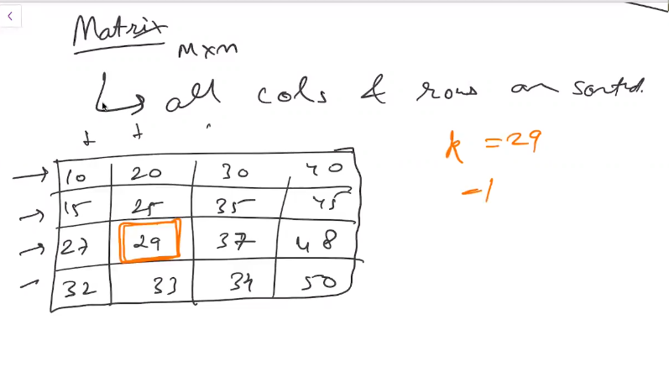

Brute force search through all the elements in matrix O(n^2)

2nd I can do a binary seacch through all the rows or columns. Binary search takes O(logn) and for n rows it will have time complexity O(n logn)

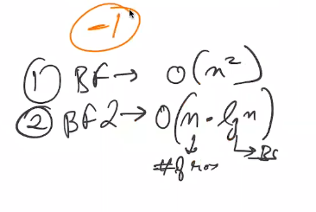

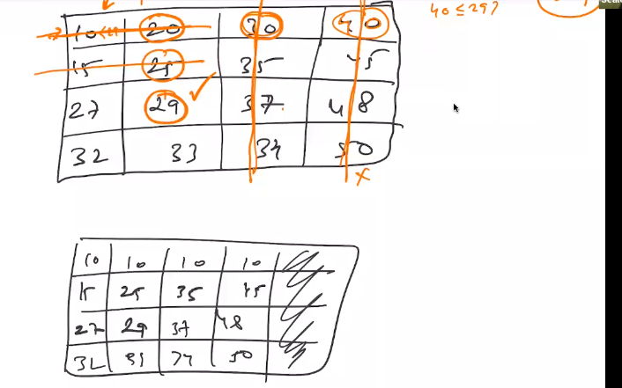

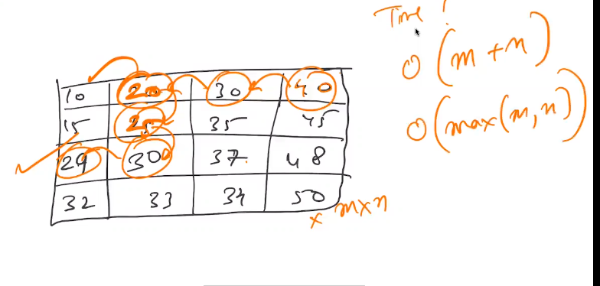

Leetcode : <https://leetcode.com/problems/search-a-2d-matrix/>

