BACKTRACKING

15:00

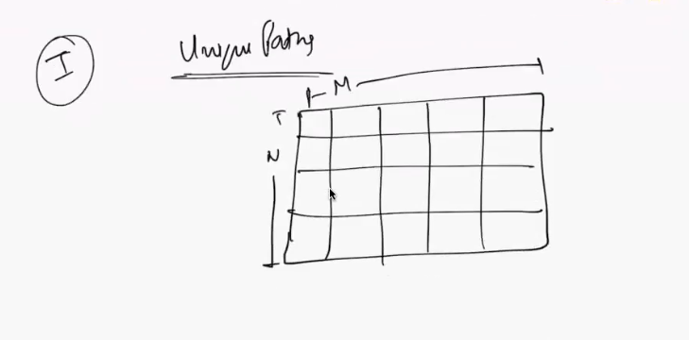

Every value of the grid can one of 4 type

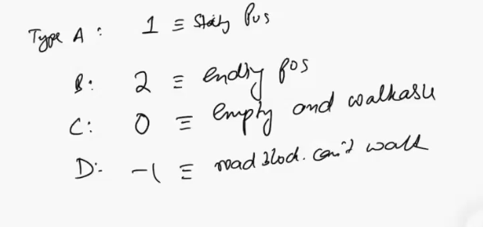

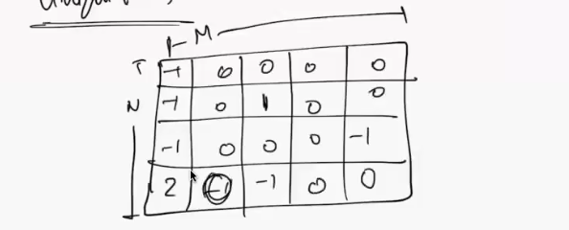

Possible movements are

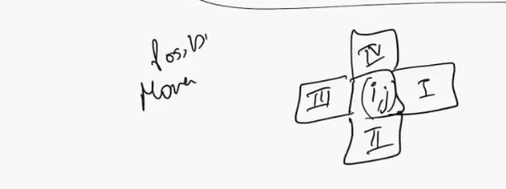

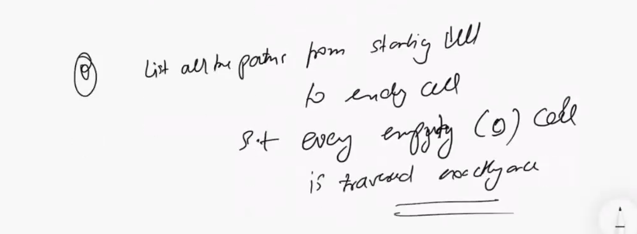

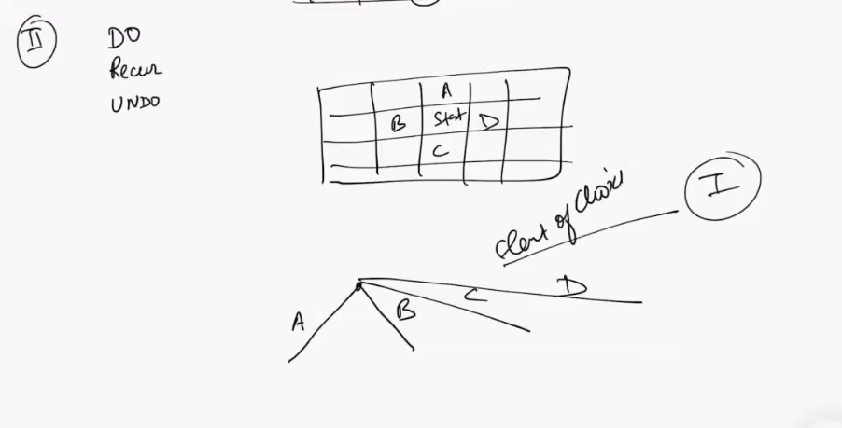



**When you make choice on a cell you can not make the decision on that cell again so you can make it -1**

**Again coming back make the change to 0**

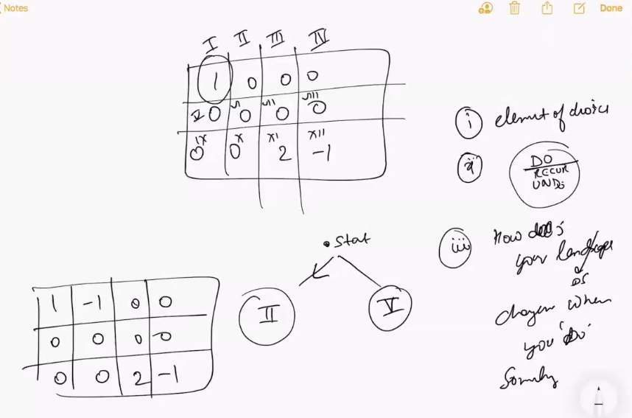

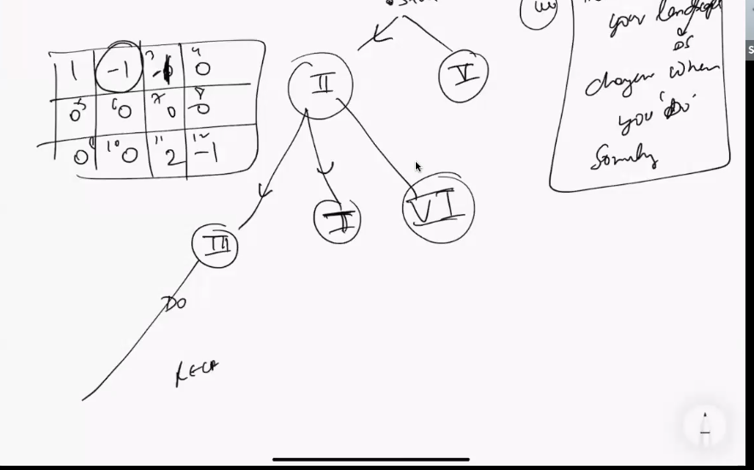

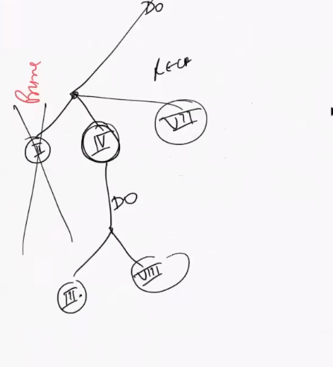

**You always have two base case positive basecase and negative base case**

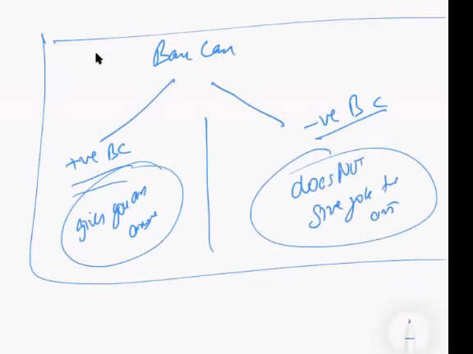

**# base case**

**# recurrence**

**Recurreance have three partl**

1. **Do**
2. **Recurrance**
3. **UNDO**

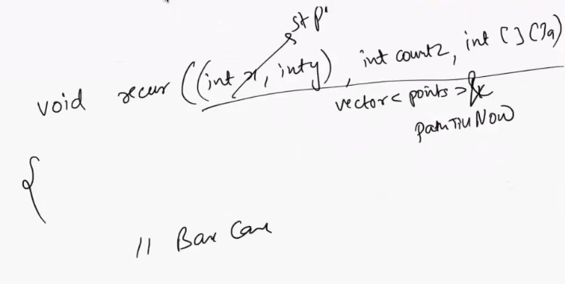

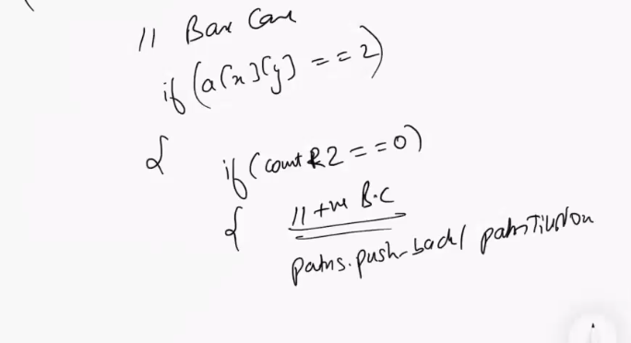

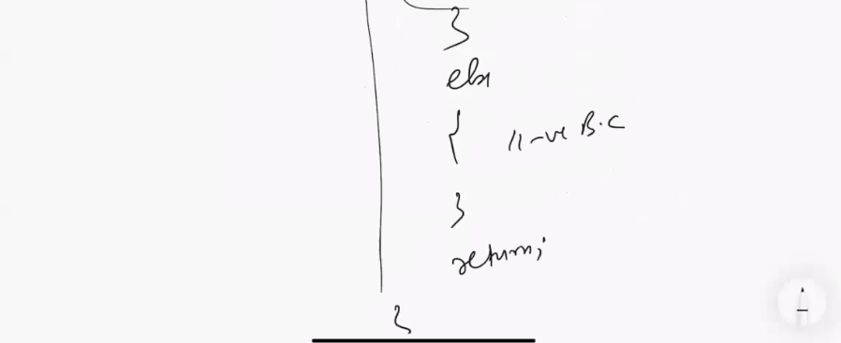



**1:04**

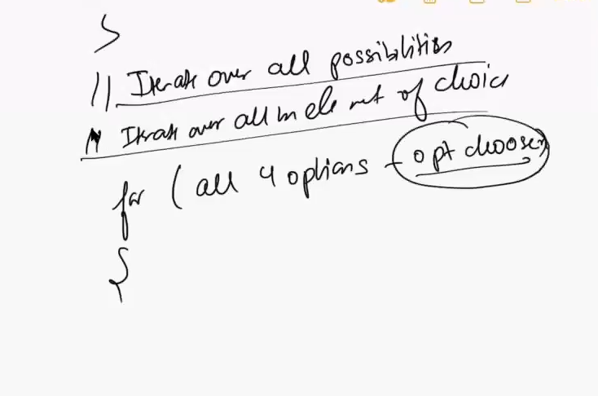

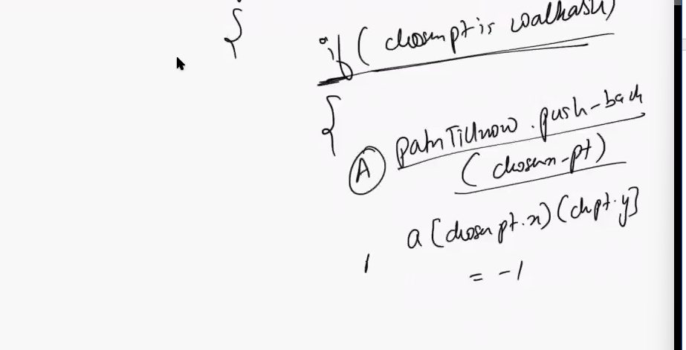

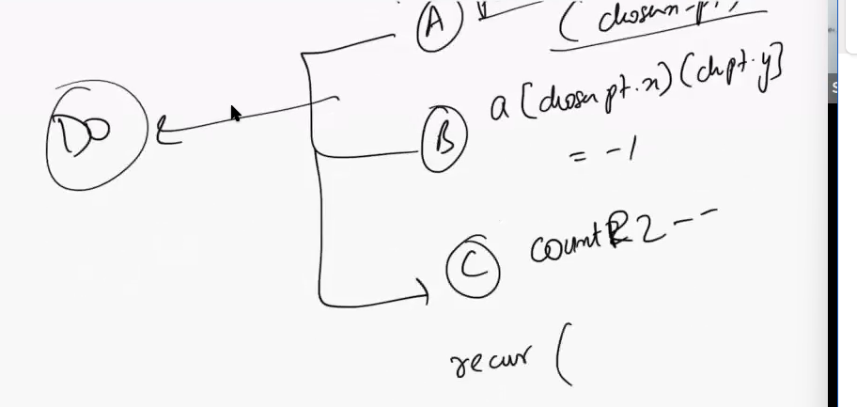

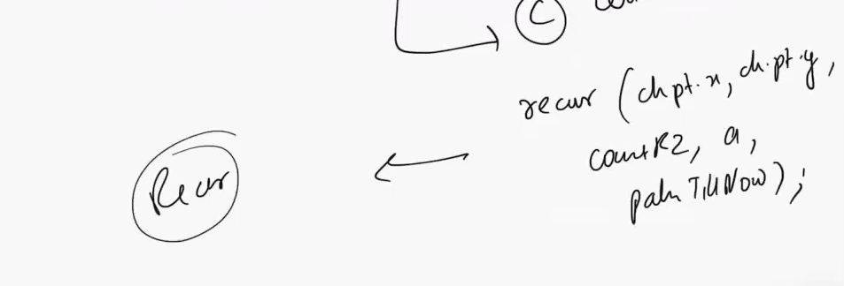

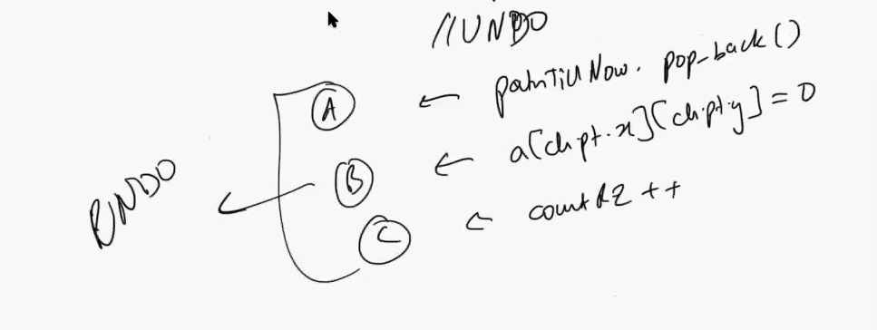

**Similar kind of problem**

**RAT IN MAZE** [**https://takeuforward.org/data-structure/rat-in-a-maze/**](https://takeuforward.org/data-structure/rat-in-a-maze/)

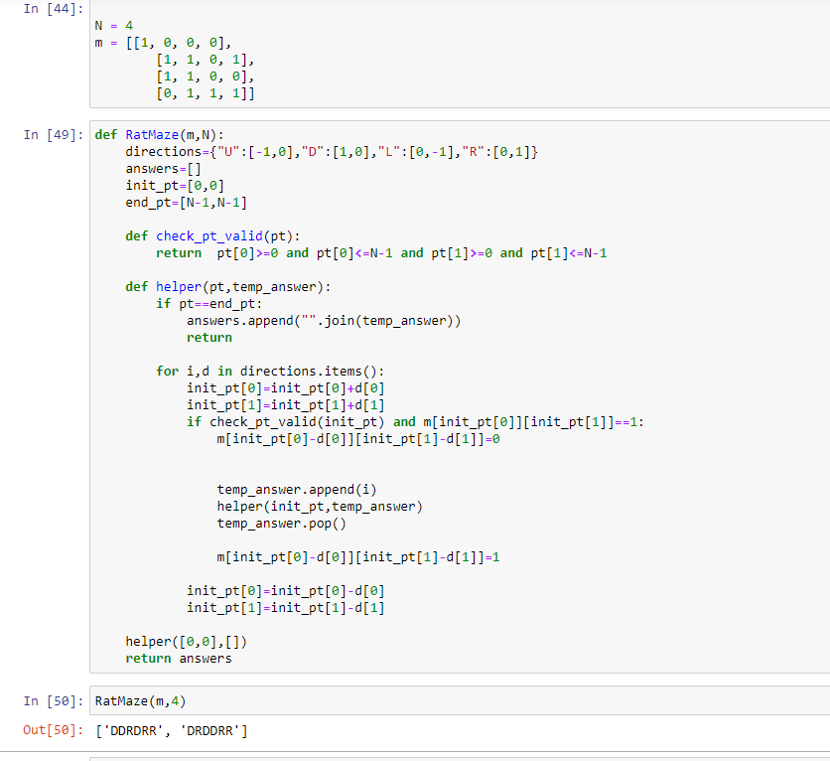

**1:10**

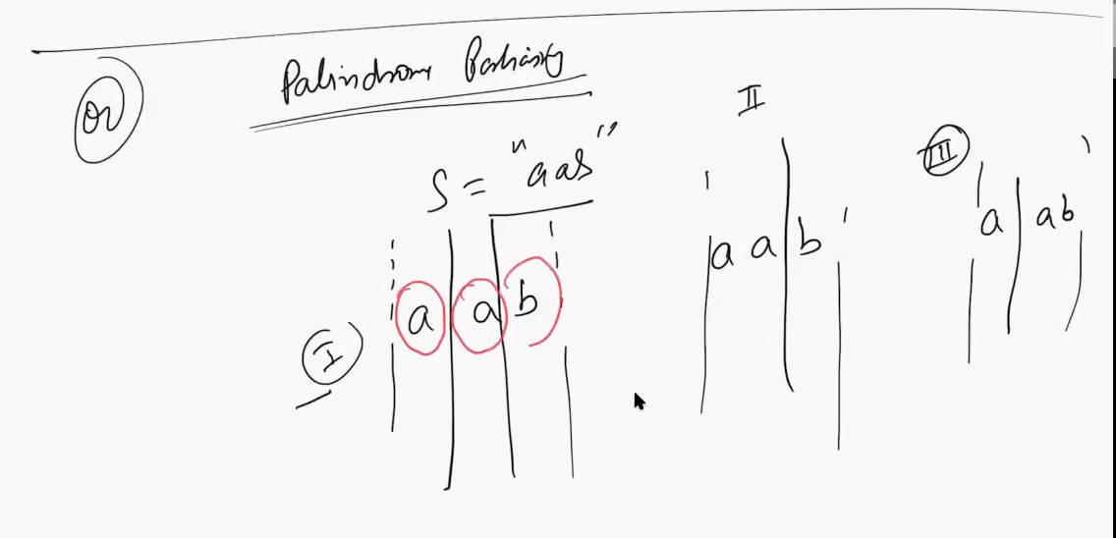

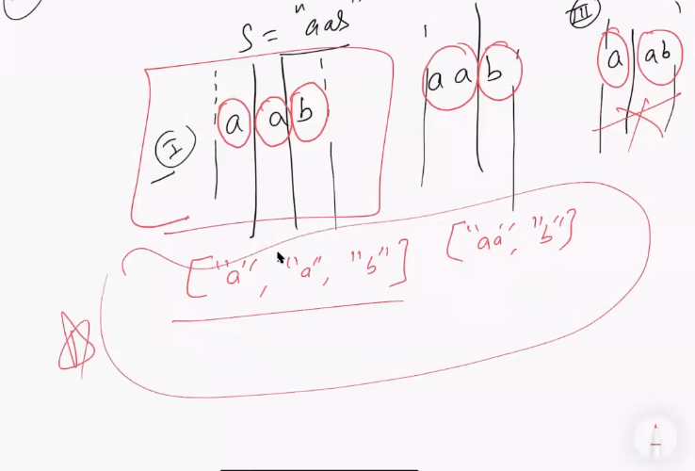

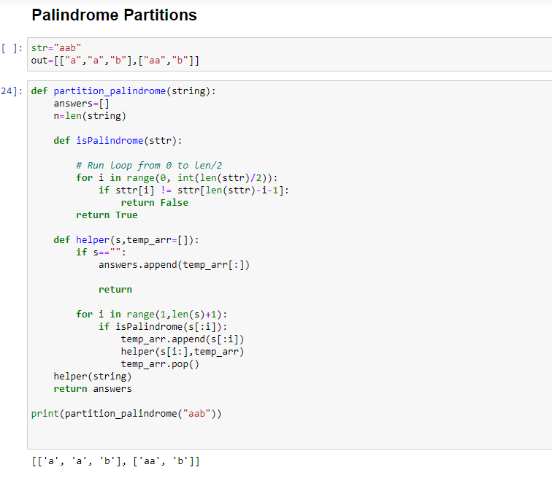

**The first thing is what is the element of choice that you have**

**After A INDEX SHOULD I INTRODUCE A Partition or not to introduce a partition**

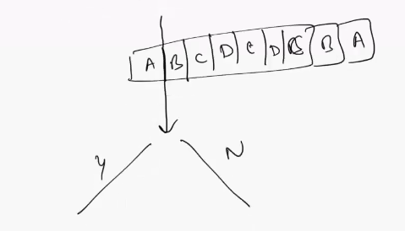

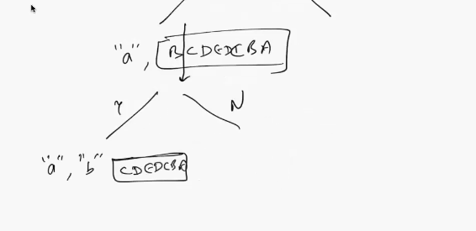

**Whenever you hit a basecase you undo your decision**

**You have time complexity is 2^n**

**1:33**

**Question 3 : generate all the possible valid parenthesis**

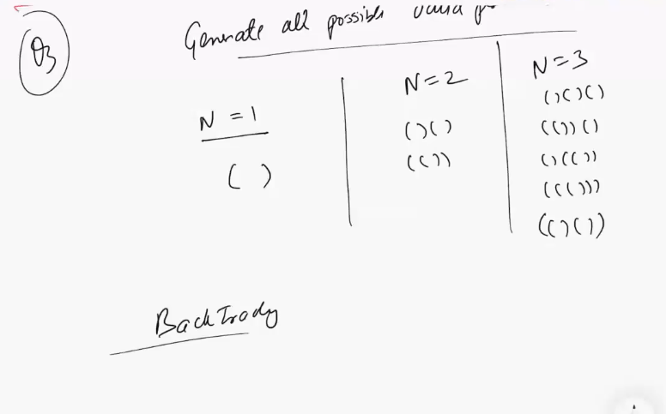

**There is only 2 choices either chose a opening bracket or a closing bracket**

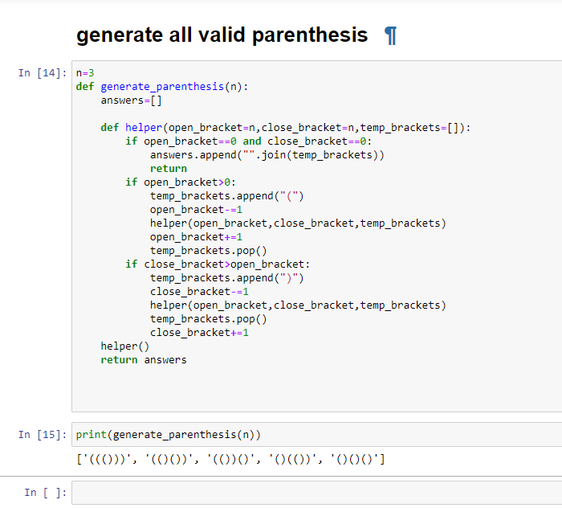

**1:39**

**Backtracking 2**

