SEARCHING

Binary Search

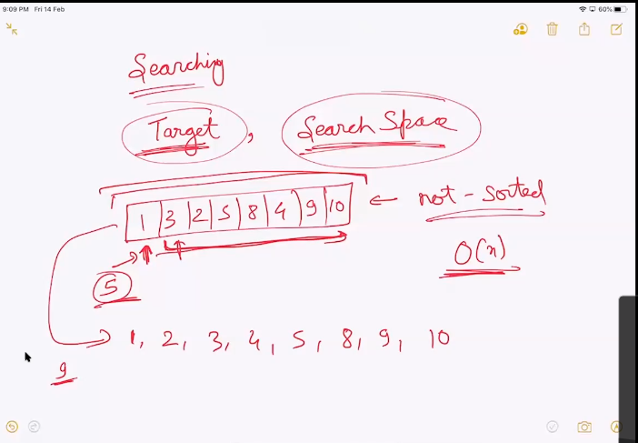

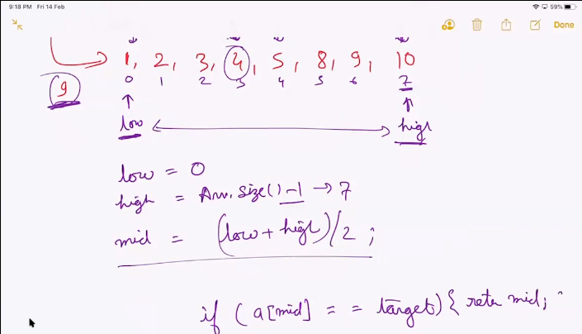

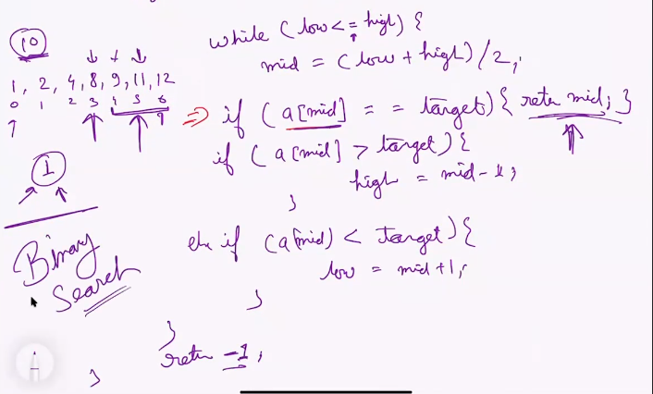

Time complexity is log(n)

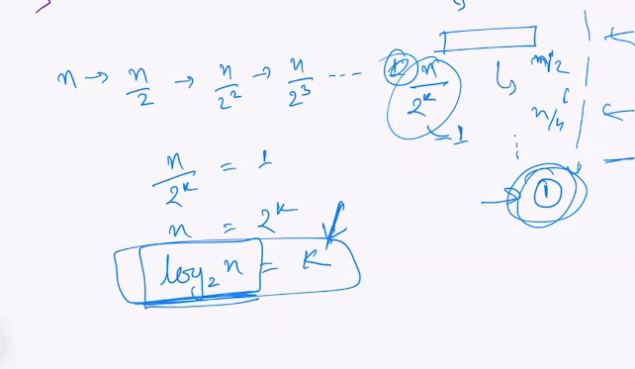

# question 1:

We have repetative number what is the first occurance of the number?

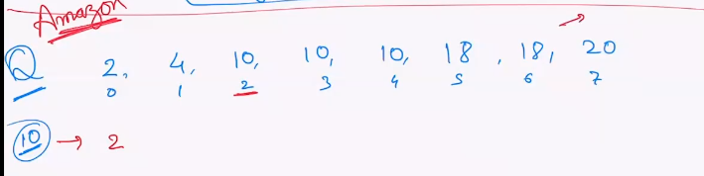

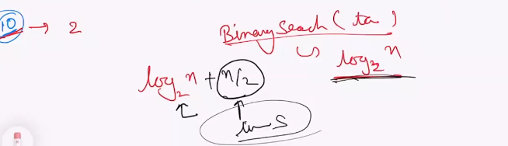

Can we optimize from linear to log

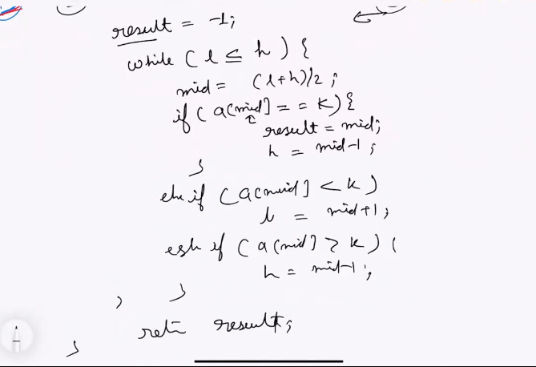

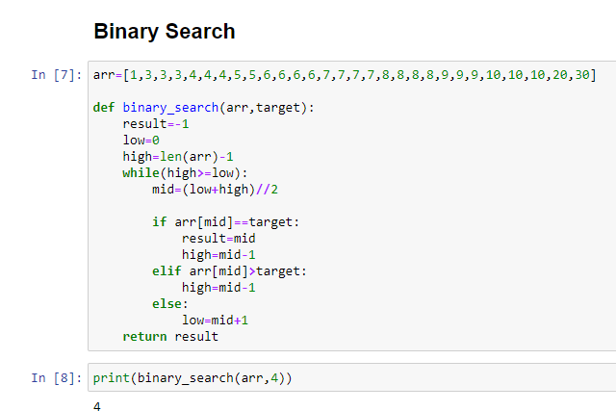

Queation 2:

Frequency of a number in a given array

Left occurance of the element and right occurance of the occurance

Question 3:

Facebook

You have an array . It was sorted , someone rotated it

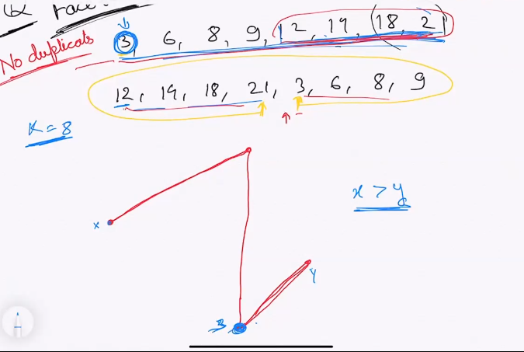

You have to find a target in the rotated sorted array

Leetcode <https://leetcode.com/problems/search-in-rotated-sorted-array/>

Minimum number of the first part will always be greater than the maximum number of the second part

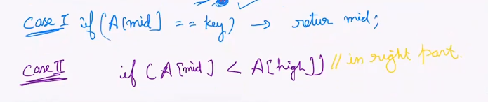

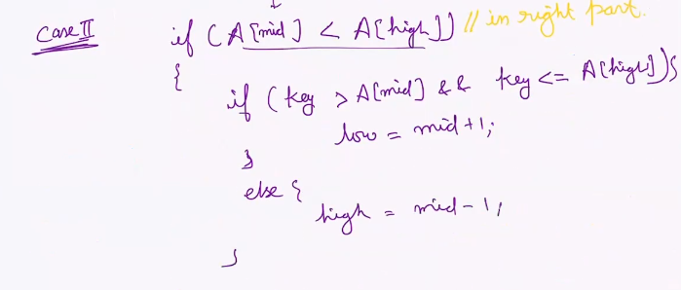

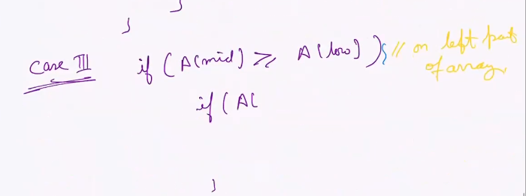

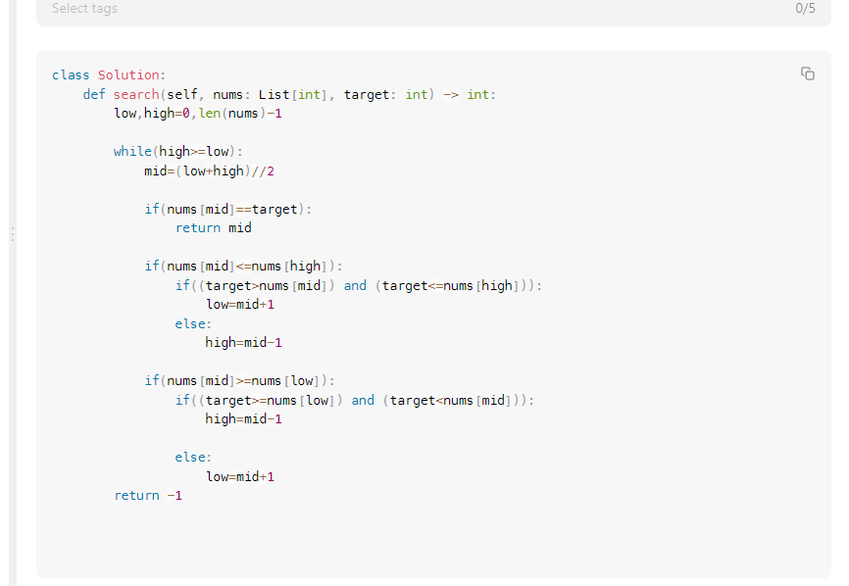

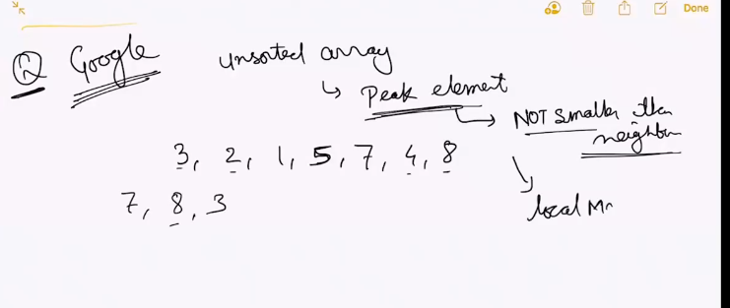

Leetcode problem <https://leetcode.com/problems/find-peak-element/>

1:25

Question 4 : asked in google

You have to find the peak element in a array

A peak element is that is not smaller than its neighbours

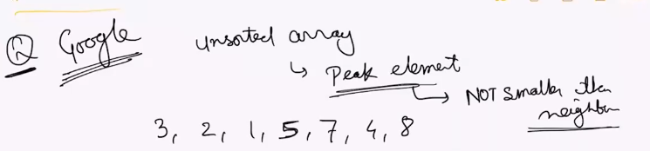

Here 7,8,3 are peak element.

You have to find the local maxima

Brute force is go through the element and check if it is local maxima or not

O(N) in this approach

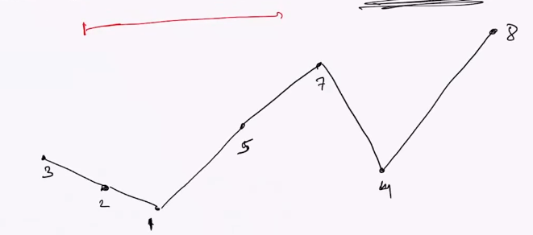

When all the elements are same there is no local maxima in the array

[1,1,1,1,1,1,1]

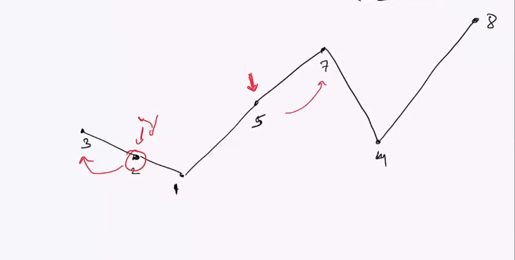

If we take a random number if I check if it a local maxima or not. It is always possible that it have a maxima either on the left side of the array or the right side of the array

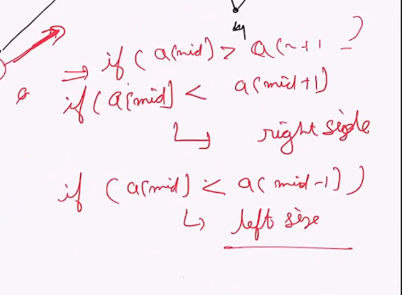

1:56

Question 5: Amazon + Microsoft+ Expedia