**REPORT**

**Microprocessor Lab**

**001910501005**

**Atanu Ghosh**

**JU BCSE UG-II Sem-II**

Assignment – 1

Q1 : **Load the contents of the memory locations 2200H and 2201H into registers. Add these registers and store the result in memory locations 2202H and 2203H.**

Sol :

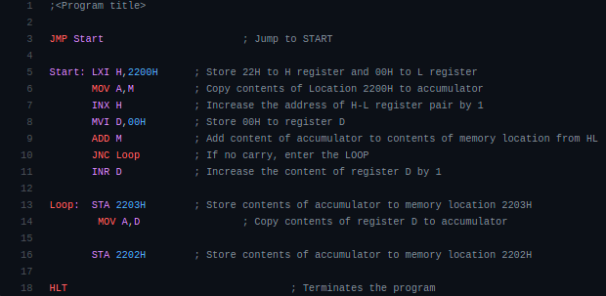

Q2 : **Find the sum of N numbers stored in consecutive locations starting from 2500H. The value of N is stored in 2200H. Store the result in locations 2300H and 2301H.**

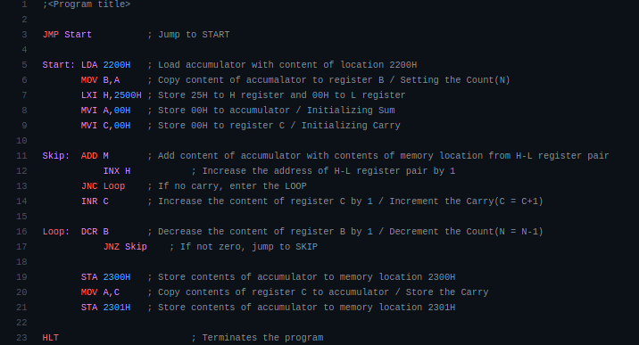Sol :

Q3 : **Find the sum of the least significant 4 bits and most significant 4 bits of a byte stored in memory location 2500H. Store the result in 2550H.**

**Sol :**

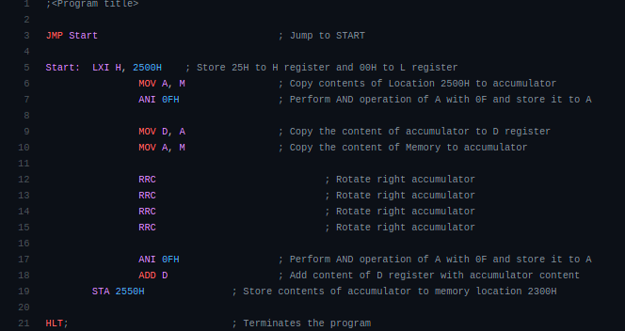

**Q4 : Write a program to count the ‘1’s and ‘0’s of a byte stored in 2500H. Store the result in 2610H and 2511H, respectively**

**Sol :**

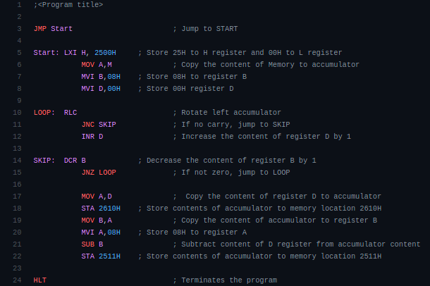

**Q5 : Write a program to sum two 16-bits binary numbers.**

**Sol :**

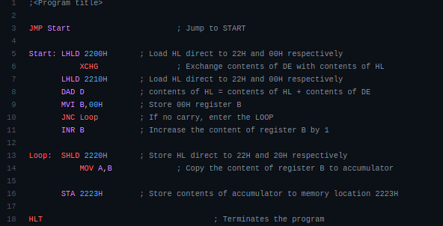

**Assignment - 2**

**Q1 : Two numbers MNH and KLH are stored in 2050H and 2051H, respectively. Write a program to assemble them as NKH and LMH store them in 2052H and 2053H.**

**Sol :**

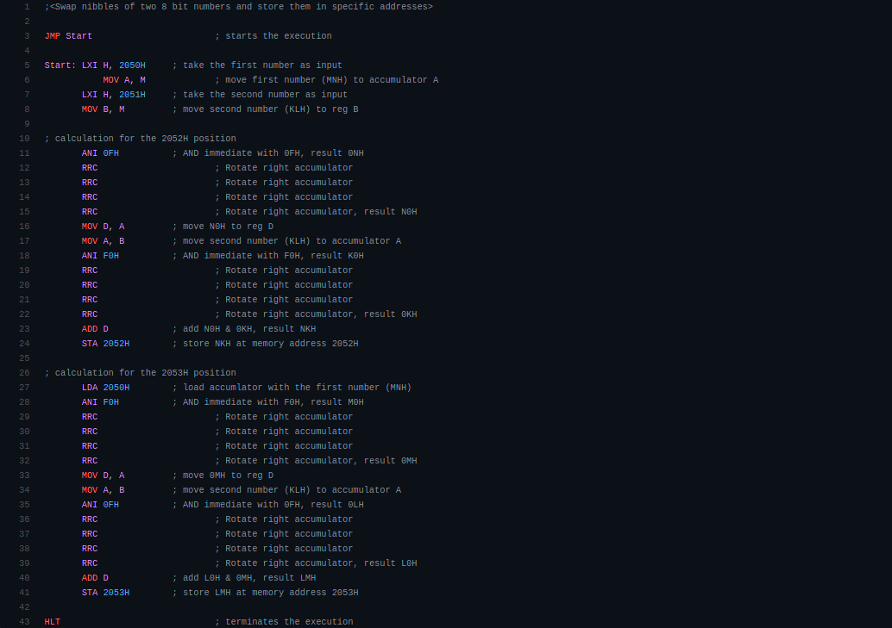

**Q2 : Two numbers A & B are stored in 2050H and 2051H, respectively. Write a program to perform A×B and store the result in 2052H and 2053H.**

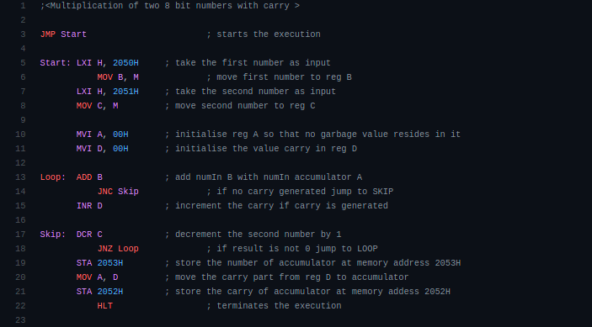**Sol :**

**Q3 : N numbers are stored in consecutive m/m location starting from 2050H. The value N is stored in 204FH.**

**i) Find the maximum among the N numbers.**

Sol :

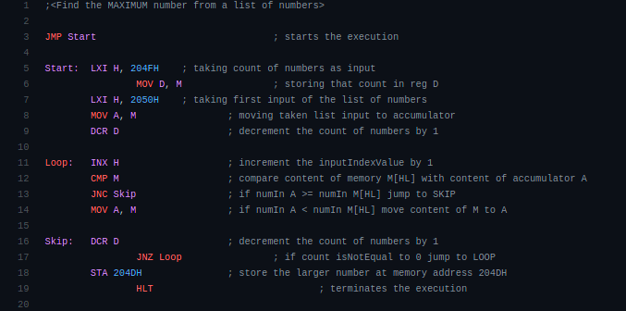

**ii) Find the minimum among the N numbers.**

Sol :

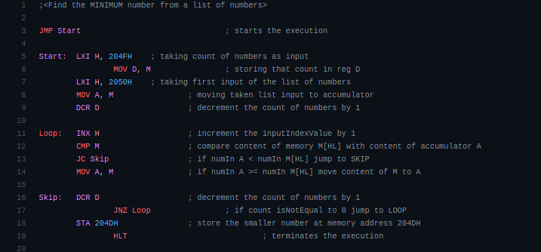

**iii) Sort the N numbers in ascending order.**

Sol :

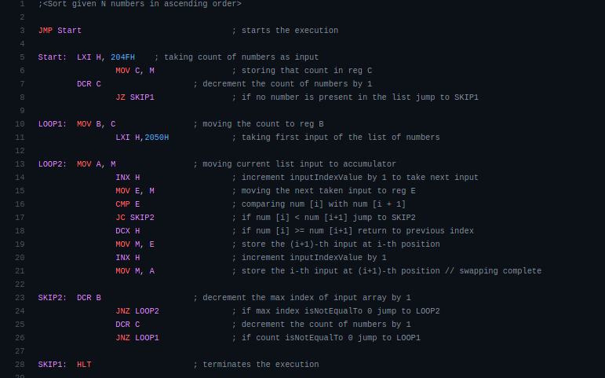

**iv) Sort the N numbers in descending order.**

Sol :

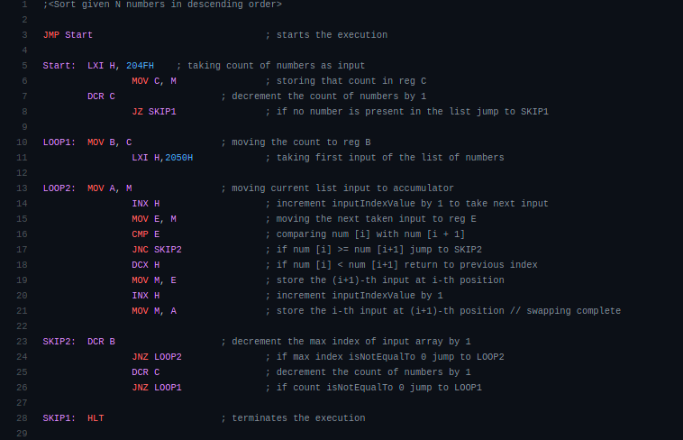

Q4 : **N numbers are stored in consecutive m/m location starting from 2050H. The value N is stored in 204FH. Write a program to copy the even and odd numbers starting from 2100H and 2200H, respectively. Store the total no. of even and odd numbers in 2300H and 2201H, respectively.**

Sol :

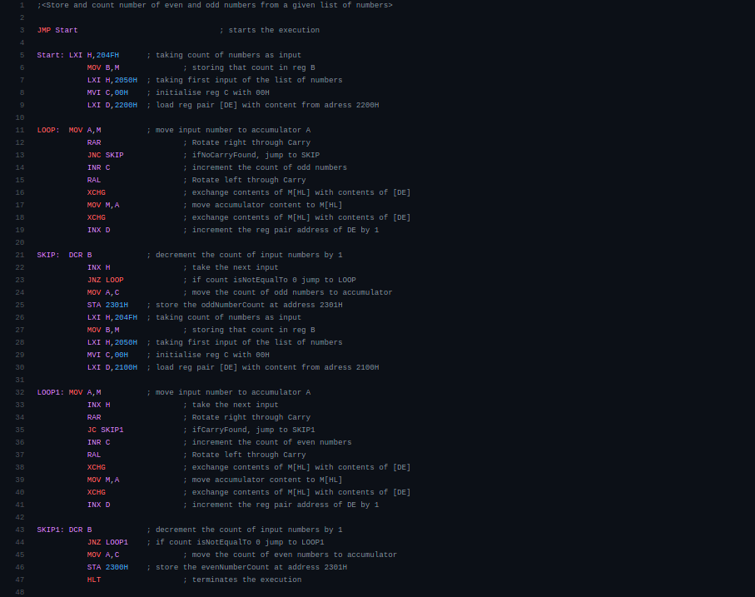

Q5 : **N numbers are stored in consecutive m/m location starting from 2050H. The value N is stored in 204FH. Write a program to test whether a number stored in 204EH is present in the list. If present, store its position in the list at 204DH; otherwise store FFH.**

Sol :

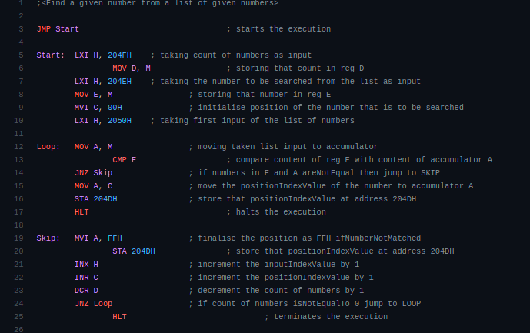

Assignment – 3

Q1 : **A set of N data bytes is stored in m/m locations starting from 2501H. The value of N is stored in 2500H. Write a program to store these data bytes from m/m location 2600H if D0 or D7 is 1; otherwise reject the data byte.**

Sol :

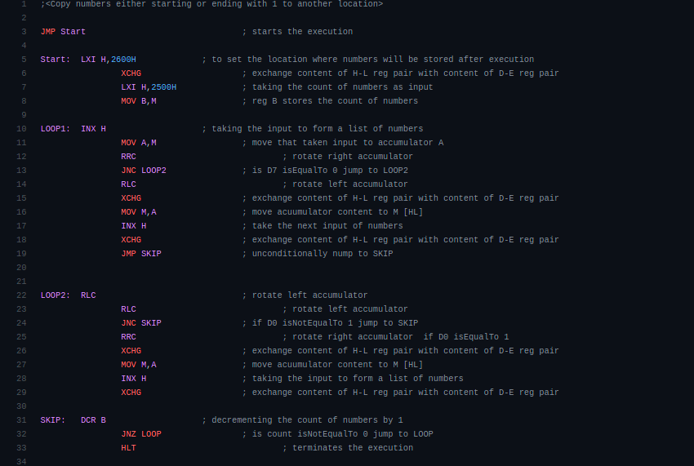

Q2 : **There are N data bytes stored from m/m location 2200H. The value of N is stored in 21FFH. Write an 8085 program to find the sum of integers whose LSB and MSB are 1. Store the result in 2500H and 2501H.**

Sol :

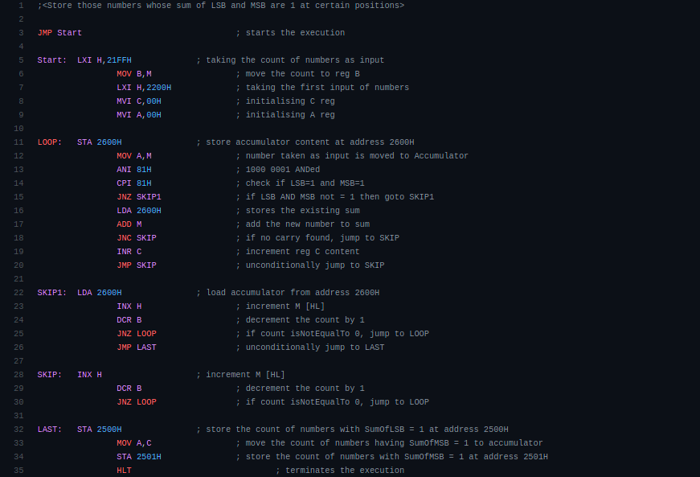

Q3 : **Write an 8085 program to generate N th fibonacci number using function and store it in 2050H. The value of N (8-bits) is stored in memory 2060H.**

Sol :

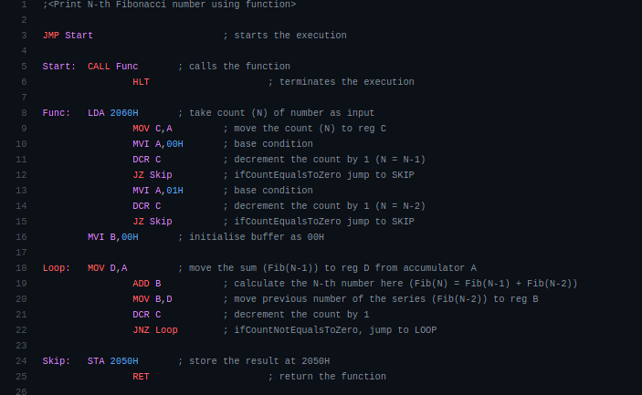

Q4 : **Write a program to transfer a block of bytes of size N from location1 to location2 (location2 > location1) when the size of overlap between the two locations is defined by M. The values of N and M are stored in 201EH and 201FH, respectively.**

Sol :

