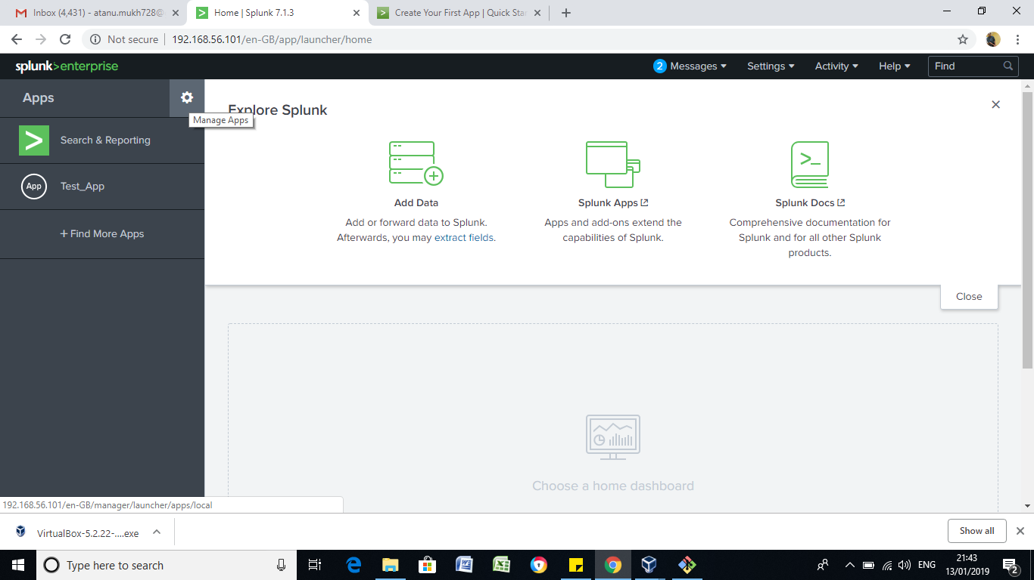

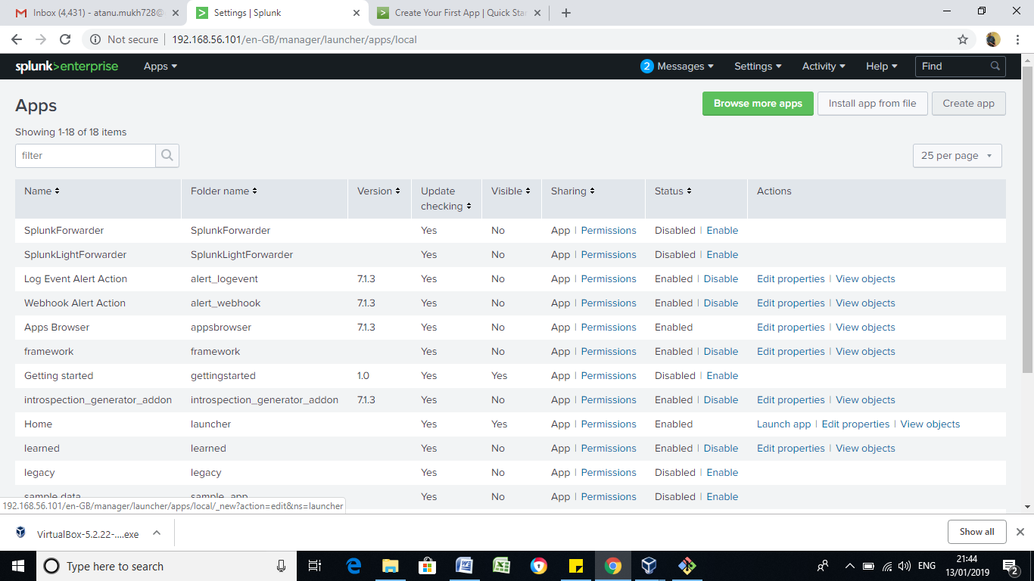

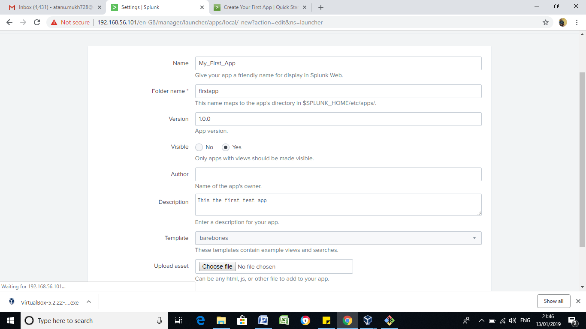

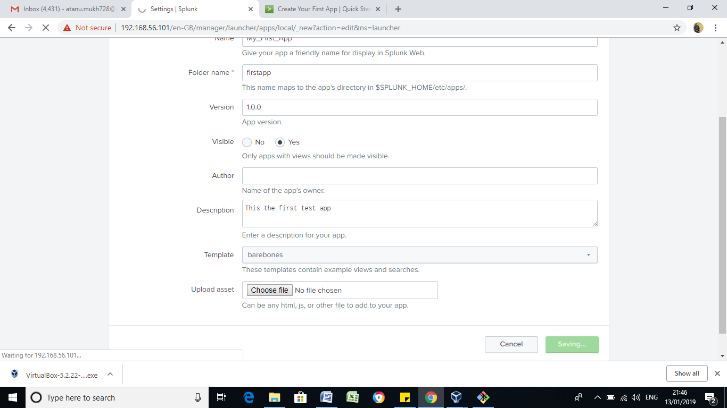

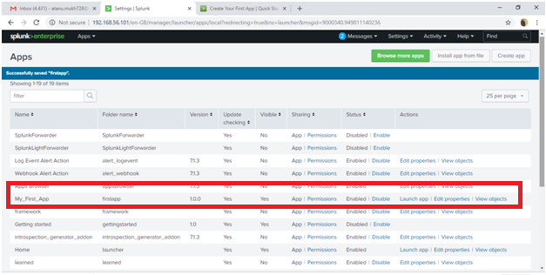

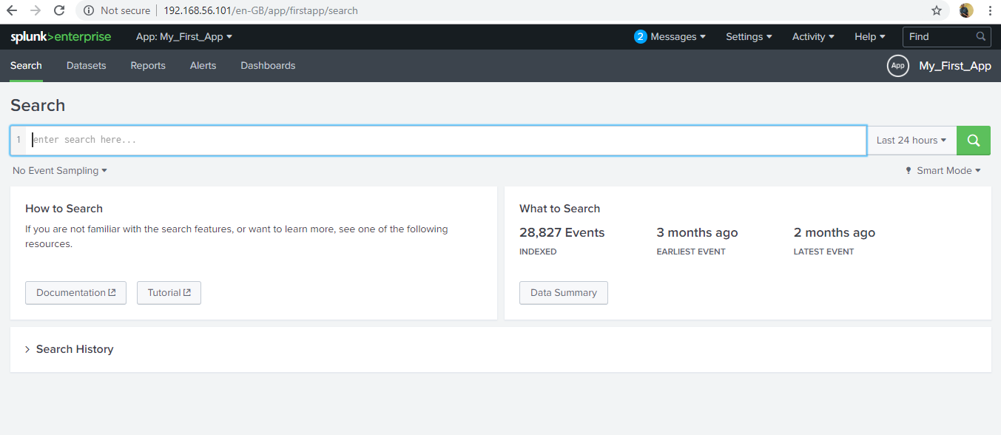

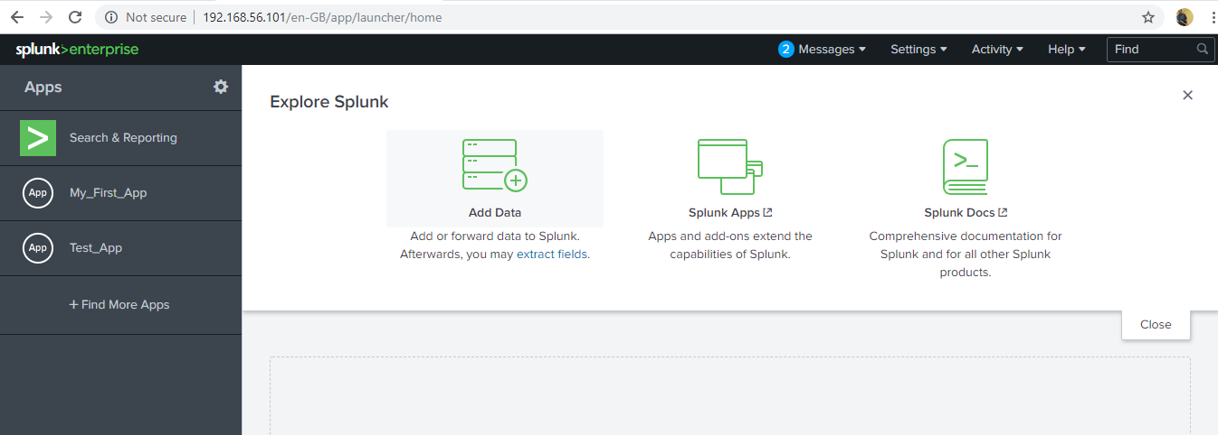

.

|-- bin

| `-- README

|-- default

| |-- app.conf

| `-- data

| `-- ui

| |-- nav

| | `-- default.xml

| `-- views

| `-- README

|-- local

| |-- app.conf

| `-- data

| `-- ui

| |-- nav

| | `-- default.xml

| `-- views

| `-- mydashboard1.xml

`-- metadata

|-- default.meta

`-- local.meta

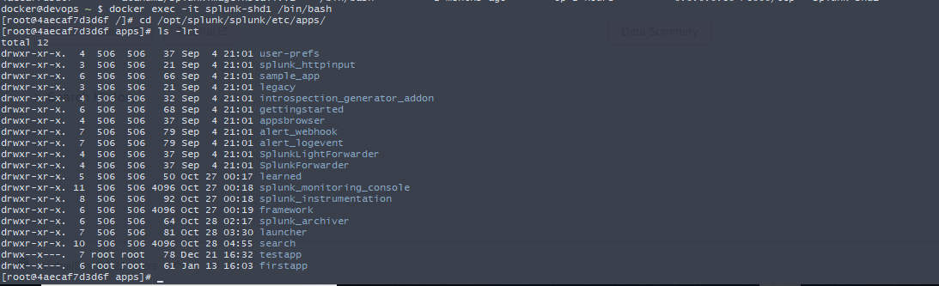

[root@4aecaf7d3d6f apps]# cd firstapp/

[root@4aecaf7d3d6f firstapp]# ls

**bin** **default** **local** **metadata**

[root@4aecaf7d3d6f firstapp]#

[root@4aecaf7d3d6f local]# mkdir -p data/ui/nav

[root@4aecaf7d3d6f local]# ls

app.conf **data**

[root@4aecaf7d3d6f local]#

[root@4aecaf7d3d6f local]# cd data/ui/nav/

[root@4aecaf7d3d6f nav]# ls

default.xml

[root@4aecaf7d3d6f nav]# vi default.xml

[root@4aecaf7d3d6f nav]#

<nav search_view="search">

<view name="search" default='true' />

<view name="datasets" />

<view name="reports" />

<view name="alerts" />

<view name="dashboards" />

<collection label="Lists of Dashboard">

<view name="mydashboard" />

</collection>

</nav>

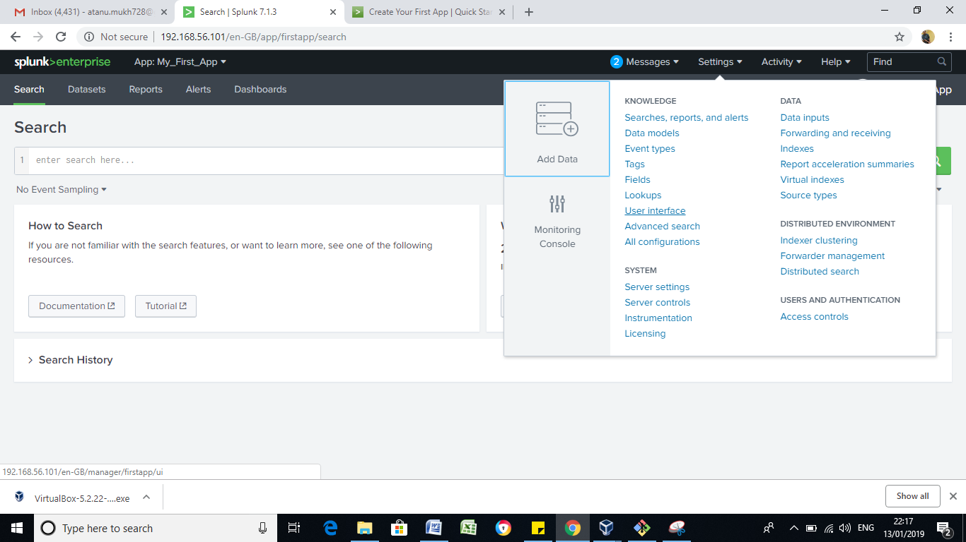

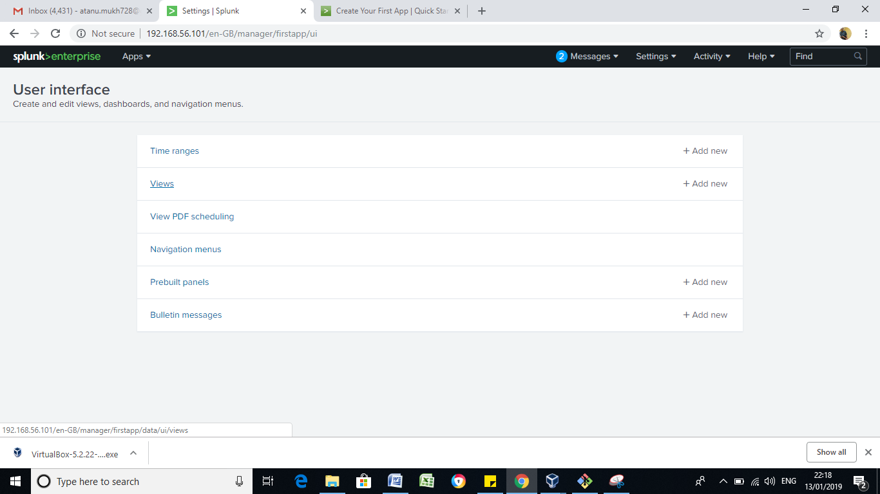

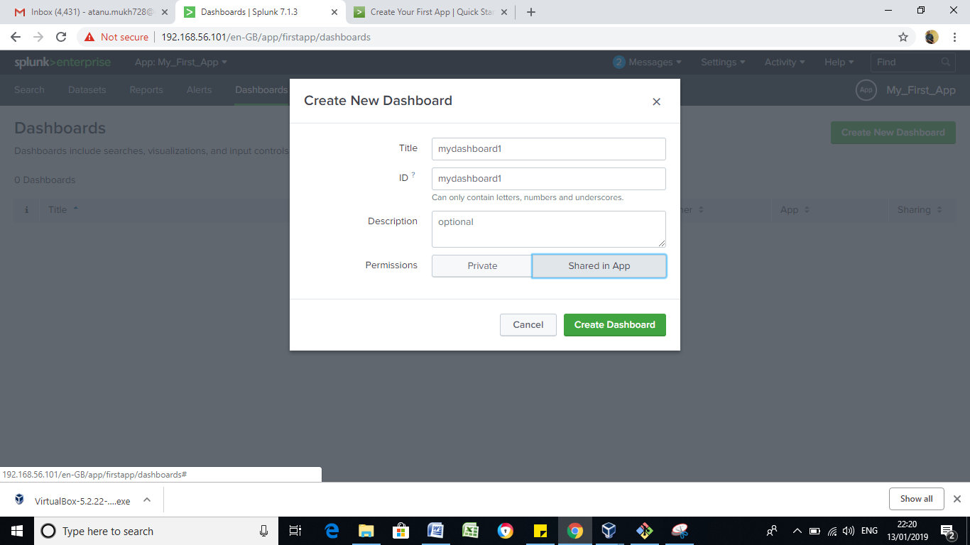

[root@4aecaf7d3d6f nav]# ls

default.xml

[root@4aecaf7d3d6f nav]# vi default.xml

[root@4aecaf7d3d6f nav]# cd ../views/

[root@4aecaf7d3d6f views]# ls

mydashboard1.xml

[root@4aecaf7d3d6f views]# cat mydashboard1.xml

<dashboard>

<label>mydashboard1</label>

</dashboard>[root@4aecaf7d3d6f views]# pwd

/opt/splunk/splunk/etc/apps/firstapp/local/data/ui/views

[root@4aecaf7d3d6f views]#

