Hospital Appointment System

System Design

v1.1

14.12.2019

Atanur Demir
Şükrü Taha Demirer

Prepared for
SE301 Software Engineering


Table of Contents
1. Introduction 1
1.1. Purpose of the System 1
1.2. Design Goals 1
1.3. Definitions, Acronyms, and Abbreviations 1
1.4. References 1
2. Survey of Current Architectures for Similar Systems 1
3. Proposed Software Architecture 1
3.1. Overview 1
3.2. System Decomposition 1
3.3. Hardware Software Mapping 2
3.4. Persistent Data Management 2
3.5. Access Control and Security 2
3.6. Global Software Control 2
3.7. Boundary Conditions 2
4. Subsystem Services 2
5. References 2

SYSTEM DESIGN DOCUMENT

Introduction
This System Design Document for HAS (called as Hospital Appointment System) project provides the complete description of the system. This document also mostly follows the functionalities identified in the SDD document of the project, however some changes has been made in the structural arrangement of the system and all these changes were stated under the related subsections.

As we identified before starting the project, HAS is a web development project and we wrote this project using the Python language and its framework, Django. In addition, we used the MYSQL database for HAS. This database is kept on an online platform (Heroku) in accordance with our web development project.

The concepts and explanations (determination of functional and nonfunctional requirements, writing scenarios, drawing the use-case diagram etc.) that are of great importance in the project development process can be found in the RAD document that we have submitted before.

Purpose of the System
HAS is a replica of an existing hospital appointment system called as MHRS. MHRS acts as a website where only patients can make appointments, view them, change them etc. Doctors do not use this system, each doctor uses a system specific to their own hospital to view appointments and patients, etc. Our aim is to bring both the doctor and the patient together on the same platform within the HAS system.

Design Goals
- Usability: We aim to ensure that the majority of users, both doctors and patients, can easily use the system. In order to achieve this, we try to comply with the template design and the other design methodologies.

- Reusability: In our system, all users can perform their own operations more than once. Functions can be used multiple times without any need to make changes to the system.

- Privacy: Users' personal data (user names, user id no, user phone numbers etc.) should be kept confidential in the system. Our design goal is to keep user data free from potential threats.

- Learnability: We emphasize that the functions within the system are easy to understand. In order to achieve this, we pay attention to the descriptions of the functions, the placement of the buttons and the warning messages on the designed .html pages.

- Accessibility: We aim to make HAS system suitable for every user and a place where every user can be reached. Our system can be accessed online from every interface, and will be available to different users, such as visitors, doctors, admin and patients.

- Maintainability: Has system should be designed in such a way that it is suitable for external intervention whenever required. In order to achieve this, we have given the necessary permissions to the Admin. Administrators will be able to intervene in any aspect of the system and provide the necessary maintenance.

- Reliability: Our system should be in a structure that will not collapse and continue to function in case of potential problems. In accordance with HAS project and the languages we use, we preferred Heroku hosting system. Thanks to this system, the system will be able to continue to operate in a reliable structure without any problems.

- Performance: Our users should not experience performance problems in the system. Users should not wait more than five seconds while being transferred from one page to another. Likewise, users should not wait more than five seconds when login or logout. Our design goal is that the reaction rate of HAS does not exceed the time we have determined.

Definitions, Acronyms, and Abbreviations
HAS | Hospital Appointment System
SDD | System Design Document
RAD | Requirements Specification and Analysis
MHRS | Merkezi Hekim Randevu Sistemi
MVT | Model – View – Template
MVC | Model – View – Controller

References
MHRS Website: https://www.mhrs.gov.tr/

Survey of Current Architectures for Similar Systems
Describe the architecture of the system being replaced. If there is no previous system, this section can be replaced by a survey of current architectures for similar systems. The purpose of this section is to make explicit the background information that system architects used, their assumptions, and common issues the new system will address.

Proposed Software Architecture
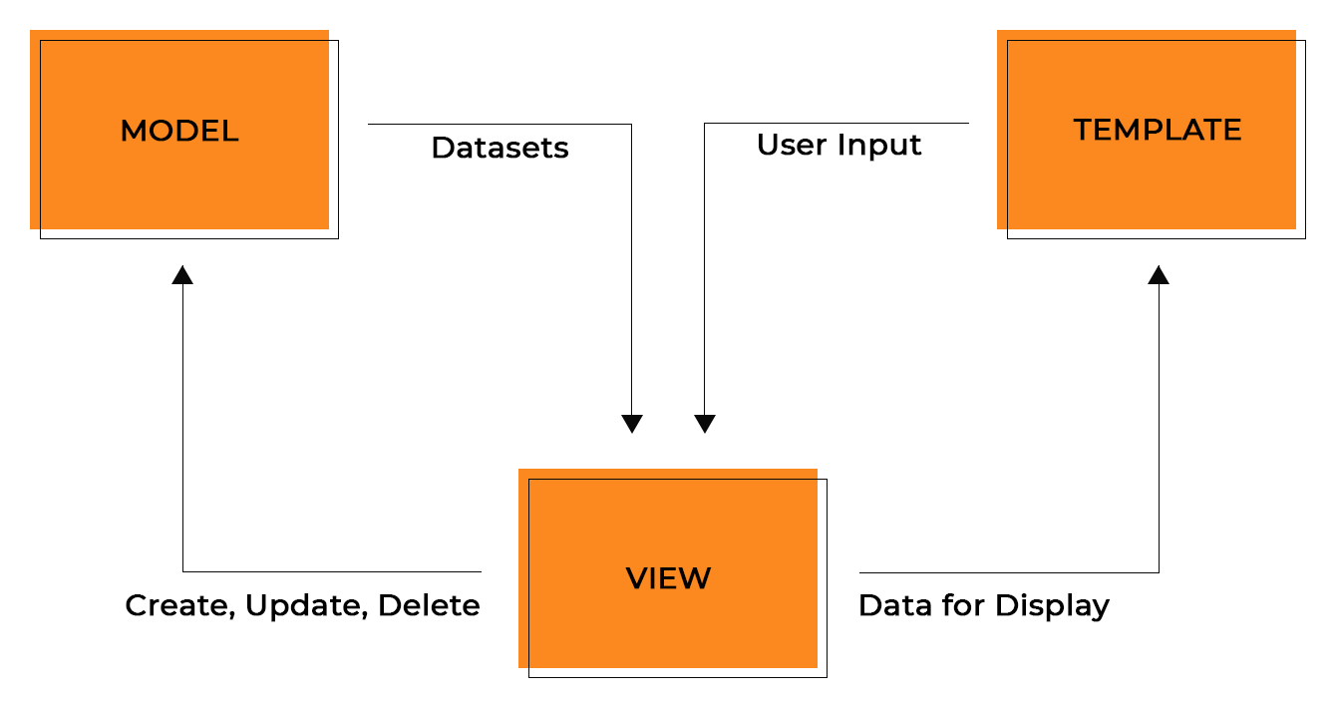

Overview
The HAS system uses Django, a framework for Python language. Django is a high-level Python web framework that enables rapid development of secure and maintainable websites. In addition, it has a design pattern in itself called as MVT pattern.

In a traditional data-driven website, a web application waits for HTTP requests from the web browser (or other client). When a request is received the application works out what is needed based on the URL and possibly information in POST data or GET data. Depending on what is required it may then read or write information from a database or perform other tasks required to satisfy the request. The application will then return a response to the web browser, often dynamically creating an HTML page for the browser to display by inserting the retrieved data into placeholders in an HTML template.

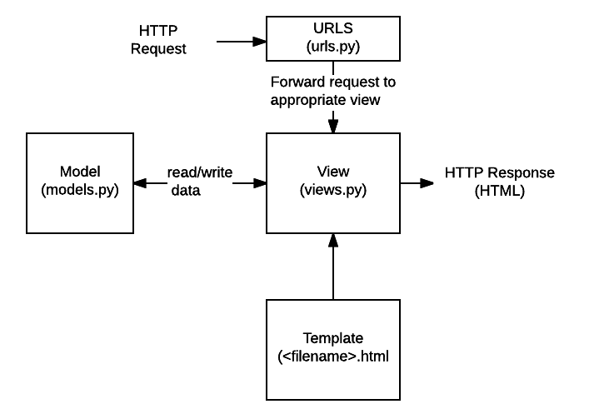
Django web applications typically group the code that handles each of these steps into separate files:

URLs: While it is possible to process requests from every single URL via a single function, it is much more maintainable to write a separate view function to handle each resource. A URL mapper is used to redirect HTTP requests to the appropriate view based on the request URL. The URL mapper can also match particular patterns of strings or digits that appear in a URL and pass these to a view function as data.

View: A view is a request handler function, which receives HTTP requests and returns HTTP responses. Views access the data needed to satisfy requests via models, and delegate the formatting of the response to templates.

Models: Models are Python objects that define the structure of an application's data, and provide mechanisms to manage (add, modify, delete) and query records in the database.

Templates: A template is a text file defining the structure or layout of a file (such as an HTML page), with placeholders used to represent actual content. A view can dynamically create an HTML page using an HTML template, populating it with data from a model. A template can be used to define the structure of any type of file; it doesn't have to be HTML!

System Decomposition
Describe the decomposition into subsystems and the responsibilities of each. This is the main product of system design.

Hardware Software Mapping
Describe how subsystems are assigned to hardware and off-the-shelf components. It also lists the issues introduced by multiple nodes and software reuse.

Persistent Data Management
Describe the persistent data stored by the system and the data management infrastructure required for it. This section typically includes the description of data schemes, the selection of a database, and the description of the encapsulation of the database.

Access Control and Security
Describe the user model of the system in terms of an access matrix. This section also describes security issues, such as the selection of an authentication mechanism, the use of encryption, and the management of keys.

Global Software Control
Describe how the global software control is implemented. In particular, this section should describe how requests are initiated and how subsystems synchronize. This section should list and address synchronization and concurrency issues.

Boundary Conditions
Describe the start-up, shutdown, and error behavior of the system. (If new use cases are discovered for system administration, these should be included in the requirements analysis document, not in this section.)

Subsystem Services
Describe the services provided by each subsystem. Although this section is usually empty or incomplete in the first versions of the SDD, this section serves as a reference for teams for the boundaries between their subsystems. The interface of each subsystem is derived from this section and detailed in the Object Design Document.

References
The following is an example of listing a book in this section. Check the text to see how it is cross referenced (The whole document is based on [1]).

- Bruegge B. & Dutoit A.H.. (2010). Object-Oriented Software Engineering Using UML, Patterns, and Java, Prentice Hall, 3rd ed.

