**Manual- Create Docker Image**

**Pre-requisites:**

* GIT installed
* Docker installed

**Please follow the below steps in order to build a Docker Image for the web-application (Front end)**

* **Step 1** - Open command Terminal and Checkout the repository <https://github.com/atanusarkar001/simplewebapplication.git>
  + Git clone <https://github.com/atanusarkar001/simplewebapplication.git>
  + 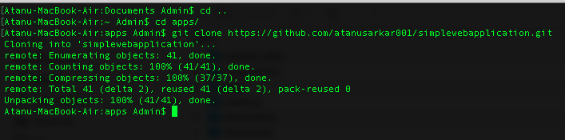
* **Step 2** - Navigate to folder simplewebapplication in checked out location in your local hard drive i.e C:\ABS\simplewebapplication\
* **Step 3** – Run the following command. This will create a Docker image named simpleapp for the web-application
  + docker build --rm -f simpleapp/Dockerfile -t simpleapp:v1 simpleapp
  + 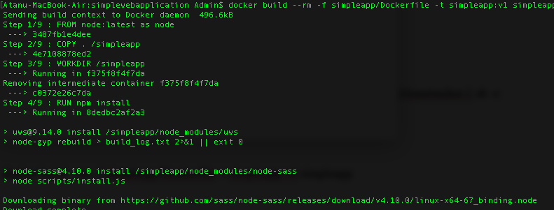
  + 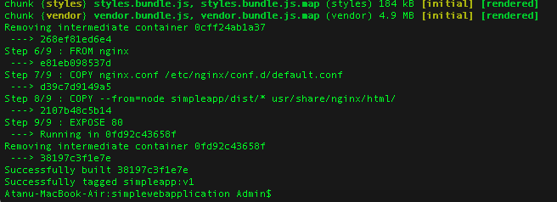
* **Step 4** – Run the following command in order to create a new network. We are going to run both the Front end and back end inside the same network.
  + docker network create -d bridge newnetwork
* **Step 5** – Run the following command in order to run the backend application container and attach it to the newly created network at the same time. The backend application is called timetracker and an already built Image is existing in the dockerhub
  + docker run -d --name backend --network newnetwork -p 8080:8080 alirizasaral/timetracker:1
  + Container is now running and can be tested with the below url
  + http://localhost:8080/records?email=aliriza.saral@gmail.com
  + 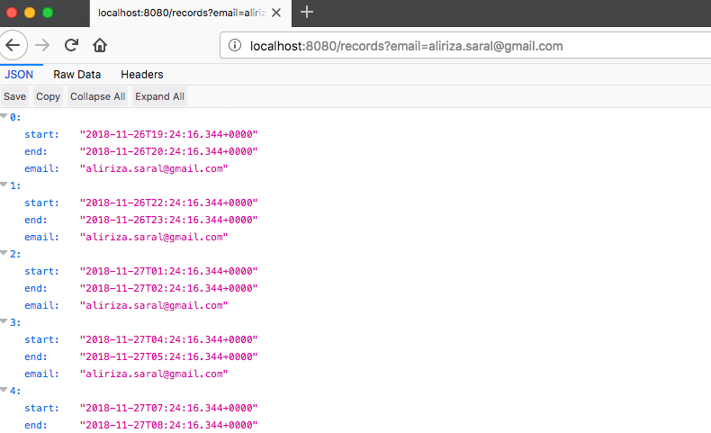
* **Step 6** – Execute the following command to run the Frontend application container and attach it to the network as well
  + docker run -d --name webapp --network newnetwork -p 8300:80 simpleapp:v1
* **Step 7** - Both the front end and the backend are up and running and ready to use. Please go through the How to Use Frontend manual to test it.