**Manual- How to Use The Front end**

**Pre-requisites:**

* Steps mentioned in Manual Create Docker Image have been successfully performed
* Recommended browser- Chrome, Firefox

**Please follow the below steps in order to Use the already up and running Web application**

* **Step 1** - Open http://localhost:8300 on your browser.
* **Step 2** - Select radio button for Search
* **Step 3** - Fill in an email address which is already existing in the timetracker service (i.e.

[aliriza.saral@gmail.com](mailto:aliriza.saral@gmail.com))

* **Step 4** - You can select the max number of results you want (default is 10)
* **Step 5** - Click on search button. Email address, In time and out time should be displayed in a table below

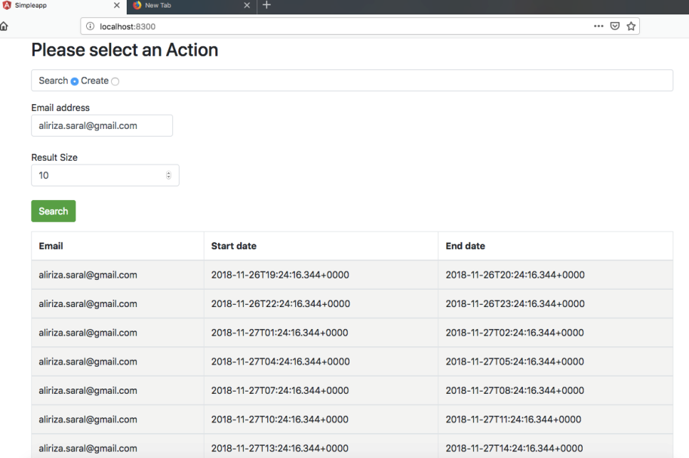

* **Step 6** - Select radio button create.
* **Step 7** - Fill in an email address in email text box (Email format validation exist) .i.e [somerandomguy@gmail.com](mailto:somerandomguy@gmail.com)
* **Step 8** - Select Start and end date and time from the date and time pickers
* **Step 9** - Click on button add new entry. If message 'Insert was a success' shows up. Then the insert was successful.

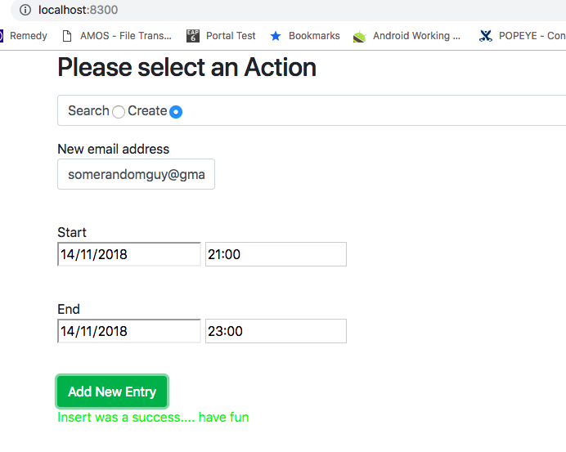

* **Step 10** - Click on search radio select and search for email address somerandomguy@gmail.com recently inserted.
* **Step 11** - Results should be displayed including the new entries.