Secure system engineering
Assignment :-1
Name: Atara Rushi
Roll No: cb.sc.p2cys25005

1. Introduction
This lab demonstrates building a secure authentication system using bcrypt, simulating attacks using Hydra, implementing protections like rate limiting and account lockout, and adding TOTP-based 2FA.

2. Aim
To design and implement a secure login system and protect it from credential stuffing attacks.

3. Tools Used
Node.js, Express, MySQL (XAMPP), bcrypt, Hydra (Kali Linux), Speakeasy, Google Authenticator

4. Database Design
CREATE TABLE users (
id INT AUTO_INCREMENT PRIMARY KEY,
email VARCHAR(255) UNIQUE,
password VARCHAR(255),
failed_attempts INT DEFAULT 0,
lock_until BIGINT DEFAULT NULL,
twofa_secret VARCHAR(255),
twofa_enabled BOOLEAN DEFAULT FALSE,
last_otp VARCHAR(10),
last_otp_time BIGINT
);

5. Phase 1: bcrypt Implementation
Passwords are hashed before storing.
const hash = await bcrypt.hash(password,10);
Login uses compare:
await bcrypt.compare(password,user.password);
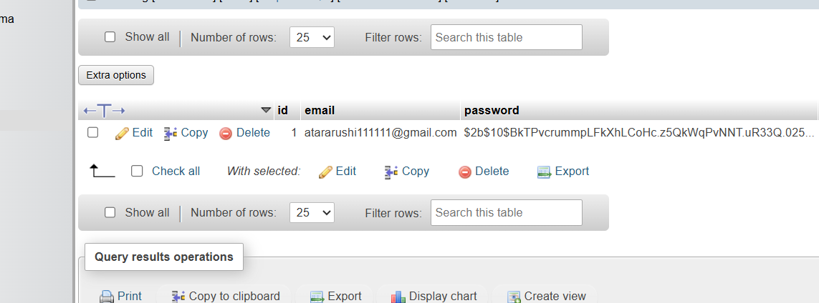
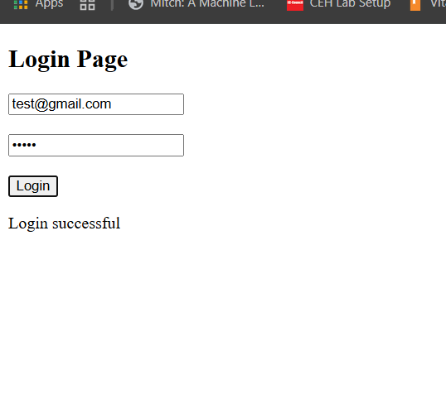
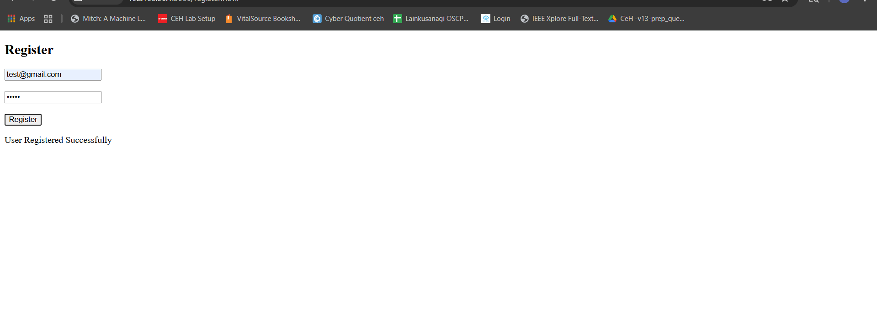

6. Phase 2: Attack using Hydra
Hydra performs credential stuffing attack.
hydra -V -l test@gmail.com -P rockyou.txt 192.168.X.X -s 5000 http-post-form "/login:email=^USER^&password=^PASS^:S=Login success"
Result: Password cracked before protection.
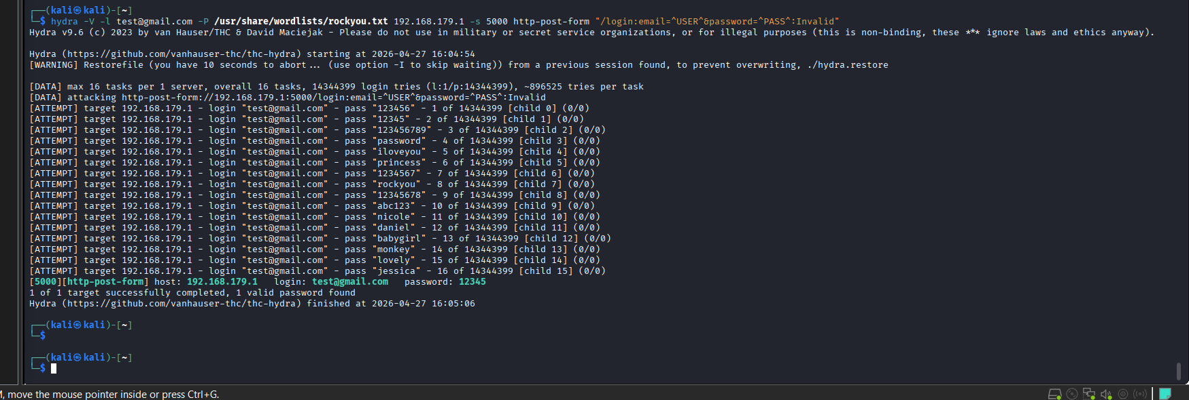

7. Phase 3: Protection
Rate limiting restricts attempts.
const limiter = rateLimit({windowMs:60000,max:5});
Account lockout:
if(attempts>=5){
lock=Date.now()+15*60*1000;
}
Result: Attack blocked.
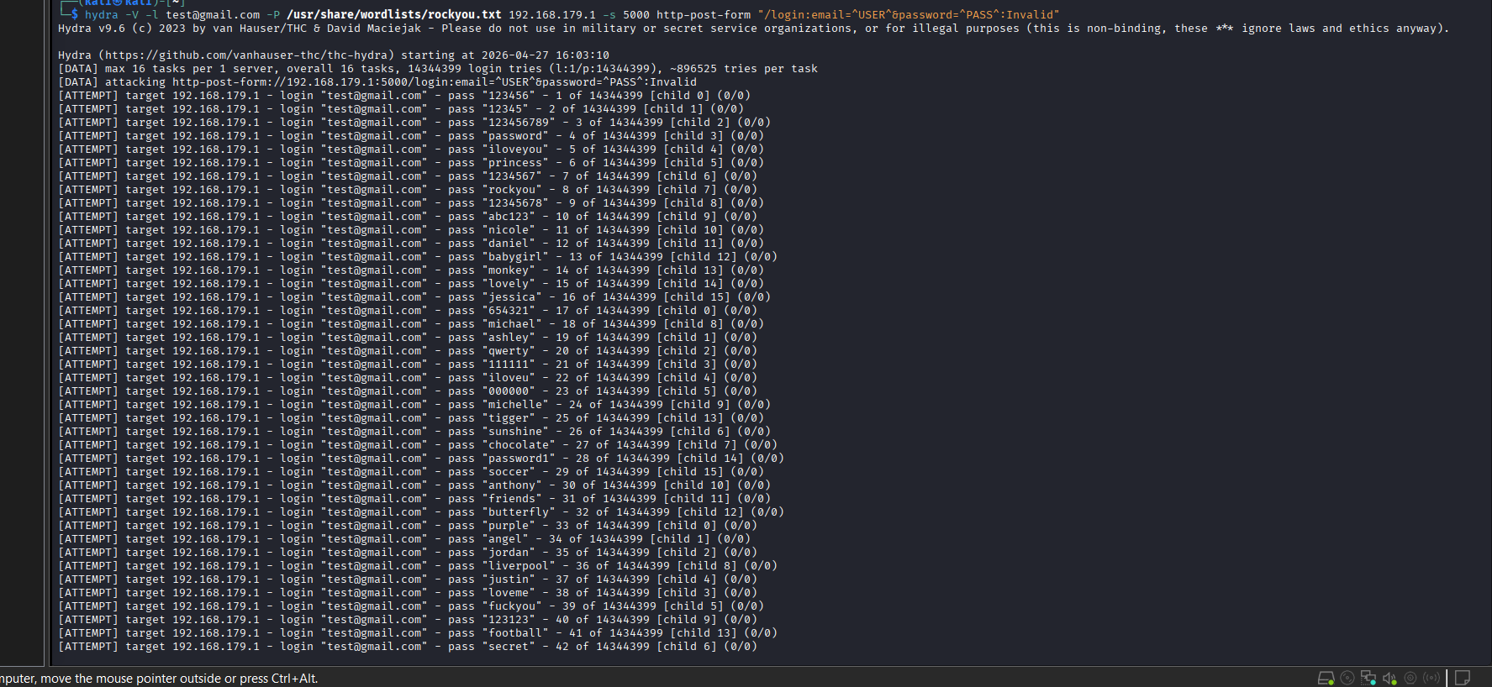
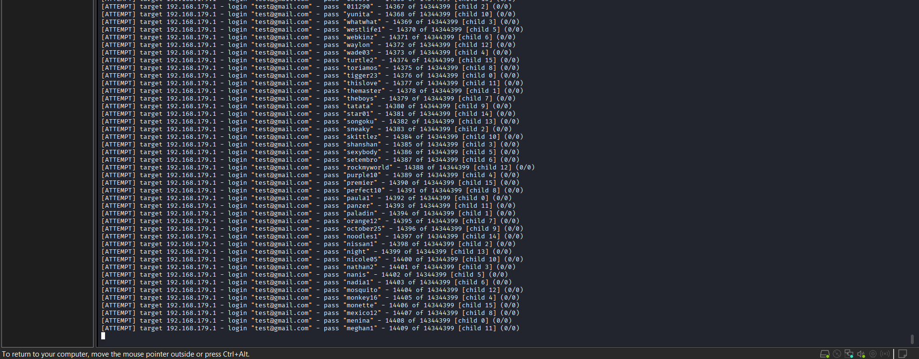

8. Phase 4: 2FA (TOTP)
Secret generated and QR displayed.
const secret=speakeasy.generateSecret({length:20});
QRCode.toDataURL(secret.otpauth_url);
User scans QR using Google Authenticator.
Screenshot: QR + Authenticator OTP
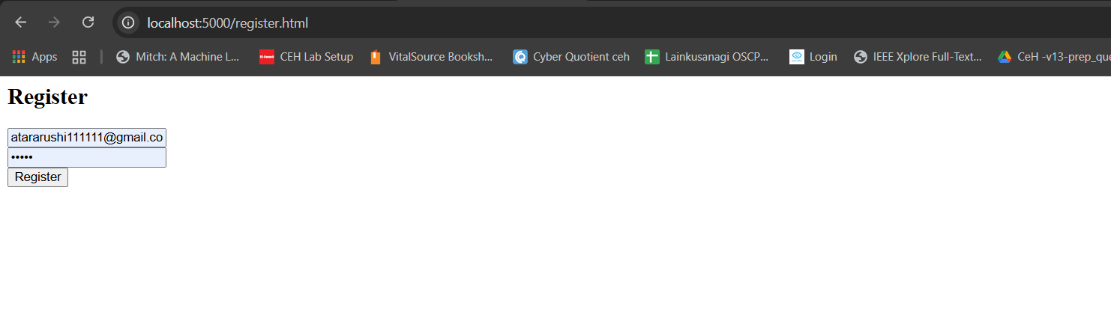
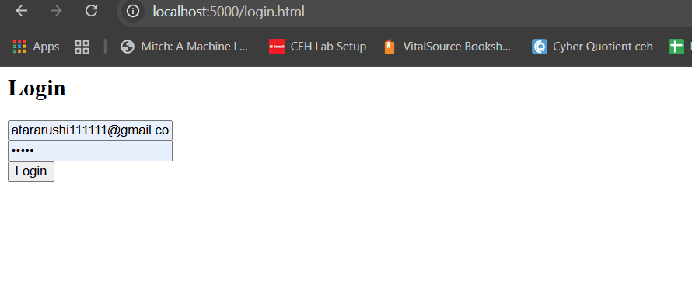
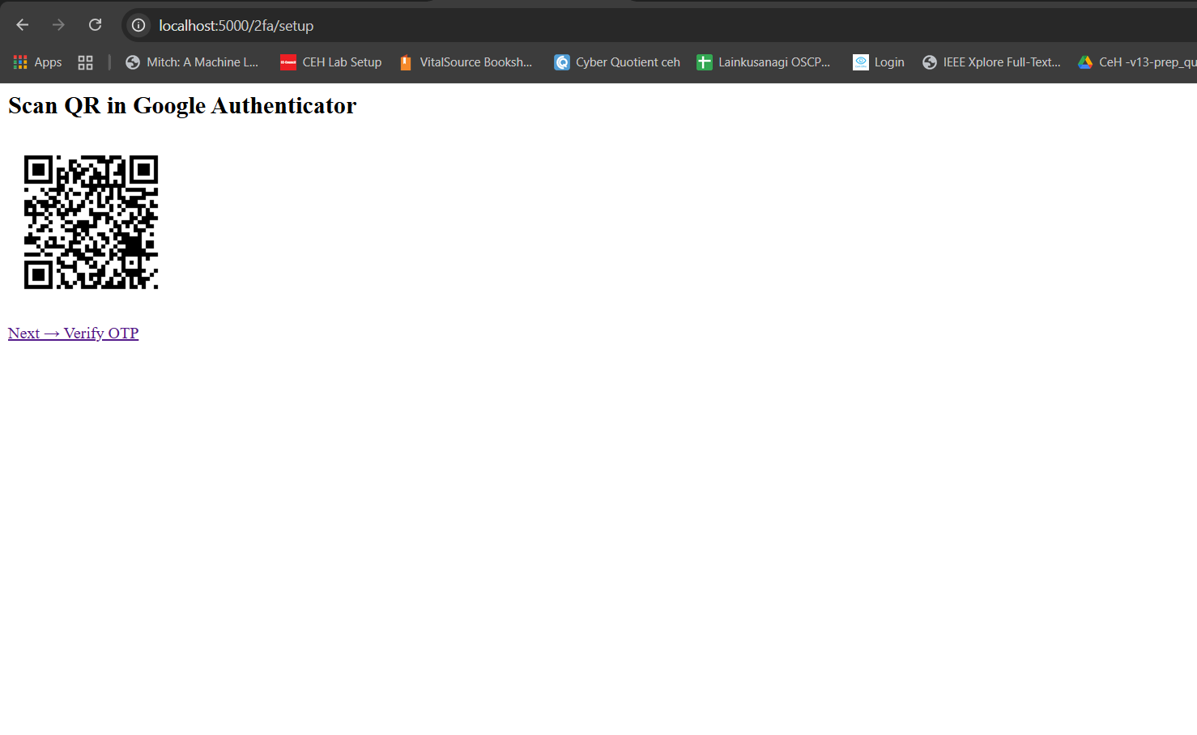

9. OTP Verification
speakeasy.totp.verify({
secret:user.twofa_secret,
encoding:"base32",
token,
window:2
});
if(user.last_otp===token){
return "Replay attack detected";
}
Screenshots: success, invalid OTP, replay

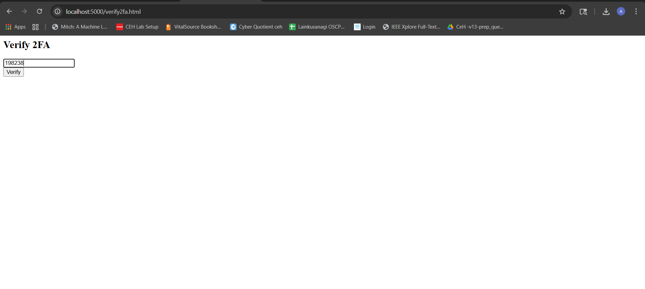
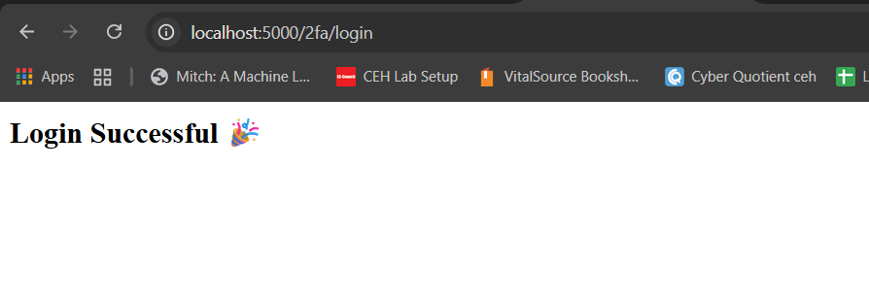

10. Complete Flow
Register → Login → Setup QR → Scan → Verify → Login again → OTP → Access

11. Sample Logs
SESSION SET: test@gmail.com
EXPECTED OTP: 123456
USER OTP: 123456
Login Successful

12. Analysis
Before: attack successful
After: blocked
With 2FA: fully secure

13. Conclusion
System secured using multi-layer approach.
Github repo :
https://github.com/atararushi001/system_secure_Assignment_1

