Nature of Data:
Bimonthly Data from Jan-Feb 2000 to Nov-Dec 2024
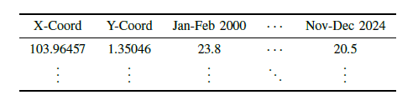
Prediction Task:
- Forecasting LST for the midterm predictive scenario (up to 2 years ahead)
Approaches:
- Rolling Window
  - Pick length k of training data (We will limit our investigation to k ∈ {9,10,11,12,13} years to save time); these choices also make sense for the mid-term predictive scenario
  - Randomly pick a sample of 10 training sets (of length k) and their corresponding validation sets (their true values up to 2 years ahead) to train our data and validate our data
    - Concrete E.g. A randomly picked sample of a training set for years = 9 would be {Mar-Apr 2000,…,Jan-Feb 2009} and my validation set would be {Mar-Apr 2009,…, Jan-Feb 2011}
  - Average the 10 sample RMSE statistics (5 in total) over all 10 training sets to get the final RMSE statistics
    - We let RMSE_q be the RMSE obtained by just considering the prediction for forecast horizon of q
      - RMSE_1 will be the RMSE that considers the forecasts made for the 1st 2-month period and RMSE_3 considers the 3rd 2-month period and so on
    - For each window k, we get the final RMSE_1, RMSE_3, RMSE_6, RMSE_9, RMSE_12, and their average
- 23 years Train/2 years Test Split
  - Use 2000-2022 as our training data and 2023-2024 as our test data
  - The rest of the steps are the same as the Rolling Window Approach

Baseline Models:

ARIMA

 | Window = 9 | Window = 10 | Window = 11 | Window = 12 | Window = 13 | Window=  23 (23/2 Split)
RMSE_1 | 3.04 | 3.47 | 3.83 | 4.93 | 6.40 | 5.88
RMSE_3 | 3.22 | 2.87 | 5.04 | 6.62 | 6.51 | 2.54*
RMSE_6 | 3.10 | 2.75 | 3.71 | 5.59 | 6.28 | 4.08
RMSE_9 | 2.50 | 2.59 | 3.87 | 4.45 | 5.34 | 1.19*
RMSE_12 | 2.67 | 2.87 | 2.56 | 3.30 | 5.93 | 4.93
Average | 2.91 | 2.91 | 2.81 | 4.98 | 6.09 | 3.72

Interpretation

- Prior Knowledge:
  - ARIMA tends to perform better in the short-term predictive scenario (up to few months ahead), especially when no sudden structural changes are expected
- Results show that ARIMA performs best when trained on train data of smaller window sizes (5yrs)
  - ARIMA is less able to capture longer term trends in train data of larger window sizes
- Advantages and Disadvantages of ARIMA:
  - Adv: Model is interpretable along time dimension
  - Adv: Model does not require large amounts of data to get decent results (RMSE < 3)
  - Disadv: Model tells us nothing about spatial autocorrelation
  - Disadv: Separate ARIMA model must be fit for each point

LSTM (Trained for 100 epochs)

Without Regularization

 | Window = 9 | Window = 10 | Window = 11 | Window = 12 | Window = 13 | Window=  23 (23/2 Split)
RMSE_1 | 3.55 | 2.08 | 4.15 | 2.77 | 2.60 | 5.51
RMSE_3 | 3.56 | 1.52 | 2.90 | 2.24 | 2.17 | 1.72
RMSE_6 | 3.18 | 1.63 | 2.76 | 2.27 | 2.08 | 2.93
RMSE_9 | 3.57 | 1.60 | 3.71 | 2.17 | 2.47 | 1.15
RMSE_12 | 3.12 | 1.51 | 3.38 | 2.42 | 2.00 | 3.92
Average | 3.40 | 1.67 | 3.38 | 2.37 | 2.26 | 3.05

With Regularization (Dropout = 0.2, Weight Decay = 1e-6)

 | Window = 9 | Window = 10 | Window = 11 | Window = 12 | Window = 13 | Window=  23 (23/2 Split)
RMSE_1 | 3.54 | 2.09 | 4.15 | 2.79 | 2.61 | 5.48
RMSE_3 | 3.54 | 1.51 | 2.91 | 2.23 | 2.17 | 1.96
RMSE_6 | 3.15 | 1.63 | 2.76 | 2.27 | 2.08 | 3.12
RMSE_9 | 3.53 | 1.58 | 3.71 | 2.17 | 2.46 | 1.10
RMSE_12 | 3.07 | 1.52 | 3.37 | 2.45 | 2.01 | 3.98
Average | 3.37 | 1.67 | 3.38 | 2.38 | 2.27 | 3.13

- Prior Knowledge:
  - LSTM tends to perform better in the long-term predictive scenario (up to a decade ahead)
  - Data-intensive and requires more data than GPs/ARIMA models to produce better estimates
- Results show that as expected, LSTM performs generally better when trained on longer window sizes
  - For the 23/2 train-test split, results might be better if we allow for longer training
  - Regularization here has minimal improvement on results
- Advantages and Disadvantages of LSTM:
  - Adv: Model allows for the most flexibility in capturing complex relationships
  - Disadv: Model requires larger amounts of data to perform well, and LST data is scarce
  - Disadv: Model is not that interpretable for policymakers
Bayesian GP Model :
Setup:
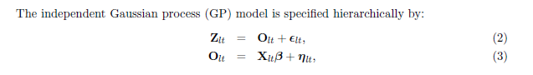
where l is the spatial dimension while t is the time dimension. Z_{lt} represents the observed LST values, O_{lt} is the sum of regressors whose coefficients are in \beta and a Gaussian process {\eta_lt}. epsilon_{lt} is the nugget effect, a Gaussian random variable which explains leftover variance.
This is a Bayesian hierarchical model where parameters are estimated via MCMC (Markov Chain Monte Carlo) (such as the \beta coefficients).
Things we can experiment with this model:
- What choice of regressors to choose (lags.. I have Z_t, maybe I can regress on Z_{t-1}, .. Z_{t-k}, we can choose k)
- What covariance function to model our spatial autocorrelation
- How to deal with our spatial decay parameter/hyperparameter \phi found in the covariance function
  - Can treat as a hyperparameter and use Grid Search to find optimal
    - Phi is a member of {0.1,0.2,…,2}
  - Can treat as a parameter and estimate within the Bayesian MCMC framework
  - Some other approach?
Reason for choice:
- Has been successful in modelling environmental space-time data such as concentration of pollutants
  - Hints at possible success in something similar like LST modelling although never applied to it
- In comparison to ARIMA and LSTM:
  - Allows for more flexible modelling of Spatio-temporal relationships through the kernel/covariance function and regressors, capturing more complex relationships than ARIMA
  - Provides more interpretability than LSTM through its parameters where spatial decay in the covariance function can tell us for example the effective range of spatial autocorrelation
- Bayesian framework provides useful uncertainty quantification of parameters and forecasts which is useful for policymakers Z
GP Experiment Results:
General Methodology for GP Experiments:
- From our 25 years of data, sample randomly 10 10/2-years train-test splits
- Pick a variable to test while keeping all other variables constant
- For each level of our test variable, fit models to each of our 10 10/2-years train-test splits and find their RMSE statistics
  - We let RMSE_q be the RMSE obtained by just considering the prediction for forecast horizon of q
      - RMSE_1 will be the RMSE that considers the forecasts made for the 1st 2-month period and RMSE_3 considers the 3rd 2-month period and so on
  - We get the following RMSE statistics: RMSE_1, RMSE_3, RMSE_6, RMSE_9, RMSE_12, and their average

- Average the RMSEs to get the representative RMSE statistics for each level of our test variable

- Finding optimal number of lags to regress on

 | Lag = 1 | Lag = 2 | Lag = 3  (Optimal) | Lag = 4 | Lag = 5 | Lag = 6
RMSE_1 | 1.76 | 1.76 | 1.76 | 1.88 | 1.93 | 1.96
RMSE_3 | 2.92 | 2.89 | 2.86 | 3.06 | 3.01 | 3.06
RMSE_6 | 2.31 | 2.19 | 2.15 | 2.42 | 2.38 | 2.45
RMSE_9 | 2.95 | 2.87 | 2.81 | 2.98 | 2.90 | 2.95
RMSE_12 | 2.80 | 2.74 | 2.79 | 3.09 | 3.01 | 3.03
Average | 2.55 | 2.49 | 2.47 | 2.69 | 2.65 | 2.69

- Using 3 lags (equivalent to 6 months worth of previous LST data) seems to give the best model before reaching a plateau for average RMSE

- Finding optimal covariance function

 | Exponential | Spherical  (Optimal) | Gaussian | Matern
RMSE_1 | 1.70 | 1.69 | NA | NA
RMSE_3 | 2.93 | 2.89 | NA | NA
RMSE_6 | 2.24 | 2.18 | NA | NA
RMSE_9 | 2.88 | 2.84 | NA | NA
RMSE_12 | 2.82 | 2.77 | NA | NA
Average | 2.51 | 2.47 | NA | NA

- Gaussian and Matern functions do not give good fits (Estimation process results in non-positive definite matrices)
- Exponential and Spherical functions which handle more drastic/harsh decreases in spatial autocorrelation suit our model better
  - This implies that in our spatial data, there is rapid decrease in spatial autocorrelation

- Comparison between Bayesian Inference and Grid Search Approaches for our Spatial Decay Parameter/Hyperparameter Phi
Bayesian Inference

 | Small mean,  Low variance | Small mean,  High variance | Medium mean,  Low variance | Medium mean,  High variance | Large mean,  Low variance | Large mean,  High variance | Uninformative (flat)
RMSE_1 | 1.69 | 1.68 | 1.69 | 1.68 | 1.69 | 1.69 | 1.68
RMSE_3 | 2.89 | 2.89 | 2.89 | 2.89 | 2.89 | 2.89 | 2.89
RMSE_6 | 2.18 | 2.18 | 2.18 | 2.18 | 2.18 | 2.18 | 2.18
RMSE_9 | 2.85 | 2.84 | 2.84 | 2.84 | 2.84 | 2.84 | 2.84
RMSE_12 | 2.77 | 2.77 | 2.77 | 2.77 | 2.77 | 2.77 | 2.77
Average | 2.47 | 2.47 | 2.47 | 2.47 | 2.47 | 2.47 | 2.47

- Choice of prior does not really matter for our model estimation (Prediction performance is not sensitive to choice of prior)
Phi estimated is normally located in the range of 0.5 to 1 for Bayesian Inference
Grid Search
 | Phi = 0.6 | Phi = 0.8 | Phi = 1.0 | Phi = 1.2 | Phi = 1.4 | Phi = 1.6
RMSE_1 | 1.76 | 1.75 | 1.75 | 1.76 | 1.76 | 1.77
RMSE_3 | 2.85 | 2.86 | 2.88 | 2.90 | 2.92 | 2.95
RMSE_6 | 2.15 | 2.16 | 2.18 | 2.20 | 2.22 | 2.25
RMSE_9 | 2.81 | 2.82 | 2.83 | 2.86 | 2.88 | 2.91
RMSE_12 | 2.78 | 2.79 | 2.79 | 2.80 | 2.81 | 2.83
Average | 2.47 | 2.48 | 2.49 | 2.50 | 2.52 | 2.54

- Carefully chosen candidate values in Grid Search can give average RMSE values as good as Bayesian Inference
- In some cases, the RMSE for individual models fitted using Grid Search are better (Within our sample of 10 models fitted)
- This implies that a possible methodology we can use would be:
  - First fit our Bayesian GP model by treating our spatial decay parameter, phi, as a parameter to be estimated by Bayesian MCMC and get an estimate value of phi by using the median of the posterior
  - Create a list of candidate values for phi near the estimated value to refit our Bayesian GP model using Grid Search

GP Results
 | Window = 9 | Window = 10 | Window = 11 | Window = 12 | Window = 13 | Window=  23 (23/2 Split)
RMSE_1 | 2.63 | 3.76 | 1.74 | 2.86 | 2.26 | 2.06
RMSE_3 | 3.87 | 3.40 | 2.69 | 2.02 | 2.69 | 6.23
RMSE_6 | 4.32 | 3.04 | 4.12 | 2.65 | 2.28 | 1.85
RMSE_9 | 2.77 | 2.85 | 2.30 | 2.44 | 1.82 | 0.98
RMSE_12 | 3.30 | 4.17 | 2.10 | 2.35 | 2.38 | 3.28
Average | 2.98 | 3.44 | 2.59 | 2.46 | 2.29 | 2.88

Comparison between GP and ARIMA Results:
ARIMA Results:
 | Window = 9 | Window = 10 | Window = 11 | Window = 12 | Window = 13 | Window=  23 (23/2 Split)
RMSE_1 | 3.04 | 3.47 | 3.83 | 4.93 | 6.40 | 5.88
RMSE_3 | 3.22 | 2.87 | 5.04 | 6.62 | 6.51 | 2.54*
RMSE_6 | 3.10 | 2.75 | 3.71 | 5.59 | 6.28 | 4.08
RMSE_9 | 2.50 | 2.59 | 3.87 | 4.45 | 5.34 | 1.19*
RMSE_12 | 2.67 | 2.87 | 2.56 | 3.30 | 5.93 | 4.93
Average | 2.91 | 2.91 | 2.81 | 4.98 | 6.09 | 3.72

- GP model outperforms ARIMA as training data (in terms of average RMSE) increases (from window 11 onwards) - reflection of its superior ability to capture longer-term trends
LSTM Results:
 | Window = 9 | Window = 10 | Window = 11 | Window = 12 | Window = 13 | Window=  23 (23/2 Split)
RMSE_1 | 3.55 | 2.08 | 4.15 | 2.77 | 2.60 | 5.51
RMSE_3 | 3.56 | 1.52 | 2.90 | 2.24 | 2.17 | 1.72
RMSE_6 | 3.18 | 1.63 | 2.76 | 2.27 | 2.08 | 2.93
RMSE_9 | 3.57 | 1.60 | 3.71 | 2.17 | 2.47 | 1.15
RMSE_12 | 3.12 | 1.51 | 3.38 | 2.42 | 2.00 | 3.92
Average | 3.40 | 1.67 | 3.38 | 2.37 | 2.26 | 3.05

- GP model outperforms LSTM in terms of average RMSE increases for window 9, window 11 and the 23/2 split, while it is only slightly less accurate than LSTM for windows 12 and 13 (difference in average RMSE < 0.1); this is expected due to LSTM’s greater flexibility but this makes GPs an attractive option since they are more interpretable while only being slightly less accurate than LSTMs

Showcasing Interpretability of GP Results:
Predictions and Uncertainty Quantification:
Left: True Values
Middle: Predictions for forecast horizon h
Right: Prediction Interval to showcase uncertainty (Same for all h)
h = 1
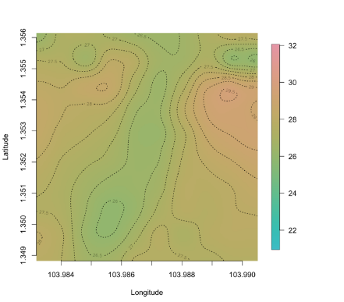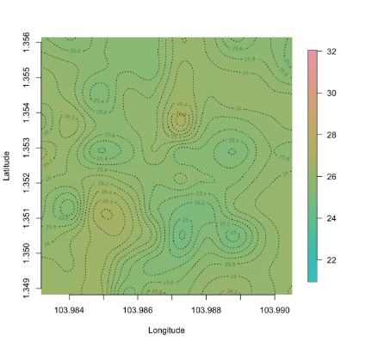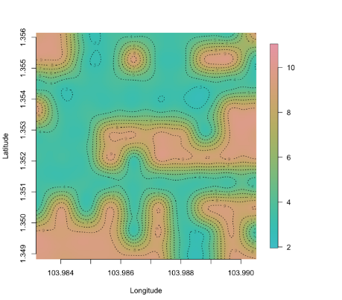

h = 6
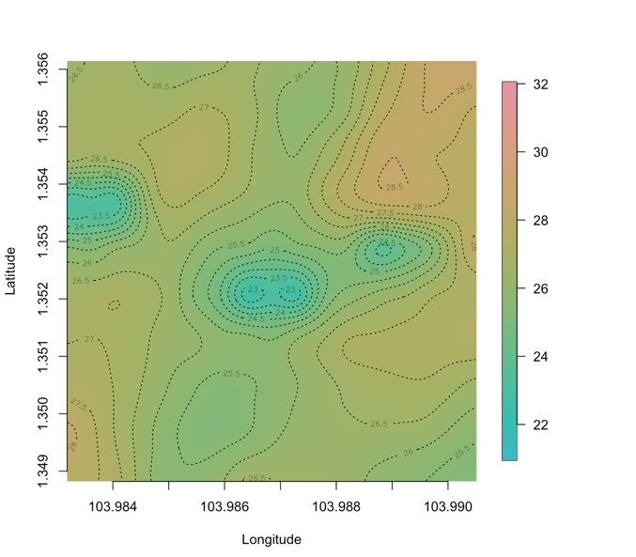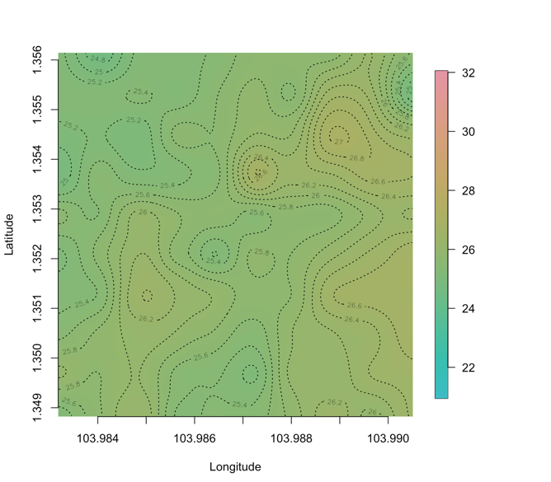
One can further calculate parameters such as:
- Effective Range: 1.18km (One can expect values within 1.18km to be similar)
  - When implementing cooling strategies, such strategies should cover such an area

Revisiting Project Objective Objectives:
- Primary Objective: Develop a spatio-temporal GP model that balances predictive accuracy and interpretability for mid-term LST forecasting in localized neighborhoods ✓
  - By predictive accuracy, we mean having a low average RMSE over forecast horizons < 3
  - By interpretability, we mean deriving metrics which would help policymakers in their decision making, i.e. prediction intervals and effective range
- Secondary Objectives:
  - Compare the GP-based solution to existing methods in terms of predictive accuracy ✓
  - Evaluate different hyperparameter selection frameworks for GPs ✓
  - Showcase GP model’s interpretability advantages over ML models ✓
Revisiting Success Measures
- Relatively Low RMSE
  - GP average RMSE of 2-3, values considered good w.r.t literature ✓
  - Superior performance than ARIMA ✓ but only for windows > 10
  - Average RMSE not worse than LSTM > 1 ✓
- Retrieval of Interpretable insights from GP models
  - Prediction intervals and effective range helps policymakers estimate variability of LST and the spatial area in which cooling interventions should be implemented ✓
- Insights from Experiments w.r.t Hyperparameter Optimization and Kernel Selection
  - Methodology which uses Bayesian inference as the first step to estimate the phi parameter and Grid Search as the second step to finetune the phi parameter leads to the best accuracy ✓

