Bilkent University Ata Seren

CS353 Database Systems Section-2

Homework 2 Answers 21901575

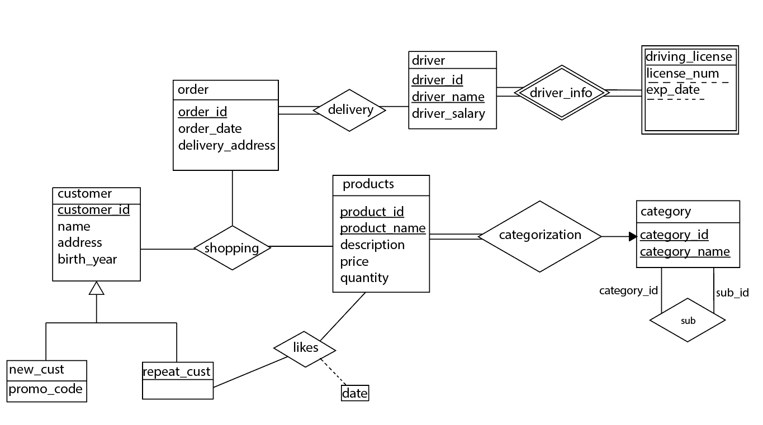Q1) ER Diagram of database system for an online pet shop:

Q2) Relational model of the ER diagram:

customer(customer_id, name, address, birth_year)

products(product_id, product_name, description, price, quantity)

order(order_id, order_date, delivery_address)

shopping(customer_id, product_id, product_name, order_id)

FK: customer_id references customer

FK: (product_id, product_name) references products

FK: order_id references order

new_cust(customer_id, promo_code)

FK: customer_id references customer

repeat_cust(customer_id)

FK: customer_id references customer

likes(product_id, product_name, customer_id,date)

FK: (product_id, product_name) references products

FK: customer_id references repeat_cust

driver(driver_id, driver_name, driver_salary)

delivery(driver_id, driver_name, order_id)

FK: (driver_id, driver_name) references driver

FK: order_id references order

driving_license(driver_name, license_num, exp_date)

FK: driver_name references driver

category(category_id, category_name)

sub(category_id, sub_id)

FK: category_id references category

categorization(category_id, category_name, product_id, product_name)

FK: (category_id, category_name) references category

FK: (product_id, product_name) references products