- Abstract
Understanding the principles of information transfer along the nerve fibres is a key issue for biomedical studies since it is the starting point of further studies such as ENG and EEG. Studies in the past have shown that the information transfer along a nerve fibre is mainly related with ion flow across the nerve cell membrane and the membrane voltage due to the differences of the ion concentrations inside and outside the nerve. Furthermore, it is also known that the nerve cell membrane can be modeled by means of electrical idealizations used in the circuit theory in order to obtain a characterization for propagating information in the form of action potentials. The purpose of this study is to obtain a powerful tool for computational modeling of the nerve cell for both action potential generation and propagation. A user-friendly interface is also aimed.

- Introduction
The nerve cell membrane has a semi-permeable structure with different permeabilities to different ions. The most significant ions for action potential generation and propagation are sodium (Na⁺), Potassium (K⁺), and Chlorine (Cl⁻). The semi-permeable structure of the nerve cell membrane and the electrogenic Na-K pump cause an ion concentration difference and a resulting potential gradient across the membrane. This potential (named as the Nernst potential) difference is formulated in terms of the ion concentrations at both sides of the membrane, ion permeability, ion valance, electron charge and temperature. As an example, for sodium:
E_{Na}= -k.T.ln( [Na_{i}⁺]/[Na_{o}⁺] )/(z_{Na}.q) (1)
k is the Boltzman’s constant, z_{Na} is the valance of Na⁺ (which is +1), [Na_{i}⁺] and [Na_{o}⁺] are Na⁺ concentrations inside and outside the cell, respectively.
Typical voltage across a nerve cell membrane that is not stimulated is around -90mV (the reference electrode is assumed to be in the extracellular fluid) and called the resting membrane potential (V_{r}). Due to separated charges at a distance w (width of the membrane), a membrane capacitance is also present. At rest situation, Na⁺ concentration is higher outside and the K⁺ potential is higher inside the cell membrane.
When current is applied by some means to the membrane and the net positive charge is increased inside the cell, the membrane voltage increases towards zero from –90mV. Relating to the amplitude and the duration of the applied current, membrane voltage may change in different ways. The membrane voltage increases gradually (although having a non-linear behavior) up to a certain level. When that threshold is exceeded, a sharp peak is observed. This peak is explained with the change in the membrane conductance for certain ions and is called the action potential. The membrane has voltage gated Na and K channels, which are opened at different voltage levels, providing higher conductance for the related ions and resulting in a change of the membrane voltage beyond the effect of the applied current. That is, the membrane “fires” after some level (dependent on the applied input’s amplitude & duration) of applied stimulus.
The experiments on the nerve cell characteristics are performed and appropriate explanatory nerve cell membrane model is developed by Hodgkin & Huxley (the detailed information is presented in the theory part). In the Hodgkin & Huxley experiment, current is applied into the cell with a setup that allows adjusting the cell membrane voltage to a desired level. By blocking ion channels selectively with the help of certain drugs, individual ion currents and the related voltage characteristics are measured. After the collection of data, a numerical model is developed for membrane conductance for certain ions by methods in the sense of curve fitting. This model is very useful in explaining the behavior of the nerve cell membrane by relating the applied input current, membrane voltage, membrane capacitance, and the conductance for the Na⁺, K⁺.
The next step is to model the propagation of the action potential caused by a stimulus that is applied at some point of the nerve fibre (actually, stimuli are generally applied and “sensed” at the specialized receptor cells and then transmitted to the “carrier axon” at the synapses. Secreted chemicals are effective at that process, but for understanding the propagation process only, there is no harm to assume an applied stimulus at some point on the “body” of the nerve fibre). The applied current is directly effective for a relatively small part of the fibre. Therefore the propagation action is due to the effect of an activated part on the fibre on the neighboring parts of the nerve fibre. Hence the numerical procedure is a bit different than the action potential generation modeling although it uses the Hodgkin & Huxley model (H-H model) as a basis. (Refer to the theoretical part for more details.)
The effect of the electrogenic Na-K pump can also be added to the models, but this pump is rather slow compared to the voltage-gated channels and is more effective for the resting conditions. Therefore the Na-K pump is not taken into account in this study (i.e., it is assumed to be a non-electrogenic pump).

- Theory
Although this study does not cover the experimental setup design, it is useful to present information about the voltage clamp experiment sufficient for a better understanding of the action potential generation and propagation processes. A brief schematic of the experiment is presented below.

Figure 1: The Hodgkin- Huxley Experiment Setup

The experiment is basically performed by adjusting the reference voltage, which is an input to the comparator that adjusts the current generator to null the difference between the reference and the measured membrane voltages. The applied current is determined by reading the voltage over a resistor. Hence the membrane voltage and current is recorded at the same time enabling the scientist to calculate the membrane conductance. The experiment is performed for different cases (for the cases in which no ion is blocked, Na is blocked, K is blocked etc.) and the recorded data is examined. The resulting model is based on a numerical model where the membrane voltage at any time instant is found iteratively using variable ion conductances at the previous instant, which is (ideally) an infinitesimally short time period before. Applying a curve fitting algorithm, the conductance values for Na and K are found to be dependent on three variables (m, h and n) which satisfy the differential equations of the same kind:
dn/dt = (1-n).α_{n} – n.β_{n}
dh/dt = (1-h).α_{h} – h.β_{h} (2)
dm/dt = (1-m).α_{m} – m.β_{m}
where all α and β values are voltage dependent parameters and are found by curve fitting:
α_{n}= 0.01(10-v_{m})/(e^{(10-vm)/10}-1) β_{n} = 0.125 e^{-vm/80} (3)
α_{m}= 0.1(25-v_{m})/(e^{(25-vm)/10}-1) β_{m} = 4 e^{-vm/18} (4)
α_{h} = 0.07 e^{-vm/20} β_{h} = 1/(e^{(30-vm)/10}+1) (5)
here the v_{m}(i) = V_{membrane}(i) - V_{rest}(i) at the i^{th} time step.
Therefore α and β values change at each time step, so do m, n and h. The relation between m, n, h and the conductance are;
g_{Na} = g_{Na}.m³.h g_{K} = g_{K}.n⁴ (6)
where, g_{Na} is the maximum possible sodium conductance, and
g_{K} is the maximum possible potassium conductance.
Note that m, n, and h are all between 0 and 1, so are their positive powers.
At any time instant, the total membrane current is given as:
I_{tot} = I_{applied} + g_{Na} (v_{m}-E_{Na}) + g_{K} (V_{m}-E_{K}) + g_{l} (v_{m}-E_{l}) (7)
where g_{l} is the leakage (Cl⁻) conductance and E’s are the Nernst potentials of individual ions.
At time zero, the cell is assumed to be at rest, having V_{rest} as its membrane voltage, therefore v_{m} = 0. If the current is applied at the next time instant, the total membrane current will change and result in a voltage difference of
Δv_{m}=I_{tot}.Δt/C_{m} (8)
C_{m} is the membrane capacitance and Δt is the step size for time.
The membrane voltage at the next time instant is obtained by adding this difference to the present value and the all of the above parameters are updated to obtain the conductances for the next time step. With the new conductance and voltage values, new Δv_{m} obtained and the algorithm is repeated. Note that the applied current in equation (7) must be added as long as the input is present.
For the propagation, the algorithm used in the generation modeling must be modified. First of all, the nerve fibre is assumed to be an infinitely long cylinder of radius a. Since the problem has a continuous nature, an ideal simulation must take infinitesimal nerve fibre segments of dx and perform the iteration. But this is computationally impossible. Therefore we again use discretization and assume the membrane voltage is unchanged for each discrete element (node). If we let the length of each element be Δx, we may apply the H-H model for every element, and model the axon as network of H-H blocks as shown below (this model is known as the core conductor model):
r_{o}. Δx I_{o}
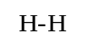

i_{p}
i_{m}

r_{i}. Δx I_{i}
Figure 2: The core-conductor model
here, r_{i} is the intracellular, r_{o} is the extracellular axial resistances per unit length.
ΔI_{o} = (i_{p} + i_{m}). Δx ΔI_{i} = i_{m}. Δx (9)
Above equations are the discretized forms of differential equations relating the change in the intracellular and extracellular currents to the membrane current at each discrete element (node). Similarly,
ΔΦ_{i} = -I_{i}.r_{i}.Δx and ΔΦ_{o} = -I_{o}.r_{o}.Δx , (10)
ΔV_{m} = (ΔΦ_{i} - ΔΦ_{o}) (11)
Starting from these basic equations and after a straightforward derivation (which will not be presented here. Refer to Plonsey & Barr [1] pp.158-165 for the derivation), we get:
ΔV_{m} = Δt.a.Δ²V_{m/}(2.C_{m}. (Δx)².R_{i} ) - Δt Σ(I_{tot/}C_{m}) (12)

The term Δ²V_{m} can be implemented as V_{m} ^{i-1} - 2V_{m}^{i} + V_{m} ^{i+1} i.e., its difference (in a sense) from the neighbouring nodes. Note that using V_{m} or v_{m} will not change the calculation.
The simulation of the action potential propagation starts with assigning an initial rest voltage to every node. The input is assumed to be applied to the first node only, therefore the applied current term appears only for the first node’s total current expression. Other nodes’ voltages will be changing due to the change of the first node’s increased potential and its indirect effects on the neighbours. If the first node is the leftmost one, we can say that each node on its right will be stimulated by the left neighbour node and will stimulate the right neighbour. Note that for the inputs that are below the threshold will attenuate along the fibre.
The simulation starts at an initial time and calculates the difference in membrane voltage for every node along the nerve fibre using the latest previous membrane voltages, and calculated conductances (for I_{tot}). Then the next time step’s voltages are obtained by adding the differences (ΔV_{m}’s) to the present V_{m} and the conductances are updated just like it is done for the action potential generation simulation. After performing these computations for every node, the simulation moves to the next time instant and repeats the procedure for that instant. At the end of the simulation, membrane voltages at every all instants for every node are obtained and displayed successively to visualize the propagation.

4) Results
MATLAB is chosen as the code development environment for the simulation because of it powerful tools for scientific calculations, data display and matrix algebra, and its easy-to-use programming language syntax.
Both of the mentioned algorithms are implemented and made accessible via a graphical user interface (GUI). The user can apply up to six different inputs at any (positive) time he/she desires with any (positive) duration. The choice between action potential generation and propagation simulations can be made by using simple radio buttons that are available in the GUI.
The simulation results meet with the expectations. When some characteristic inputs (a long duration input for example) are applied, it is observed that the simulation gives correct results. Some examples (as well as the snapshots of the GUI) are presented below:

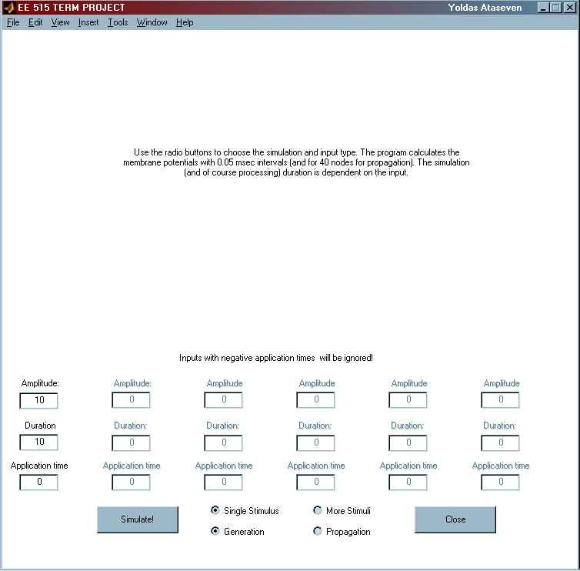

Figure 3: The GUI
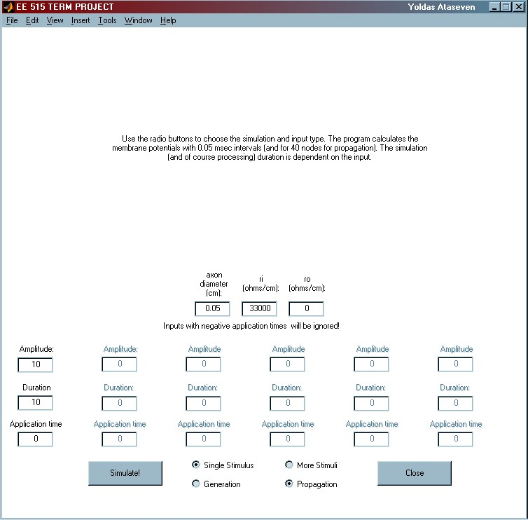

Figure 4: The GUI when propagation is selected
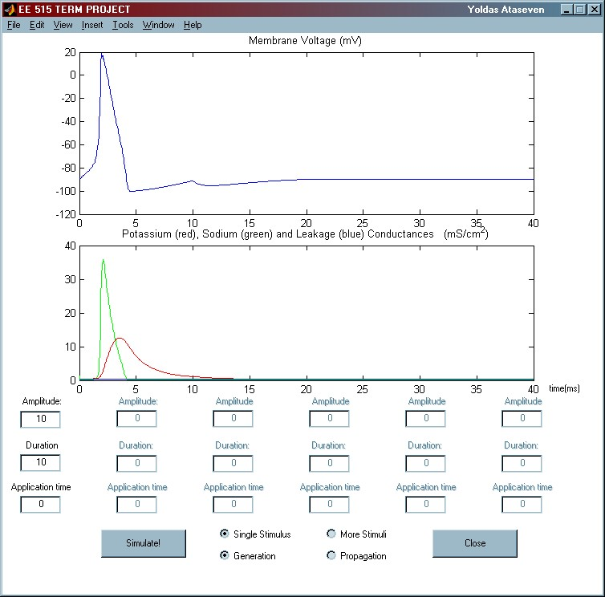

Figure 5: Action potential generation (membrane current and ion conductances)
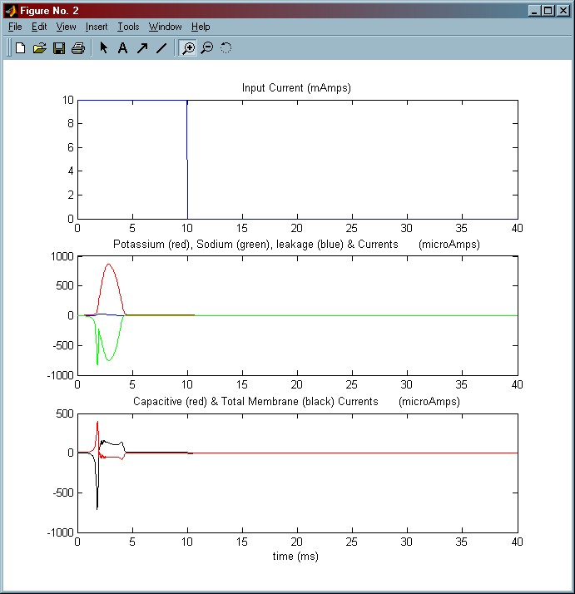

Figure 6: Action potential generation (applied current, ionic, capacitive & membrane voltages)

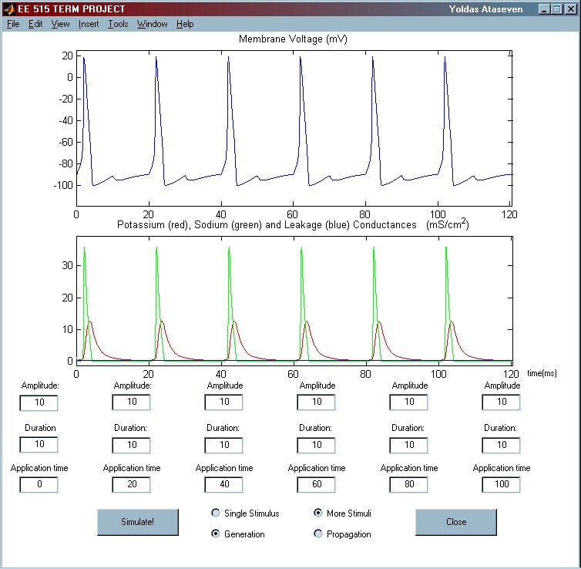

Figure 7: Action potential generation for a pulse train

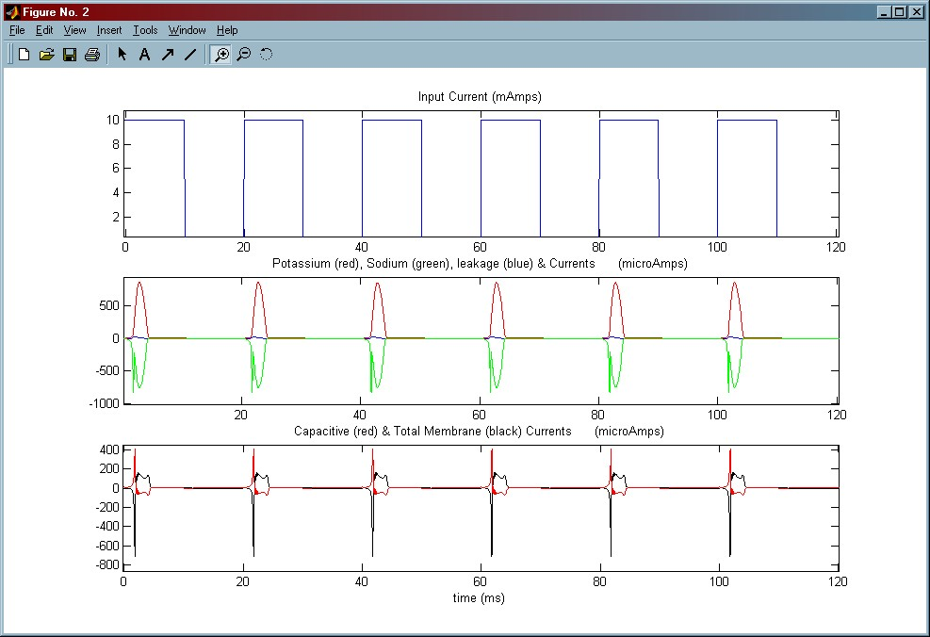
Figure 8: Action potential generation for a pulse train
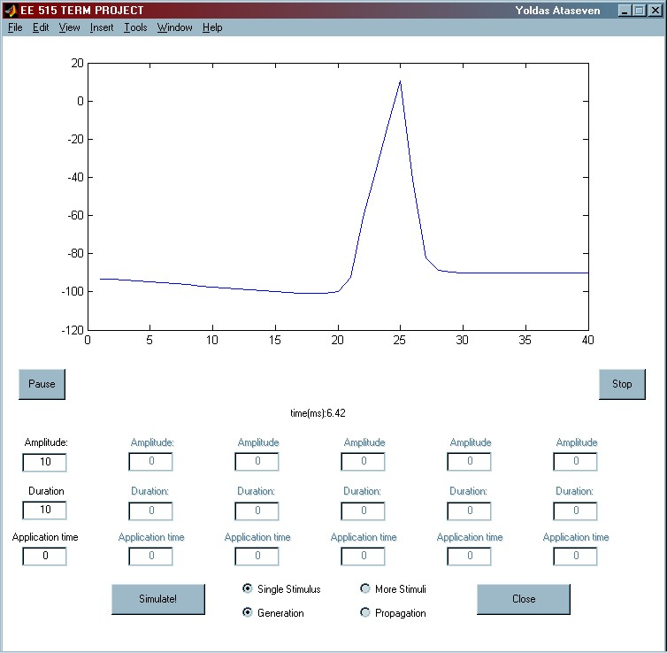

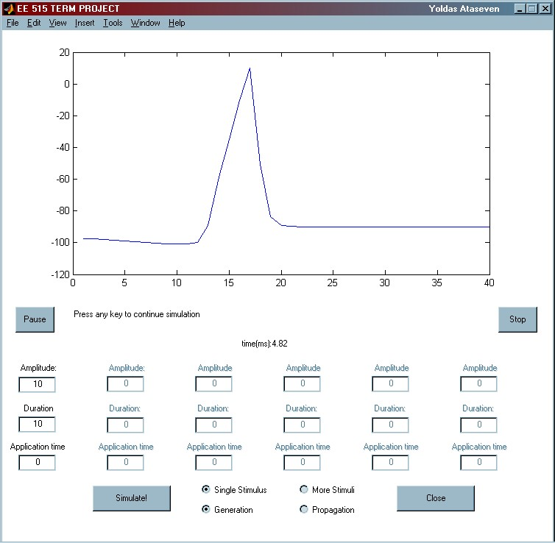
Figure 9: Action potential propagation snapshot

Figure 10: Action potential propagation (paused) snapshot
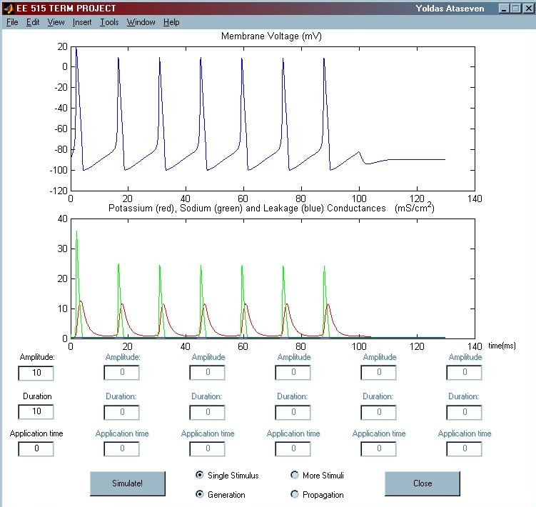

Figure 11: Action potential generation (long duration post-threshold input)
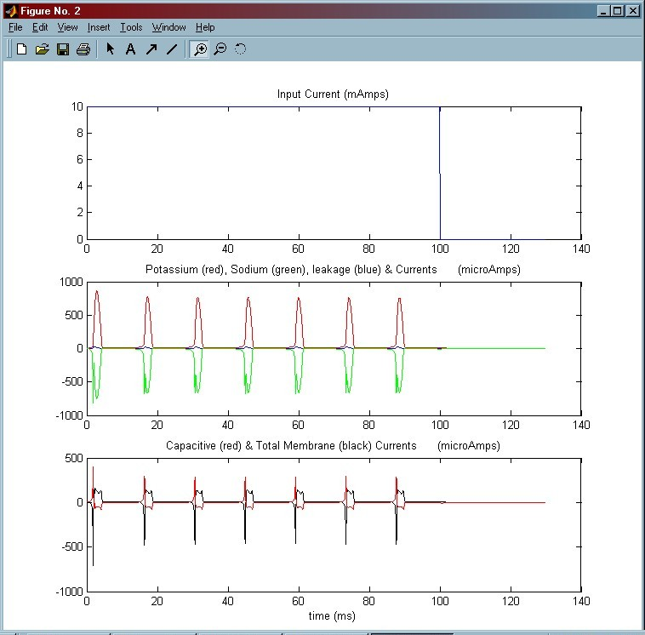

Figure 12: Action potential generation (long duration post threshold-input : currents)
Absolute refractory period is observed to be around 10 msecs. A slight drop is observed for the peak voltage and conductance values when a long, post-threshold stimulus is applied.
5) Conclusion
The term project for EE 515 Bioelectricity & Biomagnetism course has demonstrated the behaviour of an unmyelinated nerve fibre’s responses when inputs with different durations and amplitudes are externally applied to the fibre. It is now a simple task to obtain time-duration curves with little modifications on the code. Furthermore, the speed of the propagation in an unmyelinated nerve fibre can easily be calculated and as a conclusion it can be stated that the speed of propagation is independent of the applied input’s amplitude and duration if the threshold is exceeded. By this simulation, discussing the speed of a sub-threshold stimulus may not be appropriate since the attenuation distorts the generated waveform.
The slight drop observed for the peak voltage and conductance values when a long, post-threshold stimulus is applied is also an expected result and may be explained with the nerve getting “tired”.
For propagation, real-time display is not possible if every frame is to be displayed (20000 frames/sec). If not: The simulation results show that the “signal” passes through a 4mm patch in about 10 msecs and this means that to be able to observe the signals propagation, a longer patch must be modelled because of the capabilities of the human eye. But this will result either a worse accuracy (if node length is increased) or a longer processing time (if more nodes are used in the model). Actually, real-time display of a propagating neural pulse is not necessary since we can obtain the desired information using “slow motion” as well.
Yoldaş Ataseven
115888
References
[1] Plonsey,R., Bar R.C., Bioelectricity, KA/PP,2000
[2] Gulrajani,R.M., Wiley, 1998
[3] http://www.mathworks.com

