ABSTRACT

Nuclear Magnetic Resonance Imaging (NMRI) is a medical imaging modality, which is widely used in medical diagnosis. NMRI is based on measuring the overall response of a spin system of nuclear magnetic moments under a constant static magnetic field and applied Radio Frequency (RF) magnetic stimuli (RF excitation and gradient fields). Constructing NMR images is done in the frequency domain using controlled combinations of gradients. Understanding the Free Induction Decay (FID) and echo signals require an understanding of magnetic moments’ de-phasing and re-phasing concepts as well as the T1, T2 and spin spectral density effects. In this work, (MATLAB) software is introduced for simulation of a simple object’s (a cube of constant spin spectral density, T1 and T2 distributions) stimulation for NMRI purposes. The user can change several parameters to see the resulting behavior via a GUI. Examples of some possible simulation results are also introduced.

INTRODUCTION

In 1952, the use of magnetic resonance idea is presented by Bloch and Purchell. NMRI is first used by Lauterbar in 1972, which was called zeugmabiography by him. Then it is revised by him in 1973 with the name “Image Formation” by reduced local interaction. In 1978, first commercially available device is developed by Andrew. Many publications are presented on NMRI and a number of improvements are achieved since then.

The purpose of this study is to obtain a simulation tool (for educational purposes), which demonstrates the application of RF excitation pulses, gradient fields and constant static magnetic field (B₀) on a uniform cubic object and which simulates on-resonance, off-resonance excitations and slice selection, de-phasing and re-phasing of magnetic dipole moments, phase and frequency encoding.

In the remaining sections of the report, mathematical background used in this project is stated briefly, the results are presented and discussed. In the theory part, the mathematical and physical background is presented in limited detail. This part actually aims to introduce the basic concepts of NMRI. In the results section of the report, outputs of the program are presented by using selected snapshots of the outputs. In the discussion and conclusion part, the performance of the developed tool is discussed and possible improvements are suggested.

THEORY

The theory of the NMRI is developed concerning the Hydrogen atom, which is the basic element for the human body.

We know from physics that a hydrogen atom has two discrete magnetic quantum numbers, namely +½ and –½ . The magnetic moment of Hydrogen atom is given by μ = γ.J, where J is the angular momentum and γ is the (material dependent) gyromagnetic constant.

When H atom is put in constant static magnetic field (B₀=B₀. â_{z}), its magnetic moment’s z-component aligns either in the same or the opposite direction of this field, while it also experiences experiences a torque acting on it. This torque is given by, τ= μ x B₀. Wİth the effect of this torque, the magnetic moment precesses about the z-axis, being either in m_{I} = + ½ or m_{I} = - ½ state. The rotation frequency (also known as the Larmour frequency) under this constant static magnetic field is ω₀ = γ.B₀
If we consider a small volumetric element, the transverse components of individual magnetic moments are arbitrary at any time instant, and statistically, they sum up to zero. Therefore, if we denote the resultant (overall) magnetization vector for this volumetric element as M, this vector has z component only under static magnetic field, B₀ .

The time-dependent behavior of the magnetic moment is determined by the Bloch Equation for a more general case:

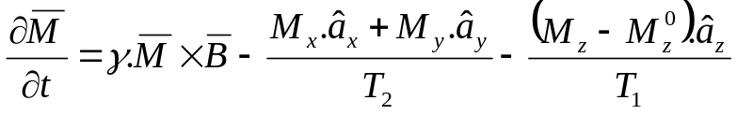

where M_{x}, M_{y}, and M_{z} are the x, y and z components of M and M_{z}⁰ is the steady-state value for M for z-directed constant magnetic field, the steady-state value is along z due to the statistical cancellation in the transverse plane mentioned above. T₁ and T₂ are the longitudinal and transverse time constants, respectively. T₁ is caused by the static magnetic field, B₀, which forces the magnetic moments to align along z-direction. T₂ is the transverse decay factor which is mainly caused by the interaction between the neighboring magnetic moments, B₀ inhomogeneties, etc. It is a fact that T₂<T₁.

The Bloch Equation is the key tool for understanding and modeling the time-dependent behavior of the magnetic moments.

Rotating Frame

Rotating frame is a coordinate system, which rotates with ω₀ in clock-wise (cw) direction about the z-axis w.r.t the laboratory frame. The relation between for the magnetization vector components w.r.t the laboratory frame and the rotating frame is:

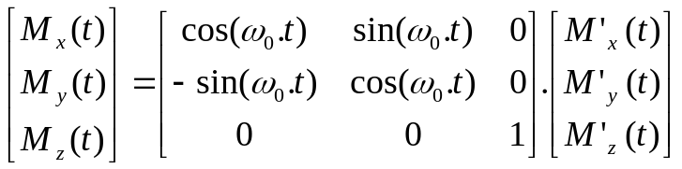

Gradient Fields

When a gradient field of the form G_{x} = G_{x} . â_{z} is applied in addition to the static magnetic field, B0, then the precessional frequency of the magnetic moments will also be space dependent. Then for any point,
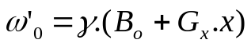

This relation may be extended to include y and z gradients easily.

RF Fields

RF fields of the form 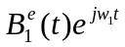 (or RF pulses) are used to excite the magnetization vectors and change their direction. From physics, it is again known that a magnetic moment of free-precessional frequency ω₀ can be excited by an RF pulse, only if the frequency of the RF pulse is ω₀. This is due to the necessity that the applied RF field must have an energy exactly equal to the energy gap between spin-up and spin-down states of the H-atom (RF fields of frequencies other than ω₀ has very small effects on the magnetization vector directions). Such a pulse can cause the magnetic moment align in some other direction other than â_{z}. The governing set of equations for the general RF excitation (along x’) are:

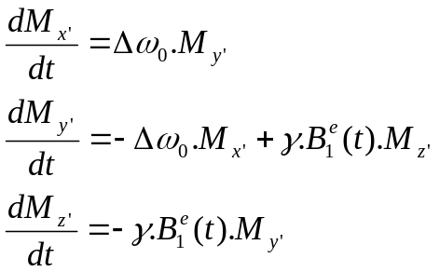
where 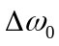=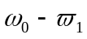.

Note that these equations are also valid for off-resonance excitation and can be implemented iteratively for computational purposes. Also note that these eqns are given in the rotating frame.

These relations are derived from the rotating frame version of the Bloch Equation and are for an RF pulse (of arbitrary frequency) along x’ direction. For an arbitrary directed RF field (tilt angle φ and phase angle θ), The magnetization vector just after the RF pulse can be found using the rotation matrices. Rotation matrices transform the magnetization vector spatially to where it would be when the RF field is applied along a direction represented by (φ,θ). Transformation is done by:

M_{rot}(0₊) = R_{z’}(φ).R_{y’}(θ’). M_{rot}(0₋)

Here, θ’= π/2–θ and M_{rot}(0₋) is the magnetization vector found by the differential equations above. Note that, this transformation is different than the usual special transformation (which is also given in [1]) since the effect of .R_{y’}(-θ’).R_{z’}(φ) term in the usual formula is also included in M_{rot}(0₋).

One of the vital concepts in NMRI is signal detection. Although signal detection and image formation are beyond the scope of this work, it is necessary to state that the measured response of a spin system for some excitation is directly proportional to magnitude of the overall (resultant) magnetization vector’s transverse component at every time instant and sampling the measured signal directly gives special frequency information along some path determined by the applied gradient field(s). Therefore, the measured signal’s amplitude is relatively larger when the individual transverse magnetizations are in phase and smaller when they are out-of phase (canceling each other)

Another key point is that, since the sampled signal gives frequency information and the image is constructed by taking the inverse Fourier Transform, we need symmetric frequency-domain content to obtain a real image. Echo signals (which are symmetric) are preferred rather than FID signals (in most cases) for this reason.

An echo signal is obtained when individual transverse magnetization vectors are re-phased from a de-phased situation and then de-phased again. The peak amplitude is obtained at the instant where the transverse magnetic moments are totally re-phased. There are a number of methods for obtaining echo signals. In this work, gradient echoes are implemented.

The main idea for obtaining a gradient echo is based on changing the spatial precessional frequency distribution in time. Let us consider a gradient field applied along z-direction as G_{z}= G_{z}.z.â_{z}. Such a gradient field encodes slices (planes) of the object that are parallel to the transverse plane. If an RF pulse is applied afterwards, it will change the direction of the magnetization vectors for a certain slice only. The orientation and thickness of this slice is dependent on the gradient field strength and the RF pulse bandwidth. This selective excitation of the magnetization vectors is called slice selection.

After slice selection, let us assume an x-gradient of the form G_{x}= -G_{x}.x.â_{z} is turned on for a period of T_{p}, to impose precession frequencies varying with x. Points with larger x values will be precess slower than the ones with relatively smaller x values. This gradient will change the precession frequencies for all slices, but due to slice selection, the effects of change will be noticed for the selected slice only, since the measured signal is created by the transverse component. The x-gradient will force the magnetic moments to be out of phase coherence. Again, assume gradient field amplitude is reversed to have G_{x}= G_{x}.x.â_{z} at t=T_{p} for a perion of 2.T_{p}. Now the situation is reversed and points with larger x values are faster by the same amount (when the negative gradient was applied). Therefore at t = 2.T_{p} the magnetic moments will gain phase coherence resulting in a peak in the measured signal. After t = 2.T_{p} the phase coherence will again be lost and the measured signal will decay. During this process, the decay due to T₂ will also be in effect.

The idea presented above can be modified by using different gradient field sequences concerning the trajectory in the frequency plane. The developed software is useful for this purpose.

RESULTS

For the simulation purposes, MATLAB software is developed. A snapshot of the MATLAB GUI is on the next page. The user is allowed to change initial magnetization vector, RF excitation parameters, gradient field parameters, object parameters (number and thickness of slices, gyromagnetic constant, T₁ and T₂). Output options are also available: The user can view the results in the laboratory frame or in the rotating frame. The transverse plane only or 3-D views are also available. The simulation is performed interactively by letting the user to browse in time via a slider bar. The used gradient field combination is also plotted as a separate figure. For each simulation, calculation is done only for the slice selected by the user. Calculation for multiple layers at the same time is avoided due to processing time considerations.

The default values of the program selects the slice for z = 0 which is the selected slice for viewing. Gradient sequence is chosen for the simplest echo generation using x-gradient only. As expected, this sequence results in phase coherence at 2.T_{p} (t = 100ms). In figure 2, the gradient fields are plotted for the default case. In figure 3, the transverse view at the time instant for phase coherence is shown. Figure 4 shows the same instant in 3-D.
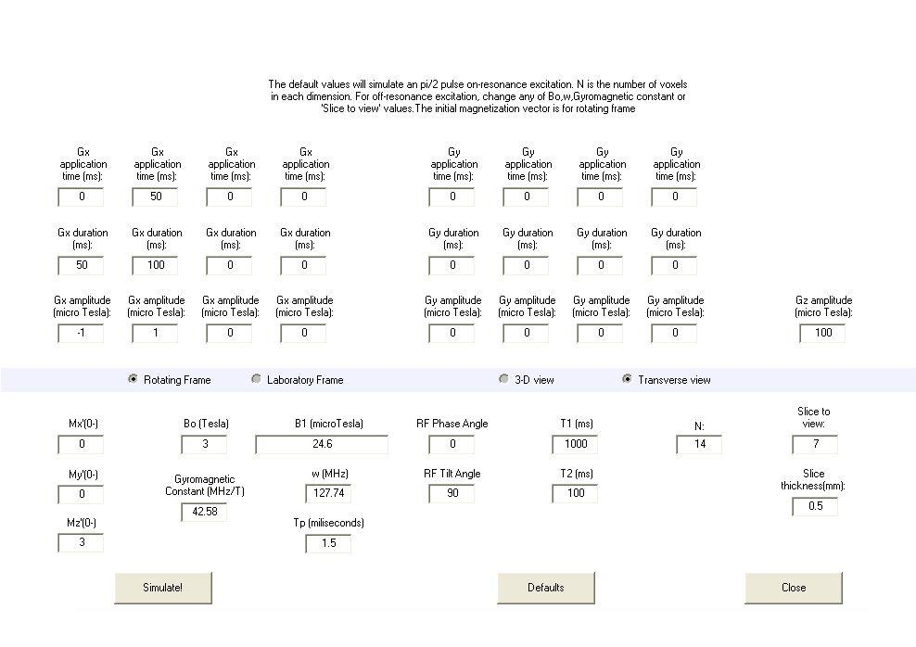
Figure 1: A snapshot of the GUI (giris.m)

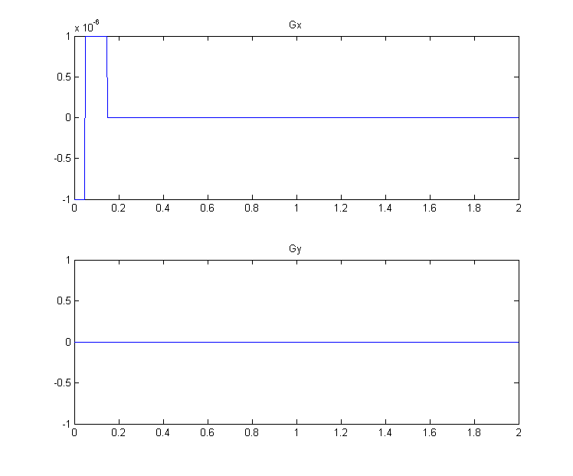
Figure 2: Default gradient fields.
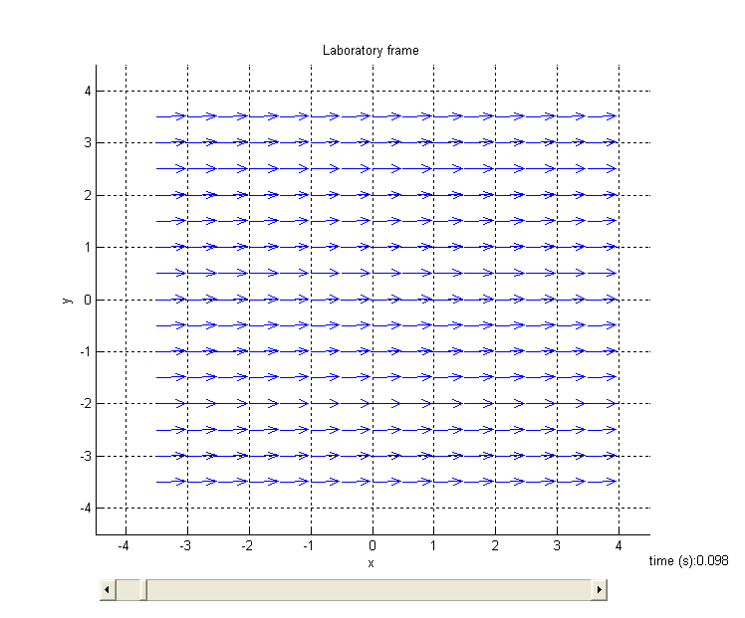
Figure 3: Transverse components at the phase coherence instant for the laboratory frame using default values

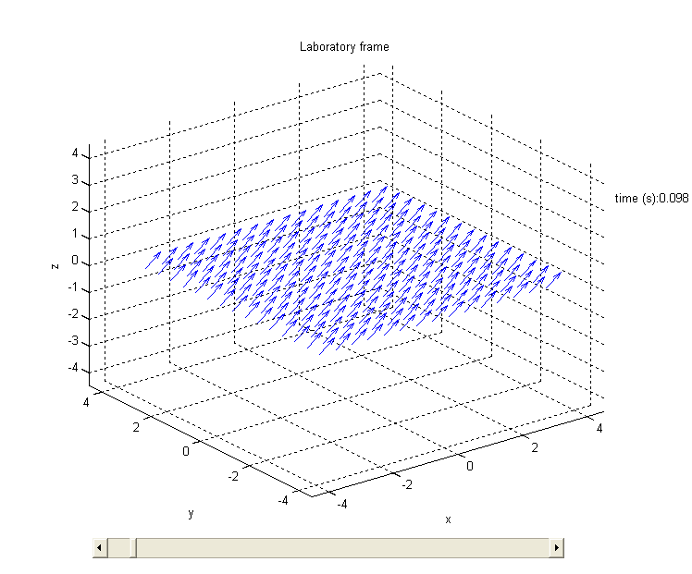
Figure 4: 3-D view at the phase coherence instant for the laboratory frame using default values
At each computation, the magnetic moments are computed for 1000 time instants for every voxel. Although the processing time is reasonable for the default values, it may be long if the number of voxels per dimension (N) is increased considerably.

For the default values, the frequency change along x axis is clearly seen for both laboratory and rotating frames. The off-resonance excitation is also observable for other slices. From the experiments, it is seen that for default values (except for the RF field frequency), approximately for each 2.15 KHz step in the RF field frequency selects the next slice. Since the slice thickness is very small (0.5 mm), isolated selection of a slice is not possible for the default slice thickness. User must set the thickness to 1mm or double the z-gradient for isolated selection. But note that in this case, the step size will be different for the RF field and the frequency, which selects the same slice (other than z = 0) will be different.

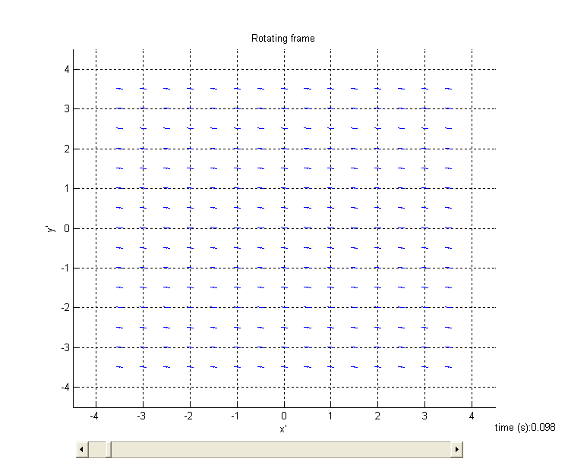
Figure 5: Off-resonance excitation (slice 9) for default values (rotating frame). Note that the transverse components are re-phased, but their magnitudes are negligible.

As a last example, I present a case in which y’-gradient is turned on in addition to the x-gradient. The values for x’ and y’ gradients are identical. The view at the re-phasing instant is same for the “x’-gradient only” case, therefore here I prefer to show the most out-of phase situation for both cases to emphasize the difference in spatial encoding.

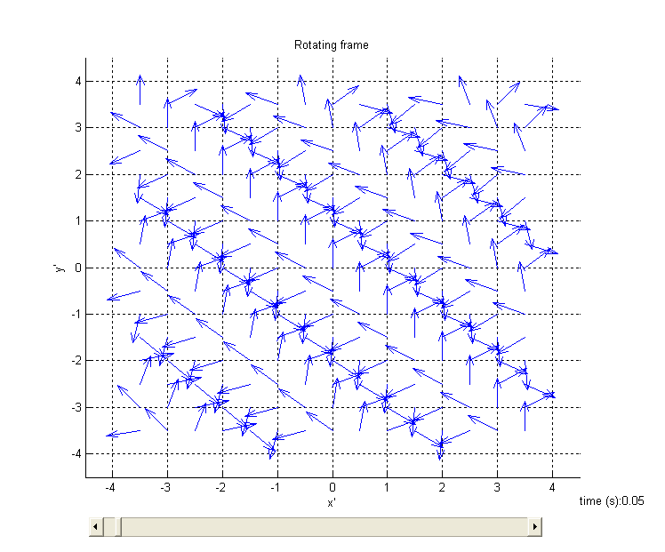
Figure 6: “The most out-of-phase” instant for the case both x’ and y’ gradients are on. Note that the “equi-phase” lines have a negative slope.

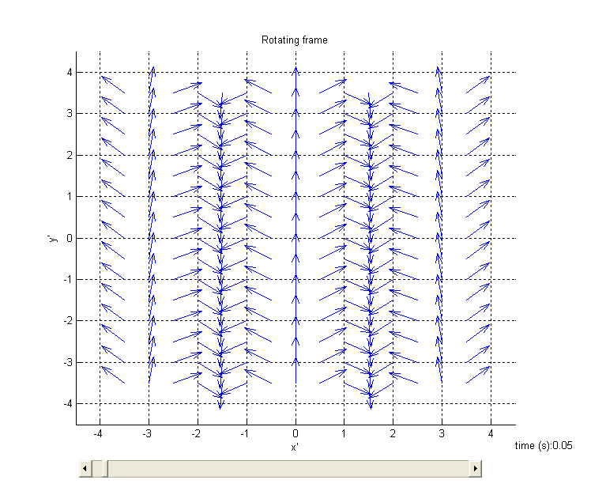
Figure 7: “The most out-of-phase” instant for the case only x’ gradient is on. Note that the “equi-phase” lines have infinite slope (parallel to y’ axis)

DISCUSSION AND CONCLUSION

As stated in the results part, the developed software is successful for a number of gradient echo imaging simulations. The program is user-friendly and can be used for teaching biomedical engineering students (even the programmer) since it allows the user changing many parameters and observing the results in laboratory or rotating frame. There are many possible combinations for observation, but unfortunately, all of them cannot be presented here.

Although the developed software is successful, it lacks some properties. The missing parts in the developed software can be summarized as follows:
  - Spin echo imaging is not implemented. But this may be eliminated to some extend by changing the initial magnetization vector.
  - Object is strictly uniform in both spin density, T₁ and T₂. This problem can be eliminated with little programming effort since the program structure is suitable.
  - Although controls on the gradient fields are flexible, the total number of components is limited to 4. Longer sequences cannot be implemented.

These are not in the scope of this project work, but if completed, the tool will be more powerful.

