Abstract

The aim of the project is to obtain back projection of a 2-D object for user-controlled sampling rates for angle step size (or number of steps for θ) and projection resolution (resolution in t) entered by the user. Projections are taken and back projection is performed in two steps.

I. Introduction

The German physicist Conrad Roentgen discovered X-rays in 1895. As well as being used as a radiological method in their own right, X-rays are also used to produce CT (Computerized Tomography) images.
X-rays are part (high frequency band) of the electromagnetic spectrum, which also contains visible light, ultra-violet light, radio waves, and infrared radiation. X-rays are useful for imaging as they penetrate materials, which do not transmit any of these other types of electromagnetic radiation.
To generate X-rays a current is passed through a vacuum tube. This induces electrons from a heated metal element (cathode) to pass across the vacuum and strike a tungsten target (anode). The anode then emits energy in the form of X-rays.
In CT scanning a beam of X-rays is used to image sections of the body. The X-rays fall onto detectors. The X-ray tube rotates around the patient. This allows multiple data to be collected concerning all of the tissues in the section being imaged. 2-D and 3-D images can be generated by a computer that records and processes the data.
The purpose of the project is to demonstrate the forward and inverse problem solutions for X-ray CT. The first step of the project is about the forward problem and deals with the acquisition and classification of projection data. The second step is about the inverse problem and deals with the reconstruction of the object whose projection data are available. MATLAB is used as a tool for this purpose.
In this report, the theoretical (mathematical only) background for X-ray imaging systems, the algorithm used in the solution and some samples obtained by the developed algorithm are presented.

II. Theoretical Background

X-ray tomography is based on both physics and mathematics. In this project, the mathematical part of X-ray tomography (which can be used for magnetic resonance imaging applications) is demonstrated.

The X-ray tomography is performed by taking projections from the object (patient body) at different angles and reconstructing the object with back projection methods. The figure on the following page illustrates an X-ray imaging system.
y

detectors

β(x,y) θ
x

sources

Figure 1: Basic schematic for an X-ray tomography system.

An X-ray imaging system senses the attenuation coefficient of the objects. The detectors are intensity-sensitive and the received intensity is related to the attenuation coefficient distribution along the X-ray photon path by the differential equation:

dI/dx = -β.I where x is along the projection line from the source to the detector.

Placing the object into a Cartesian coordinate system as shown above, the projection lines will have the equation:
x.cosθ + y.sinθ = t

Where t is the distance of the line to the origin.

And the projection data can be formulated as

p(t) = β(x,y).δ(x.cosθ + y.sinθ - t)dxdy

This is simply a line integral which adds up all the attenuation coefficient values along the line (specified by t and θ) of integration. This equation is the answer for the forward problem.

The image of the object can be obtained by a simple back projection algorithm, which is based on the idea of reflecting the projection data along their lines of integration, from which the data are obtained. These reflections are added up in 2-D and a back projection is obtained. The back projection can be formulated as:

f(x,y) = p(t). δ( x.cosθ + y.sinθ - t)dtdθ

This formula states that a projection datum obtained for a specific line determined by some t and θ is added to all of the points on that line. This operation is done for all θ and t values (i.e. for all projection data). This equation is the answer for the inverse problem to some extend.

However, in reality, the number of detectors is finite and therefore continuous data acquisition is impossible. Imaging facilities use discrete methods. In the discrete world, the integration is replaced with summation.

When the single back projection is further examined for its impulse response, the reconstructed image is found to have tails due to the errors caused by reflection process. These tails contribute to a degree of blurring for the reconstructed image and cause loss of information for details in the image. The discrete nature of the real systems deteriorates the blurring effect. The blurring can be reduced by applying a simple filter (|ω|) in Fourier domain (Filtered Back Projection) or convolving the projection data with the inverse Fourier of this filter (Convolution Back Projection).

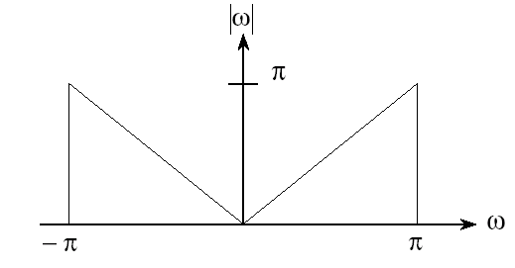

Figure 2: Fourier domain filter which is multiplied with the Fourier transform of projection data for every θ. (Filtered Back Projection)

The filtered back projection has also some limitations although it has a better performance (for spatial resolution) than simple back projection: |ω| is not band limited, but real systems cannot take all frequencies into account in computations. Additionally, finite number of projection angles and detectors necessitates interpolation and loss of details. Furthermore, taking Fourier Transform of data for each angle increases processing time.

Convolution back projection is similar to filtered back projection, but everything is done in spatial domain in this method. Inverse Fourier Transform of |q| is used as the convolution mask. Increase in data resulted from the convolution may be eliminated by taking the meaningful part of the resultant data (that are obtained by the convolution).
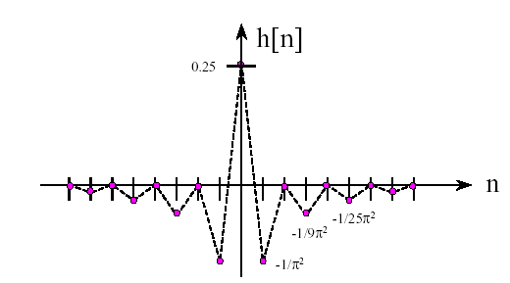
Figure 3: The discrete convolution function (inverse Fourier Transform of the filter example given above for filtered back projection), which is convolved with the projection data for each angle of projection in spatial domain. (Convolution Back Projection)

In one other Fourier Domain method, the central slice theorem is used for reconstruction. The central slice theorem states that a slice taken at some θ from the 2-D Fourier transform of an (2-D) object is the 1-D Fourier Transform of the projection taken from that object at the same angle in spatial domain. Therefore image can be reconstructed by placing the 1-D Fourier Transform of a projection to its angle of projection in the Fourier domain and then taking 2-D inverse Fourier Transform of the result.

The solution algorithm for the project is as follows:

III. Program Algorithm:

The program consists of several different m-files. Five of them (Proje main menu, proje1 earlier-defined objects, proje2 matrix input, Proje3 image file, Proje4 samples) are for user interface and they (except Proje4) call a processing program, proj1 with the arguments taken from the user. The main algorithm is in proj1.

The program first takes the projection data from the input object and then reconstructs the image using these projection data in summary. The details are presented below.

The program takes the matrix size and defines the interval for t according to the object size. The t matrix (although it is not implemented as a matrix) has ‘number of samples’ elements and has a length of:

Length = ceil( ( (number of columns)² + (number of rows)² )^{1/2} )

Where Length is the length of the matrix, ceil is the standard MATLAB ceil function, number of rows is the height of the object and number of columns is the width of the object.

Then the y values corresponding to specific theta, t and x values are calculated and stored in a 3-D matrix (number of steps for projection angle x number of columns in the image x number of detectors). This matrix therefore stores the (x,y) values for the points on the projection lines.

The lines has the equation in the form:

y = -x*cotθ + t/sinθ

The θ = pi and θ = 0 values are taken special care as they cause a division by zero error in the equation. Actually they give the same data so computation is done only once for them.

Then a 2-D (number of steps x number of detectors) matrix is established. The values of the matrix is calculated by adding the pixels values corresponding to (x,y) pairs on the projection lines.

The back projection is done through an inverse algorithm. The projected data is back projected using the pixel values on projection lines, which are already stored in the 3-D matrix mentioned above. The projected data (as a whole) and the back projected image are mapped to gray scale for proper visualization. Mapping is done by:

Datum = Datum * 255 / max(Data)

Where Datum is an element in the matrix and max(Data) is the maximum element in the matrix (3-D projection matrix or 2-D back projected image).

It is possible to improve the contrast of the back projected image by histogram equalization, which is out of the course scope. The image obtained using histogram equalization is also presented in file “imhistli.m”.

IV. Results

Sample images (circle, ellipse, rectangle, square and circular ring) and their reconstructed images are available in the program menu. Although it is not presented in the menu, a phantom and its back projection, which shows the spatial resolution is also presented in file “performance.m”. “imhistli.m” is the histogram equalized image for this phantom. It is observed that the program can distinguish items, which have the distance down to three-six pixels between them.

They are also presented in addition to other different objects and their reconstructed images below.
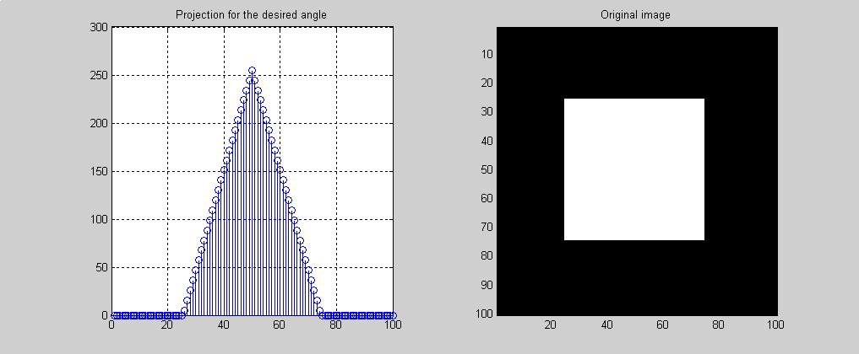
Figure 4:
A square and its
projection at π/4

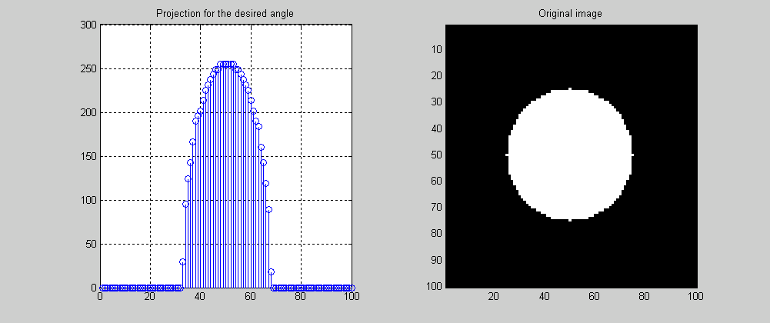

Figure 5: An circle and its projection at π/3

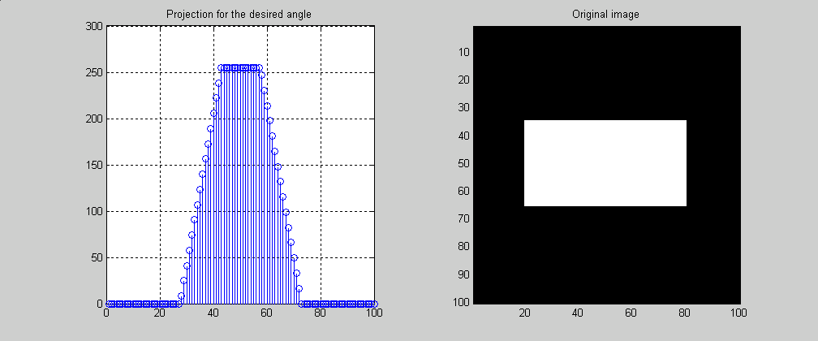

Figure 6: A rectangle and its projection at π/4

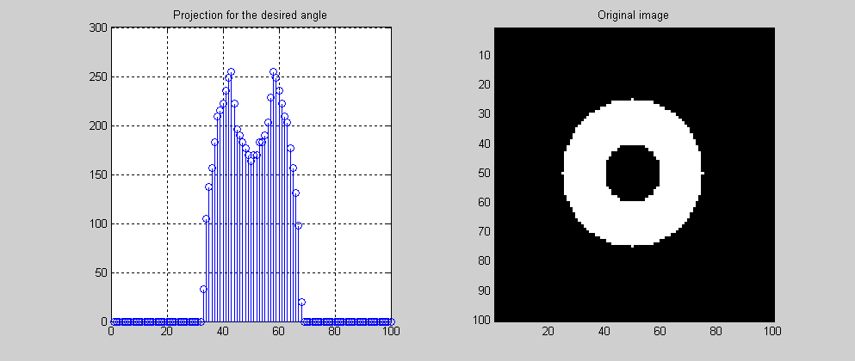

Figure 7: A ring and its projection at π/3

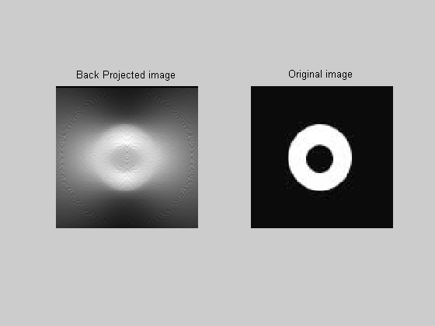

Figure 5: A ring and its back projection

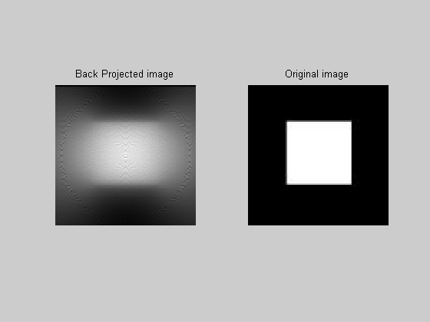
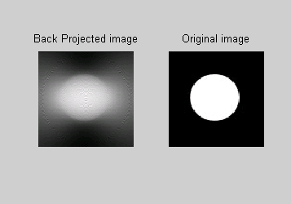

Figure 6: A circle and its back projection Figure 7:A square and its back projection

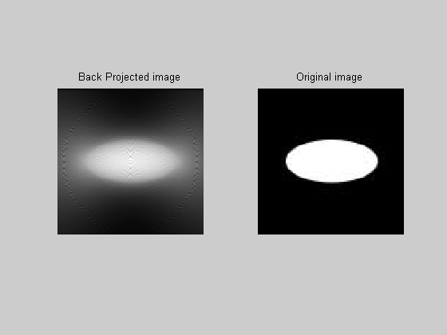
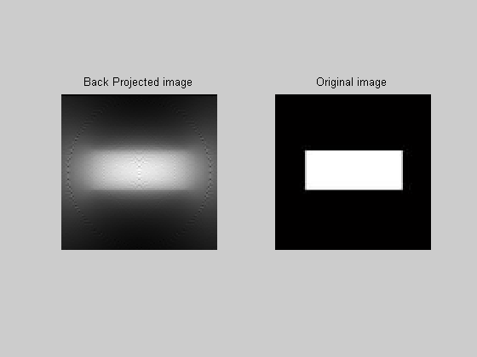

Figure 8:An ellipse and its back projection Figure 9:A rectangle and its back projection

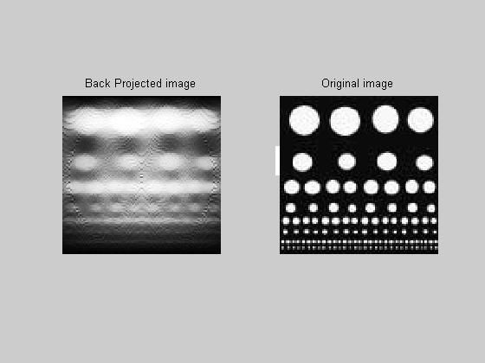
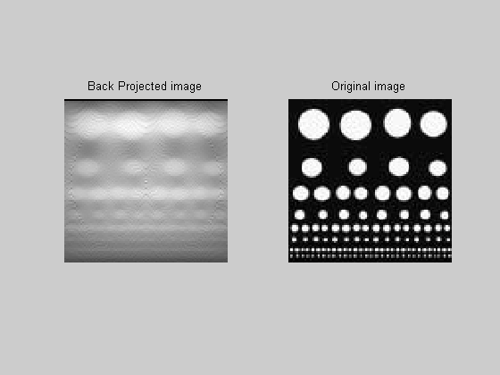

Figure 10:The ‘performance’ Figure 11: The histogram equalized (performance.m) ‘performance’ (imhistli.m)

V. Discussion and Conclusion

The X-ray tomography is based on physical and mathematical bases. In this report, the physics lying behind X-ray CT is explained briefly and the mathematical background of X-ray CT and an implementation on MATLAB are presented.

The results that are obtained for back projection are matching with the expectations. The objects are obtained with a degree of blurring after back projection.

It can be observed from the results that approximating the lines of integration with the diagonals of the pixels that are nearest to those lines results in an increased blurring. It must be noted that the images that are used as phantoms are 100x100. Therefore the number of lines passing a pixel (lines/pixel) is low even for 250 detectors. Using smaller objects will result in better performance.

Filtered Back Projection and Convolution Back Projection, which could not be implemented for a number of reasons, are expected to reduce the blurring of the reconstructed images.

VI. References

1) http://www.seas.smu.edu/~cd/EE5345/lect5_spr00.PDF

2) http://www.teaching-biomed.man.ac.uk/student_projects/2000/mmmr7gjw/ technique6.htm

