Forecasting freshwater cyanobacterial harmful algal blooms for Sentinel-3 satellite resolved U.S. lakes and reservoirs.

Blake A. Schaeffer¹, Natalie Reynolds², Hannah Ferriby³, Wilson Salls¹, Deron Smith⁴, John Johnston⁴, Mark Myer⁵

1. US EPA, Office of Research and Development, Durham, NC
2. Oak Ridge Institute for Science and Education, US EPA, Durham, NC
3. Tetra Tech, Inc.
4. US EPA, Office of Research and Development, Athens, GA
5. US EPA, Office of Chemical Safety and Pollution Prevention, Durham, NC

Corresponding author: schaeffer.blake@epa.gov

Supplemental material and methods
Study area
Myer et al. (2020) presented a limited 103 lakes in Florida, only a fractional representation of the southeast climate zone and specifically a sub-topical representation. These sub-tropical conditions do not translate to the remainder of the United States. This study expanded the area to include all nine CONUS climate regions defined by the National Center for Environmental Information (Coffer et al., 2020; Karl and Koss, 1984). Most of the satellite-resolved lakes were found in the Eastern Temperate Forest (39.5%), Northern Forest (22.8%), and Great Plains (20.8%) regions. The Northwestern Forested Mountains had 8.7% of the lakes, while North American Desert, Mediterranean California, Marine West Coast Forest, and Tropical Wet Forest and Temperate Sierras ecoregions had 4.7%, 1.9%, 1.0%, 0.5%, and 0.5% of the lakes, respectively. Lakes in this study varied in size from Wolf Reservoir in Arkansas, which was 1.28 km², to the Great Salt Lake in Utah, which was 4,309 km². The elevation ranged from -47.89 m below sea level at Salton Sea, California, to 3,147 m at Turquoise Lake in Colorado. Glaciated lakes accounted for 56%, while headwater, isolated, or terminal lakes accounted for 13% (Cheruvelil et al., 2021; Smith et al., 2021).

Satellite data processing
The National Aeronautics and Space Administration (NASA) obtained Sentinel-3A/B Ocean and Land Colour Instrument (OLCI) imagery from the European Space Agency under a data sharing agreement, and the data were processed by the NASA Ocean Biology Processing Group (OBPG; https://oceancolor.gsfc.nasa.gov/about/projects/cyan/). This study retrieved weekly maximum satellite detections over CONUS from the OLCI sensors, covering January 2017 through December 2021, at a spatial resolution of 300 m using version 4.0 of CyAN processing. The OBPG utilized the standard satellite ocean color software package (l2gen), which is distributed publicly within the SeaWiFS Data Analysis System (SeaDAS; http://seadas.gsfc.nasa.gov). The data were processed using a Shuttle Radar Topography Mission (SRTM)-derived 60 m land mask that included missing lakes and reservoirs in Rhode Island and Massachusetts (Urquhart and Schaeffer, 2020). However, the SRTM land mask and SeaDAS processing are static in relation to waterbody size and did not account for periods of drought or flood during the study period. Satellite imagery was corrected for cloud presence and shadow, snow or ice presence on water bodies, and the presence of land pixels at the water’s edge causing adjacency effects (Urquhart and Schaeffer, 2020; Wynne et al., 2018). The median of CI_{cyano} pixel values was calculated to represent each lake’s cyanobacteria bloom condition in each week.

Performance metrics
Cutoff optimization was performed by maximizing Youden's index on the validation dataset, which is defined as the cutoff at which sensitivity and specificity are balanced and at a maximum. The receiver operating characteristic (ROC, Fig. S2) curve is a plot of the true positive rate against the false positive rate, at various cutoff values (McLaughlin, 2012). The area under the curve (AUC) value is the area under the ROC curve and provides an overall measure of the model's predictive performance, regardless of the chosen cutoff. It is important to note that a cutoff point must be chosen above which a prediction is considered positive and below which it is considered negative. The AUC value ranges from 0 to 1, with higher values indicating better model performance. A model with an AUC of 0.5 has no predictive power, while a model with an AUC of 1.0 has perfect predictive power.
The following additional model performance measures were used to evaluate the quality of predictions made by the model (see Fig. S3 for confusion matrix reference). The performance of the model was evaluated for the training, validation, and prediction phases by analyzing the prediction probabilities of true positives (TP), false positives (FP), true negatives (TN), and false negatives (FN) using several metrics.
Accuracy is the proportion of correct predictions made by the model out of all predictions made calculated as:
$Accuracy=\frac{TP+TN}{P+N}$ Equation 4
Sensitivity is the proportion of true positive predictions made by the model out of all actual positives in the dataset. It measures the ability of the model to correctly identify positive cases calculated as:
$Sensitivity=\frac{TP}{TP+FN}$ Equation 5
Specificity is the proportion of true negative predictions made by the model out of all actual negatives in the dataset. It measures the ability of the model to correctly identify negative cases.
$Specificity=\frac{TN}{TN+FP}$ Equation 6
Precision is the proportion of true positive predictions made by the model out of all positive predictions made. A high precision value indicates the forecasts are conservative and only make positive predictions when the event is actually occuring. Precision is calculated as:
$Precision=\frac{TP}{TP+FP}$ Equation 7
False omission rate is the proportion of negative cases that were incorrectly predicted as negative by the model out of all actual negatives in the dataset. It measures the fraction of negative cases that were missed by the model calculated as:
$False omission rate=\frac{FN}{TN+FN}$ Equation 8
F1 score is the harmonic mean of precision and sensitivity, which balances the trade-off between precision and sensitivity and is a useful measure when the dataset is imbalanced, calculated as:
$F1 score=2∙ \frac{precision∙sensitivity}{precision+sensitivity}$ Equation 9
Kappa is a measure of agreement between the model predictions and the actual labels in the validation dataset. It considers the expected agreement due to chance and compares it to the observed agreement between the model predictions and validation labels. The Kappa coefficient ranges between −1 and 1 where higher values indicate higher agreement (Cohen, 1960; Goodman and Kruskal, 1954), and is calculated with relative observation agreement (p_{o}) and the probability of chance agreement (p_{e}) as:
$Kappa=\frac{p_{o}-p_{e}}{1-p_{e}}$ Equation 10
Brier score is a measure of the accuracy of probabilistic predictions made by the model (Brier, 1950). A lower Brier score indicates better predictions. Brier score is the mean squared error of the forecast that includes the measure of forecast probability (f_{p}), the actual event outcome (o_{e}), and number of forecasted events (N) calculated as:
$Brier= \frac{1}{N}\sum_{t=1}^{N}{{\left(f_{p}-o_{e}\right)}^{2}}$ Equation 11

Supplemental discussion
The number of cyanoHAB weeks (Fig. S4) for which a lake exceeded the WHO threshold in this study were compared against annual cyanoHAB temporal frequency and spatial extent metrics previously reported by Coffer et al. (2021) and Schaeffer et al. (2022). Lakes with higher cyanoHAB weeks also had increased temporal frequency. This was expected because temporal frequency was a similar measure as cumulative bloom weeks but with slightly different thresholds and durations. The temporal frequency referred to the total number of satellite observed chlorophyll-a detections within a calendar year, and cyanoHAB weeks were the number of weeks for which a lake exceeded the WHO Alert Level 1 threshold during the 2017-2021 study period. CyanoHAB weeks did not have a clear statistical correlation with spatial extent previously reported by Schaeffer et al. (2022), which was logical because a temporal quantification of cyanoHAB weeks would not necessarily directly translate to a spatial measure of cyanoHAB area. However, the lakes in the lower and upper quantiles of cyanoHAB weeks showed a distinct separation in spatial extent. The upper quantile of ≥ 41 cyanoHAB weeks reported in this study (Fig. S4) had a median spatial extent of 100% and lakes with < 41 cyanoHAB weeks had a median spatial extent of 25% (Schaeffer et al., 2022).
The temporal changes in probability of cyanoHABs showed a pattern (Fig. S5) consistent with previously published ecological patterns of cyanobacteria seasonal biomass changes (Feng et al., 2018; Marshall and Peters, 1989; Rohwer et al., 2023; Shi et al., 2019). Initiation typically occurred in early spring, between April through June, with a maximum from July through September, and declined mid-September through November. The subsidence phase generally lasted from December through April, with a small rise in January, potentially due to recently reported winter blooms (Jacoby et al., 1994; Ma et al., 2016; Padisa´k et al., 2010; Reinl et al., 2023; Üveges et al., 2012; Wejnerowski et al., 2018). However, since this model was trained with satellite data, it may not capture winter blooms under snow or ice due to the satellite quality flagging protocol. The results from this study differed from lakes in Florida reported by Myer et al. (2020), with increased log odds in May and a strong secondary increase November into December, and Florida winter blooms were previously confirmed (Coffer et al., 2020). This study did not exhibit the same strong secondary increase across the nation’s lakes in the winter and was likely due to the signal being dampened by lakes in northern climate zones.
The spatial random effect (Fig. 2) identified residual error attributed to location, which may reflect the influence of unmeasured predictors. Unmeasured predictors may include watershed characteristics such a soil type and slope, land use change (Iiames et al., 2021), lake types (Eloranta, 1986; Phillips et al., 2008), population dynamics (Huisman and Hulot, 2005), and changes in nutrients, regional climatic differences, water column stratification, and light alterations (Carey et al., 2012; Chorus et al., 2021; Paerl et al., 2001). Future research would need to resolve the complex interplay of all these and other potential unmeasured predictors with system specific ecosystem mechanistic models.

Supplemental tables
Table S1. Results of the statistical evaluation metrics obtained from two additional machine learning models and four additional neural network models.
Supplemental figures

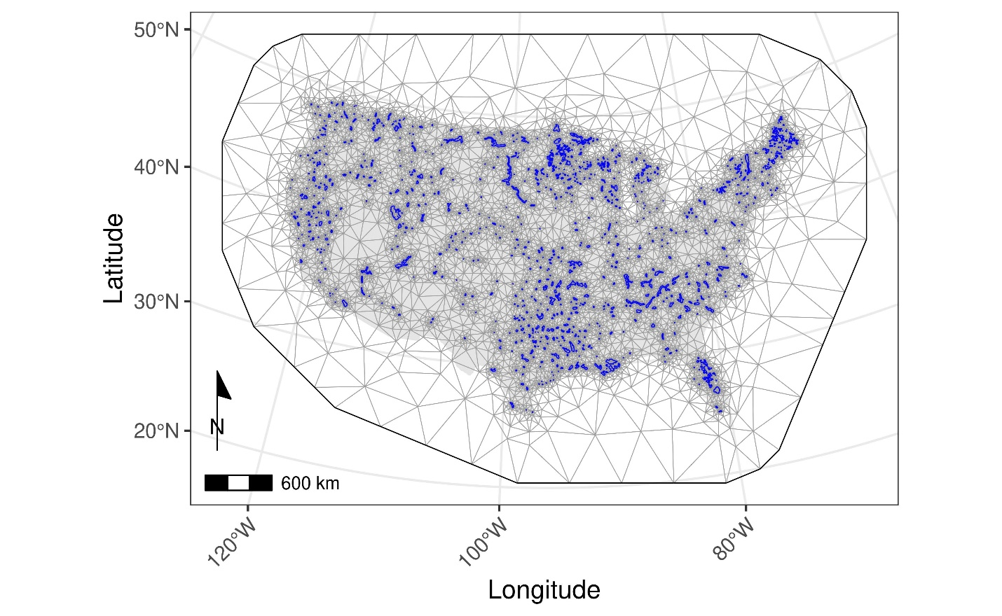
Figure S1. Delaunay triangulation mesh on which the values of the spatial model were defined. The outer black line was the boundary of the mesh, and gray lines were all the triangles in the mesh with the objective of retaining an isosceles shape and as equal area as possible. The blue represents internal mesh boundaries with a finer spatial resolution using the lake polygon shapefile.
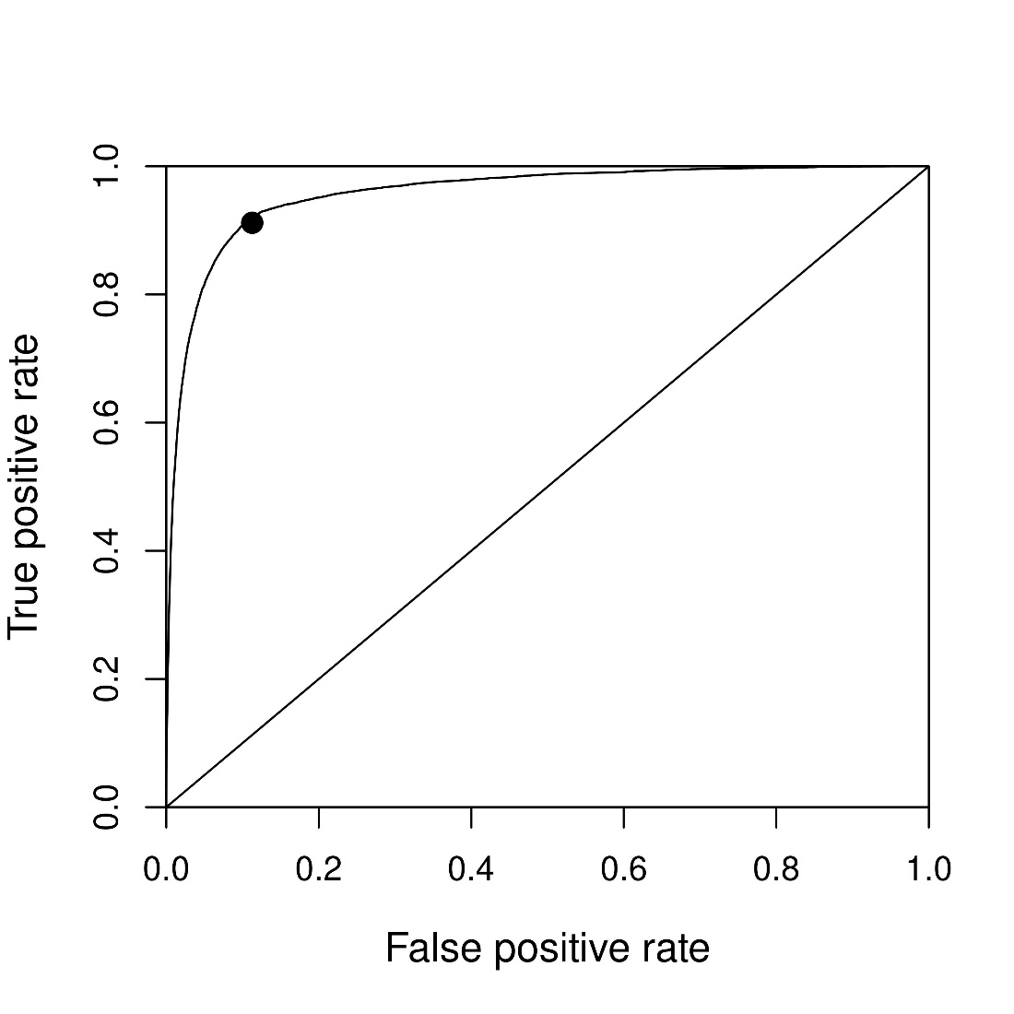
Figure S2. The receiver operating characteristic (ROC) curve. The ROC curve portrays the trade-off between sensitivity and specificity when setting a cut-off point in a binomial classification model. The output of a binomial model is a number between 0 and 1, and in order to make predictions based on the model, a cut-off point must be chosen above which a prediction is considered positive, and below which it is considered negative. The ROC curve plots true positive rate on the y-axis and the false positive rate on the x-axis. The line represents all possible values of the cut-off point for the model, and the black dot is the optimal point at which true positive rate is maximized and false positive rate is minimized as defined by Youden’s index. This cutoff point results in the best accuracy value and was set at 0.10 in this study. The AUC value is the integral of the ROC curve and measures the overall quality of the model predictions irrespective of which cutoff rate is chosen.

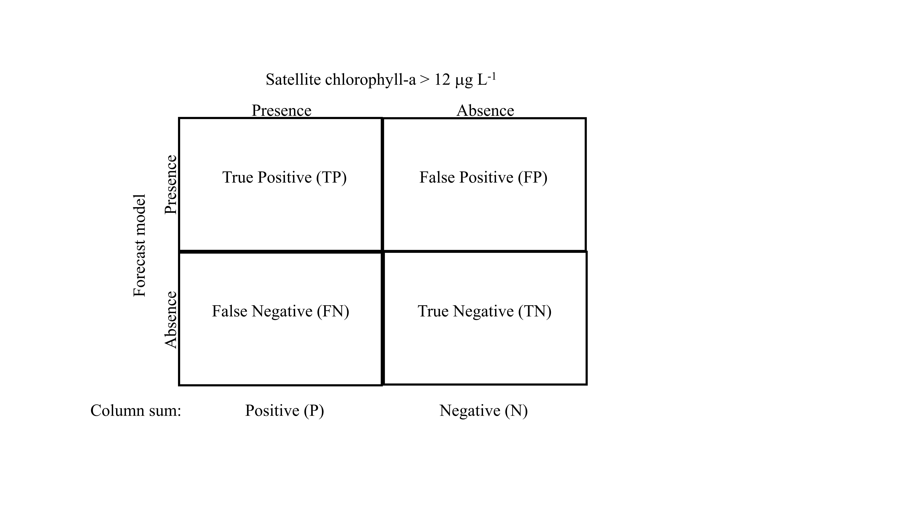
Figure S3. A conceptual confusion matrix that outlines the four scenarios used to evaluate agreement between the forecast model and presence or absence of satellite chlorophyll-a >12 μg L⁻¹.

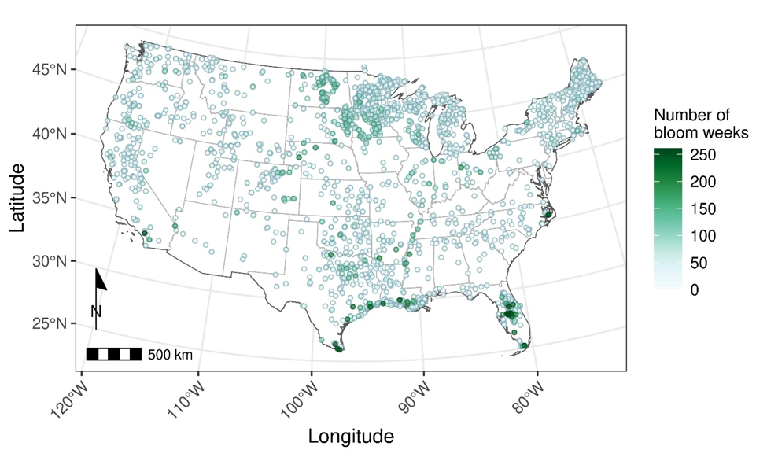
Figure S4. Choropleth map of the number of Alert Level 1 cyanoHAB weeks in lakes from 2017 to 2021.

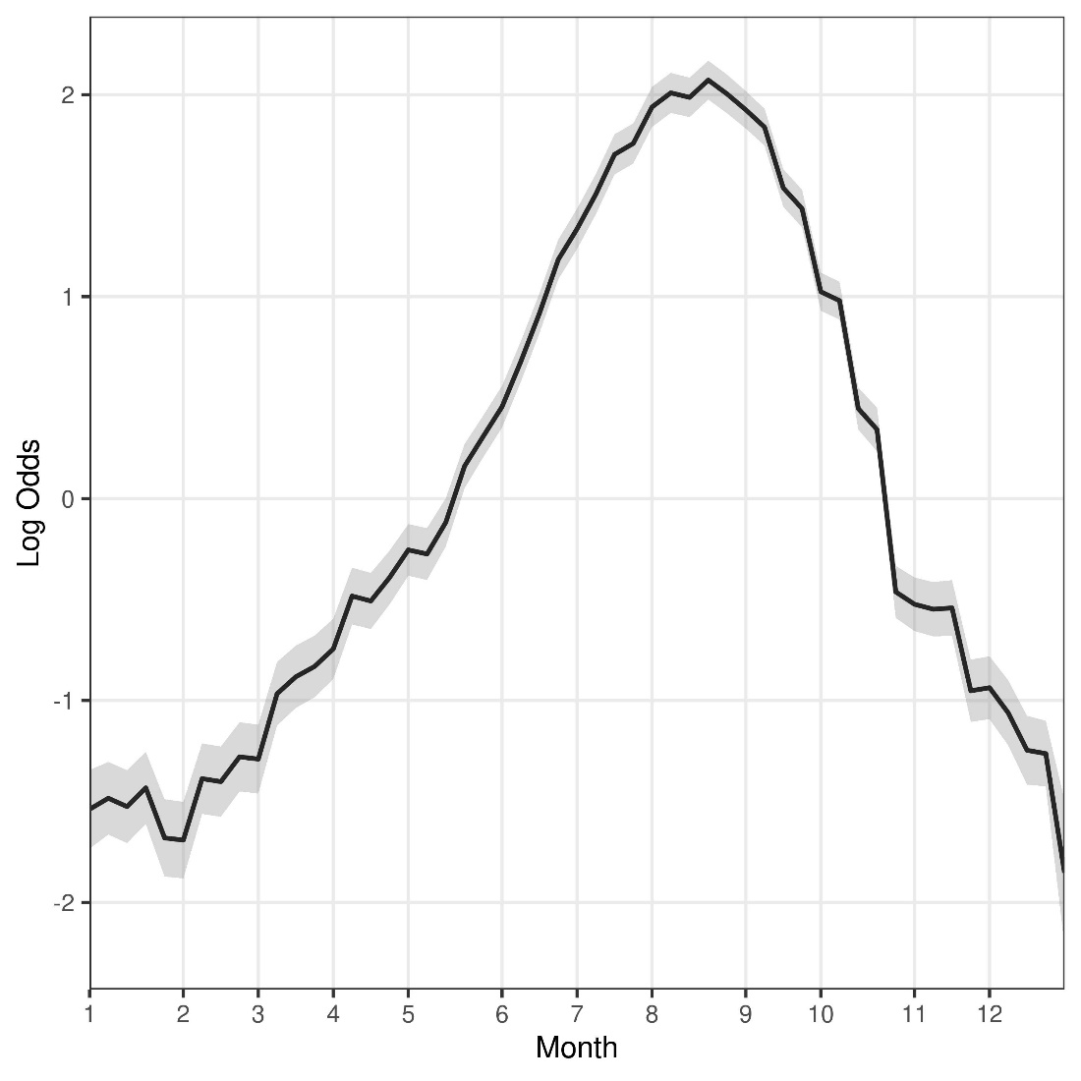
Figure S5. Mean AR(1) temporal trend corresponding to week of year across all study years and lakes. The shaded area represents the 95% credible interval.

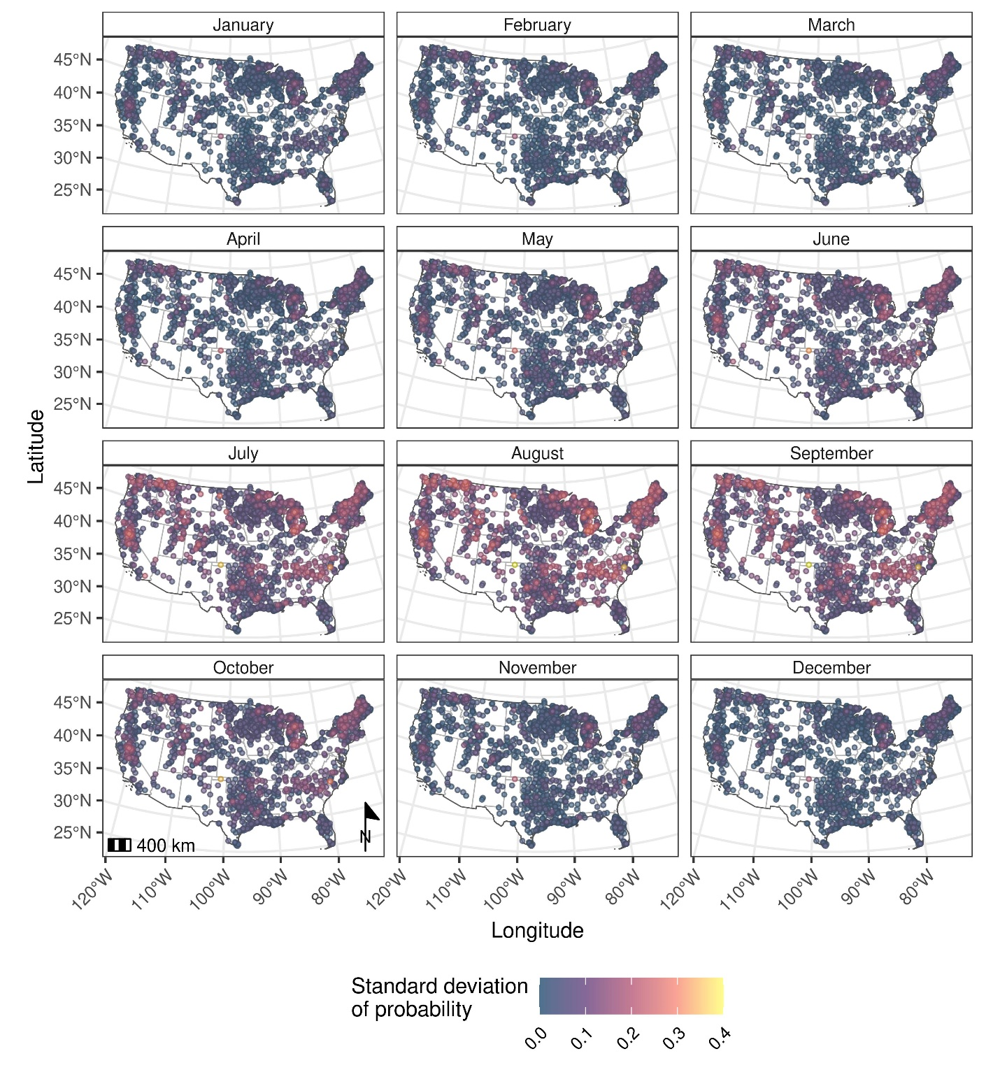
Figure S6. Map of standard deviation of exceedance of WHO Alert Level 2 bloom event for the second week of every month in 2021.
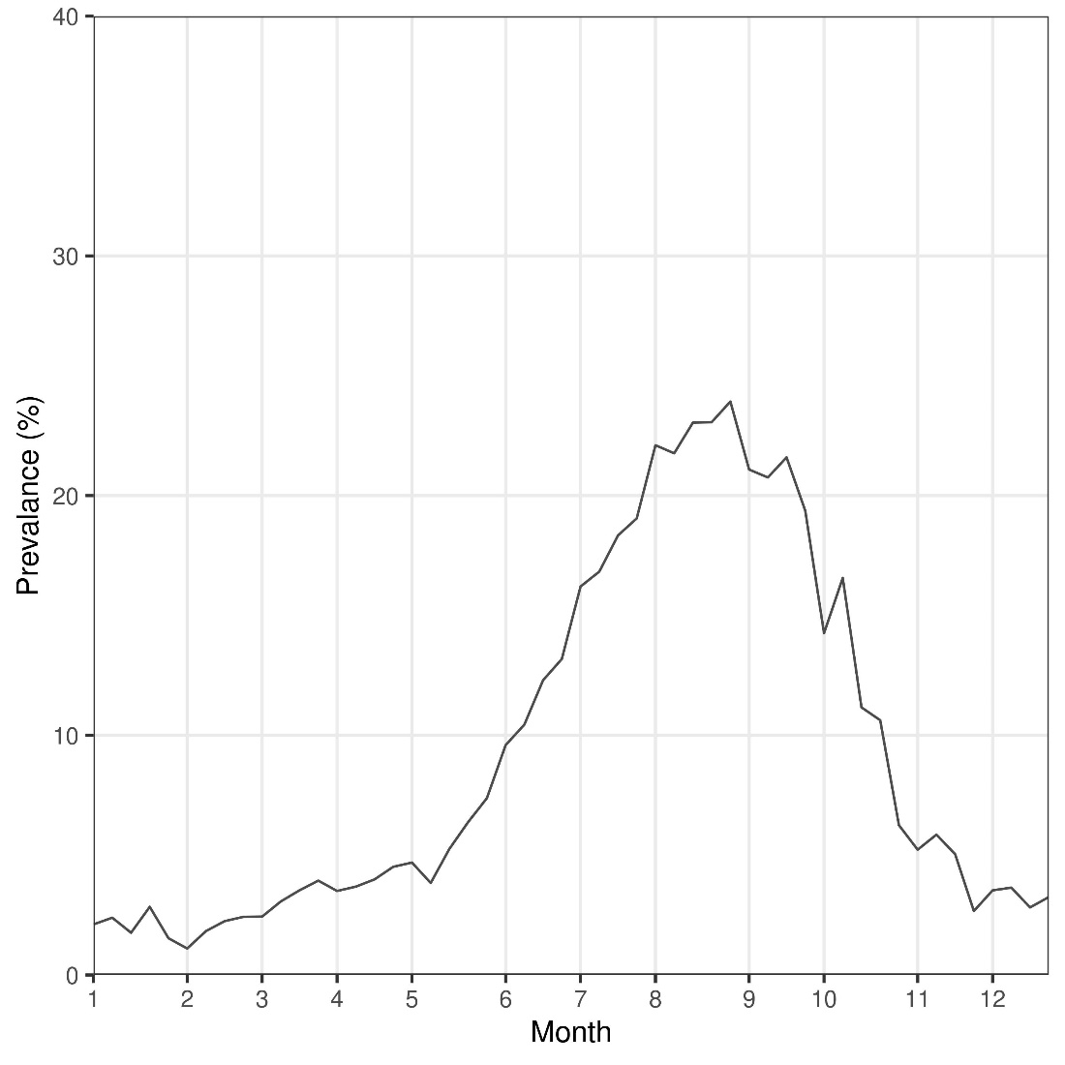
Figure S7. Model results for the positive prevalence weekly changes over time during the 2021 prediction period.

Supplemental references
Brier, G.W., 1950. verification of forecasts expressed in terms of probability. Monitoring Weather Review 78, 1-3.
Carey, C.C., Ibelings, B.W., Hoffmann, E.P., Hamilton, D.P., Brookes, J.D., 2012. Eco-physiological adaptations that favour freshwater cyanobacteria in a changing climate. Water Res 46, 1394-1407.
Cheruvelil, K.S., Soranno, P.A., McCullough, I.M., Webster, K.E., Rodriguez, L.K., Smith, N.J., 2021. LAGOS‐US LOCUSv1.0: Data module of location, identifiers, and physical characteristics of lakes and their watersheds in the conterminous U.S. Limnology and Oceanography Letters 6, 270-292.
Chorus, I., Fastner, J., Welker, M., 2021. Cyanobacteria and Cyanotoxins in a Changing Environment: Concepts, Controversies, Challenges. Water 13.
Coffer, M., Schaeffer, B., Darling, J., Urquhart, E., Salls, W., 2020. Quantifying national and regional cyanobacterial occurrence in US lakes using satellite remote sensing. Ecological Indicators 111, https://doi.org/10.1016/j.ecolind.2019.105976.
Coffer, M., Schaeffer, B., Salls, W., Urquhart, E., Loftin, K., Stumpf, R., Werdell, P., Darling, J., 2021. Satellite remote sensing to assess cyanobacterial bloom frequency across the United States at multiple spatial scales. Ecological Indicators 128, 107822.
Cohen, J., 1960. A coefficient of agreement for nominal scales. Educational and Psychological Measurement 20, 37-46.
Eloranta, P., 1986. Phytoplankton structure in different lake types in central Finland. Ecography 9, 214-224.
Feng, T., Wang, C., Wang, P., Qian, J., Wang, X., 2018. How physiological and physical processes contribute to the phenology of cyanobacterial blooms in large shallow lakes: A new Euler-Lagrangian coupled model. Water Res 140, 34-43.
Goodman, L.A., Kruskal, W.H., 1954. Measures of Association for Cross Classifications*. Journal of the American Statistical Association 49, 732-764.
Huisman, J., Hulot, F.D., 2005. Population dynamics of harmful cyanobacteria: Factors affecting species composition., in: Huisman, J., Matthijs, H.C.P., Visser, P.M. (Eds.), Harmful Cyanobacteria. Springer, Norwell, MA, pp. 143-176.
Iiames, J.S., Salls, W., Mehaffey, M.H., Nash, M.S., Christensen, J., Schaeffer, B., 2021. Modelling anthropogenic and environmental influences on freshwater harmful algal bloom development detected by MERIS over the Central United States. Water Resources Research 57.
Jacoby, J.M., Gibbons, H.L., Hanowell, R., Bouchard, D.D., 1994. Wintertime blue-green algal toxicity in a mesotrophic lake. Journal of Freshwater Ecology 9, 241-251.
Karl, T., Koss, W.J., 1984. Regional and national monthly, seasonal, and annual temperature weighted by area, 1895-1983.
Ma, J., Qin, B., Paerl, H.W., Brookes, J.D., Hall, N.S., Shi, K., Zhou, Y., Guo, J., Li, Z., Xu, H., Wu, T., Long, S., 2016. The persistence of cyanobacterial (Microcystis spp.) blooms throughout winter in Lake Taihu, China. Limnology and Oceanography 61, 711-722.
Marshall, C.T., Peters, R.H., 1989. General patterns in the seasonal development of chlorophyll a for temperate lakes. Limnology and Oceanography 34, 793-971.
McLaughlin, D.B., 2012. Assessing the predictive performance of risk-based water quality criteria using decision error estimates from receiver operating characteristics (ROC) analysis. Integr Environ Assess Manag 8, 674-684.
Myer, M.H., Urquhart, E., Schaeffer, B.A., Johnston, J.M., 2020. Spatio-temporal modeling for forecasting high-risk freshwater cyanobacterial harmful algal blooms in Florida. Frontiers in Environmental Science 8, 581091.
Padisa´k, J., Hajnal, E., Krienitz, L., Lakner, J., Uveges, V., 2010. Rarity, ecological memory, rate of floral change in phytoplankton—and the mystery of the Red Cock. Hydrobiologia 653, 45-64.
Paerl, H.W., Fulton, R.S., Moisander, P.H., , J.D., 2001. Harmful freshwater algal blooms, with an emphasis on cyanobacteria. The Scientific World 1, 76-13.
Phillips, G., Pietiläinen, O.P., Carvalho, L., Solimini, A., Lyche Solheim, A., Cardoso, A.C., 2008. Chlorophyll–nutrient relationships of different lake types using a large European dataset. Aquatic Ecology 42, 213-226.
Reinl, K.L., Harris, T.D., North, R.L., Almela, P., Berger, S.A., Bizic, M., Burnet, S.H., Grossart, H.P., Ibelings, B.W., Jakobsson, E., Knoll, L.B., Lafrancois, B.M., McElarney, Y., Morales‐Williams, A.M., Obertegger, U., Ogashawara, I., Paule‐Mercado, M.C., Peierls, B.L., Rusak, J.A., Sarkar, S., Sharma, S., Trout‐Haney, J.V., Urrutia‐Cordero, P., Venkiteswaran, J.J., Wain, D.J., Warner, K., Weyhenmeyer, G.A., Yokota, K., 2023. Blooms also like it cold. Limnology and Oceanography Letters.
Rohwer, R.R., Hale, R.J., Vander Zanden, M.J., Miller, T.R., McMahon, K.D., 2023. Species invasions shift microbial phenology in a two-decade freshwater time series. Proc Natl Acad Sci U S A 120, e2211796120.
Schaeffer, B.A., Urquhart, E., Coffer, M., Salls, W., Stumpf, R.P., Loftin, K.A., Werdell, P.J., 2022. Satellites quantify the spatial extent of cyanobacterial blooms across the United States at multiple scales. Ecol Indic 140, 1-14.
Shi, K., Zhang, Y., Zhang, Y., Li, N., Qin, B., Zhu, G., Zhou, Y., 2019. Phenology of Phytoplankton Blooms in a Trophic Lake Observed from Long-Term MODIS Data. Environ Sci Technol 53, 2324-2331.
Smith, N.J., Webster, K.E., Rodriguez, L.K., Cheruvelil, K.S., Soranno, P.A., 2021. LAGOS-US LOCUS v1.0: Data module of location, identifiers, and physical characteristics of lakes and their watersheds in the conterminous U.S. ver 1., in: Initiative, E.D. (Ed.), EDI Data Portal.
Urquhart, E.A., Schaeffer, B.A., 2020. Envisat MERIS and Sentinel-3 OLCI satellite lake biophysical water quality flag dataset for the contiguous United States. Data in Brief 28, 104826.
Üveges, V., Tapolczai, K., Krienitz, L., Padisák, J., 2012. Photosynthetic characteristics and physiological plasticity of an Aphanizomenon flos-aquae (Cyanobacteria, Nostocaceae) winter bloom in a deep oligo-mesotrophic lake (Lake Stechlin, Germany). Hydrobiologia 698, 263-272.
Wejnerowski, L., Rzymski, P., Kokocinski, M., Meriluoto, J., 2018. The structure and toxicity of winter cyanobacterial bloom in a eutrophic lake of the temperate zone. Ecotoxicology 27, 752-760.
Wynne, T., Meredith, A., Briggs, T., Litaker, W., Stumpf, R., 2018. Harmful algal bloom rorecasting branch ocean color satellite imagery processing guidelines. . NOAA Technical Memorandum NOS NCCOS 2018 252, 48.

