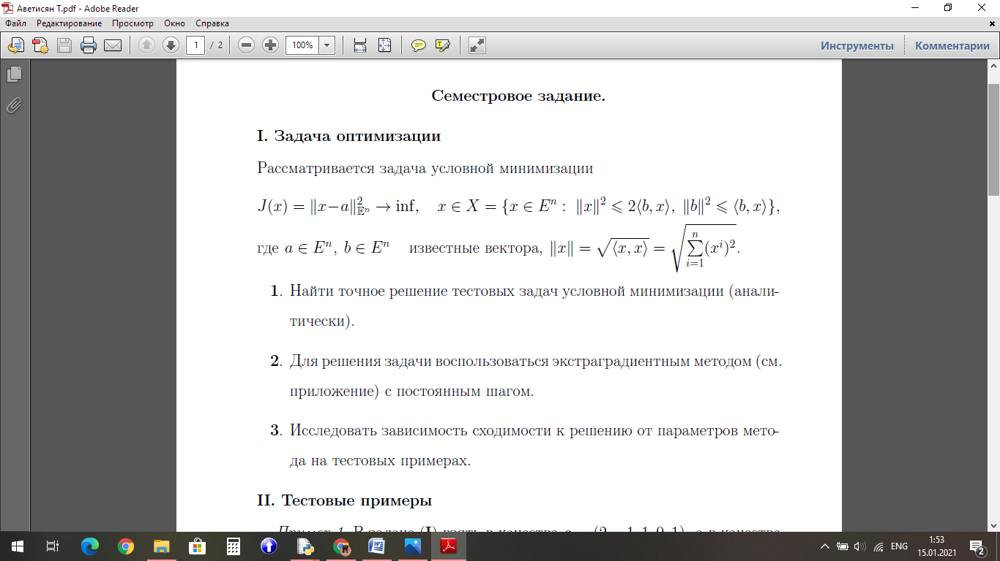  
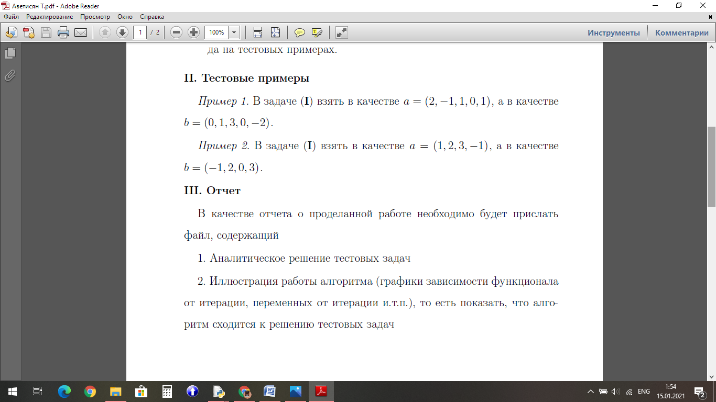



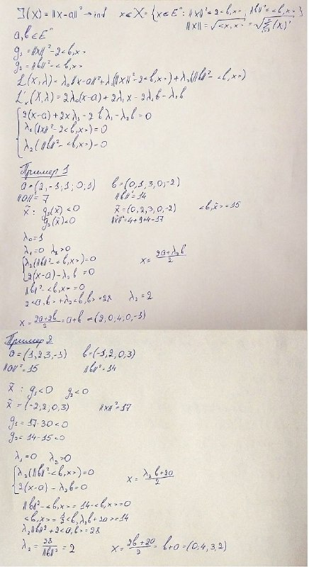



Код программы

from math import sqrt

print("Введите номер примера")

inp = int(input())

if inp == 1:

x0=[1,1,0,0,0]

a=[2,-1,1,0,1]

b=[0,1,3,0,-2]

else:

x0=[1,1,0,0]

a=[1,2,3,-1]

b=[-1,2,0,3]

beta = 0.125

l1 = 0

l2 =2

l0 = [l1, l2]

xk = x0

eps =0.001

iteracii = 0

def J(x):

j=0

for i in range(len(x)):

j+=(x[i]-a[i])**2

return j

def J_x(x):

j_shtrix=[]

for i in range(len(x)):

j_shtrix.append(2*(x[i] - a[i]))

return j_shtrix

def normab_2(x):

norma_b = 0

for i in range(len(b)):

norma_b += b[i]**2

return norma_b

def b_x(x):

bx = 0

for i in range(len(b)):

bx += b[i]*x[i]

return bx

def normax_2(x):

norma_x =0

for i in range(len(x)):

norma_x += x[i]**2

return norma_x

def g_1(x):

norma_x = normax_2(x)

bx = b_x(x)

g1 = norma_x - 2*bx

return g1

def g_2(x):

g_2 =0

bx = b_x(x)

norma_b = normab_2(x)

g2 = norma_b - bx

return g2

def g1_shtrix(x):

g1_shtrix= []

for i in range(len(b)):

g1_shtrix = x[i]-b[i]

g1_shtrix = 2*g1_shtrix

return g1_shtrix

def g2_shtrix(x):

g2shtrix = []

for i in range(len(b) ):

g2shtrix.append(- b[i])

return g2shtrix

def L_x(xk):

l_x=[]

for i in range(len(x0)):

t = 2*(xk[i] - a[i]) +l1*2*(xk[i] - b[i]) - l2*b[i]

l_x.append(t)

return l_x

def L_l(xk):

l_l=[]

g1 = g_1(xk)

g2 = g_2(xk)

l_l = [g1, g2]

return l_l

x_k = []

l_k = []

xk = x0

xk_minus1 =[]

xk_1 = []

lk_1 = []

x_k_1 = []

l_k_1 = []

lk = l0

l_x = L_x(xk)

while True :

for i in range(len(xk)):

x_k_1.append(xk[i] - beta * l_x[i])

x_k = x_k_1

x_k_1 = []

l_l = L_l(xk)

for i in range(len(l0)):

l_k_1.append(lk[i] + beta * l_l[i])

l_k = l_k_1

l_k_1 =[]

if l_k[i] < 0:

l_k[i] = 0

xk_k_1=[]

l_x = L_x(x_k)

xk_minus1 = xk

for i in range(len(x0)):

xk_1.append(xk[i] - beta * l_x[i])

xk= xk_1

xk_1 = []

l_l = L_l(x_k)

for i in range(len(lk)):

lk_1.append( lk[i] + beta * l_l[i])

lk = lk_1

lk_1=[]

j_raznost_1 = J(xk)

j_raznost_2 = J(xk_minus1)

j_raznost = j_raznost_1 - j_raznost_2

if j_raznost < 0:

j_raznost= - j_raznost

norma_shtrix =normax_2(xk)

norma_shtrix= sqrt(norma_shtrix)

for i in range(len(xk)):

xk_k_1.append(xk[i]- xk_minus1[i])

norma_xk_k_1 = normax_2(xk_k_1)

norma_xk_k_1 = sqrt(norma_xk_k_1)

iteracii+=1

if j_raznost <= eps or norma_shtrix <= eps or norma_xk_k_1 <= eps:

break

xk_k=[]

for i in range(len(xk)):

xk_k.append(int(xk[i]*10000) / 10000)

print("Решение")

print(xk_k)

print("Количество итераций = ", iteracii)

Пример 1

При β = 0.125

|  |  |  |  |
| --- | --- | --- | --- |
| Значение ꜫ | Решение | | Количество итераций |
| ꜫ = 0.1 | [1.9211, 0.0788, 3.6845, 0.0, -0.9211] | | 12 |
| ꜫ = 0.01 | [1.9905, 0.0094, 3.9621, 0.0, -0.9905] | | 22 |
| ꜫ = 0.0001 | | [1.9999, 0.0, 3.9996, 0.0, -0.9999] | 44 |

При ꜫ = 0.001

|  |  |  |
| --- | --- | --- |
| Значение β | Решение | Количество итераций |
| β = 0.125 | [1.999, 0.0009, 3.9963, 0.0, -0.999] | 33 |
| β = 0.25 | [1.9996, 0.0003, 3.9985, 0.0, -0.9996] | 23 |
| β = 0.3 | [1.9998, 0.0001, 3.9995, 0.0, -0.9998] | 49 |

Пример 2

При β = 0.125

|  |  |  |  |
| --- | --- | --- | --- |
| Значение ꜫ | Решение | | Количество итераций |
| ꜫ = 0.1 | [0.0788, 3.7634, 2.7634, 1.8422] | | 12 |
| ꜫ = 0.01 | [0.0076, 3.977, 2.977, 1.9846] | | 23 |
| ꜫ = 0.0001 | | [0.0, 3.9997, 2.9997, 1.9998] | 45 |

При ꜫ = 0.001

|  |  |  |
| --- | --- | --- |
| Значение β | Решение | Количество итераций |
| β = 0.125 | [0.0007, 3.9977, 2.9977, 1.9985] | 34 |
| β = 0.25 | [0.0003, 3.9989, 2.9989, 1.9992] | 23 |
| β = 0.3 | [0.0, 4.0002, 3.0002, 2.0001] | 50 |

Количествоитераций

**Пример 2**

Значение

Количествоитераций

Аветисян Татевик 801 группа