EXECUTIVE OVERVIEW

Local AI Health Guidance Platform

Executive summary
This product demonstrates how a healthcare organization can guide a patient from a health concern to an appropriate next step using AI on one local HP ZGX device. It combines an adaptive consultation, relevant records, practical guidance and explained doctor matches in one responsive website and mobile app experience.
For healthcare CIOs and CTOs, the value proposition is better care navigation, less avoidable clinician workload, better prepared appointments and potential reductions in unnecessary episode spending. These are outcomes to validate. The demo proves the workflow and local execution; it does not prove clinical effectiveness or financial savings.
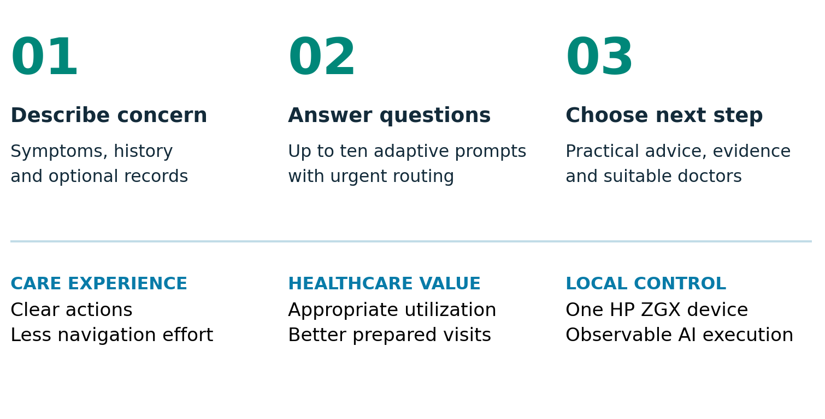

How to use this master document
Read pages 1 to 5 for executive value, pages 6 to 16 for the complete experience and pages 17 onward for implementation. The implementation section defines stable requirements, contracts, code ownership and tests. Version 2.0 replaces the earlier planning document. All code paths are proposed until implemented and verified; no application code is claimed to exist.
EXECUTIVE OVERVIEW

Where healthcare value comes from
The product helps users choose the right level of care and prepare useful information for that encounter. It can reduce avoidable demand only when guidance is appropriate, understood and followed without delaying necessary evaluation.
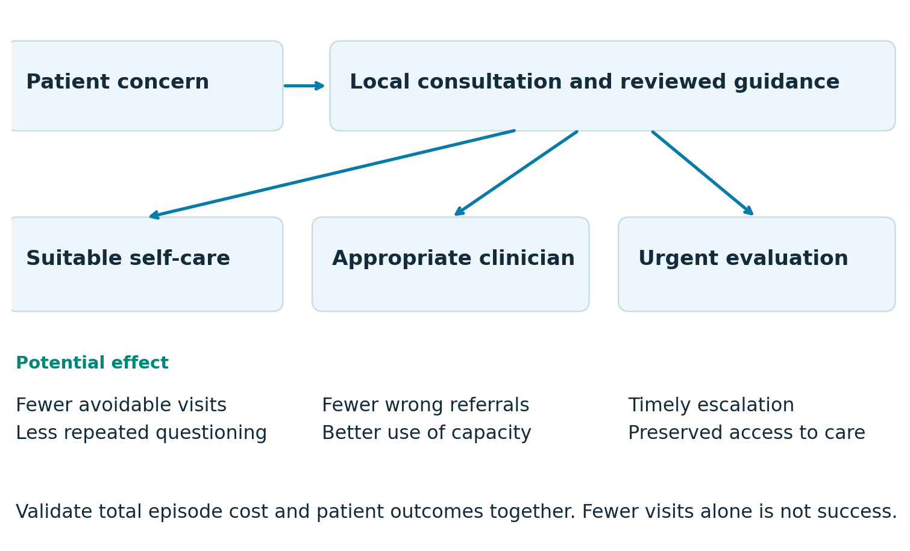

Less burden with better access
A concise intake and portable summary can reduce repetitive questioning. Relevant specialty matching can reduce misdirected appointments and referral rework. Reviewed advice may resolve suitable low-acuity questions without an unnecessary visit. Urgent concerns must move toward timely evaluation rather than being optimized for fewer encounters.

Who can realize the benefit
Patients may save time, travel and out-of-pocket expense. Clinicians may recover capacity for complex care. Health systems may reduce scheduling friction. Insurers and organizations accountable for total cost may benefit from more appropriate utilization. Under fee-for-service arrangements, fewer visits can reduce revenue; capacity gains and payer savings are different economic outcomes [S1, S2].
EXECUTIVE OVERVIEW

Healthcare benefit register
These eight value hypotheses cover the core stakeholders. Each is linked to product requirements and an outcome measure so the benefit narrative can be tested rather than repeated as a promise.
ID and beneficiary | Mechanism and potential benefit | Measure
B01 Patients | Better choice of doctor. Specialty guidance and preference matching can reduce wrong-destination appointments. | Appropriate-first-destination rate; repeat referrals
B02 Clinicians | Less avoidable demand. Reviewed advice for suitable concerns may resolve questions without an unnecessary visit. | Clinically adjudicated avoidable visits; delayed-care events
B03 Clinical staff | Less repetitive intake. Confirmed histories and concise summaries can reduce repeat questioning and preparation time. | Net staff minutes per episode, including correction time
B04 Health systems | More useful appointment capacity. Redirecting unsuitable demand can free slots for patients needing those services. | Wait time and filled capacity by specialty
B05 Insurers and risk-bearing providers | Lower avoidable episode spending. Fewer inappropriate visits and better navigation may lower total episode cost. | Risk-adjusted allowed cost per episode with quality controls
B06 Patients and caregivers | Less travel and confusion. Clear actions, visit options and a portable summary can reduce navigation effort. | Time to next step; out-of-pocket cost; comprehension
B07 CIO and privacy teams | Greater control of sensitive data. Local inference and lifecycle controls reduce dependence on external processing. | Verified outbound payloads; deletion completion; access tests
B08 CTO and operations teams | Observable and adaptable AI delivery. Versioned local models, visible evidence and reproducible builds support technical oversight. | Reproducible run rate; recovery time; measured cost per run

Additional potential effects include better health literacy, greater patient confidence, less navigation work for caregivers and more consistent intake. They depend on usability, source quality and appropriate follow-through. Clinical staff must not inherit a larger correction or escalation workload than the platform removes [S3].
EXECUTIVE OVERVIEW

How to validate value and spending

Measure appropriate care rather than visit avoidance alone
Use a prospective pilot with a matched comparison group or randomized rollout where feasible. Define eligible episodes, baseline utilization, follow-up windows and exclusions before analysis. A clinician reviewer should adjudicate potentially avoidable visits and inappropriate delays using a blinded process where practical. Patient intent to skip a visit is not a verified avoided visit.
Outcome | Definition and evidence
Appropriate destination | Among reviewed episodes that need clinical care, the share whose first destination matches the adjudicated care setting or specialty. Report access failures separately.
Net clinical time | Baseline intake, navigation and documentation time minus the pilot time, including AI-output review, correction, escalation and support.
Episode spending | Total allowed medical cost for eligible episodes over a predefined window, adjusted for case mix and compared with a valid baseline. Report patient out-of-pocket cost separately.
Quality and access | Urgency disagreements, delayed necessary care, repeat contacts, escalation events, time to care and user comprehension. Report differences across relevant groups.

An honest economic model
Payer net value = attributable reduction in total allowed episode cost minus program operating cost. Provider net value = usable capacity or labor benefit plus applicable quality or risk-contract benefit minus operating cost and any lost contribution margin. Do not count the same episode reduction twice, and do not call freed minutes cash savings unless expenditure actually falls.
Local delivery cost includes device amortization, energy, support, model and source licensing, maintenance, clinical review and integration. Compare equivalent workload, quality and utilization assumptions before claiming that local inference costs less than a cloud alternative. This document assigns no invented savings percentage or return on investment.

What the demo can measure now
Completion, time per step, response latency, valid citations, directory filter accuracy and network behavior are measurable with synthetic cases. Real referral outcomes, avoided visits, insurer savings and patient health outcomes remain “Not measured” until a suitable pilot supplies evidence [S1, S2].
EXECUTIVE OVERVIEW

Local execution and executive proof
One ZGX device hosts the application, local AI inference, health data, document processing and evidence stores. The retrieval gateway is also local; only approved requests cross to external public sources. The browser runs on a demonstration computer connected through a trusted network [S4].
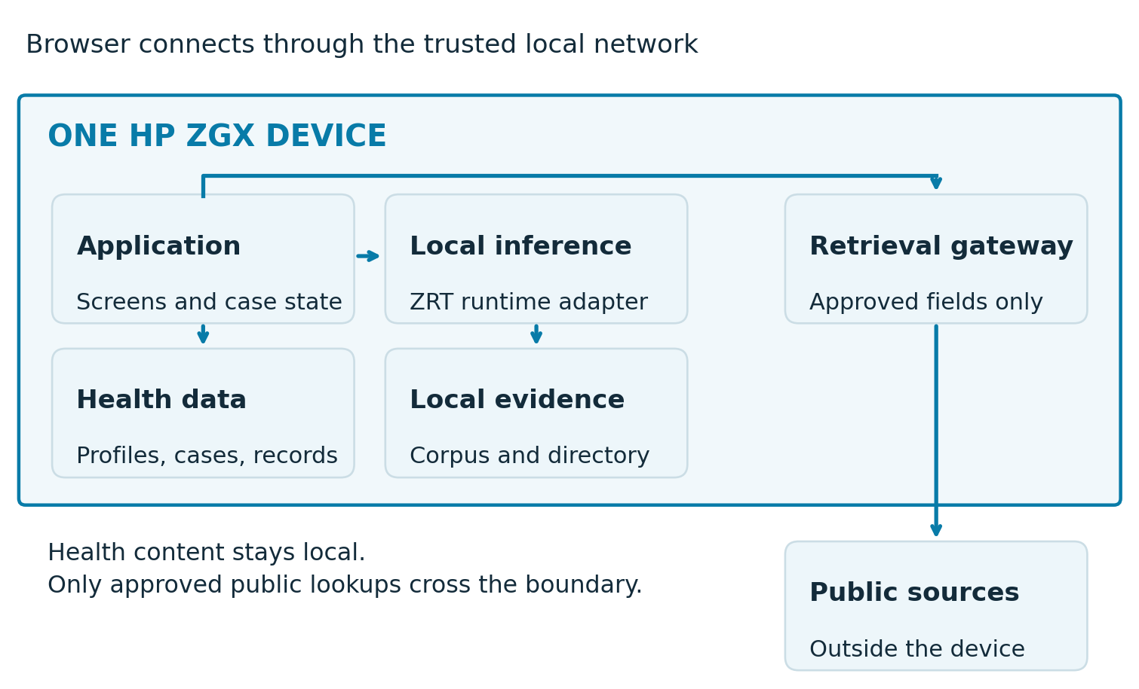

A five minute presentation
0:00 to 1:00: explain the concern and local data choices. 1:00 to 2:00: confirm a report fact and answer two adaptive questions, with earlier answers transparently prefilled. 2:00 to 3:00: show guidance and its supporting source. 3:00 to 4:00: compare doctor matches and preview the summary. 4:00 to 5:00: show actual runtime measurements, cached operation and guest reset.
Use a clearly fictional patient. Prepare a separate urgent-interruption example. The healthcare outcome story is a hypothesis; the live proof is the complete workflow, controlled processing and honest handling of uncertainty.
EXPERIENCE MAP

The complete digital experience
The first build is one responsive web application. Its public website explains the product; its application routes serve patients on desktop and mobile; its presenter routes demonstrate local operation. “App” means the mobile layout of these same application routes. Native iOS and Android builds are outside this release, avoiding duplicate implementations.
Surface | Pages and screens | Navigation
Public website | W01 Home; W02 How it works; W03 For healthcare; W04 Privacy; W05 Help. | Header links and a consistent Start consultation action.
Patient setup | A01 Start and consent; A02 Health profile; A03 Describe concern; A04 Records. | Profile and records are optional. The primary concern is required.
Consultation | A05 Adaptive questions; A06 Review; A07 Guidance; A08 Sources. | One question at a time, review before generation, evidence on demand.
Care navigation | A09 Doctor preferences; A10 Matches; A11 Doctor details; A12 Summary. | No automatic booking or transmission of the consultation.
Continuity and exceptions | A13 History; A14 Data settings; A15 Urgent action; A16 Service limits. | Urgent routing supersedes the normal path. Saved history requires sign-in.
Presenter tools | O01 Runtime; O02 Controls; O03 Scenarios. | Separate role and navigation; no patient-facing infrastructure clutter.

What the screen catalogue represents
The next six pages show every planned page and screen as a visual concept. Each has a unique identifier used in the route registry, code filename and tests. Their text is illustrative, not a clinical script. Detailed screen contracts follow before the AI implementation specification.
Loading, empty, offline, validation, unauthorized, stale and failed states are variants of their owning screen. Dialogs for deletion, external links and unsaved edits belong to that screen and do not create hidden routes. The route registry below is the complete first-release inventory.
VISUAL SCREEN CATALOGUE / W01, W02, W03, W04

Screen concepts 1
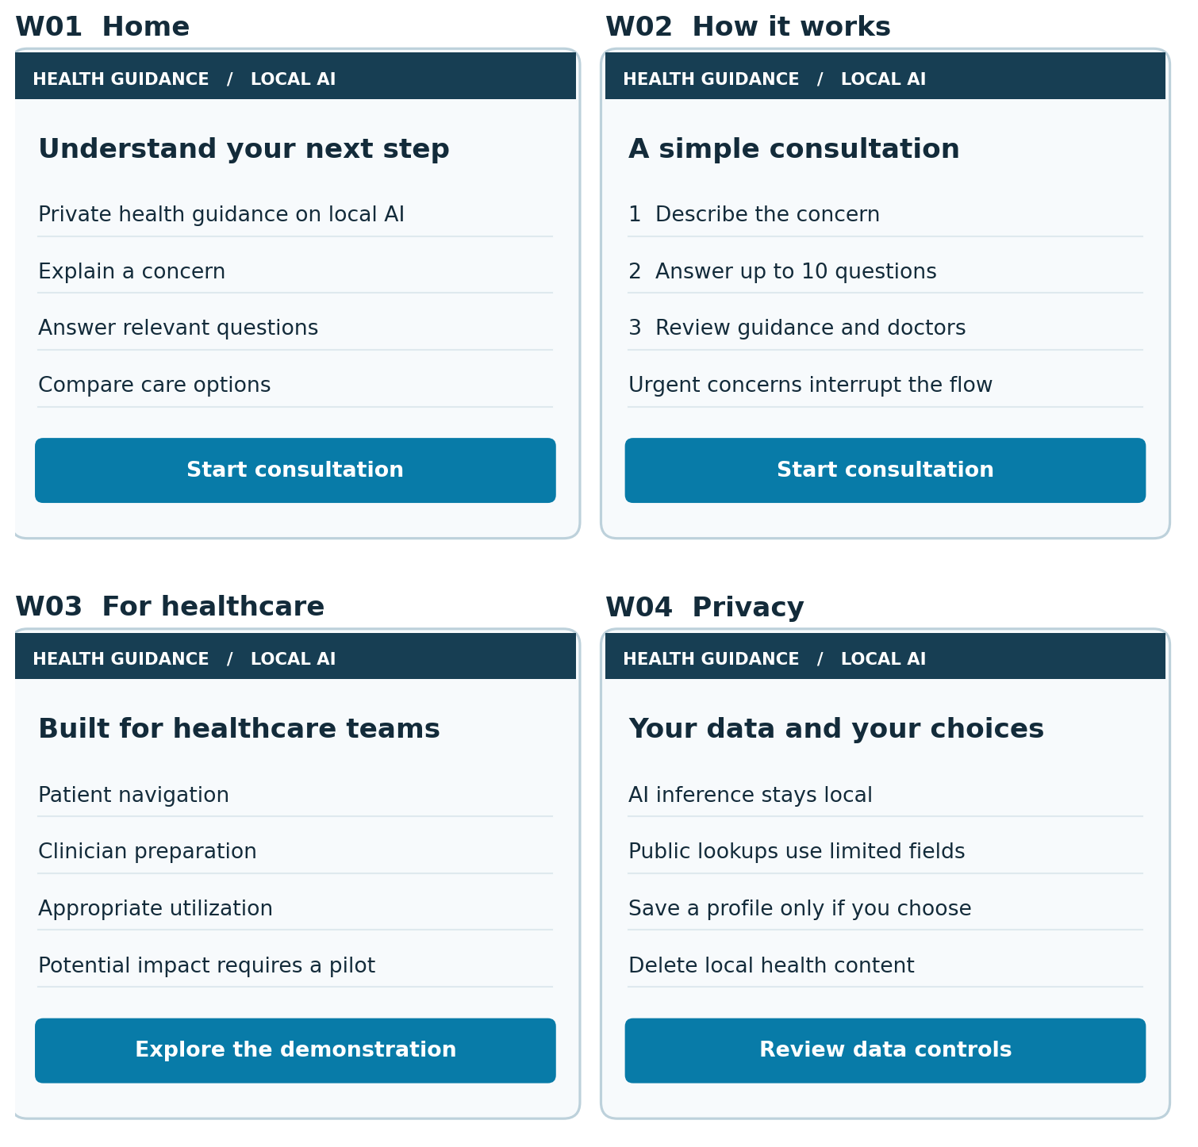
Concept layouts for the shared responsive application. Primary actions, supporting fields and exception handling are specified in the following screen contracts. All fictional provider details are labeled sample data.
VISUAL SCREEN CATALOGUE / W05, A01, A02, A03

Screen concepts 2
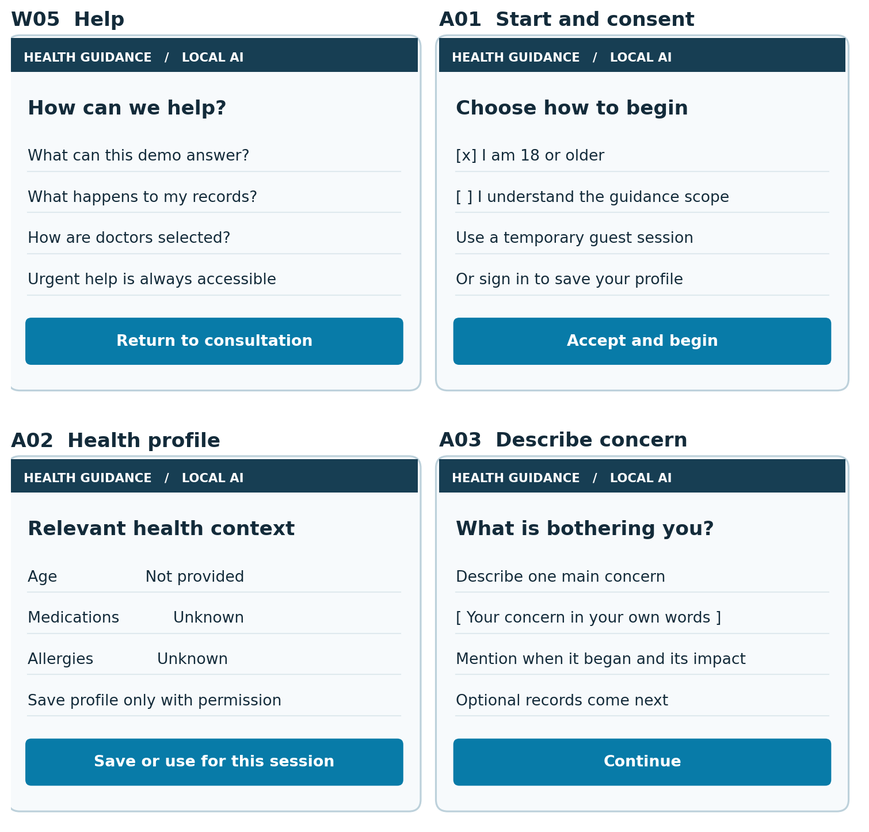
Concept layouts for the shared responsive application. Primary actions, supporting fields and exception handling are specified in the following screen contracts. All fictional provider details are labeled sample data.
VISUAL SCREEN CATALOGUE / A04, A05, A06, A07

Screen concepts 3
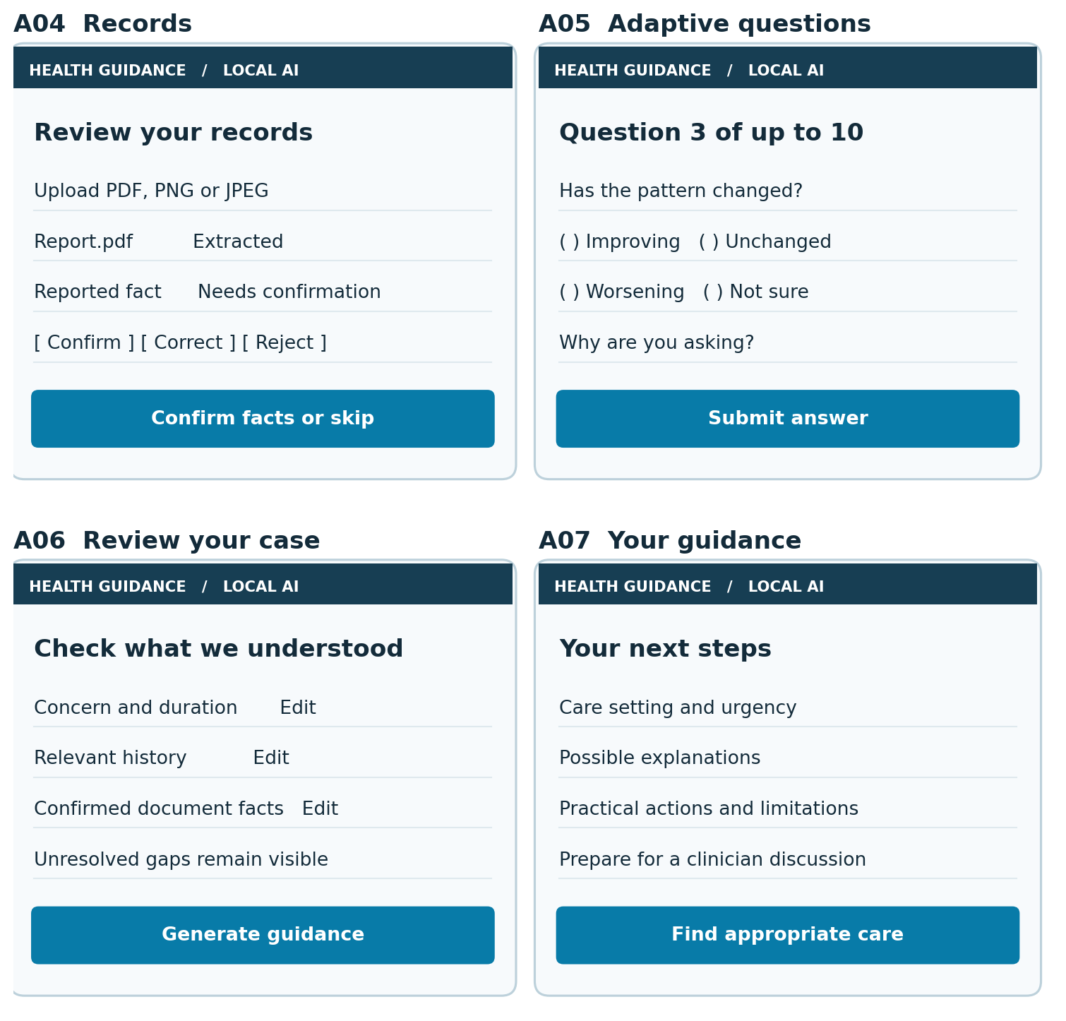
Concept layouts for the shared responsive application. Primary actions, supporting fields and exception handling are specified in the following screen contracts. All fictional provider details are labeled sample data.
VISUAL SCREEN CATALOGUE / A08, A09, A10, A11

Screen concepts 4
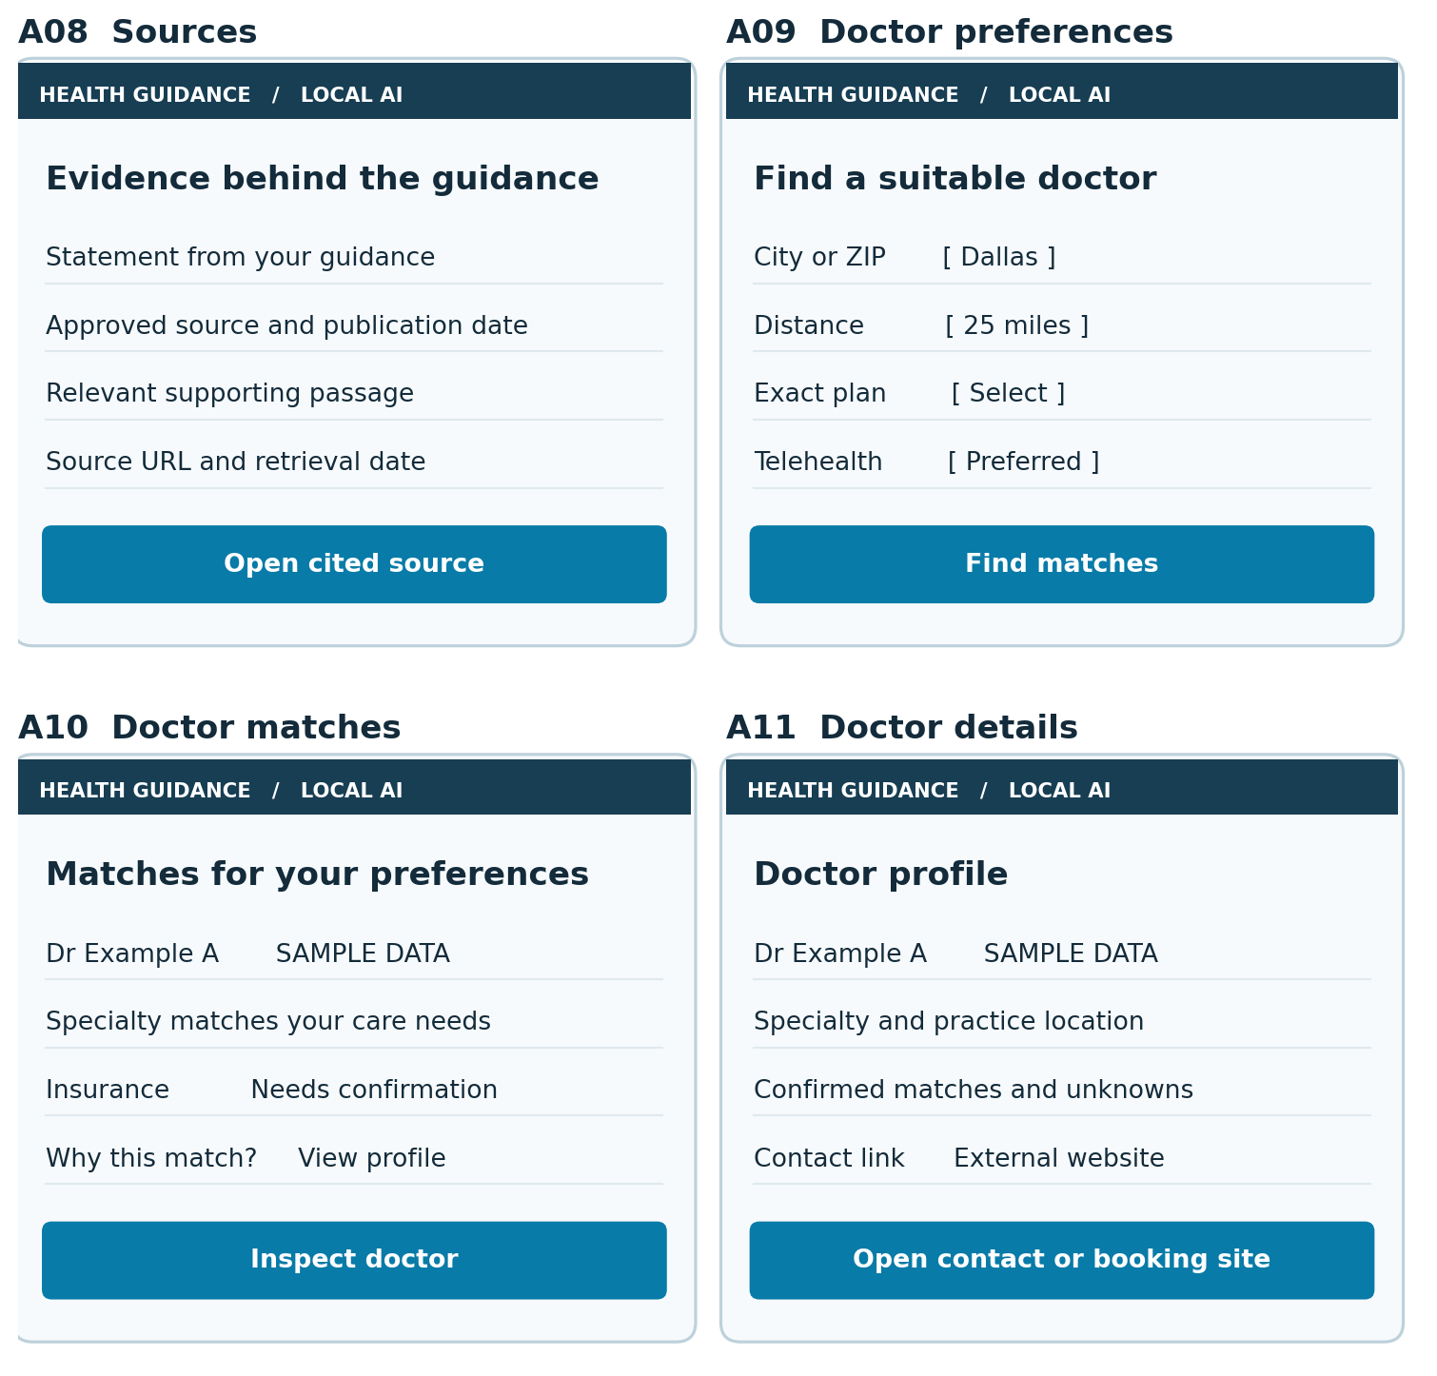
Concept layouts for the shared responsive application. Primary actions, supporting fields and exception handling are specified in the following screen contracts. All fictional provider details are labeled sample data.
VISUAL SCREEN CATALOGUE / A12, A13, A14, A15

Screen concepts 5
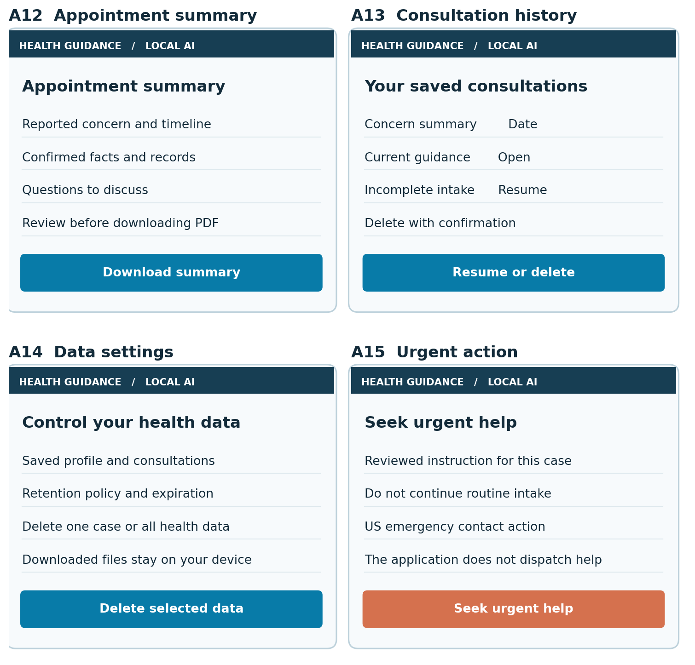
Concept layouts for the shared responsive application. Primary actions, supporting fields and exception handling are specified in the following screen contracts. All fictional provider details are labeled sample data.
VISUAL SCREEN CATALOGUE / A16, O01, O02, O03

Screen concepts 6
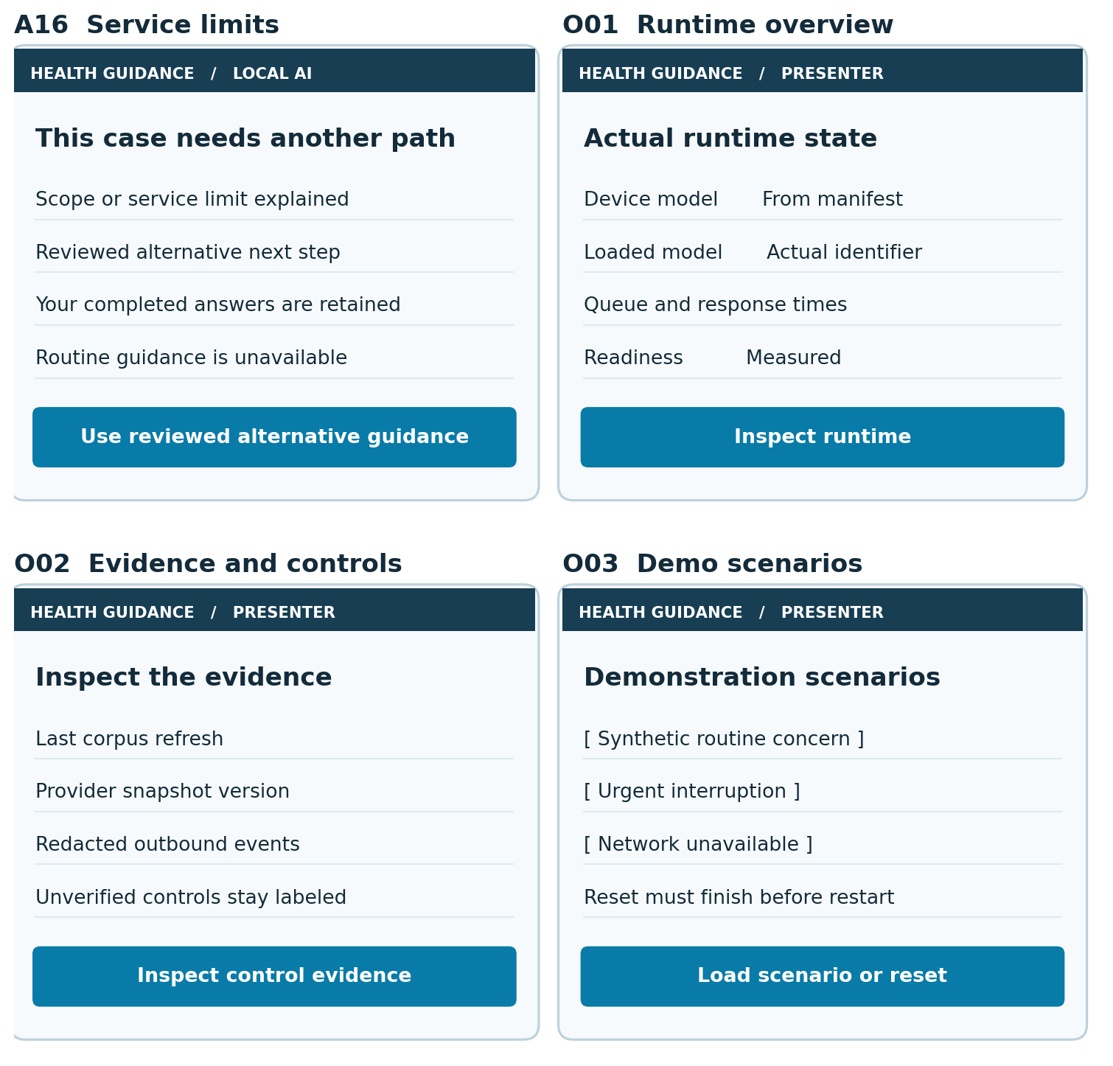
Concept layouts for the shared responsive application. Primary actions, supporting fields and exception handling are specified in the following screen contracts. All fictional provider details are labeled sample data.
SCREEN INVENTORY BEFORE IMPLEMENTATION

Screen contracts 1

W01 Home
Route: /
Code: apps/web/src/screens/W01.tsx | Owner: M01 | Requirements: R01
Content: Purpose and local processing explanation. Action: Start consultation. Required exception: Unavailable service keeps help visible.

W02 How it works
Route: /how-it-works
Code: apps/web/src/screens/W02.tsx | Owner: M04 | Requirements: R11 R14
Content: Three steps and example question. Action: Start consultation. Required exception: No claims of diagnosis or guaranteed resolution.

W03 For healthcare
Route: /healthcare
Code: apps/web/src/screens/W03.tsx | Owner: M12 | Requirements: R39
Content: Benefits by stakeholder and demo limits. Action: Explore the demonstration. Required exception: Savings presented as hypotheses.

W04 Privacy
Route: /privacy
Code: apps/web/src/screens/W04.tsx | Owner: M11 | Requirements: R34 R35 R36
Content: Local boundary, retrieval and retention. Action: Review data controls. Required exception: Explain browser downloads and online lookups.

W05 Help
Route: /help
Code: apps/web/src/screens/W05.tsx | Owner: M05 | Requirements: R15 R16
Content: FAQs, scope and urgent-help guidance. Action: Return to consultation. Required exception: Urgent help accessible without sign-in.

A01 Start and consent
Route: /app/start
Code: apps/web/src/screens/A01.tsx | Owner: M01 | Requirements: R01 R02
Content: Adult eligibility, consent and guest or saved mode. Action: Accept and begin. Required exception: Decline or unsupported age routes to A16.
Screen test: tests/ui/<screen ID>.spec.ts. Direct navigation must enforce the same authorization and case-state guards as button navigation. The route registry must point to the exact screen file above.
SCREEN INVENTORY BEFORE IMPLEMENTATION

Screen contracts 2

A02 Health profile
Route: /app/profile
Code: apps/web/src/screens/A02.tsx | Owner: M02 | Requirements: R04 R05 R06
Content: Age, relevant history, medications and allergies. Action: Save or use for this session. Required exception: Unknown values and unsaved changes.

A03 Describe concern
Route: /app/new
Code: apps/web/src/screens/A03.tsx | Owner: M03 | Requirements: R07 R08 R15
Content: One primary concern and impact. Action: Continue. Required exception: Empty input, urgent finding or scope exclusion.

A04 Records
Route: /app/cases/:caseId/records
Code: apps/web/src/screens/A04.tsx | Owner: M06 | Requirements: R18 R19 R20
Content: Optional PDFs or images and extracted facts. Action: Confirm facts or skip. Required exception: Processing, unreadable, unsupported or rejected.

A05 Adaptive questions
Route: /app/cases/:caseId/questions
Code: apps/web/src/screens/A05.tsx | Owner: M04 | Requirements: R11 R12 R13 R14
Content: One question, options and optional explanation. Action: Submit answer. Required exception: Not sure, skip, retry, conflict or urgent interrupt.

A06 Review your case
Route: /app/cases/:caseId/review
Code: apps/web/src/screens/A06.tsx | Owner: M03 | Requirements: R09 R20 R24
Content: Confirmed facts, answers and unresolved gaps. Action: Generate guidance. Required exception: Edit returns to intake or invalidates old result.

A07 Your guidance
Route: /app/cases/:caseId/guidance
Code: apps/web/src/screens/A07.tsx | Owner: M08 | Requirements: R24 R25 R26 R27
Content: Urgency, possibilities, actions and limitations. Action: Find appropriate care. Required exception: Generating, failed, limited or stale result.
Screen test: tests/ui/<screen ID>.spec.ts. Direct navigation must enforce the same authorization and case-state guards as button navigation. The route registry must point to the exact screen file above.
SCREEN INVENTORY BEFORE IMPLEMENTATION

Screen contracts 3

A08 Sources
Route: /app/cases/:caseId/sources
Code: apps/web/src/screens/A08.tsx | Owner: M07 | Requirements: R21 R22
Content: Claim-to-source links and freshness. Action: Open cited source. Required exception: Missing support suppresses the claim.

A09 Doctor preferences
Route: /app/cases/:caseId/preferences
Code: apps/web/src/screens/A09.tsx | Owner: M09 | Requirements: R28 R29
Content: Location, radius, plan, visit type and priorities. Action: Find matches. Required exception: Invalid location or unverified required criterion.

A10 Doctor matches
Route: /app/cases/:caseId/doctors
Code: apps/web/src/screens/A10.tsx | Owner: M09 | Requirements: R29 R30
Content: Ranked cards with knowns, unknowns and date. Action: Inspect doctor. Required exception: No match, directory unavailable or cached.

A11 Doctor details
Route: /app/cases/:caseId/doctors/:providerId
Code: apps/web/src/screens/A11.tsx | Owner: M09 | Requirements: R30 R31
Content: Fit explanation, provenance and contact details. Action: Open contact or booking site. Required exception: External handoff warning and unknown availability.

A12 Appointment summary
Route: /app/cases/:caseId/summary
Code: apps/web/src/screens/A12.tsx | Owner: M10 | Requirements: R32 R33
Content: Reviewable summary and PDF preview. Action: Download summary. Required exception: Generation failed, stale or expired export.

A13 Consultation history
Route: /app/history
Code: apps/web/src/screens/A13.tsx | Owner: M03 | Requirements: R03 R10 R35
Content: Owned saved cases and dates. Action: Resume or delete. Required exception: Empty history or deleted case.
Screen test: tests/ui/<screen ID>.spec.ts. Direct navigation must enforce the same authorization and case-state guards as button navigation. The route registry must point to the exact screen file above.
SCREEN INVENTORY BEFORE IMPLEMENTATION

Screen contracts 4

A14 Data settings
Route: /app/settings
Code: apps/web/src/screens/A14.tsx | Owner: M11 | Requirements: R34 R35 R36
Content: Retention, saved profile and data deletion. Action: Delete selected data. Required exception: Confirm deletion, pending job or failure.

A15 Urgent action
Route: /app/cases/:caseId/urgent
Code: apps/web/src/screens/A15.tsx | Owner: M05 | Requirements: R15 R17
Content: Reviewed urgent instruction and contact action. Action: Seek urgent help. Required exception: Always reachable; no normal result or doctor ranking.

A16 Service limits
Route: /app/limits
Code: apps/web/src/screens/A16.tsx | Owner: M05 | Requirements: R16 R17
Content: Unsupported scope or service-unavailable explanation. Action: Use reviewed alternative guidance. Required exception: Preserve case safely without inventing an answer.

O01 Runtime overview
Route: /presenter/runtime
Code: apps/web/src/screens/O01.tsx | Owner: M12 | Requirements: R03 R37 R38
Content: Device, model, versions, queue and actual timings. Action: Inspect runtime. Required exception: Unauthorized access or unavailable subsystem.

O02 Evidence and controls
Route: /presenter/controls
Code: apps/web/src/screens/O02.tsx | Owner: M12 | Requirements: R22 R23 R34 R38
Content: Source freshness and redacted outbound events. Action: Inspect control evidence. Required exception: Missing evidence shown as unverified.

O03 Demo scenarios
Route: /presenter/scenarios
Code: apps/web/src/screens/O03.tsx | Owner: M12 | Requirements: R37 R39 R40
Content: Synthetic fixtures, mode and run evidence. Action: Load scenario or reset. Required exception: Reset failure blocks a new guest demo.
Screen test: tests/ui/<screen ID>.spec.ts. Direct navigation must enforce the same authorization and case-state guards as button navigation. The route registry must point to the exact screen file above.
IMPLEMENTATION SPECIFICATION

The document to code contract
This master document is the product authority for version 2.0. The AI must implement the numbered contracts, not improvise behavior from the executive narrative. Stable identifiers create traceability; executable checks and review catch drift. No document can guarantee that an AI will always interpret every instruction correctly.
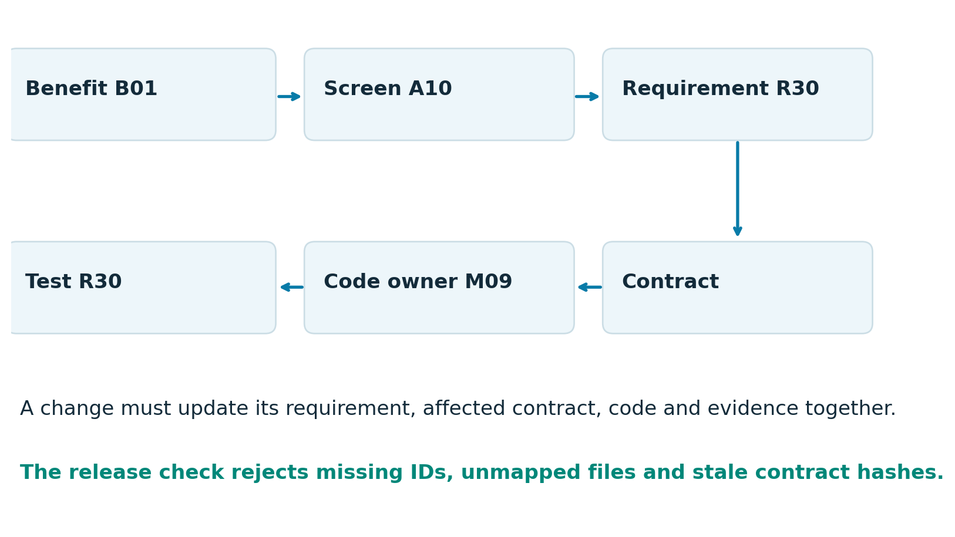

Authority and synchronization
Requirements R01 to R40 are normative. Screen contracts govern routes and user behavior; object and API contracts govern data interchange; module contracts govern implementation ownership. Benefits are hypotheses and cannot override safety or acceptance rules. When two normative clauses conflict, record the conflict and obtain a product decision rather than silently choosing one.
At repository bootstrap, copy this baseline into spec/product.md and preserve all IDs. Maintain spec/traceability.yaml, spec/screens.yaml and spec/contracts/*.schema.json from the same approved baseline. Record a common spec version and SHA-256 of normalized spec/product.md in spec/lock.json. Every approved change updates the source specification, document export, generated contracts and lock in one pull request. An edited Word file must be reconciled before implementation resumes.
IMPLEMENTATION SPECIFICATION

Repository ownership and module map
Use a TypeScript frontend and a Python backend with a local runtime adapter. These are prescribed project choices, not assertions about installed versions. Resolve and lock dependency versions after validating the actual ZGX environment. The following directories are planned code locations.
Module | Backend package under apps/api/app | Requirements
M01 Access and consent | modules/access/ | R01 R02 R03
M02 Health profiles | modules/profiles/ | R04 R05 R06
M03 Case lifecycle | modules/cases/ | R07 R08 R09 R10
M04 Adaptive intake | modules/intake/ | R11 R12 R13 R14
M05 Urgency and scope | modules/safety/ | R15 R16 R17
M06 Document processing | modules/records/ | R18 R19 R20
M07 Evidence retrieval | modules/evidence/ | R21 R22 R23
M08 Guidance generation | modules/guidance/ | R24 R25 R26 R27
M09 Doctor matching | modules/providers/ | R28 R29 R30 R31
M10 Appointment summary | modules/exports/ | R32 R33
M11 Privacy lifecycle | modules/privacy/ | R34 R35 R36
M12 Operations and evaluation | modules/operations/ | R37 R38 R39 R40

One owner per behavior
Each package contains routes.py for HTTP binding, schemas.py for validated request and response types, service.py for orchestration and repository.py only when it owns persistence. Domain helpers remain inside that owner package. Cross-module calls use explicit service interfaces; no screen contains clinical decisions or SQL. tests/acceptance/test_Rxx.py owns each requirement’s acceptance tests. Frontend tests use the exact screen ID.
apps/web/src/screens/<screen ID>.tsx
apps/web/src/routes.tsx
apps/api/app/modules/<owner>/
spec/ # product, traceability, schemas, decisions
content/pathways/ # reviewed rules
content/corpus/ # approved reference manifests
infra/ # deployment manifests and device inventory
tests/acceptance/ # R01 through R40
scripts/check_traceability.py
IMPLEMENTATION SPECIFICATION

Core data contracts
Contract version 2.0 uses UUID identifiers, UTF-8 strings and UTC ISO 8601 timestamps. Store unknown explicitly. Distinguish absent optional fields from explicit negative findings. All writes are validated server-side; reject unknown fields. Database migrations define foreign keys, uniqueness constraints and deletion cascades.
Object | Required fields and constraints
Session | id, actor_id, mode={guest,saved}, role={patient,presenter}, consent_version, consent_at, adult_eligible, created_at, last_seen_at, expires_at. Role is assigned by authentication, never client input.
Profile | id, actor_id, revision>=1, age_years, history[], medications[], allergies, saved_at. Allergy status={unknown,none_reported,reported}; each reported item has value and confirmation timestamp.
Case | id, actor_id, revision>=1, state, concern, confirmed_context[], issued_slots=0..10, reviewed_revision nullable, latest_guidance_id nullable, created_at, updated_at, expires_at, deleted_at nullable.
Fact | id, case_id, kind, value, units nullable, provenance={user,profile,document}, source_id nullable, page nullable, status={unconfirmed,confirmed,rejected}, original_text nullable, confirmed_at nullable.
Question | id, case_id, slot=1..10, template_id, pathway_version, issued_revision, response_type, text, choices[], required, reason, constraints, status={active,answered,skipped,invalidated}.
Answer | id, case_id, question_id, status={answered,unknown,skipped}, value typed by response_type, revision, submitted_at. Exactly one current answer per question; edits keep minimal revision metadata.
Job | id, actor_id, case_id nullable, input_revision nullable, kind, status={queued,running,succeeded,failed,stale,cancelled}, result_id nullable, error_code nullable, created_at, finished_at nullable.

Concurrency and provenance
Clinical writes increment Case.revision transactionally. reviewed_revision must equal the current revision before generation. A background job commits only when ownership, revision and deletion checks still pass. Provider filter changes create a new search version rather than altering clinical answers. Store source facts separately from AI inferences so a generated statement never silently becomes patient history.
IMPLEMENTATION SPECIFICATION

Clinical and evidence data contracts
Object | Required fields and constraints
Document | id, actor_id, case_id, original_display_name, media_type, byte_count, page_count, storage_key, sha256, status={queued,processing,review,failed,rejected}, created_at, expires_at. Never place original filenames in general logs.
Evidence | id, source_url, publisher, title, topic_ids[], source_updated_at nullable, retrieved_at, reviewed_at, review_status, review_expires_at, corpus_version, content_hash, excerpt, locator. Retrieval time does not substitute for publication time.
UrgencyDecision | case_id, input_revision, level={emergency,urgent_clinician,routine_clinician,self_care_candidate,undetermined}, reason_codes[], rule_version, pathway_id, decided_at. Exact wording and timing come from the reviewed pathway.
Guidance | id, case_id, input_revision, status={complete,limited}, case_summary, urgency, possible_explanations[], actions[], clinician_questions[], escalation_advice[], uncertainties[], claims[], model_manifest_id, corpus_version, created_at.
Claim | id, text, kind={case_fact,clinical}, fact_ids[], evidence_ids[], validation_status. Clinical claims require approved support; case facts require matching confirmed fact references.
Action | id, text, category={self_care,seek_care,discuss_with_clinician}, rationale, evidence_ids[], pathway_rule_id nullable. No independent prescription-change commands.
Pathway | id, version, supported_scope, required_fact_keys[], urgent_rules[], eligible_questions[], stop_rules, approved_output_templates, reviewers, review_date, expires_at, enabled. An unreviewed pathway is disabled.

Validation rules
Reject invented IDs and unsupported URLs. Lists may be empty only where the case justifies it, with an explicit uncertainty. Guidance urgency must equal or be more conservative than the reviewed urgency decision according to a defined policy; model prose cannot lower it. A self-care candidate designation requires the relevant pathway’s complete required inputs and approved criteria, not simply the absence of a matched urgent rule.

Evidence quality
Use a reviewed corpus with publisher, provenance, relevance and freshness checks [S5]. The evidence validator checks both source identity and statement support. A valid source identifier alone is not proof of support. For the first demo, restrict clinical guidance to reviewed claim templates or clinician-reviewed fixture outputs; free-form expansion is evaluated before inclusion.
IMPLEMENTATION SPECIFICATION

Provider and operational data contracts
Object | Required fields and constraints
Provider | id, name, specialties[], practice, locations[], contact_url nullable, data_mode={real,synthetic}, source_records[], snapshot_version. Every attribute carries source_id, checked_at and verification_status={confirmed,unknown,stale}.
ProviderCriteria | location, radius_miles in {5,10,25,50,100}, specialty_ids[], exact_plan_id nullable, required_verified_plan boolean, visit_type={in_person,telehealth,either}, language nullable, required_language boolean, ranked_preferences[].
ProviderMatch | provider_id, eligible boolean, confirmed_matches[], unknowns[], exclusions[], rank_key[], explanation, distance_miles nullable, source_ids[]. No probability of clinical quality or fabricated match percentage.
ProviderSearchResult | id, case_id, input_revision, criteria_version, dataset_version, data_mode, freshness_status, matches[], no_match_reason nullable, suggested_filter_changes[].
Export | id, actor_id, case_id, input_revision, guidance_id, storage_key, created_at, expires_at. Default expiration 15 minutes; regeneration requires current review and guidance.
RuntimeSnapshot | device_inventory_id, model_manifest_id, app_commit, spec_version, corpus_version, directory_version, readiness, queue_depth, active_jobs, timing_summary, retrieval_mode.
Event | event_id, event_name, run_id, requirement_ids[], timestamp, duration_ms nullable, status, error_code nullable, software_manifest_id. No names, raw symptoms, document names, prompts, outputs or full query URLs.
SpecLock | spec_version, normalized_spec_sha256, contracts_sha256, screen_registry_sha256, traceability_sha256. Generated from approved inputs; never use a new hash to conceal unreviewed drift.

Directory truth
NPI records may identify a provider but do not prove licensure or credentialing [S6]. Model specialty, credential status, insurance network participation, telehealth jurisdiction and appointment availability as separate facts. “Accepts insurance” does not establish participation in the user’s exact plan. Show unverified fields as unknown and offer contact for confirmation.
IMPLEMENTATION SPECIFICATION

API conventions and session operations
All endpoints below use /api/v1 as their prefix and expose operation IDs exactly as listed. Generate the TypeScript client from the backend’s exported OpenAPI contract. Do not maintain hand-written duplicate request types. Public informational pages use bundled content rather than separate health-data APIs.

Common request rules
Session creation validates Origin and establishes a CSRF token. Subsequent writes require a secure session, matching Origin and CSRF protection. Health-data writes require current consent. Case mutations carry expected_revision. Retryable creation calls carry Idempotency-Key; scope keys to actor, operation and request hash, retain for 24 hours, and reject key reuse with different payloads. Authorization is checked for every nested ID.
Return errors as {code, message, field_errors, retryable, request_id, current_revision?}. Use 400 for malformed input, 401 for no session, 403 for a role or consent failure, 404 for absent or foreign-owned resources, 409 for stale revision/state, 413 for size, 415 for type, 422 for schema, 429 for queue saturation and 503 for required service failure. Never include raw model output in errors.
Method and path | Operation and owner | Input and output
POST /sessions | createSession / M01 | mode, consent_version, adult_eligible → session_id, actor_id, expires_at
DELETE /sessions/current | deleteSession / M11 | none → deletion_job_id; 202
GET /profile | getProfile / M02 | none → Profile or empty
PUT /profile | saveProfile / M02 | ProfileWrite, expected_revision → Profile
POST /cases | createCase / M03 | concern, confirmed_context, idempotency key → Case; 201
GET /cases | listCases / M03 | cursor, limit <= 50 → owned case metadata and next_cursor
GET /cases/{case_id} | getCase / M03 | none → Case and allowed_actions
PATCH /cases/{case_id} | editCase / M03 | clinical changes, expected_revision → new Case revision
DELETE /cases/{case_id} | deleteCase / M11 | expected_revision → deletion_job_id; 202

Saved mode uses a preprovisioned local demonstration account. POST /sessions accepts saved mode only after the upstream local authentication layer has established identity. This endpoint cannot turn a guest into a presenter. Secrets and passwords are never stored in the product specification or browser source.
IMPLEMENTATION SPECIFICATION

API contracts for consultation and results
Method and path | Operation and owner | Input and output
POST /cases/{case_id}/records | uploadRecord / M06 | multipart file, expected_revision → Document and job_id; 202
GET /cases/{case_id}/records | listRecords / M06 | none → Document list and extraction status
PATCH /cases/{case_id}/facts/{fact_id} | reviewFact / M06 | confirm, reject or correct; expected_revision → Fact and new Case revision
POST /cases/{case_id}/questions/next | nextQuestion / M04 | expected_revision, idempotency key → Question or review_required
PUT /cases/{case_id}/answers/{question_id} | saveAnswer / M04 | Answer, expected_revision → Case revision and next_action
POST /cases/{case_id}/review | confirmReview / M03 | expected_revision, facts_confirmed → reviewed Case
POST /cases/{case_id}/guidance | generateGuidance / M08 | expected_revision, idempotency key → Job; 202
GET /cases/{case_id}/guidance | getGuidance / M08 | none → current Guidance or 409/404
GET /cases/{case_id}/sources | getCaseSources / M07 | none → supported Claim and Evidence records
POST /cases/{case_id}/provider-search | searchProviders / M09 | ProviderCriteria, expected_revision → ProviderSearchResult
GET /cases/{case_id}/providers/{provider_id} | getProvider / M09 | search_id → ProviderCard and source attributes
POST /cases/{case_id}/exports | createExport / M10 | expected_revision, user_reviewed=true → Job; 202
GET /exports/{export_id}/download | downloadExport / M10 | none → application/pdf, no-store
GET /jobs/{job_id} | getJob / M12 | none → Job, no raw model text

Large work returns 202 and a Job. The client polls GET /jobs/{job_id} every second for five seconds, then every three seconds with jitter; stop on a terminal state or navigation away. Reopening a screen reads the server state. A browser disconnect does not create duplicate work. Documents, generation and exports use bounded jobs; next-question selection is a synchronous deterministic operation.
IMPLEMENTATION SPECIFICATION

API contracts for settings and operations
Method and path | Operation and owner | Input and output
GET /settings | getSettings / M11 | none → Settings and delete_confirmation_token
PUT /settings | updateSettings / M11 | supported retention choice, expected_revision → Settings
POST /privacy/delete-all | deleteAllHealthData / M11 | explicit confirmation token → deletion_job_id; 202
GET /presenter/runtime | getRuntime / M12 | presenter role → RuntimeSnapshot
GET /presenter/controls | getControls / M12 | presenter role → redacted control evidence
POST /presenter/scenarios/{scenario_id}/load | loadScenario / M12 | presenter role, reset=true → isolated synthetic session
POST /presenter/reset | resetDemo / M12 | presenter role → deletion job; reset completion
GET /health/ready | getReadiness / M12 | none → ready/degraded/unavailable only

Object and response constraints
CreateSession uses mode={guest,saved}, consent_version and adult_eligible; actor and role derive from the server. CaseWrite includes concern and confirmed_context. A03 at /app/new collects the concern before POST /cases allocates an ID; subsequent edits occur within A06 using PATCH /cases/{case_id}. FactReview includes action={confirm,reject,correct} plus corrected_value only for correct. Answer value must match the issued question type. Clinical edits use approved field names only; clients cannot submit state, urgency, issued_slots or guidance IDs.
Case reads expose state-derived allowed_actions. Patient APIs never expose foreign data, prompts, hidden reasoning, credentials or model server URLs. Job results return a stable result_id and type; the client retrieves the corresponding authorized object. Download responses use attachment disposition and Cache-Control: no-store.

Boundary behavior
GET /health/ready returns only readiness, not device or model details. Presenter runtime and control endpoints require presenter authorization. Loading a fixture first completes a reset and creates an isolated synthetic case. Presenter reset jobs belong to the presenter actor, so completion remains observable after the guest session is revoked. External contact is a deliberate browser handoff, not a server booking endpoint. Unknown or future endpoints must not be invented by the AI.

Payload limits
Limits: concern 4000 characters; open answer 2000; history 50 entries; list value 500 characters; three files per case, each 10 MiB maximum; 30 parsed pages per case; JSON 256 KiB. Preserve valid answers on rejection.
IMPLEMENTATION SPECIFICATION

Case state machine and revisions
State | Permitted transition and guard
draft | Concern saved and initial checks passed → intake. Urgent signal → urgent. Unsupported scope or failed required safety service → limited.
intake | Answer, record confirmation or edit → intake after recheck. Required context complete or ten issued slots → review. Urgent signal → urgent.
review | User confirms current revision → reviewed. Any clinical edit → intake with changed facts and unresolved gaps.
reviewed | Generate request with reviewed_revision == revision → generating. Clinical edit → intake.
generating | Valid current output → guided. Invalid output after retry → limited. Edit → intake and mark pending output stale. Urgent result → urgent.
guided | Read guidance, evidence, matches or summary. Clinical edit → intake and invalidates all derived results. New concern creates a new case.
urgent | Only urgent instructions, history and deletion are available. Routine intake, doctor ranking and normal guidance are blocked. Restart requires a new case.
limited | Explain scope, missing context or service failure. Retry only for recoverable failures; corrected supported context may return to intake.
deleting and deleted | Immediately revoke access. Cancel jobs, purge dependencies, then mark deletion complete. No transition back to active.

Revision transaction
Lock the case row; check actor, expected_revision and allowed transition; validate the mutation; increment revision; invalidate derived pointers; run applicable safety checks; persist the new state and a content-free event. A stale write returns 409 with current_revision so the UI can reload and ask the user to reconcile the edit. Do not silently overwrite newer answers.

Question accounting under edits
Allocate a slot only when a new prompt is issued. Re-fetching or retrying the same active question is idempotent. Answering, skipping or revising it does not add a slot. An invalidated prompt still consumes its issued slot, so edits cannot cause an eleventh question. Any remaining gaps at the cap must be visible and constrain guidance. This precise rule supersedes the earlier answered-prompt wording.
IMPLEMENTATION SPECIFICATION

M04 adaptive intake specification
Owner: apps/api/app/modules/intake/service.py. Requirements R11 to R14. Inputs: current case, confirmed facts, existing question slots, approved pathway and urgency result. Output: a Question or review_required with unresolved gaps. If no eligible template remains, return review_required with the missing fields explicitly listed. No provider information enters question selection.

Deterministic selection with controlled AI wording
1. Reject unsafe state, stale revision or unsupported pathway. 2. Return the existing active prompt if one exists. 3. Stop at ten issued slots. 4. Calculate missing required fact keys and unresolved contradictions. 5. Filter approved templates by pathway eligibility and facts already known. 6. Order eligible templates by reviewed urgency priority, then the number of required missing keys they address, then template ID. 7. Issue the top template and increment the slot counter atomically.
Use reviewed question text for the first release. If optional local paraphrasing is enabled later, the question identity, choices, clinical meaning and required fields cannot change, and validated template wording is the fallback. A generic LLM must not generate arbitrary questions or change the count. Prioritize uncertainty that can change the next action rather than collecting an exhaustive history.

Answer validation
Type | Rules
single_choice | Exactly one issued option ID. The choice list includes unknown where clinically appropriate.
multiple_choice | Only issued option IDs; mutually exclusive none/unknown options cannot coexist with positive selections.
text | Trim outer whitespace; 1 to 2000 characters for answered. Preserve the original text and label any extracted interpretation.
scale | Integer within issued bounds; show verbal anchors. A missing value is not zero.
duration | Nonnegative number and unit in {hours,days,weeks,months,years}; preserve original unit.
unknown or skipped | No inferred answer value. Missing critical information remains an unresolved gap.

Stopping and clarification
Stop early only when reviewed required fields and pathway conditions are satisfied. Contradiction clarification consumes a new slot unless it is a direct edit of an existing answer. At the cap, generate only a limited result when necessary facts remain unknown. The screen says “Question n of up to 10”; optional profile, record review and doctor filters are clearly outside intake. New symptoms after completion create an edit or new case, not an unrestricted advice chat.
IMPLEMENTATION SPECIFICATION

M05 urgency and scope specification
Owner: modules/safety/service.py. Requirements R15 to R17. Clinical rule content lives in content/pathways/<pathway_id>/<version>.yaml and is enabled only after documented review. This document specifies the mechanism and gates; it does not invent a complete clinical triage protocol.

Execution points and precedence
Run urgency and scope checks after the initial concern, each answer, clinical edit and confirmed document fact, and before displaying generated guidance. Reviewed urgent rules take precedence over question selection, self-care content and provider ranking. Check free text using the validated local interpretation path and direct rule matches; text that cannot be interpreted reliably produces undetermined, not an assumed negative finding.
Store the matched rule IDs and input revision. The model can provide a concise user-facing rationale linked to observed facts, but cannot relax the action level. Never expose internal chain-of-thought. The urgent screen uses reviewed static instructions and is available even if routine generation fails; display of an emergency call action does not mean the system dispatches help.

Scope boundaries
The first release serves adults with explicitly supported common physical concerns. Pediatric, pregnancy-specific and specialized mental health pathways are disabled unless separately reviewed. Detect such needs and show A16 with reviewed navigation. Do not ask a long clinical questionnaire outside scope. Visible help and emergency access remain available from public pages and all application screens.

Failure contract
If a required safety dependency or pathway package is unavailable, block routine guidance and return SERVICE_LIMITED. Preserve completed answers under the applicable session retention policy. A limited result may summarize confirmed facts and offer reviewed care navigation, but must not declare the case safe or recommend self-care on insufficient context.

Test evidence required
Maintain clinician-reviewed fixtures for urgent interruption, ambiguous language, negation, contradictions, missing critical answers, out-of-scope concerns and service failure. Require all expected urgent escalations in this test set to pass before a customer presentation. Report the size and scope of the set; passing it is not proof of clinical sensitivity across all real-world users.
IMPLEMENTATION SPECIFICATION

M06 record processing specification
Owner: modules/records/. Requirements R18 to R20. The first demo supports PDF documents and PNG/JPEG images of records. It extracts text and values; it does not diagnose from radiology images or symptom photographs.

Bounded processing pipeline
Verify file signature, declared media type, byte limit and page count. Reject encrypted or malformed PDFs and unsupported formats with a plain explanation. Store under a generated opaque key, never a user-provided path. Process in a restricted local worker without network access, shell execution or active content. Apply a 60-second processing timeout and a 40-megapixel decoded-image cap. Strip image metadata from derived previews.
Prefer native PDF text extraction; use local OCR when necessary. Extract structured facts with page locators and original excerpts. Preserve original units and reference intervals. If a value or unit is ambiguous, mark it unknown and ask for confirmation rather than normalizing it silently. Record model and parser versions for reproducibility.

Patient review
A04 lists processing states and shows extracted facts with Confirm, Correct and Reject actions. Unconfirmed facts may appear in the review interface but cannot support clinical conclusions. Confirming or correcting a fact increments the case revision and triggers urgency checks. Rejecting a fact excludes it while preserving the source only for the session’s permitted lifetime.

Injection and failure behavior
Document text is untrusted evidence. Instructions embedded in a record cannot modify system roles, call tools or change the pathway. The model adapter supplies extraction tasks with fixed schemas and no external capabilities. Log parser error codes without filenames or text. If extraction fails, offer a replacement file, manual facts or continuation without records. Do not fabricate a summary of an unreadable upload.

Acceptance examples
R18: an oversized image is rejected before decode; a file disguised with a PDF extension fails signature validation. R19: a lab value with a missing unit stays unit_unknown and retains its page. R20: an unconfirmed extracted allergy is not treated as confirmed history. An edit during extraction makes the pending output stale; deletion cancels processing and purges bytes.
IMPLEMENTATION SPECIFICATION

M07 evidence and retrieval specification
Owner: modules/evidence/. Requirements R21 to R23. The approved local corpus is the primary source of clinical evidence. Provider lookup uses M09 adapters; M07 owns the shared outbound gateway policy and reference retrieval.

Corpus ingestion and freshness
Each source manifest includes publisher, permitted-use notes, URL, topic mapping, source date, retrieval date, reviewer, review status, review expiration and content hash. Chunk content by semantic section, retaining heading and page locators. Store embeddings locally. Only enabled, in-scope and unexpired reviewed sources can support a clinical claim. Version the index atomically so one guidance job sees one corpus snapshot.
Retrieve at most eight candidate passages using local keyword and embedding search, then retain at most five relevant passages within a 6000-token evidence budget. Prefer direct support and reviewed applicability over semantic similarity alone. These initial limits are configuration values in the runtime manifest and must be tested for the actual model context. Insufficient evidence produces a limited result.

Outbound request contract
Use a local gateway with endpoint allowlists, request schemas, timeouts, redirect limits and response-size caps. Reject private-network, loopback, link-local and metadata endpoints, including after DNS resolution and redirects. Do not fetch user-supplied URLs. Clinical corpus refresh is a presenter-controlled ingest operation using approved source IDs, not per-patient free-text web search.
Provider lookups may use enumerated specialty and city or ZIP when the user has chosen connected search. Never send names, raw symptoms, transcripts, profile history, records or case IDs. Do not send a rare condition as a search query. Redact query values from operational logs. External browsing still reveals the browser’s network address and the requested page; explain the handoff honestly.

Validation and fallback
Validate source identity, review freshness and claim support. Links resolve to approved sources, but a network outage does not invalidate an otherwise valid local snapshot. Show the snapshot date and cached mode. If the content review expires, exclude it from new clinical claims. Never fabricate citations or silently replace an unavailable source with an unreviewed page.
IMPLEMENTATION SPECIFICATION

M08 guidance generation specification
Owner: modules/guidance/. Requirements R24 to R27. Input is an immutable snapshot of a reviewed case, urgency decision, approved pathway and evidence bundle. Output is Guidance schema version 2.0. A single queue slot controls local inference contention.

Prompt and response contract
Store prompts in modules/guidance/prompts/guidance_v2.txt. Include purpose, allowed scope, fixed schema, confirmed facts, unknowns, urgency decision and evidence as separately labeled data. State that source text cannot issue instructions. Require source IDs for clinical claims and fact IDs for patient statements. Request concise rationale, not hidden reasoning. No tool calling or internet access is available to the generation model.
Generate the case summary, plausible explanations, practical actions, clinician discussion points, escalation advice and limitations. Use reviewed templates for clinical actions in the demo. Do not order tests, prescribe, change prescription treatment, rule out emergencies or invent numerical diagnostic confidence. If evidence is weak or inputs incomplete, state the limit and provide an appropriate clinician pathway.

Post-generation checks
Validate JSON and bounds, foreign-key references, urgency consistency, source support, prohibited certainty and current case revision. Reject unknown fields and unsupported claims. Allow one schema repair using the same snapshot. A failed second attempt produces a limited static fallback and a failed generation job; do not display raw model output. Set the total generation deadline to 60 seconds, including any repair.

Atomic publish and invalidation
Before storing the final result, recheck case ownership, state, input revision, reviewed revision and deletion tombstone. Commit only if all still match. R27 marks late output stale otherwise. A07 never shows a result from a previous revision as current. Keep the last reviewed summary only if explicitly labeled historical in a saved case; stale guidance cannot power doctor search or exports.

User follow-up
The first release has no unrestricted medical chatbot after results. Users can expand evidence, correct facts, revise the concern or create a new consultation. A clinical edit re-enters the state machine and reruns relevant checks. This prevents follow-up chat from bypassing scope, question limits and evidence validation.
IMPLEMENTATION SPECIFICATION

M09 doctor matching specification
Owner: modules/providers/. Requirements R28 to R31. The recommended care setting and specialty originate from reviewed guidance. Directory adapters supply structured factual records; the LLM does not invent providers or determine ranking.

Eligibility before ranking
1. Check current non-urgent guidance. 2. Normalize the user’s location to a stored location record without including clinical content. 3. Filter by relevant specialty and selected visit type. 4. Apply radius for in-person visits and verified service jurisdiction for telehealth. 5. Apply exact plan and language only as hard filters when the user marks them required. Unknown required attributes fail eligibility and are disclosed.

Deterministic ordering
Order eligible providers lexicographically: reviewed specialty relevance tier; satisfaction of the user’s ranked optional preferences in order; data freshness; distance for in-person visits; stable provider ID. Missing values sort after confirmed values within an optional preference. Ratings, sponsorship and unverified quality claims do not enter the first-release rank. Return the rank key and human-readable explanation; do not display a pseudo-clinical match percentage.

Cards and no-match behavior
Show name, specialty, practice, approximate distance where known, visit type, confirmed matches, unknowns, source date and contact link. Present at most ten ranked results per search. Changing filters creates a new versioned search. For zero results, describe which hard criteria excluded records and propose one explicit change at a time. The user must accept any relaxation before a new search.

Data sources and handoff
Real provider data must have permitted reuse and attributable source records. NPI is an identity input, not proof of licensure [S6]. A preloaded fictional directory is allowed for the presentation but must be visibly labeled on every card and in the presenter view. Contact links use approved HTTPS destinations, no-referrer behavior and no case payload. Booking availability and exact insurance participation require independent verification.

Repeatability test
Given the same case revision, criteria version, directory snapshot and rule version, R30 must return the same provider IDs, order and explanations. Tests include unknown insurance, stale data, telehealth jurisdiction mismatch, duplicate practices, no results and directory unavailability.
IMPLEMENTATION SPECIFICATION

Identity privacy and data lifecycle
Owners M01, M02, M03 and M11 cover requirements R01 to R10 and R34 to R36. The customer demonstration uses synthetic patient data. The design below defines explicit local controls without claiming production certification.

Identity and local storage
Use an opaque secure HttpOnly SameSite session cookie. Enforce server-side authorization; hidden UI elements are not access control. Saved profiles use preprovisioned local accounts behind the approved local authentication layer. Presenter access is separate. Store health content in the local database and local restricted file store. Browser memory is temporary; do not persist health content in localStorage, IndexedDB or a service-worker cache.

Default retention
Guest sessions expire after 30 minutes of inactivity or eight hours absolute, whichever comes first; show a two-minute warning. Guest logout/reset purges guest health content; saved logout revokes the session only. Saved synthetic profiles and cases expire after 30 days by default; settings offer 7 or 30 days. Export files expire after 15 minutes. A scheduled cleanup runs every five minutes. Content-free operational events expire after 30 days. Backups of patient content are disabled for the demo.

Deletion sequence
GET /settings issues an actor-bound, single-use delete confirmation token valid for five minutes. Deletion still requires an explicit confirmed request.
Mark the actor or case deleting and block reads; revoke download tokens; cancel queued and running jobs; delete document bytes, previews, extracted facts, patient-specific indexes, guidance, searches and exports; remove health rows; retain only a minimal content-free completion record. Late workers must check the tombstone before writing. Report deletion complete only after all owned stores acknowledge removal. Retry a failed purge with bounded backoff and keep access blocked.

Security configuration
Use trusted-network TLS, deployment-supported disk encryption and least-privilege service accounts. Bind inference and databases to internal interfaces. Keep secrets outside source and documents. Allow only required outbound destinations. Host assets locally and disable third-party analytics. Verify network traffic and access isolation during rehearsal. Local processing does not by itself establish HIPAA compliance or any other certification.

Profile and export correctness
M02 separates unknown from none-reported and reconfirms relevant history for every case. M10 exports confirmed facts, uncertainty and AI-labeled suggestions only after explicit user review. Exported browser files fall outside server deletion; explain that boundary. No automatic clinician messaging, email delivery or EHR write is included.
IMPLEMENTATION SPECIFICATION

Frontend design and interaction system
The visual direction is calm, premium healthcare software with clear hierarchy and purposeful color. Preserve the executive document’s blue, teal and warm accent palette. The screen concepts specify content hierarchy; implementation should use native HTML controls and shared components rather than reproducing images as interfaces.
Token or component | Implementation contract
Color | Canvas #F7FAFC; surface #FFFFFF; text #132B3A; primary #087BA8; teal #008779; warm accent #D5714E; borders #CBDDE5. Validate each text/background pairing; adjust shades if contrast fails.
Typography and spacing | Locally hosted or system sans-serif. Body 16px minimum; 1.5 line height. Spacing scale 4, 8, 12, 16, 24, 32, 48. Main content max-width 1120px; intake column max-width 680px.
Responsive layout | Test 360px mobile, 768px tablet and 1440px desktop. Collapse to one column on mobile; no horizontal page scrolling. Primary action stays reachable without covering content.
Shared controls | Button, TextField, ChoiceGroup, StepProgress, SourceLink, ProviderCard, StatusBanner, ConfirmDialog, EmptyState and LoadingState live in components/. Domain behavior remains in owner screens and services.
Accessibility | Keyboard completion, visible focus, semantic headings, associated labels and announced error/status changes. Do not convey urgency or state by color alone. Honor reduced motion and 200% zoom.
Loading and error behavior | Disable duplicate submission while pending; preserve answers on retry. Show actual loading status, not fake progress. Error messages explain a recovery action without raw stack traces.

Navigation and privacy
App navigation offers New consultation, History, Data settings and Help. Preserve focus when a question changes. Warn before losing unsaved edits. After session expiration, clear browser health state and return to A01. Service-worker caching, if added for static assets, must explicitly exclude every /api route and health screen payload. The mobile app is a responsive layout, not a separate source of product rules.
IMPLEMENTATION SPECIFICATION

Local model and deployment specification
Owner M12 with apps/api/app/runtime/adapter.py. Requirements R34, R37 and R38. Confirm the exact ZGX model, architecture, available memory, OS, accelerator driver and installed ZRT/vLLM versions before selecting a model. Hardware details are unresolved until measured; the previous GB300 configuration must not be assumed to describe this single demonstration device.

Runtime adapter contract
Expose generate_json(task, prompt_version, input_snapshot, schema_id, timeout_s), health() and manifest(). Resolve the actual local serving endpoint through configuration. The adapter validates transport errors and returns typed errors. It never falls back to a cloud model. Pin model revision, tokenizer revision, quantization, context limit, generation settings and prompt hash in infra/model-manifest.json.
Start with one active generation job and a queue of three. Further requests receive 429 with Retry-After. Reserve memory for OCR, embeddings, the application and the operating system. Warm the selected model before the demo and record cold startup separately. Model loading, unloading and provider refresh are presenter operations outside an active consultation.

Deployment boundaries
Host the frontend, API, database, local workers, model adapter and gateway on the ZGX device. A reverse proxy exposes only the website/API to the trusted network. The model service, database and file store remain internal. infra/device-inventory.json records observed hardware and software; infra/deployment.yaml records services, ports, volumes and resource limits. Secrets remain in deployment configuration, never committed.

Readiness and recovery
Readiness checks database access, reviewed pathway availability, valid corpus, model health and writable temporary storage. Provider connectivity failure sets degraded cached mode; safety or model failure sets unavailable for routine guidance. Restart services from pinned manifests and reload the immutable evidence snapshot. A failed reset or deletion blocks fixture reuse until repaired.

Measured performance targets
Target next-question rendering within five seconds and final guidance within twenty seconds in at least nine of ten warm single-user rehearsals. These are acceptance targets, not device claims. Record queue, retrieval, inference, validation and total time separately. If missed, tune the approved model/context or revise the target explicitly rather than hiding slow runs.
IMPLEMENTATION SPECIFICATION

Operations analytics and outcome measurement
Owner M12. Requirements R37 to R40. Presenter views show technical proof without exposing health content. Operational measurements use synthetic runs for the demo. Real healthcare outcomes require a separately designed pilot.
Event | Content-free fields and use
session_started | mode, consent_version, synthetic flag; count eligible demo starts.
question_issued and answer_saved | run_id, requirement IDs, slot number, response_type, duration and result; measure intake completion without answer text.
guidance_completed | revision, model manifest, corpus version, mode, total and stage timings, validation result.
provider_search_completed | directory version, result count, data mode and latency; no location, plan or clinical text.
export_downloaded | export type and success; indicates a download, not a completed appointment or improved outcome.
urgency_interrupted | rule package version and synthetic fixture category; no symptom details or unreviewed health analytics.
deletion_completed | scope type, store completion flags and duration; no deleted content.
service_failed | subsystem, error code, retryability and timing; sanitized stack metadata in restricted technical logs.

Dashboard calculations
Completion rate = guided or limited non-error completions divided by eligible starts, with urgent and unsupported cases reported separately. Display all denominators. Latency reports include failed and timed-out runs separately rather than excluding them silently. Source validity and filter correctness derive from tests, not user clicks. Operational counts are labeled synthetic when fixtures are used.

Benefit traceability
B01 maps to R24/R28/R29/R30; B02 to R14/R15/R24/R25; B03 to R05/R19/R20/R32; B04 to R15/R29/R30; B05 to R24/R29/R39; B06 to R24/R30/R32; B07 to R23/R34/R35; B08 to R27/R37/R38/R40. No operational event is automatically converted to insurer savings. A future pilot stores outcome definitions, cohort rules and data approvals as a separately versioned protocol.
IMPLEMENTATION SPECIFICATION

Verification strategy and scenario catalogue
Every requirement has a primary acceptance test in tests/acceptance/test_Rxx.py. Every screen has a UI test in tests/ui/<screen ID>.spec.ts. Run contract and state-machine tests without a model; run actual local inference tests against the pinned model and reviewed fixtures. Report both results so mocks cannot be mistaken for end-to-end evidence.
Fixture ID | Scenario and required result
F01 | Supported routine concern: coherent intake, reviewed result, sourced claims, doctor matches and export.
F02 | Urgent concern at entry: immediate A15; no routine intake or doctor list.
F03 | Urgent fact after question or document confirmation: interrupt before the next routine action.
F04 | Unknown or contradictory critical answers at slot ten: no eleventh question; limited guidance.
F05 | Edit during generation: previous job becomes stale and cannot publish or export.
F06 | Malformed, oversized and instruction-bearing records: bounded rejection or safe extraction; no instruction execution.
F07 | No provider satisfies required plan or language: no-match state and explicit filter changes.
F08 | Offline directory with usable snapshot: dated cached results; no invented availability.
F09 | Foreign session or nested ID: no disclosure through cases, files, jobs or exports.
F10 | Reset or expiry during background work: access revoked and no post-deletion writes.
F11 | Missing corpus, failed urgency service or model timeout: reviewed limited state, no cloud fallback.
F12 | Keyboard, mobile, zoom and refresh navigation: complete journey with preserved state and visible focus.

Before presentation, complete ten consecutive full rehearsals on the actual device, including failure recovery. All reviewed urgent fixtures, ownership checks, data-boundary checks and deletion checks must pass. This is a demonstration release gate, not validation for use with real patients. Record fixture version, model manifest, commit, spec hash, timestamps and failed cases [S7].
IMPLEMENTATION SPECIFICATION

Requirement traceability 1
Normative acceptance clauses. Primary implementation is the owning module service; routes, schemas and repositories inherit these IDs. Register any helper file with the same IDs in spec/traceability.yaml. Tests below are planned paths, not claims of existing test execution.

R01 Start without creating an account
Given an available service, accepting guest mode creates one isolated session; refreshing does not create a second actor.
Code: modules/access/service.py | Test: tests/acceptance/test_R01.py

R02 Record versioned consent
Given no current consent, any health-data write is rejected with CONSENT_REQUIRED; acceptance records version and timestamp.
Code: modules/access/service.py | Test: tests/acceptance/test_R02.py

R03 Enforce owner and role boundaries
Given another actor’s identifier, all case, job, file and export reads or writes return a non-disclosing 404; presenter routes reject guest roles.
Code: modules/access/service.py | Test: tests/acceptance/test_R03.py

R04 Represent unknown profile facts
Given a skipped allergy field, persist unknown rather than no allergies; explicit denial remains a separate value.
Code: modules/profiles/service.py | Test: tests/acceptance/test_R04.py

R05 Confirm reused profile context
Given a saved medication list, starting a new case requires confirming or correcting relevant values before using them as current facts.
Code: modules/profiles/service.py | Test: tests/acceptance/test_R05.py

R06 Keep profile saving optional
Given guest mode, using profile context does not create a persistent profile; authenticated save requires an explicit action.
Code: modules/profiles/service.py | Test: tests/acceptance/test_R06.py

R07 Create a versioned primary concern
Given a valid concern of 1 to 4000 characters, create a case at revision 1; duplicate idempotent requests return the same case.
Code: modules/cases/service.py | Test: tests/acceptance/test_R07.py

R08 Enforce legal state transitions
Given a case in urgent state, generation and doctor search return STATE_CONFLICT; the client cannot override the transition.
Code: modules/cases/service.py | Test: tests/acceptance/test_R08.py
IMPLEMENTATION SPECIFICATION

Requirement traceability 2
Normative acceptance clauses. Primary implementation is the owning module service; routes, schemas and repositories inherit these IDs. Register any helper file with the same IDs in spec/traceability.yaml. Tests below are planned paths, not claims of existing test execution.

R09 Invalidate dependent outputs on edit
Given revision n guidance, an accepted clinical edit creates revision n+1; old questions, guidance, matches and exports cannot be served as current.
Code: modules/cases/service.py | Test: tests/acceptance/test_R09.py

R10 Resume owned saved cases
Given a saved case, history resumes its server state; a deleted or expired case cannot be restored by browser back navigation.
Code: modules/cases/service.py | Test: tests/acceptance/test_R10.py

R11 Cap intake at ten prompts
Given ten issued intake slots, the next-question action returns review_required and creates no eleventh slot; editing a slot adds no slot.
Code: modules/intake/service.py | Test: tests/acceptance/test_R11.py

R12 Choose relevant questions without duplication
Given confirmed facts, select only an eligible unanswered template; order by reviewed urgency priority, required-gap coverage then stable template ID.
Code: modules/intake/service.py | Test: tests/acceptance/test_R12.py

R13 Preserve answer type and uncertainty
Given single, multi, text, scale, duration, skipped or unknown input, validate against the issued question schema and persist the correct type.
Code: modules/intake/service.py | Test: tests/acceptance/test_R13.py

R14 Stop with sufficient context or explicit limits
Given completed required fields or exhausted slots, return review with unresolved gaps; a remaining critical gap prevents reassuring self-care guidance.
Code: modules/intake/service.py | Test: tests/acceptance/test_R14.py

R15 Interrupt on reviewed urgent signals
Given an urgent fixture at concern, answer, edit or confirmed record input, route to urgent before further intake or routine guidance.
Code: modules/safety/service.py | Test: tests/acceptance/test_R15.py

R16 Handle unsupported scope
Given a minor or unsupported clinical pathway, show service limits and an appropriate reviewed care pathway; do not fabricate specialized guidance.
Code: modules/safety/service.py | Test: tests/acceptance/test_R16.py
IMPLEMENTATION SPECIFICATION

Requirement traceability 3
Normative acceptance clauses. Primary implementation is the owning module service; routes, schemas and repositories inherit these IDs. Register any helper file with the same IDs in spec/traceability.yaml. Tests below are planned paths, not claims of existing test execution.

R17 Fail safely when urgency cannot be assessed
Given failed safety checks, block routine result generation and serve the reviewed fallback; urgent help remains visible.
Code: modules/safety/service.py | Test: tests/acceptance/test_R17.py

R18 Reject unsafe or oversized uploads
Given a disallowed type, malformed file or limit breach, reject before extraction; rejected bytes are removed and never passed to inference.
Code: modules/records/service.py | Test: tests/acceptance/test_R18.py

R19 Preserve document provenance
Given an extracted value, retain source file, page, units, reference range and exact text where available; no inferred unit conversion is stored as original.
Code: modules/records/service.py | Test: tests/acceptance/test_R19.py

R20 Require review of extracted facts
Given unconfirmed extraction, final generation cannot treat it as confirmed; reject or correct a fact without changing the original source.
Code: modules/records/service.py | Test: tests/acceptance/test_R20.py

R21 Retrieve from an approved corpus
Given a guidance request, retrieve only active approved evidence within the supported pathway; no evidence yields limited output.
Code: modules/evidence/service.py | Test: tests/acceptance/test_R21.py

R22 Validate citation identity and support
Given an unknown source ID, stale source or unsupported claim, suppress the affected claim and disclose the limit; never fabricate a URL.
Code: modules/evidence/service.py | Test: tests/acceptance/test_R22.py

R23 Control external retrieval
Given free-text content in an outbound request, deny it; only allowlisted endpoint and approved enumerated query fields are accepted.
Code: modules/evidence/service.py | Test: tests/acceptance/test_R23.py

R24 Generate a structured reviewable result
Given a reviewed current case, validated output includes urgency, rationale, actions, uncertainty, evidence and clinician discussion points.
Code: modules/guidance/service.py | Test: tests/acceptance/test_R24.py
IMPLEMENTATION SPECIFICATION

Requirement traceability 4
Normative acceptance clauses. Primary implementation is the owning module service; routes, schemas and repositories inherit these IDs. Register any helper file with the same IDs in spec/traceability.yaml. Tests below are planned paths, not claims of existing test execution.

R25 Avoid unsupported medical certainty
Given a draft claiming a definitive diagnosis, guaranteed safety or individualized prescription changes, reject it and generate a limited fallback.
Code: modules/guidance/service.py | Test: tests/acceptance/test_R25.py

R26 Bound retries and generation errors
Given invalid model output, allow at most one repair; on second failure mark the job failed with a useful retry action and no partial result.
Code: modules/guidance/service.py | Test: tests/acceptance/test_R26.py

R27 Reject stale asynchronous results
Given a result computed for revision n after an edit to n+1, discard it as stale and never install it as current.
Code: modules/guidance/service.py | Test: tests/acceptance/test_R27.py

R28 Use factual provider records
Given a displayed provider, require a stored source or a synthetic label; absent insurance, credential or availability fields remain unknown.
Code: modules/providers/service.py | Test: tests/acceptance/test_R28.py

R29 Respect hard filters
Given required verified plan coverage, an unknown record cannot enter the eligible list; offer an explicit filter change rather than relaxing it.
Code: modules/providers/service.py | Test: tests/acceptance/test_R29.py

R30 Explain deterministic ranking
Given identical case, filter and dataset versions, return the same ordering, confirmed matches, unknowns and tie-break explanation.
Code: modules/providers/service.py | Test: tests/acceptance/test_R30.py

R31 Control external contact handoff
Given a contact click, show the destination and open only an approved HTTPS link with no case data or referrer; no automatic booking occurs.
Code: modules/providers/service.py | Test: tests/acceptance/test_R31.py

R32 Generate an accurate appointment summary
Given current guidance and user review, PDF includes reported facts, source references, gaps, generation time and AI labels, without unsupported additions.
Code: modules/exports/service.py | Test: tests/acceptance/test_R32.py
IMPLEMENTATION SPECIFICATION

Requirement traceability 5
Normative acceptance clauses. Primary implementation is the owning module service; routes, schemas and repositories inherit these IDs. Register any helper file with the same IDs in spec/traceability.yaml. Tests below are planned paths, not claims of existing test execution.

R33 Expire and protect exports
Given an expired, foreign-owned or stale export, download is denied; temporary export bytes are removed on expiration or case deletion.
Code: modules/exports/service.py | Test: tests/acceptance/test_R33.py

R34 Keep health content within the local boundary
Given normal use and failure paths, network inspection shows no raw health content, cloud inference, remote fonts or third-party analytics.
Code: modules/privacy/service.py | Test: tests/acceptance/test_R34.py

R35 Delete across dependent stores
Given confirmed deletion, revoke access immediately and purge DB health rows, files, extraction, patient indexes, jobs and exports; no resurrection from late jobs.
Code: modules/privacy/service.py | Test: tests/acceptance/test_R35.py

R36 Apply configured retention
Given expired guest or saved content, a cleanup job applies the documented retention policy; logs retain no symptom text or filenames.
Code: modules/privacy/service.py | Test: tests/acceptance/test_R36.py

R37 Show truthful demo and runtime state
Given a loaded fixture, show synthetic status; device, model and software versions come from the runtime manifest, not hardcoded marketing labels.
Code: modules/operations/service.py | Test: tests/acceptance/test_R37.py

R38 Measure real performance and failures
Given a consultation run, capture request timing, queue time, errors and retrieval mode using content-free events; zero-duration fake results fail validation.
Code: modules/operations/service.py | Test: tests/acceptance/test_R38.py

R39 Separate demo metrics from outcome evidence
Given no real pilot outcomes, benefit views display not measured; synthetic scenarios and export clicks are never counted as avoided visits or savings.
Code: modules/operations/service.py | Test: tests/acceptance/test_R39.py

R40 Enforce document to code traceability
Given a changed runtime file without a registered requirement and test, the trace check fails; every required ID must have existing code and executed acceptance evidence before release.
Code: modules/operations/service.py | Test: tests/acceptance/test_R40.py
IMPLEMENTATION SPECIFICATION

AI implementation and change protocol

Required workflow for every change
1. Read spec/lock.json, the affected requirement clauses, screen contracts, object schemas and owner modules. Verify the document and repository baseline hashes. 2. State affected IDs and planned files before editing. 3. Inspect existing code and tests; extend the owner module rather than building a parallel implementation. 4. Implement the smallest complete change, including loading, error and stale states. 5. Run the affected acceptance and UI tests, contract validation and trace checks. 6. Update evidence and document the result against the same IDs.
The AI may choose internal helper names within the owning package, but must register new files. It may not change routes, clinical rules, endpoint contracts, retention, scope or ranking semantics without a specification change. If information is missing, record a named decision and implement only independent, unambiguous work. Do not invent credentials, clinical review, working hardware access or passing tests.

Exact traceability record shape
spec_version: "2.0"
requirements:
R30:
section: "M09 doctor matching specification"
benefits: [B01, B04, B06]
screens: [A10, A11]
owner: M09
code:
- apps/api/app/modules/providers/service.py
contracts: [ProviderSearchResult, ProviderMatch]
operations: [searchProviders, getProvider]
tests: [tests/acceptance/test_R30.py]
status: planned
evidence: []

Machine checks and review
scripts/check_traceability.py must verify unique known IDs; complete R01 to R40 coverage; exact W/A/O route coverage; existing paths for implemented items; contract and spec hashes; and requirement annotations for changed runtime files. tests must cite requirement IDs. CI fails for orphan runtime files, missing tests, undefined screens and unauthorized contract drift. Shared configuration and infrastructure files map to R34/R37/R38/R40 as applicable. Coverage proves linkage, not semantic correctness; review the actual behavior and test assertions.
IMPLEMENTATION SPECIFICATION

Worked change and release evidence

Example of a correctly scoped change
Request: require verified insurance participation for doctor matches. A09 already defines required_verified_plan, R29 defines unknown as ineligible and M09 owns the filter. The AI updates the A09 control, ProviderCriteria schema and M09 service, then verifies A10 no-match behavior. Tests cover confirmed in-network, confirmed out-of-network, unknown and stale plan data. A07 clinical guidance and unrelated intake code remain outside this change unless evidence shows a real dependency.

Change record template
change_id: CHG-0001
spec_version_before: "2.0"
spec_version_after: "2.1"
requirement_ids: [R29, R30]
screen_ids: [A09, A10, A11]
reason: "Approved change in insurance filter behavior"
contract_changes: [ProviderCriteria]
code_paths: ["exact paths from the repository diff"]
tests_run: ["test identifiers and observed results"]
clinical_review: "required or not applicable with reason"
rollback: "previous image, manifest and migration strategy"
approval: "named product decision reference"

Release evidence packet
Store a release manifest under evidence/releases/<release_id>/ with spec and contract hashes, application commit, device inventory, model and corpus manifests, directory snapshot, test report, rehearsal timings, network-control evidence and deletion evidence. Record any disabled features or synthetic data prominently. status=verified is permitted only when the claimed evidence exists and matches that exact release.

Definition of done
A requirement is implemented when the registered paths exist and the behavior is complete. It is verified when its relevant tests pass against the release artifacts. A customer demo is ready only when every mandatory requirement is verified, no blocking defect remains, all screen routes work, and the presenter can accurately distinguish measured facts from planned outcomes. Do not mark a requirement done based on an AI statement or code generation alone.
IMPLEMENTATION SPECIFICATION

Delivery plan and decisions
Checkpoint | Concrete deliverables | Exit condition
1 Baseline and environment | spec/product.md, registries, contracts, device inventory, reviewed pathway pack and source choices. | Hashes agree; decision log identifies unresolved blockers.
2 Complete patient journey | All W and A screens, sessions, case state, adaptive intake, guidance and local export. | Happy path and urgent/limited paths pass with fixtures.
3 Records and care navigation | Local extraction, confirmation, factual provider search and external handoff. | Provenance, unknowns, no-match and stale states pass.
4 Controls and presentation | Presenter screens, local gateway, retention/deletion, diagnostics and five-minute story. | Network, authorization, recovery and reset verified.
5 Rehearsal release | Pinned deployment, executed acceptance evidence and ten rehearsals. | All mandatory IDs verified; actual timings disclosed.

Decisions required before implementation completion
D01: exact ZGX device and compatible model/runtime, owned by the technical lead. D02: supported clinical pathways, reviewed questions and escalation wording, owned by the clinical reviewer. D03: approved evidence corpus and provider sources with permitted reuse, owned by the product and data leads. D04: local authentication, network and disk controls, owned by the infrastructure lead. D05: customer demo city and presenter account, owned by the demo owner. Role labels are proposed responsibilities, not assigned people.

Future scope
Native mobile clients, unrestricted conversational follow-up, voice, additional languages, wearable feeds, direct appointment booking, clinician inboxes, EHR integration and longitudinal care programs require new screen, contract and requirement IDs. They must not be silently added to this release. Any real-patient deployment requires separate clinical, privacy, security and intended-use review.

Document governance
Keep one active approved product baseline and a short change log. Version 2.0 adds healthcare value hypotheses, the full 24-screen inventory, implementation contracts, 40 traceable requirements and the AI change workflow. Future changes preserve IDs; retire identifiers explicitly rather than reusing them for another behavior.
IMPLEMENTATION SPECIFICATION

Sources and interpretation
External references support background principles and factual boundaries. The proposed product requirements, screen designs and implementation choices are authored for this demonstration. No source establishes that this unbuilt product reduces clinician workload, visits or spending.

S1 CMS Value Based Care
https://www.cms.gov/priorities/innovation/key-concepts/value-based-care
Background on quality, provider performance and patient experience. The product’s savings hypotheses require independent evaluation.

S2 AHRQ Care Coordination Measurement Framework
https://www.ahrq.gov/ncepcr/care/coordination/atlas/chapter3.html
Supports measuring coordination from patient, professional and system perspectives rather than a single utilization count.

S3 HealthIT Patient Engagement Playbook
https://playbook.healthit.gov/playbook/pe/full/
Background on usable health information and patient-generated data. The proposed workload benefit is an inference, not a measured product effect.

S4 HP ZGX Nano AI Station
https://www.hp.com/us-en/workstations/zgx-nano-ai-station.html
Supports local AI development and inference context. Actual application capacity and latency remain device-specific measurements.

S5 MedlinePlus Health Information Checklist
https://medlineplus.gov/webeval/EvaluatingInternetHealthInformationChecklist.pdf
Informs publisher, provenance and review checks for the proposed corpus.

S6 CMS National Provider Identifier Fact Sheet
https://www.cms.gov/files/document/npi-fact-sheet.pdf
An NPI does not establish licensure or credentialing. Provider identity and verification are separate fields.

S7 NIST Generative AI Profile
https://nvlpubs.nist.gov/nistpubs/ai/NIST.AI.600-1.pdf
Background framework for evaluating and managing generative AI risk. This document does not claim certification or full framework implementation.
References accessed 7 October 2026. Product status: planning baseline only. Patient examples and screen contents are illustrative; clinical pathways must be supplied and reviewed before they are enabled.

