HUNGRY MINDS
Growth Memo — 4 Priority Opportunities
Prepared by: K · May 2026

Hungry Minds has built something genuinely rare in DTC publishing — a premium physical product brand with 400,000+ copies sold, a Kickstarter that placed top 2 in publishing history, and a creator ecosystem most brands do not reach in a decade. The catalog spans The Book ($119), The Black Book, The Last Book, puzzles ($59), playing cards ($39), bundles up to $329, and a $1,000 Luxury Edition.

The four opportunities below represent where the highest-leverage, lowest-friction growth sits right now. Every recommendation is grounded in publicly available data — the website, Meta Ads Library, Amazon reviews, TikTok, and a competitor audit.

Data sources used in this memo:
• Amazon: 50 reviews coded across US, CA, UK, SG, SE — ICP archetypes built from this dataset
• Meta Ads Library: Live audit of all 56 active ads (May 2026)
• TikTok: 8 top-performing affiliate/organic videos — hook, body, CTA patterns extracted
• hungryminds.com: Personal checkout walkthrough — all on-site gaps verified live (May 2026)
• Competitors: rebel-thinkers.com, assouline.com, taschen.com
• Trustpilot: hungryminds.com and hungryminds.art profiles reviewed

Who Is the Hungry Minds Buyer?

From analyzing 50 Amazon reviews across 5 markets — US, CA, UK, SG, and SE — five distinct buyer archetypes emerge. These profiles form the strategic foundation for every channel recommendation in this memo.

ICP | Share | Primary Job-to-Be-Done | Best Channel
ICP 1 — The Aesthete / Coffee-Table Curator | ~40% | Social signaling, shelf presence, object quality. Often self-identifies as 'not a book person.' | IG/TikTok unboxings, r/coffeetable, r/MaleLivingSpace, interior design press
ICP 2 — The Thoughtful Gifter | ~30% | Being seen as thoughtful. Satisfaction comes from the gift act, not the reading. | Q4 gifting flows, gift-finder content, B2B and corporate outreach
ICP 3 — The Curiosity-Coded Generalist | ~28% | 'How does the world work?' Anti-digital lean. Values physical format over scrolling. | Newsletter, creator partnerships (Kurzgesagt-adjacent), SEO
ICP 4 — The Soft Prepper | ~12% | Apocalypse-curious, ironic register. Buys via aesthetic, not prepper keywords. | Aesthetic hooks only. Do NOT target hard prepper keywords in paid.
ICP 5 — The Family-Library Builder / Parent | ~10% | Curiosity prompt for kids. Gift overlap with ICP 1 and ICP 2. | Family-focused content, parent gift listicles

ICPs are non-exclusive — a single buyer often fits 2–3 (e.g., Aesthete + Gifter + Soft Prepper). Paid creative, email flows, and organic content need to speak to different archetypes at different funnel stages, not one monolithic angle.

Competitive Landscape

Three competitors are relevant across different tiers of the market. The Codex is the most direct threat — same model, same buyer. Assouline competes at the premium-luxury gift tier. Taschen is the mainstream art book benchmark Hungry Minds is quietly displacing.

 | Hungry Minds — The Book | The Codex — Rebel Thinkers | Assouline | Taschen
Price | $119 (book) / $1,000 (Luxury) | ~$89–$119 | $65–$1,500+ | $30–$200+
Format | 400pp illustrated hardcover | 350pp illustrated hardcover | Luxury oversize hardcovers | Art/photo coffee table books
Model | DTC + Amazon + KS-machine | DTC + KS-machine | DTC + flagship retail stores | Retail-first + DTC
Illustrations | 5,000+ hrs, in-house | 12 Ukrainian illustrators | Photography + licensed art | Photography + licensed art
Community | Discord, Telegram, 500K+ copies | ~5,000 KS backers (2024) | None at scale | None at scale
Creator Army | 7+ dedicated affiliates + whitelist | Not visible at scale | No creator program | No creator program
Gift Positioning | Gift box SKU, B2B landing page | Strongly positioned as gift | Core positioning — 'impossible gift' | Holiday catalog, retail gifting
Trustpilot | 3.7/5 (fulfillment issues) | ~5.0/5 (31 reviews) | Not tracked | Not tracked
Where HM Wins | Scale, creator ecosystem, AOV ladder, Kickstarter-machine model, multi-SKU catalog | — | — | —
Where HM Is Exposed | Single creator paid dependency, fulfillment complaints, underdeveloped B2B funnel | Fresher KS cycle, cleaner gifting narrative, near-perfect Trustpilot | Stronger retail and brand prestige in corporate gifting | Massive retail distribution and brand recognition

Key takeaway: Hungry Minds is competing on creator infrastructure and community in a space where the legacy players (Taschen, Assouline) have none. The Codex is the threat that validates the same buyer with a fresher cycle. The window to compound the lead is now.

OPPORTUNITY 1

Paid Social: Break the Single-Creator Dependency

56  Active Meta ads (May 2026) | 3  Creators across all 56 ads | ~70%  Est. impression share — 1 creator | 15–20  Low impression count flags

The Signal
I audited every active ad in the Meta Ads Library for Hungry Minds Publishing in May 2026. 56 active ads — all video, zero static images, zero carousels. Two copy angles run across virtually the entire account:

- "This book could save your life, or at least your dinner party. It's not a coffee table book. It's a conversation grenade."
- "When was the last time you read something and thought: 'Wait. How did someone even think of that?'"

Three whitelisted creators carry the full account: @quinnlovesreading (~60–70% of visible impressions), @scientificallysavage, and @alinereads. Pages 3 and 4 of the library show explicit 'Low impression count' flags on brand-controlled and non-quinn creative. Concentrating impression volume in a single creator introduces meaningful platform risk and limits the brand's ability to scale paid spend efficiently.

The Affiliate Army — What's Already Built
Hungry Minds has assembled a dedicated creator ecosystem. These creators post exclusively or near-exclusively about the brand:

Creator Handle | Role | Type
@quinnlovesreading | Primary paid whitelist — dominant Meta impression share | Whitelist (paid)
@readitralph | High-performing affiliate — 10% discount code | Affiliate
@alinereads | Whitelist / affiliate — Meta and TikTok | Whitelist (paid)
@scientificallysavage | Whitelist — Meta | Whitelist (paid)
@hungrymindsmiranda | Dedicated HM TikTok account | Brand creator
@jake_thebook | Dedicated HM TikTok account | Brand creator
@hungryminds.melissa (Mel) | Dedicated HM TikTok account | Brand creator
@kari.reads | Affiliate — lower reach | Affiliate
@julesreadsthebook | Affiliate — 10% off code — highest save count in the dataset (170.8K) | Affiliate
@christopherkriel_ | Affiliate — 10% off code | Affiliate

Top Organic Video Performance (Public TikTok Data, May 2026)
Saves are the most important metric — closest public proxy for purchase intent:

Creator | Likes | Saves | Length | Winning Angle
@julesreadsthebook | 588K | 170.8K | 50s | 'Banned in so many countries' — forbidden knowledge
@feleciaforthewin | 305.9K | 93.5K | 1m 5s | Object reveal — 'coolest book in my collection'
@buffyonyx | 268.1K | 66.4K | 2m 17s | Society collapse opener — curiosity + shock
@christopherkriel_ | 107.1K | 39.3K | 58s | '50 ways to see the world' — gift CTA
@quinnlovesreading | 121.8K | 57.6K | 2m 39s | Survival tips / penicillin — soft prepper angle
@quinnlovesreading | 111.5K | 35.7K | 20s | 'Governments get nervous reading this' — forbidden knowledge
@readitralph | 104.2K | 38.5K | 30s | 'Banned in some places' — forbidden knowledge
@polskihussar | 84.3K | 25.9K | 31s | Gloved unboxing — object prestige / aesthetic

The brand's dedicated creator accounts (@hungrymindsmiranda, @jake_thebook, @hungryminds.melissa) underperform the affiliates despite having the same product access. That tells me the brief matters more than the creator.

The Opportunity
- Engineer the winning formula from the top 10 organic videos — starting with @julesreadsthebook and @quinnlovesreading. Extract hook structure, body arc, and CTA. Apply this as the creative brief for all existing dedicated brand accounts and any new creator onboarding.
- Expand the whitelist roster from 3 to 8–10 creators. Target lookalikes to the organic winners — book-curious TikTok, soft prepper accounts, aesthetic/interior design creators. The playbook is proven. More hands running it at scale.
- Test a social-proof compilation ad: cut a single video from real creator clips, viewer screenshots, and comment reactions — a montage of organic word-of-mouth. Near-zero production cost from existing assets.

OPPORTUNITY 2

On-Site CRO: Fix the Leaks Before Scaling Spend

$119  Entry AOV — The Book | $19  Max bundle discount shown | 15–20%  Avg AOV lift from BNPL | 6  On-site opportunities identified

The Signal
A review of the Hungry Minds checkout experience surfaces several high-impact, low-effort conversion opportunities:

Gap / Opportunity | Observation | Why It Matters
Add-to-cart persistence | The ATC button disappears when scrolling — it is not persistently anchored. Reference benchmark: IM8 (im8.com) demonstrates effective sticky ATC execution. | Every scroll-past on a long product page represents lost conversion intent. A persistent ATC keeps the decision point visible throughout the browse experience.
Buy Now Pay Later — Klarna or Affirm | Shop Pay is present at checkout, though it is not confirmed to offer installments across all markets. Adding a dedicated BNPL option (Klarna or Affirm) surfaced prominently beneath the checkout button would reduce price anxiety at the point of decision. | Shopify data shows BNPL integration increases AOV by 15–20%. At a $119+ price point, installment visibility directly addresses the price sensitivity observed in TikTok comment data across top-performing videos.
Free shipping messaging | Free shipping is available on qualifying orders, but the message is not consistently visible across product and collection pages. Surfacing it earlier — on the product page and in the cart — removes a common pre-checkout hesitation. | Proactively surfacing shipping cost (or lack thereof) earlier in the funnel reduces drop-off. Email 4 uses free shipping as a re-engagement hook — the same message could work harder on-site.
Bundle incentive and cart upsell framing | The highest visible bundle discount is $19. The puzzle upsell ($59) appears in the cart without surfacing the bundle saving. The incentive exists; it is not yet working as hard as it could. | Surfacing 'add the puzzle and save $19' directly in the cart upsell copy requires no development — it is a copy change. A more compelling discount threshold, reviewed against COGS, could meaningfully lift bundle attach rate.
One-time checkout offer | An 'add this product for a one-time 10% discount — available at checkout only' mechanic creates a moment of exclusivity and urgency at the highest-intent point in the funnel. | Checkout-only offers are a proven AOV lever for DTC brands. The exclusivity framing (available only here, only once) converts better than a general site-wide discount because it rewards the commitment already made.
Navigation — gift and bestseller shortcuts | There is currently no 'Bestsellers' or 'Bundle & Save' category in the main navigation. Products are organised without a clear purchase-intent hierarchy. | ICP 2 (The Thoughtful Gifter, ~30% of buyers) typically arrives with a decision framework already in mind. A 'Bundles' or 'Top Picks' nav shortcut reduces decision fatigue and accelerates the path to purchase for gift buyers arriving from paid social.

The Opportunity
- Sticky ATC: a CSS/theme fix. Keeps the conversion action visible throughout a long product page scroll.
- BNPL — Klarna or Affirm surfaced beneath the checkout button: sub-one-day Shopify app install. Directly addresses the price sensitivity visible in organic TikTok comment data and positions HM alongside the standard expectation for premium DTC at this price point.
- Free shipping: surface the message on the product page and in the cart — not just in recovery emails. Removing the uncertainty earlier reduces pre-checkout hesitation.
- Bundle saving in cart: 'Add the puzzle and save $19' surfaced directly in the cart upsell — copy change only, no development required. A review of the discount threshold against COGS may reveal room to increase the incentive and lift bundle attach rate further.
- One-time checkout offer: an 'add this product for a one-time 10% discount — available at checkout only' mechanic rewards the buyer's commitment and creates a natural, low-friction AOV lift at the highest-intent moment in the funnel.
- Navigation: adding 'Bestsellers' and 'Bundle & Save' as top-level categories reduces the path length for gift buyers and first-time visitors arriving from paid social.

The underlying principle across all of the above: the on-site experience should be converting the traffic that paid media is already generating at a higher rate before additional spend is layered on.

OPPORTUNITY 3

Email: Reclassify, Reschedule, Add a Content Layer

8  Emails in 7 days (non-purchaser) | 0  Content / newsletter emails | 28%  Reviews highlight knowledge | 1  Email with gifting angle

Email Audit — What I Received
I subscribed to the Hungry Minds list and received 8 emails in 7 days. Full classification:

# | Type | Hook / Subject | CTA | Key Observation
1 | PROMO / Nurture | THE BOOK > EVERY OTHER BOOK | Complete Your Order | Heavy social proof. Strong brand voice. Fires broad.
2 | PRODUCT — Gift Card | An Instantly Perfect Gift | Gift Now | Only gifting email in the entire sequence. Gendered copy ('Give her') — worth A/B testing.
3 | PROMO / Cart Abandon | It Belongs in Your Hands, Not Your Cart | Complete Your Order | Survival/doomsday tone. No bundle mention.
4 | PROMO / Cart Abandon | A World of Wonder is a Click Away | Ship For Free | Free shipping hook. Good CTA.
5 | PRODUCT / Content | Limitless Knowledge on Every Page | Complete Your Order | Best product storytelling in the sequence. Should be earlier — Email 2 or 3.
6 | PRODUCT / Bundle Upsell | Do You Have What It Takes to Rebuild the New World? | Shop the Set | First bundle mention. Email 6 of 8. Too late.
7 | PROMO / Social Proof | Still Thinking About This? You're Not the Only One... | Return to Checkout | Group chat visual is smart. Community angle works.
8 | PROMO / Founder Note | They're Waiting for You — +5 Free Bookmarks | Return to Cart | Strongest personal touch. Founder note from Seva. Bookmarks offer is a good instinct.

What's Missing
- The email program is currently weighted toward conversion and cart recovery — there is an opportunity to introduce an educational content layer that speaks to the curiosity signals already present in the review data. 28% of Amazon reviews specifically call out the knowledge content as a highlight.
- The gifting angle — which accounts for approximately 30% of buyers based on review analysis — is addressed in only one email in the sequence, and primarily through a digital gift card lens. A dedicated gifting track with bundle framing and volume pricing cues would better serve ICP 2 (The Thoughtful Gifter).
- The bundle is introduced at Email 6 of 8. Buyers with a higher AOV ceiling would benefit from seeing the bundle option earlier in the sequence — ideally by Email 3 or 4.
- The current send cadence — 8 emails over 7 days for a non-purchaser — is at the higher end of industry norms. A 48-hour minimum gap between non-conversion emails is a widely used benchmark for list health.

Email Screenshots — Full Sequence
All 8 emails as received, in order:

Inbox view — full cadence overview:
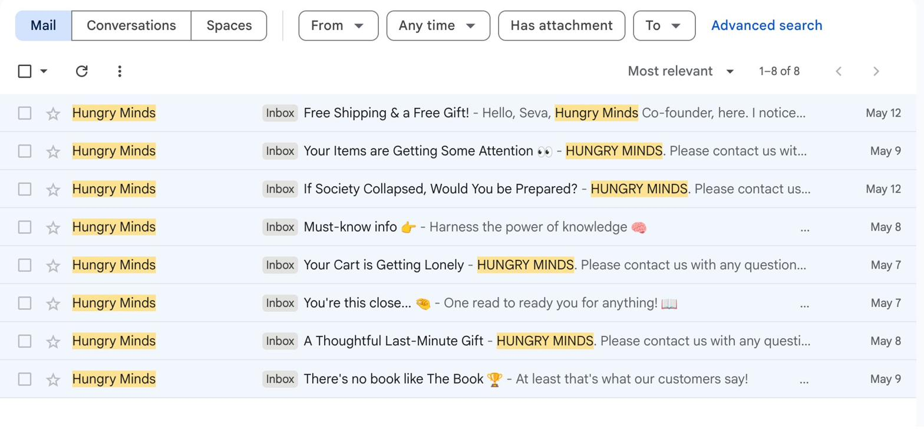

Email 1 — PROMO / Nurture  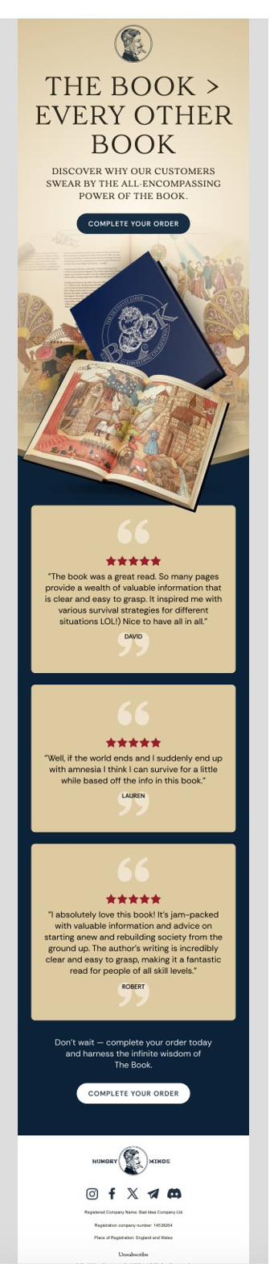 | Email 2 — PRODUCT / Gift Card  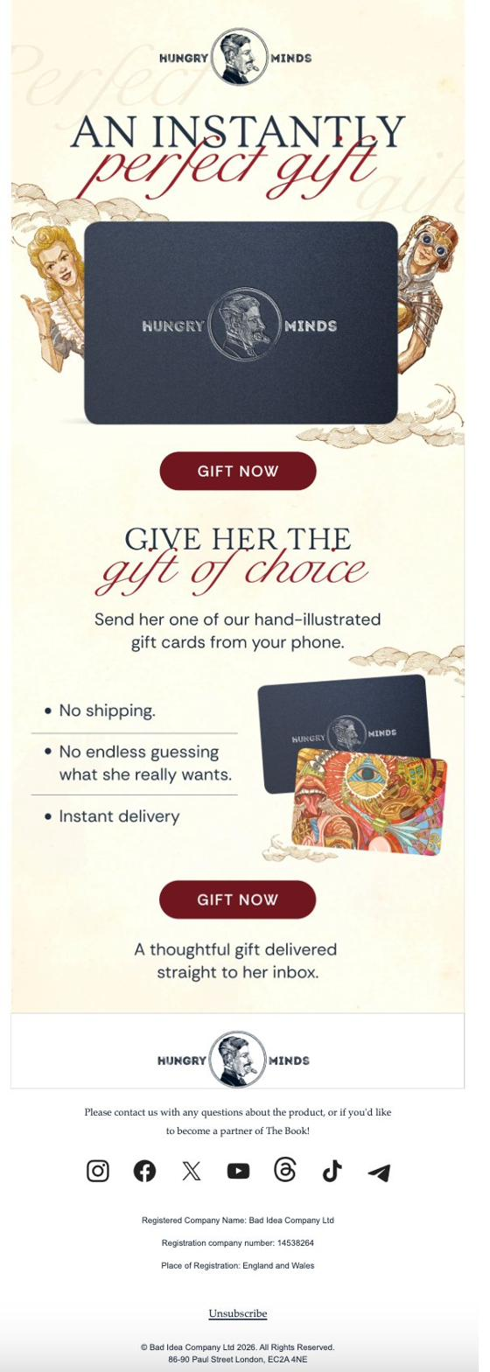
Email 3 — PROMO / Cart Abandon  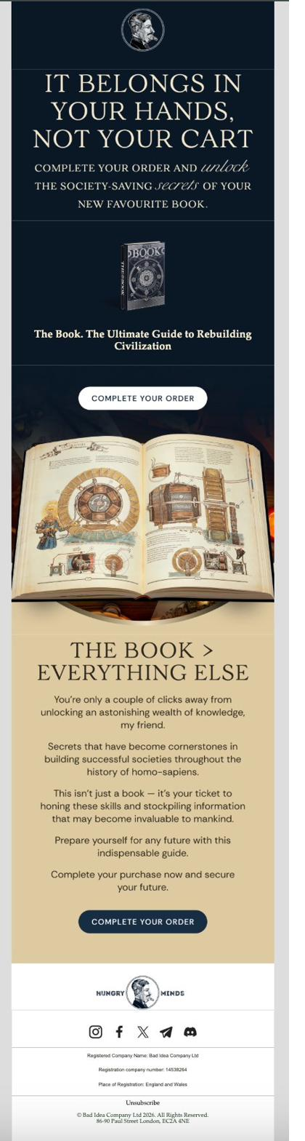 | Email 4 — PROMO / Cart Abandon  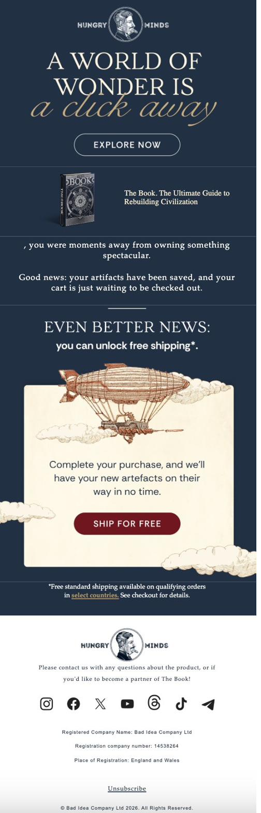
Email 5 — PRODUCT / Content (Best in Sequence)  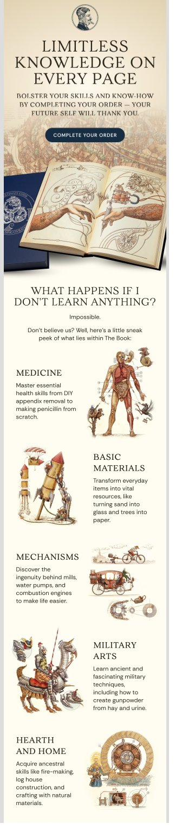  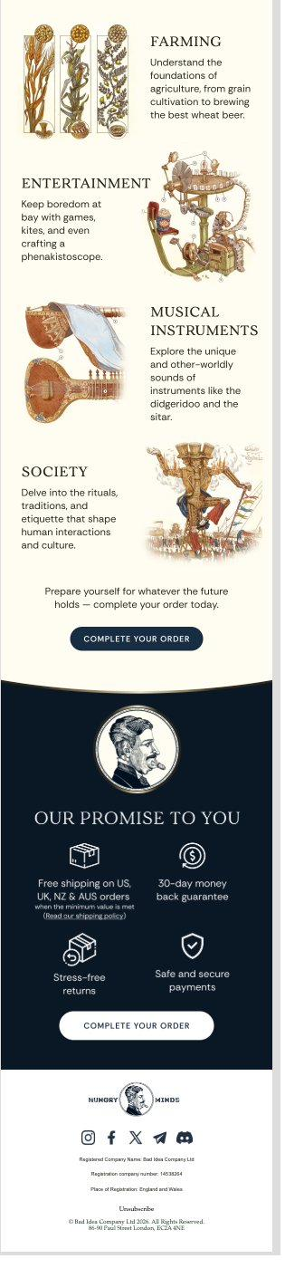 | Email 6 — PRODUCT / Bundle Upsell  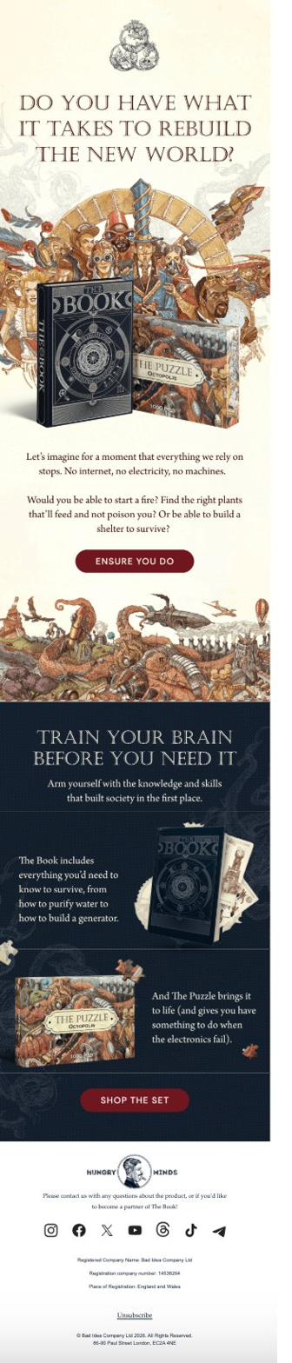
Email 7 — PROMO / Social Proof  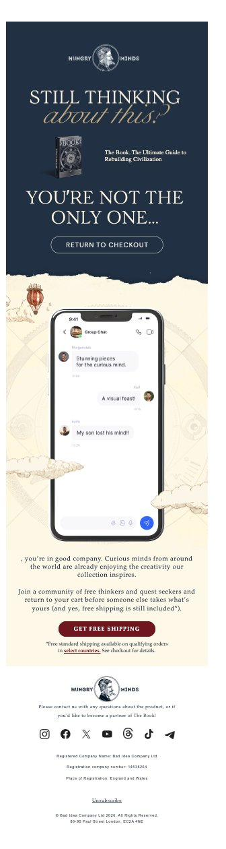 | Email 8 — PROMO / Founder Note  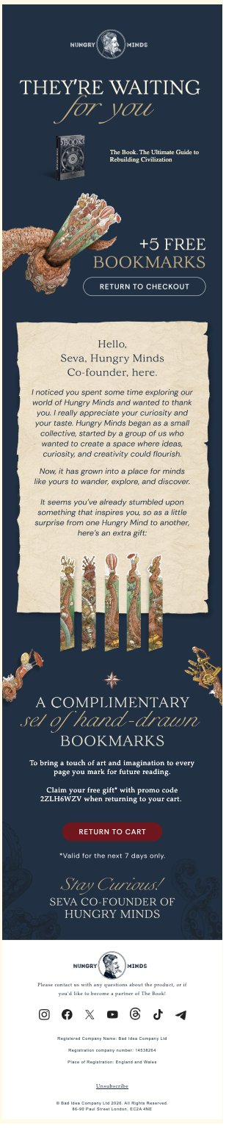

The Opportunity — TikTok-Seeded Content Layer
The highest-value addition to the email program is a newsletter layer that converts TikTok viral moments into owned-audience touchpoints. The content cost is near-zero — the knowledge already exists in the book.

How it works in practice: @quinnlovesreading posts about making penicillin. @julesreadsthebook posts a 'banned book' video pulling 588K likes. Those viewers land on the email list. The newsletter picks up the same thread — 'Here's the full chapter. Here's what quinn was talking about.' Links the creator video. Links the product.

- Bi-weekly content email seeded from top-performing TikTok topics — penicillin, fire-starting, civilizational collapse, hantavirus, doomsday angles as they trend
- Embed or link the creator video in the email — 'Here's what @quinnlovesreading said about it' — bridges social and email, reinforces purchase intent for ICP 3 (Curiosity-Coded Generalist, ~28% of buyers)
- Segment: ICP 3 gets the content track. ICP 2 (Thoughtful Gifter) gets a separate gifting-focused track with bundle suggestions and volume pricing hints.
- Cross-sell: each newsletter issue features one relevant SKU — The Black Book, The Puzzle, Luxury Edition for high-LTV subscribers

OPPORTUNITY 4

B2B & Corporate Gifting: A Channel That Does Not Need Q4

~30%  Amazon reviews with gift context | $139  Gift box SKU — live but underused | 1  B2B landing page — basic, no funnel | 0  Corporate copy in email flows

The Signal
From 50 coded Amazon reviews: approximately 30% have explicit gift context — bought as a birthday, Christmas, or anniversary gift, or deliberately for someone else. Multiple reviews note 'I bought this for my husband,' 'bought two as gifts,' family gifting patterns across markets. This is ICP 2 (The Thoughtful Gifter) showing up in the purchase data at scale.

Five public signals show Hungry Minds is already thinking about B2B:

- A dedicated B2B / corporate gifting landing page exists — captures contact info, but no visible conversion path or follow-up infrastructure
- A $139 gift box SKU is live in the catalog
- Atlanta Market Winter 2026 appearance — a wholesale gift trade show. Public signal of B2B intent.
- Press coverage in Forbes, GQ, Vogue, Globe & Mail — the social proof a procurement manager needs to justify a $100+ per-head executive gift spend
- The book's premise (rebuilding civilization, knowledge for any future) plays directly into B2B contexts: onboarding gifts, leadership offsites, client appreciation for consulting, finance, and tech firms

Assumption I am working with:
I do not know whether Hungry Minds has an internal sales team or existing corporate accounts.
The recommendation assumes no structured B2B motion yet — which is what the basic landing page
and absence of B2B email copy suggests. If corporate accounts already exist, the upside is larger.

The Opportunity
Corporate gifting does not depend on Q4. A procurement manager ordering 50 copies for a Q1 leadership offsite is as valuable as a Christmas spike — and far more predictable.

- Upgrade the landing page from a contact form to a proper B2B conversion surface: volume pricing tiers, 'request a sample' CTA, turnaround SLA for bulk orders, and any existing corporate buyer testimonials
- Build a short LinkedIn outbound sequence targeting EAs, office managers, and procurement leads at finance, consulting, and tech firms. The Forbes/GQ press coverage is the cold-outreach credibility that makes the pitch land.
- Add a gifting email track to existing Klaviyo flows. ICP 2 has one email in the current sequence. A dedicated gifting track with bundle suggestions, volume pricing hints, and corporate use-case framing captures both individual and bulk gift buyers.
- Build a 4-campaign annual gifting calendar: Q4 holiday, Q1 fiscal year-end (March/April), company anniversary season, leadership onboarding (September). Corporate gifting is a year-round channel if you build the infrastructure.

Priority Sequencing

These four opportunities compound. A better on-site experience makes paid spend convert at a higher rate. A stronger creator roster grows the email list faster. A newsletter builds the owned audience that makes B2B credible. The order matters.

# | Opportunity | Why This Sequence | Effort
1 | On-Site CRO + AOV | Paid media is already running into this funnel. Every day these gaps exist is wasted spend. | Low — CSS, copy changes, Shopify app installs
2 | Paid Social — Creator Scale | Fix the container, then pour more in. Diversify before scaling budget. | Medium — creator recruitment, briefing, whitelist setup
3 | Email — Content Layer | Owned audience is underused. Newsletter layer is low-cost content with compounding LTV impact. | Medium — Klaviyo restructure, content brief, segmentation
4 | B2B / Corporate Gifting | Real infrastructure signal exists. Needs landing page upgrade and outbound motion. | Medium — landing page redesign, LinkedIn sequence, email track

Prepared by K · May 2026 · All data sourced from publicly available information

