HUNGRY MINDS — RESEARCH PACK
Raw Data Supporting the Growth Memo · May 2026
Prepared by: K

This document contains all raw data, screenshots, and tables that underpin the growth memo. Everything is sourced from publicly available information — Amazon, TikTok, Meta Ads Library, hungryminds.com, and Trustpilot.

Section | Contents
1. ICP Archetypes | 5 buyer archetypes with full evidence from Amazon reviews
2. TikTok Video Data | 8 top-performing videos — metrics, hooks, body angles, CTAs, comment themes
3. Meta Ads Library | 56 active ads — creator breakdown, copy angles, impression signals
4. On-Site CRO Gaps | Checkout walkthrough findings, verified live May 2026
5. Competitor Analysis | The Codex (Rebel Thinkers), Assouline, Taschen
6. Amazon Review Data | Selected reviews by ICP + screenshots from Amazon listing

Section 1 — ICP Archetypes

Derived from analyzing 50 Amazon reviews across US, CA, UK, SG, and SE markets. Reviews sourced from the public Amazon listing for The Book: The Ultimate Guide to Rebuilding Civilization. Star distribution: 45/50 five-star, 5/50 four-star (Amazon default sort skews positive — noted as a methodology caveat).

ICP | Share | JTBD — Primary Motivation | Key Evidence from Reviews | Channels
ICP 1 — The Aesthete / Coffee-Table Curator | ~40% | Social signaling, shelf presence, object quality. Often self-identifies as 'not a book person.' | 'I am not a book person but was mesmerized just feeling the velvet cover' (VooDuuChild, 5★ US). 'A visual feast.' 'It belongs on a shelf where guests can see it.' | IG/TikTok unboxings, r/coffeetable, r/MaleLivingSpace, interior design press
ICP 2 — The Thoughtful Gifter | ~30% | Being seen as thoughtful. Satisfaction comes from the gift act, not the reading. | 'I bought this as a gift for my husband and I think I love it almost as much as he does' (meg, 5★ CA). 'Bought as surprise birthday gift' (Alelie Belza, 5★ CA). Multiple buyers note two copies purchased. | Q4 gifting flows, gift-finder content, B2B outreach
ICP 3 — The Curiosity-Coded Generalist | ~28% | 'How does the world work?' Values physical format. Anti-digital lean. | 'Nice to feel the weight of the book in my lap and slide my fingers across the page rather than scrolling' (Kaitlyn Collison, 5★ US). 'Good mix of abstraction, details and narrative all in one' (JA, 5★ US). | Newsletter, creator partnerships, SEO
ICP 4 — The Soft Prepper | ~12% | Apocalypse-curious, ironic register. Buys via aesthetic, not survival keywords. | Ironic register dominates: 'If the world ends and I suddenly end up with amnesia I think I can survive' (Lauren, 5★). Tactical preppers leave the loudest critical reviews — wrong audience to target. | Aesthetic hooks only. Do NOT target hard prepper keywords.
ICP 5 — Family-Library Builder / Parent | ~10% | Curiosity prompt for kids. Concerned about content appropriateness (sex section). | 'The cover glows in the dark and looks really beautiful!' Multiple parents explore it with children. Concern about 18+ content noted in negative reviews — addressed in 2024 edition. | Family-focused content, parent gift listicles

Section 2 — TikTok Video Data

8 top-performing organic/affiliate videos analyzed from public TikTok profiles. Data collected May 2026.

On saves: Saves are the most strategically important metric in this dataset.
A high save count means the viewer intended to return to the content — the closest public proxy for purchase intent.
A saves-to-likes ratio above 0.25 is strong. @julesreadsthebook's 170.8K saves on a 50-second video is exceptional.

Quantitative Performance
Creator | Likes | Saves | Shares | Comments | Length | Save/Like Ratio
@julesreadsthebook | 588,200 | 170,800 | 39,600 | 2,229 | 50s | 0.29
@feleciaforthewin | 305,900 | 93,500 | 14,100 | 3,759 | 1m 5s | 0.31
@buffyonyx | 268,100 | 66,400 | 19,200 | 1,641 | 2m 17s | 0.25
@christopherkriel_ | 107,100 | 39,300 | 17,800 | 453 | 58s | 0.37
@quinnlovesreading (v1) | 121,800 | 57,600 | 13,600 | 929 | 2m 39s | 0.47
@quinnlovesreading (v2) | 111,500 | 35,700 | 5,180 | 380 | 20s | 0.32
@readitralph | 104,200 | 38,500 | 6,131 | 1,094 | 30s | 0.37
@polskihussar | 84,300 | 25,900 | 8,973 | 688 | 31s | 0.31

Hook / Body / CTA Breakdown
Creator | Hook (First 3s) | Body Angle | CTA | Creator Type
@julesreadsthebook | 'This book would be banned in so many countries soon and I lowkey agree...' — shows book | Forbidden knowledge. Physical media advocacy. | 'I think physical media is so important to have' | Affiliate, 10% off code
@feleciaforthewin | 'I just added the coolest book to my collection and I want to show you what...' — shows book | Object reveal. Aesthetic + curiosity. | Open-ended: 'If society collapsed, would the world end up in the same place?' | Affiliate / influencer
@buffyonyx | 'This book is all about restarting society after you know...' — shows pages including controversial content | Depth walkthrough: essentials, fun stuff, art, topics. | 'I am taking this book when my house catches fire. My dogs come first.' | Paid partnership / whitelisting
@christopherkriel_ | '50 ways to see the world in a new light' — shows the book | Gift angle. | 'Would make a perfect gift — check link in bio' | Affiliate, 10% off code
@quinnlovesreading (v1) | 'Hi, I share tips everyday in case the world was going to end. Today I am going to teach you how to make penicillin' — does not show book in first 3s | Survival tips: penicillin, food, fire. | 'This book is filled with knowledge like this if the apocalypse were to happen' | Affiliate, 10% off code
@quinnlovesreading (v2) | 'There is a reason why some governments get nervous when we start reading a book like this...' — shows book within first 3s | Flips through pages: penicillin, food, fire. | 'Find fire, find clean water, what foods to eat' | Affiliate, 10% off code
@readitralph | 'This type of book is banned in some places because of what it can literally teach you' — shows book | 400 pages, beautiful illustrations, page-by-page topics, rebuilding civilization. | 'Link in bio, 10% off code' | Affiliate, 10% off code
@polskihussar | 'If civilization were to take a step backwards, I have the book that details every need...' — unboxing with gloves | Rebuilding civilization angle, art, daily pleasures like coffee. | 'When I say it explains everything, I mean it. The art itself is top tier' | Paid partnership / whitelisting

Comment Theme Analysis
Theme | Frequency | Strategic Implication
'Dr Stone' anime reference | Very high — appears in most videos | Resonates with younger curiosity buyers. Not a negative — confirms the ICP 3 (Curiosity-Coded Generalist) audience is engaged.
'Where to buy' / 'where do I get this' | High | Purchase intent is generated but not always captured. Reducing link-in-bio dependency matters.
'Expensive' / 'how much' | High | Price is the #1 objection. BNPL directly addresses this.
'Why is it banned' / 'banned where' | Medium | Validates the forbidden-knowledge hook. Organic curiosity is real.
Content-specific curiosity (penicillin, algae, fungus) | Medium | Confirms ICP 3 engaging. Newsletter content layer opportunity.
Object quality / aesthetics comments | Medium | ICP 1 (Aesthete) responding to unboxing and prestige visual content.

Section 3 — Meta Ads Library Analysis

Audited via facebook.com/ads/library searching 'Hungry Minds Publishing' with Active Ads filter. Date of audit: May 2026. Total active ads: ~56.

Ad Library Screenshots
Page 1 of results — active ads overview:
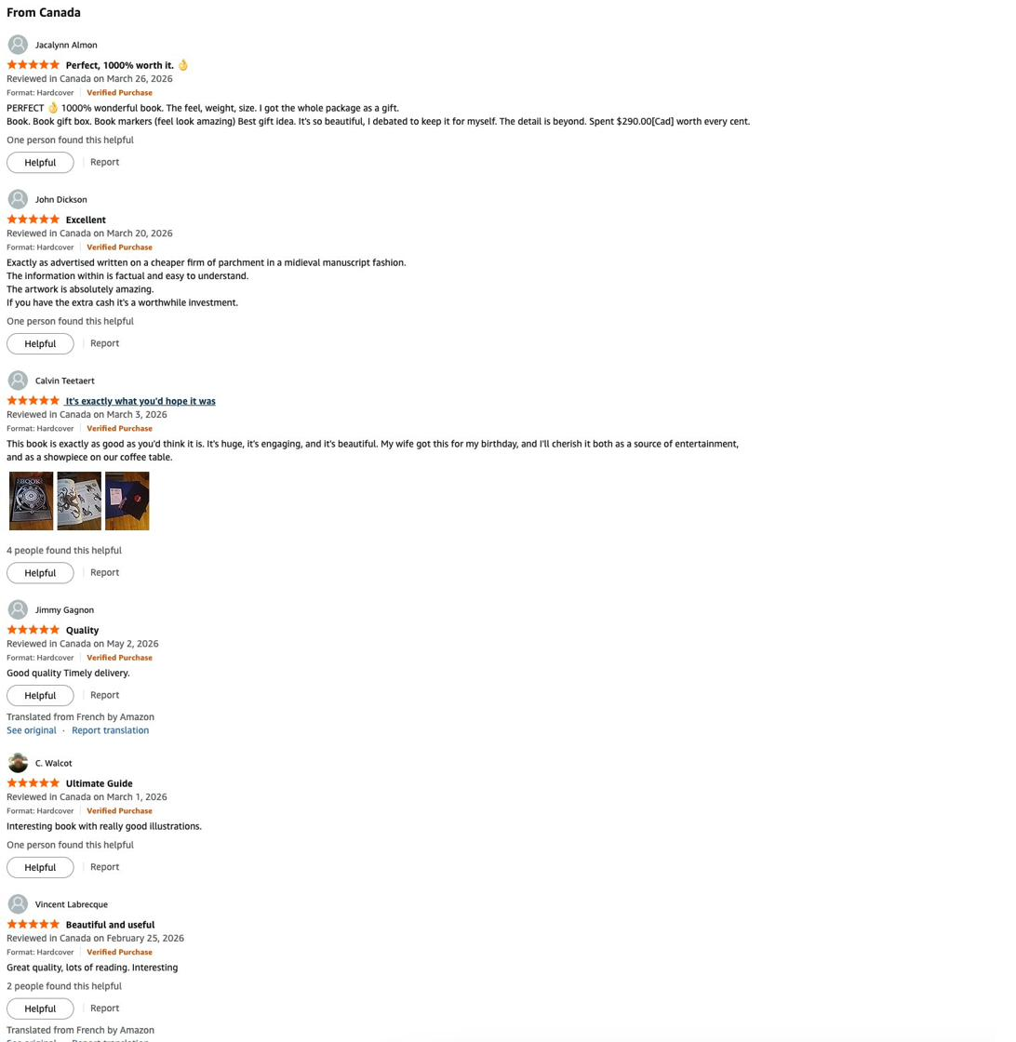

Page 2 — quinnlovesreading whitelist ads dominant:
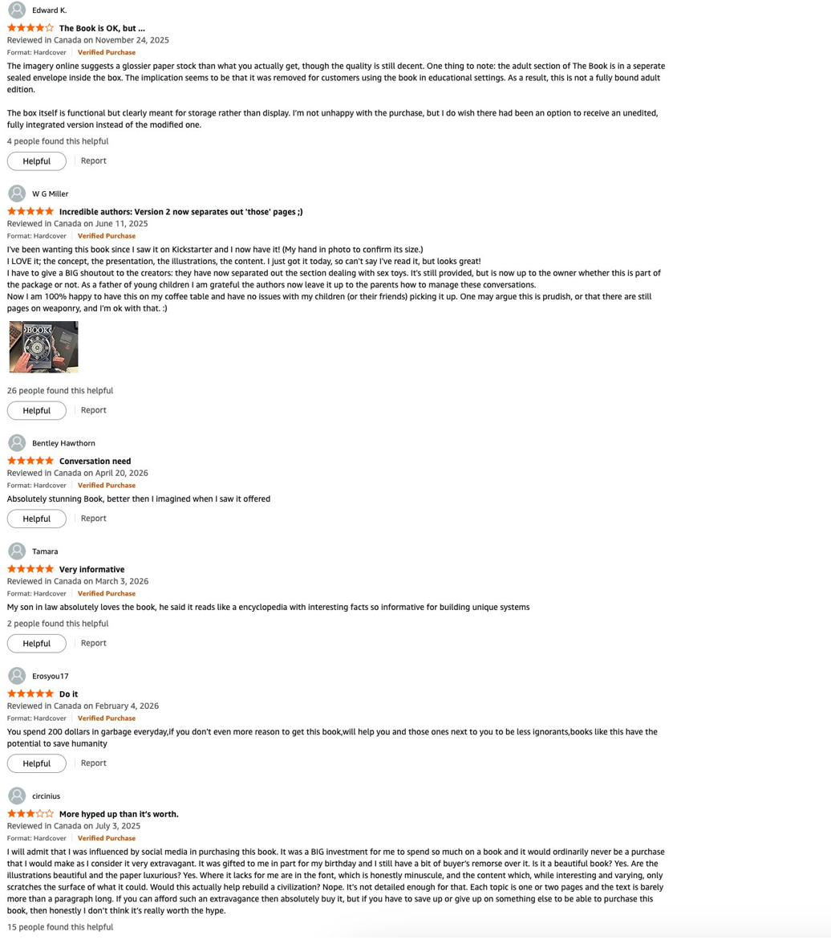

Page 3 — Low impression count flags begin:
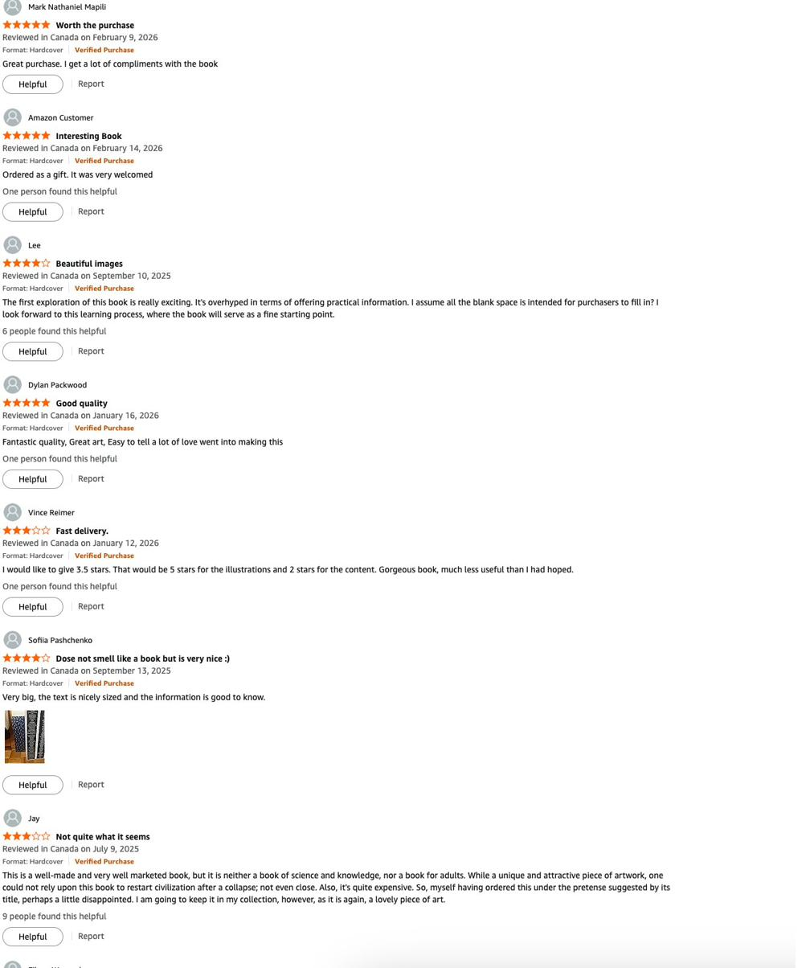

Page 4 — Majority of newer ads flagged low impression count:
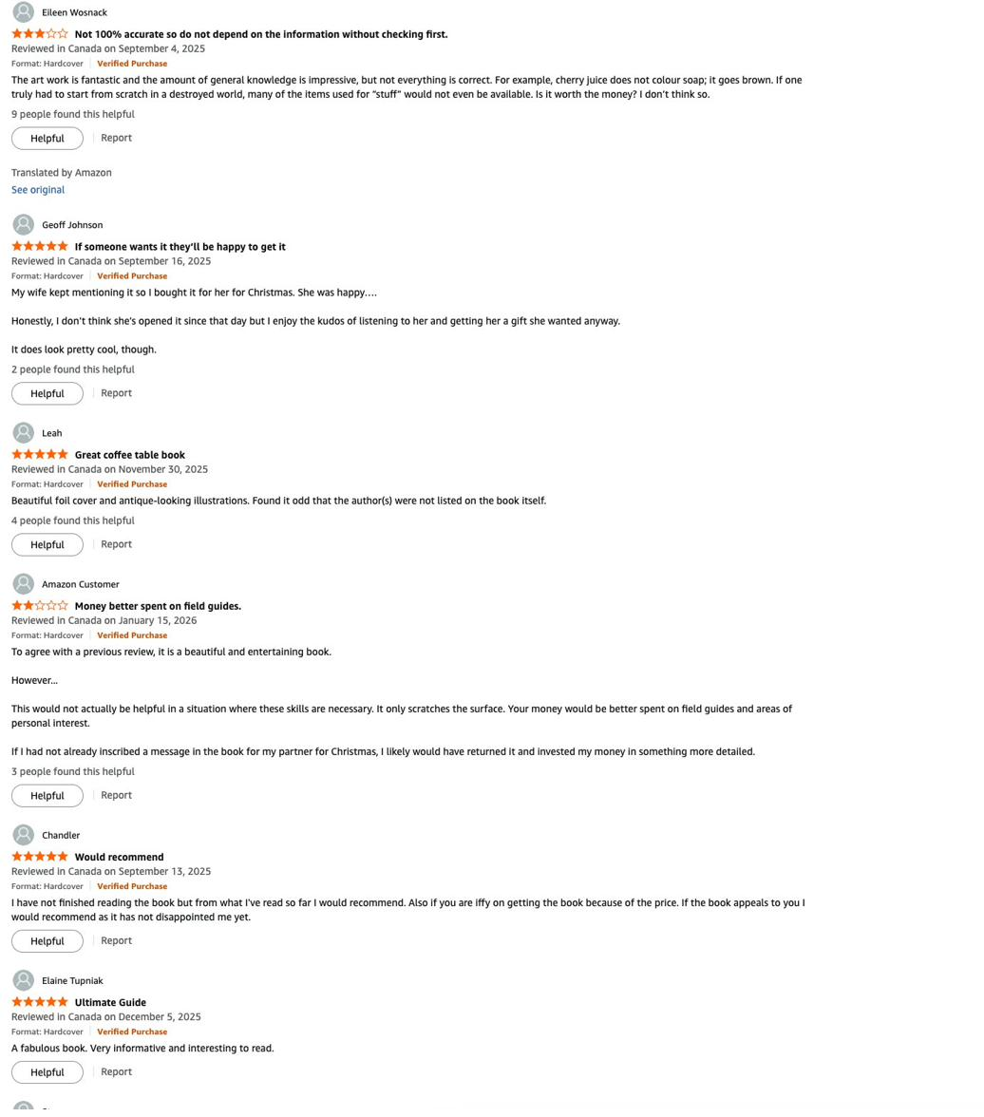

Copy Angle Analysis
Copy Angle | Approx. Ad Count | Signal
'This book could save your life, or at least your dinner party. It's not a coffee table book. It's a conversation grenade.' | ~30+ ads | Primary brand voice. Running across brand and all 3 whitelist creators.
'When was the last time you read something and thought: Wait. How did someone even think of that?' | ~15+ ads | Curiosity angle. Running across brand creative and some whitelist ads.
'Know someone who is into art, technology, history? Give them the gift of The Book.' | ~5 ads | Gift angle. Significantly underrepresented relative to the 30% gift buyer signal from Amazon reviews.

Creator Distribution
Creator | Est. Ad Presence | Impression Signal | Notes
@quinnlovesreading | ~60–70% of visible ads | High — no flags | Dominant. Single point of failure.
@scientificallysavage | ~10–15% | Mixed — some flagged | Underperforming vs quinn.
@alinereads | ~10–15% | Low impression count flags | Underperforming.
Brand-controlled (no whitelist) | ~10–20% | Low impression count flags on most | Brand creative alone does not scale without creator voice.

Section 4 — On-Site CRO Gaps

The following observations are drawn from a review of the Hungry Minds checkout experience across the main site, hungryminds.com.

Opportunity | Observation | Recommended Fix
ATC persistence | The add-to-cart button disappears on scroll. Reference: IM8 (im8.com) for sticky ATC benchmark. | CSS/theme edit — single sprint.
BNPL — Klarna or Affirm | Shop Pay is present at checkout but installments are not confirmed across all markets. A dedicated BNPL option surfaced prominently beneath the checkout button would reduce price anxiety. | Shopify app install. Shopify data: 15–20% AOV lift from BNPL at this price tier.
Free shipping visibility | Free shipping on qualifying orders is not consistently surfaced on the product page or in the cart — only in recovery emails. | Add shipping message to product page and cart banner. High signal-to-noise ratio for a no-cost change.
Bundle incentive | Max visible discount is $19. The puzzle upsell in cart shows no bundle saving. | Surface 'save $19 when you bundle' directly in the cart upsell — copy change only. Review discount threshold against COGS for further lift.
One-time checkout offer | No exclusive checkout-only offer exists currently. | An 'add this product for a one-time 10% discount — available at checkout only' mechanic rewards commitment and lifts AOV at the highest-intent moment.
Navigation — gift and bestseller shortcuts | No 'Bestsellers' or 'Bundle & Save' category in main nav. | Add top-level nav categories to reduce decision fatigue for gift buyers from paid social.

Section 5 — Competitor Analysis

The Codex — Rebel Thinkers (rebel-thinkers.com)
Source: rebel-thinkers.com, Trustpilot (rebel-thinkers.com), Kickstarter campaign page. Accessed May 2026.

Attribute | Detail
Product | 350-page illustrated encyclopedia of inventions and inventors. Da Vinci-inspired medieval style.
Publisher | Rebel Thinkers — 3 founders from Ukraine (Vlad Khvyshchuk, Nazar Ozhho, Danylo Ozhho)
Illustrators | 12 Ukrainian illustrators — 5 rounds of visual refinement
Launch Model | Kickstarter 2024 — ~5,000 backers. Sold out twice since launch.
Price | ~$89–$119 (varied by edition and Kickstarter tier)
Trustpilot | ~5.0/5 from 31 reviews (January 2026)
Positioning | 'Only book that explains How the World Works.' Strong family co-exploration angle. Gift-first narrative.
Creator Program | Not visible at scale — no dedicated affiliate army observed
Where it beats HM | Fresher Kickstarter cycle. Cleaner gifting narrative. Near-perfect Trustpilot vs. HM's 3.7/5.
Where HM beats it | Scale (400K+ vs ~5K copies), creator army, multi-SKU catalog, AOV ladder to $1,000, community infrastructure (Discord, Telegram)

Assouline (assouline.com)
Source: assouline.com product catalog, brand positioning. Accessed May 2026.

Attribute | Detail
Product | Luxury illustrated oversize hardcovers across fashion, art, travel, culture. 'The Impossible Collection' and 'Ultimate Collection' tiers.
Price Range | $65 (standard) to $1,500+ (Ultimate Collection). Gift-wrapped as standard on high-end SKUs.
Distribution | DTC via assouline.com + flagship retail stores (NYC, Paris, London, Miami). Also sold at luxury hotels.
Gift Positioning | Core identity — 'the impossible gift.' White gloves + canvas tote bag included on luxury editions.
Creator / Social | Minimal creator program. Relies on editorial press and retail placement for discovery.
Relevance to HM | Assouline owns the upper tier of the premium illustrated gift market. HM's $1,000 Luxury Edition is a direct play into Assouline's territory. HM's advantage: community, creator engine, and a more culturally accessible subject matter.

Taschen (taschen.com)
Source: taschen.com catalog, public Amazon listings. Accessed May 2026.

Attribute | Detail
Product | Art, architecture, design, photography, and pop culture coffee table books. XL and XXL editions.
Price Range | $30–$200+ (mid-range for art/coffee table category). Sale prices often 50% off.
Distribution | Retail-first (flagship stores in 10+ cities globally), Amazon, DTC via taschen.com.
Gift Positioning | Strong in holiday retail gifting. Holiday gift guide staple.
Creator / Social | No creator program. Press and retail-driven entirely.
Relevance to HM | Taschen is the benchmark Hungry Minds is quietly displacing in the consumer-curious segment. HM's illustrated approach, TikTok-native distribution, and Kickstarter-machine model reach audiences Taschen's retail-first strategy misses entirely.

Section 6 — Amazon Review Data

50 reviews coded from the Amazon public listing for The Book: The Ultimate Guide to Rebuilding Civilization. Overall rating: 4.6/5 from 2,617 global ratings as of May 2026. 82% five-star, 8% four-star, 5% three-star, 1% two-star, 4% one-star.

Key Reviews by ICP
ICP | Reviewer | Stars | Market | Date | Key Quote
ICP 1 | VooDuuChild | 5★ | US | Mar 2026 | 'I am not a book person, but I was mesmerized just feeling the velvet on the cover... I actually make a point to keep stored in the very nice box it arrives in and take it out to show any guest I have.'
ICP 1 | Kaitlyn Collison | 5★ | US | Nov 2025 | 'It's the most I've ever paid for a book, but it is gorgeous... nice to feel the weight of the book in my lap and sliding my fingers across the page rather than just scrolling the internet.'
ICP 2 | meg | 5★ | CA | Dec 2024 | 'I bought this as a gift for my husband and I think I love it almost as much as he does. The quality is exceptional but the content is beyond expectations.'
ICP 2 | Alelie Belza | 5★ | CA | May 2024 | 'Bought as surprise birthday gift for my husband. Prints and drawings are amazing. Thick and heavy.'
ICP 3 | JA | 5★ | US | Jan 2026 | 'Good mix of abstraction, details, and narrative all in one, and beautiful illustrations... pretty much any type of reader... the cover glows in the dark and looks really beautiful.'
ICP 3 | Kaitlyn Collison | 5★ | US | Nov 2025 | 'I got the book because I realized I did not know how a lot of appliances I use work. I feel like this is a good, general overview of common items in a physical form rather than just scrolling.'
ICP 4 | Lauren | 5★ | US | Unknown | 'Well, if the world ends and I suddenly end up with amnesia I think I can survive for a little while based off the info in this book.'
Critical (depth) | Donald Cameron | 3★ | CA | Jan 2025 | 'It was informative on a few subjects, I thought it would be more informative. Build an x-ray machine... Really, tropical plants... maybe. It's a nice book but not that practical in my opinion.'

Amazon Listing Screenshots
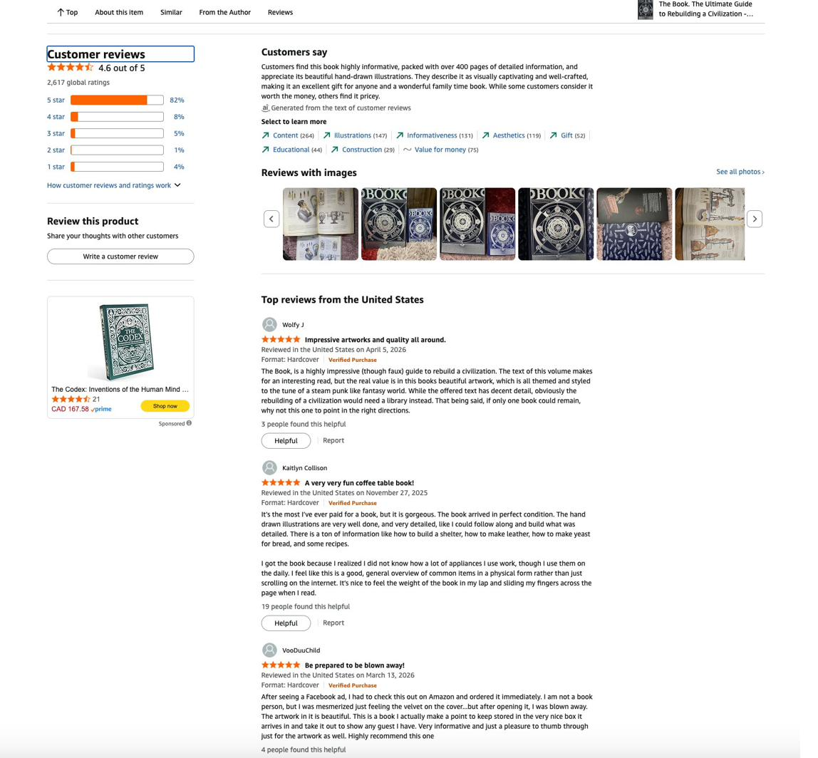

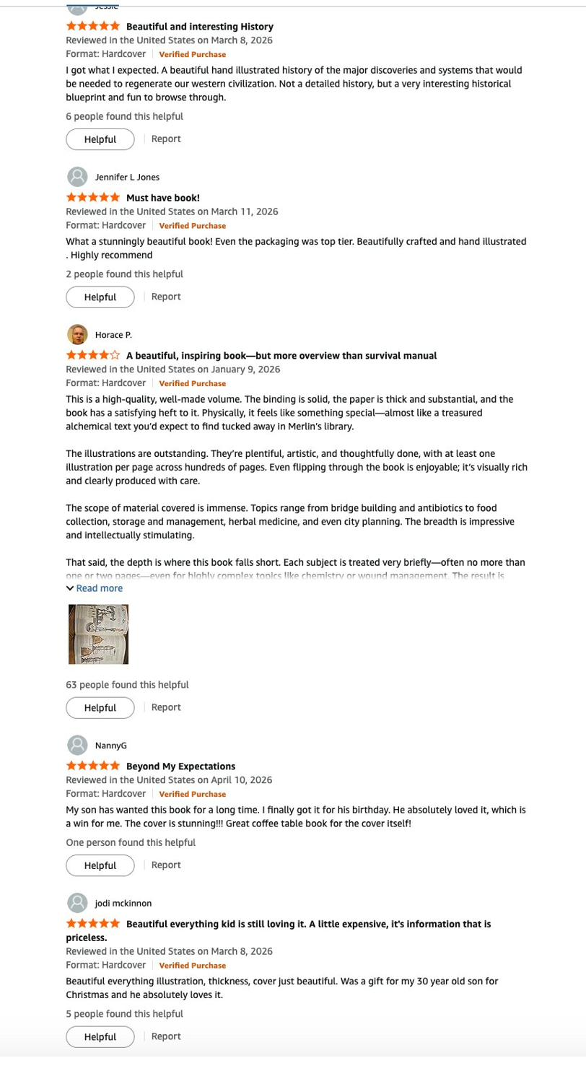

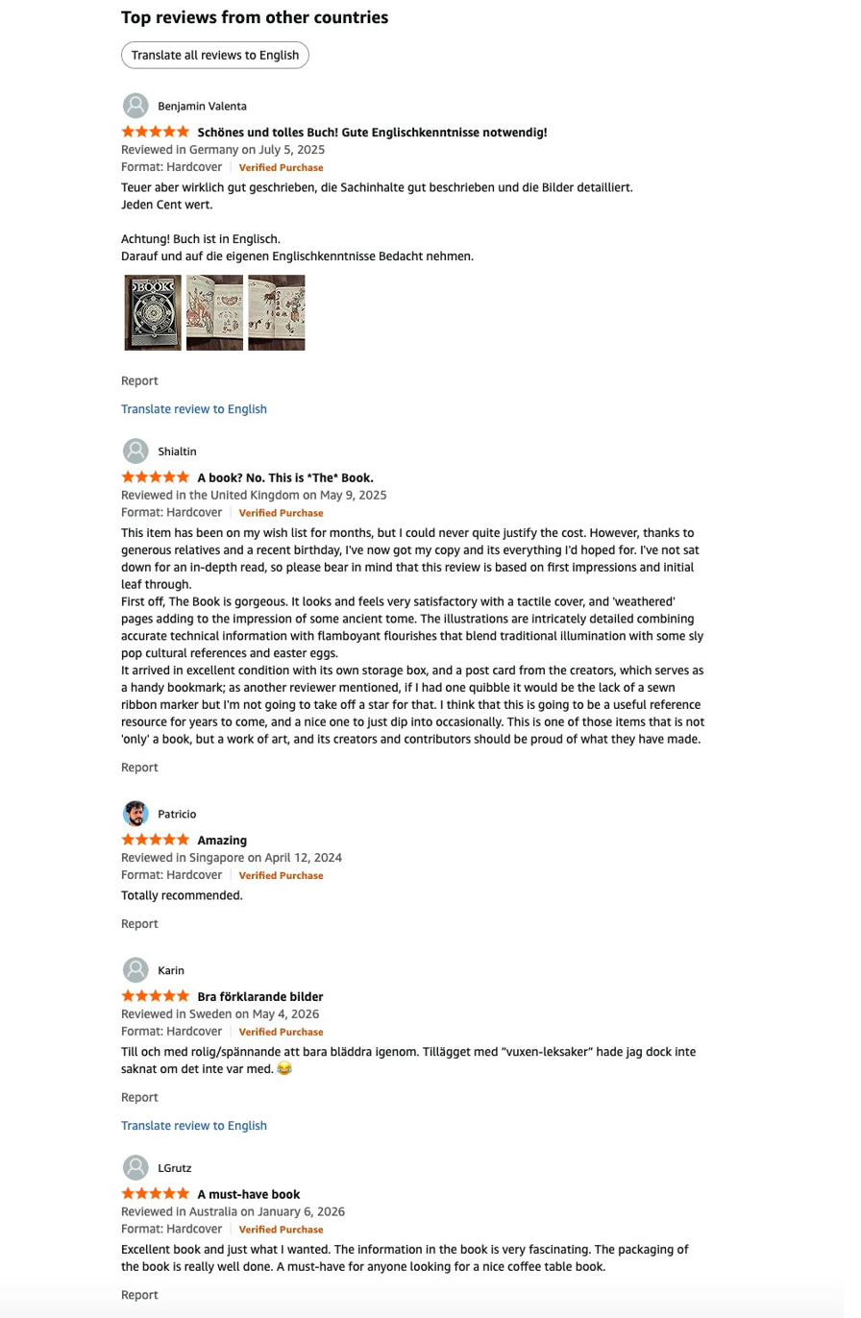

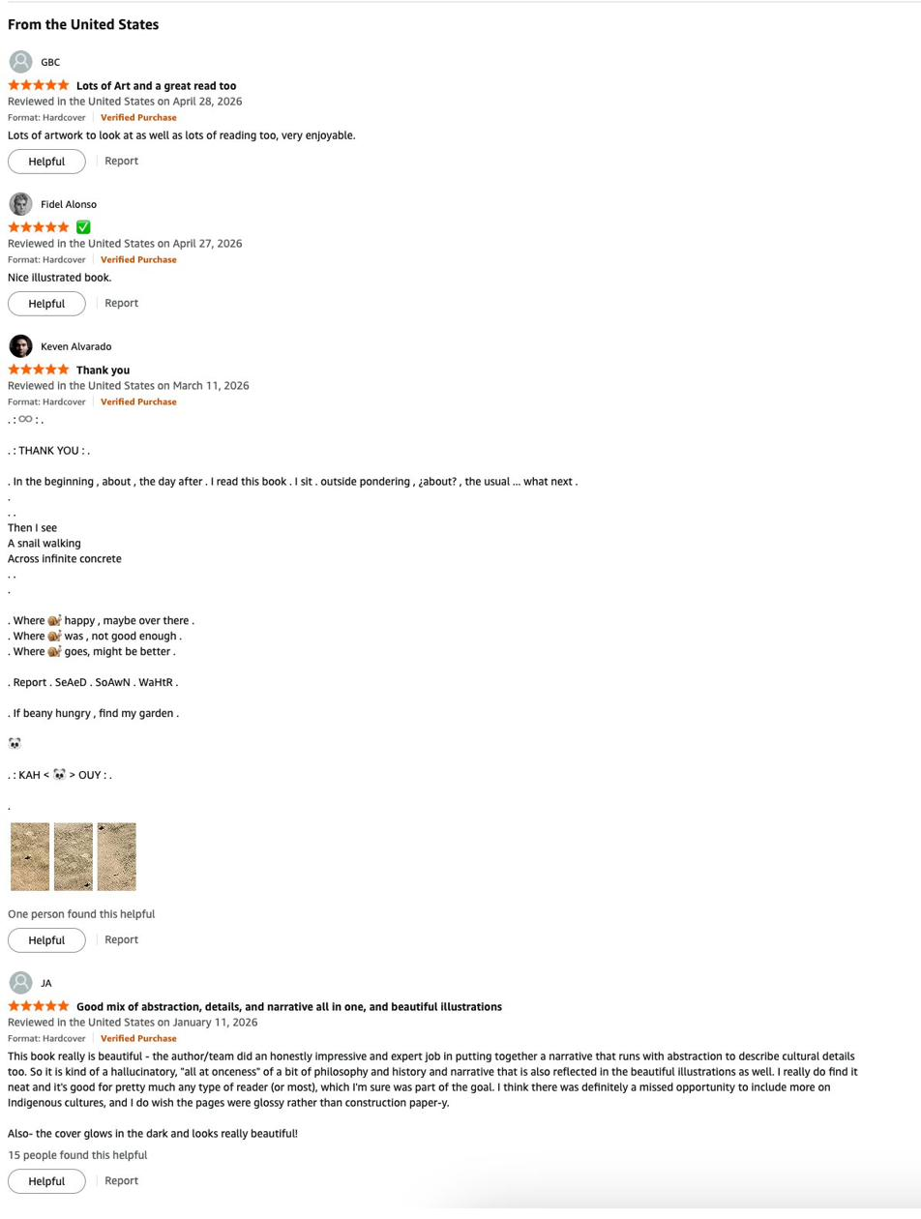

Research Pack · K · May 2026 · All data from publicly available sources

