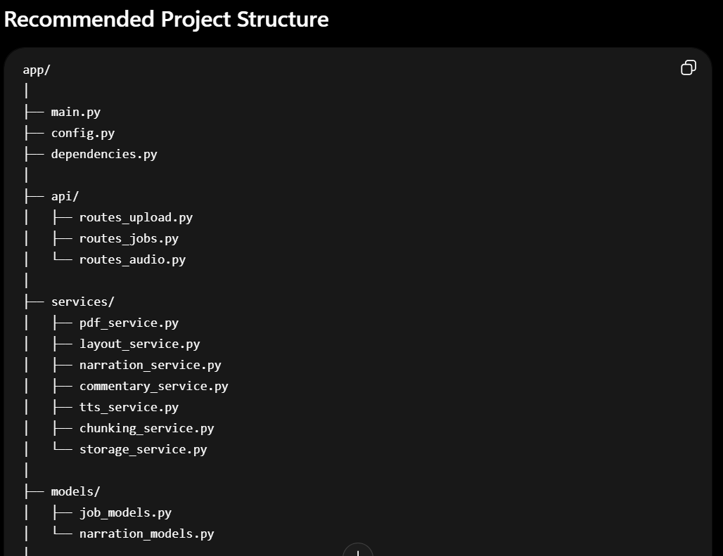
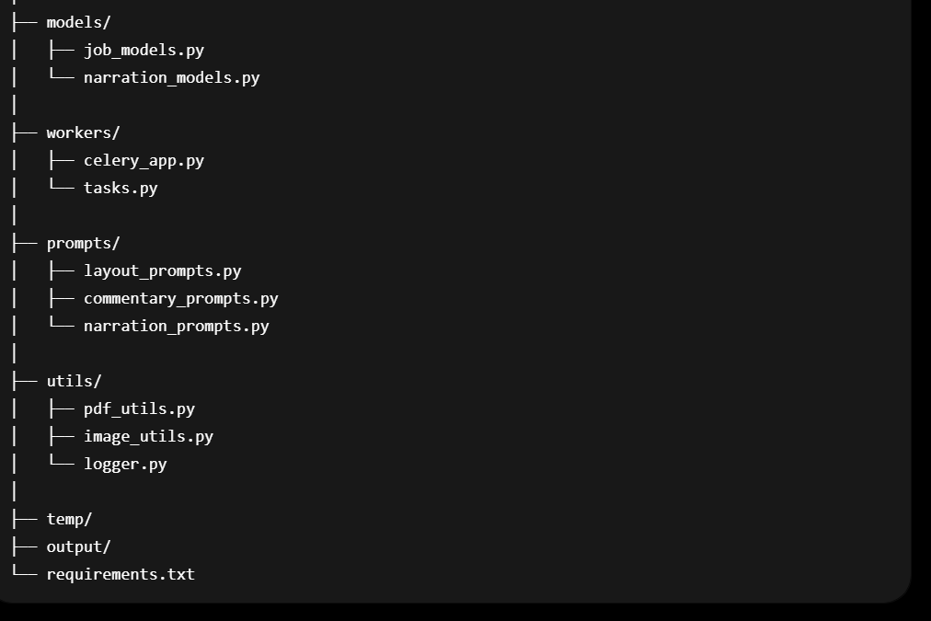

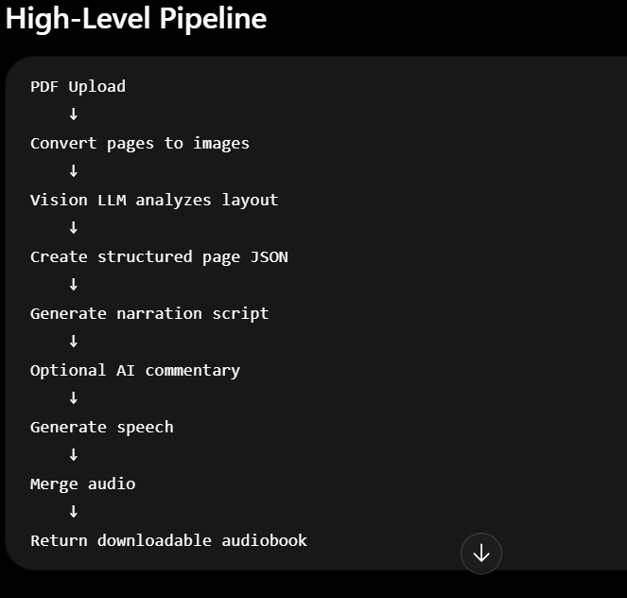

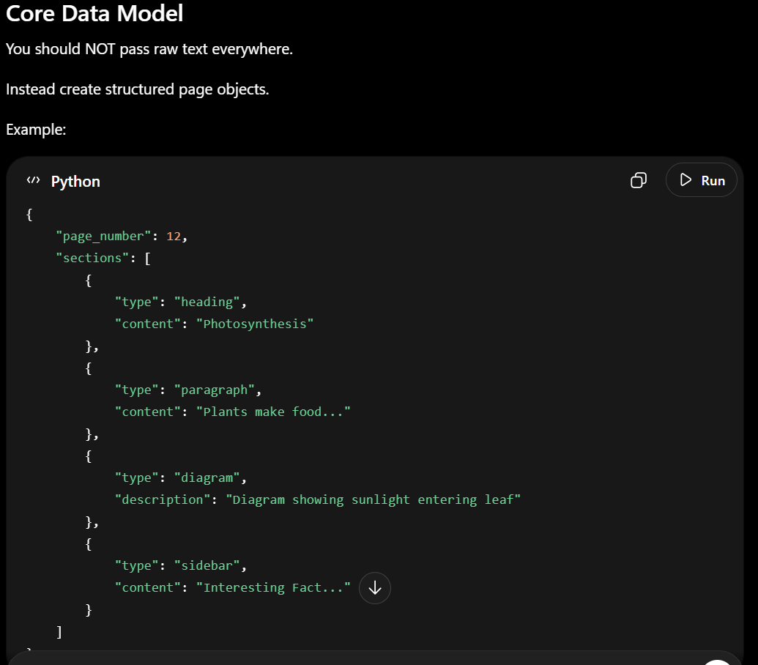

Strong Recommendation: Async Job Queue
Do NOT process PDFs synchronously.
A textbook may take:
- several minutes,
- hundreds of API calls,
- long audio generation time.
Use:
- Celery + Redis
OR
- RQ
OR
- Dramatiq

Important Production Features
1. Page Chunking
Never send entire textbook to LLM.
Use:
- page-wise,
- section-wise,
- chapter-wise chunking.

2. Audio Caching
If paragraph unchanged:
- reuse existing audio.
Huge cost savings.

3. Voice Modes
teacher
storyteller
exam-coach
child-friendly
formal
This becomes a major product differentiator.

Suggested MVP Stack
Layer | Tech
API | FastAPI
Worker queue | Celery
Queue backend | Redis
PDF parsing | PyMuPDF
Vision LLM | Gemini
Commentary LLM | GPT-5
TTS | ElevenLabs
Storage | S3/R2
DB | Postgres

Suggested Next Step
Your next milestone should be ONLY:
PDF → page images → structured JSON
Do not start with TTS first.
If the structure extraction is bad, the whole narration pipeline becomes poor.

