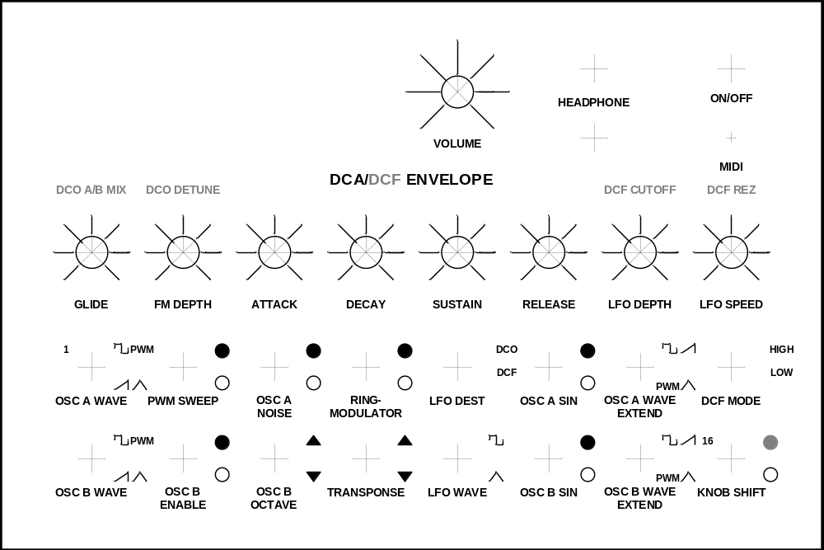
Modified Version of original Meeblip front (Nov 2011)

