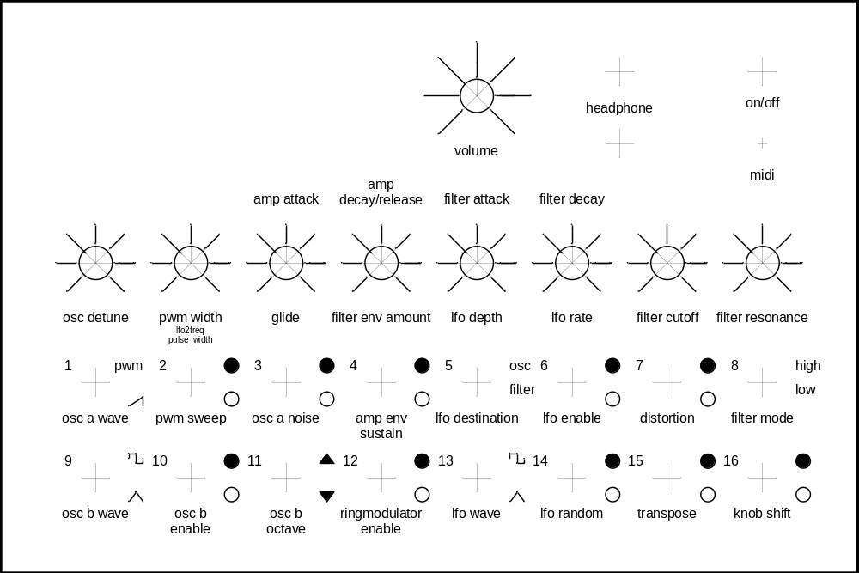

Front for my meeblip se hack (dec 2011)

