Assignment 3. Application Installation and Configuration
Student: Atazhan Gabit
Computer: Windows 11, 64-bit. Selected applications: Microsoft Edge (web browser), Telegram Web (communication application) and MySQL (database software).

1. Report table
Application | Version | Purpose | Configuration performed | Result
Web browser:  Microsoft Edge | 156.0.4314.58 | Browsing websites, searching for information, downloading files | Default search engine, download location, startup pages, tracking prevention, new user profile | Settings saved; several websites opened correctly
Communication application:  Telegram Web | 2.2 | Messaging, file sharing, voice messages, group chats | Notifications, microphone and camera permissions (browser), user profile | Message sent and received; voice message recorded
Database software:  MySQL Server + MySQL Workbench | Server  Workbench  8.0.46 | Storing and managing data in relational databases using SQL | Connection to the local server; test database test_db with a table | Database created, data inserted and read back successfully

2. Task 1. Web browser configuration — Microsoft Edge
Microsoft Edge is built into Windows 11, so the installation was verified rather than repeated.
# | Task | What was done | Where in Edge
1 | Name and version | Microsoft Edge, version 156.0.4314.58.  Status: Microsoft Edge is up to date. | … → Settings → About Microsoft Edge (edge://settings/help)
2 | Available settings | Reviewed the main sections: Profiles, Privacy, search and services, Appearance, Start, home and new tabs, Downloads, Cookies and site permissions, Languages, System and performance. | … → Settings
3 | Default search engine | Changed the search engine used in the address bar from Bing to Google. | Settings → Privacy, search and services → Address bar and search
4 | Download location | Changed the folder to a new folder Downloads\PM03; turned on "Ask me where to save each file before downloading". | Settings → Downloads → Location → Change
5 | Startup and privacy | On startup: Open tabs from the previous session. Privacy: set Tracking prevention from Balanced to Strict; checked that Microsoft Defender SmartScreen is on. | Settings → Start, home and new tabs;  Settings → Privacy, search and services
6 | User profile | Created a separate profile Study for university work, with its own favourites and history. | Profile icon (top left) → Other profiles → Set up new profile
7 | Testing | In the Study profile opened google.com, youtube.com, wikipedia.org and web.telegram.org. All pages loaded correctly; a test file was saved to Downloads\PM03. | —
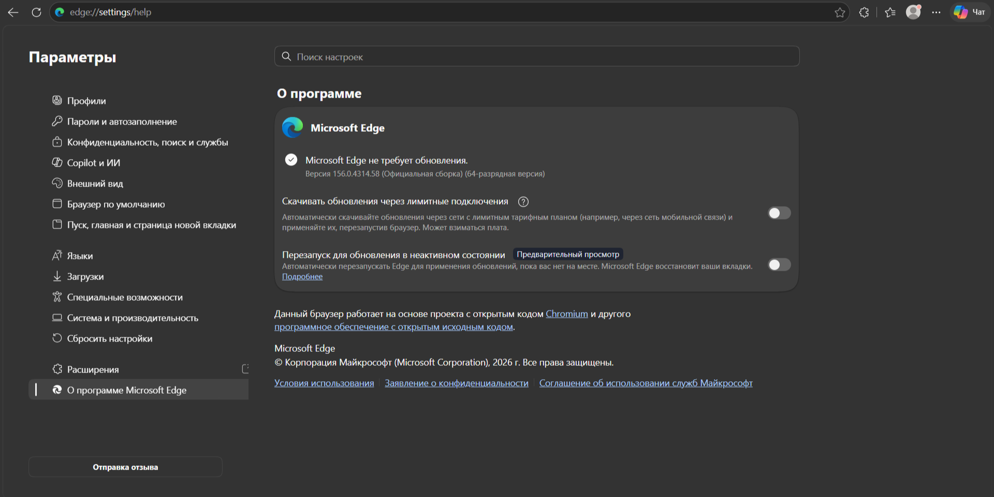
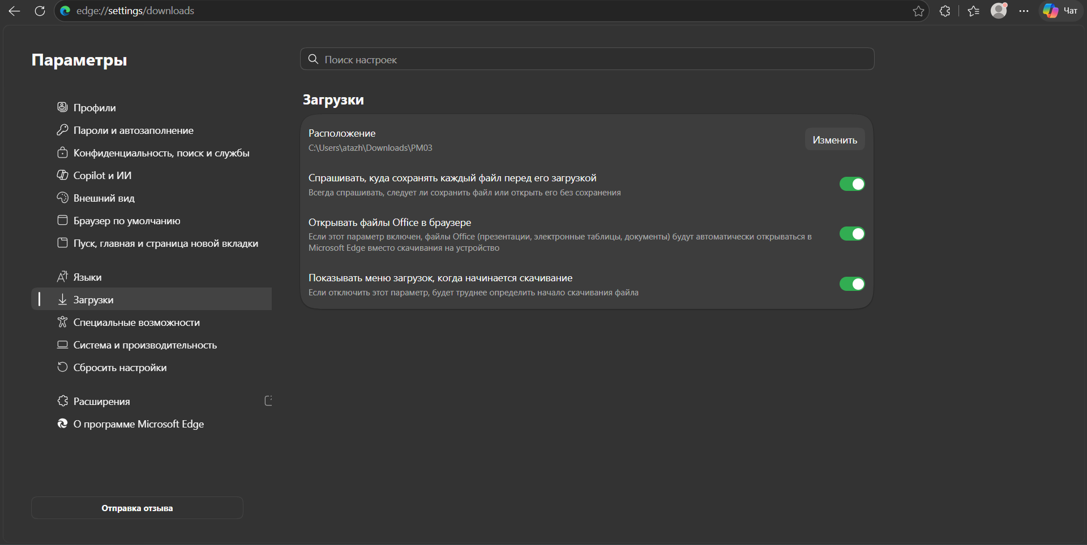
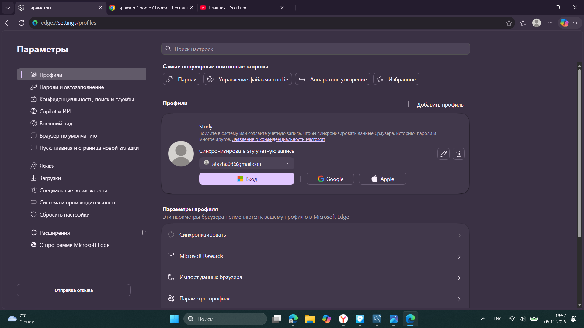

3. Task 2. Communication application — Telegram Web

Purpose and main features
Telegram Web is the browser version of the Telegram messenger, opened at web.telegram.org. It needs no installation: it runs in Microsoft Edge, and all chats are stored in the cloud, so they are the same as on the phone.
- Personal and group chats, channels
- Sending files, photos, voice and video messages
- Saved Messages — a personal cloud notebook
- Search across all chats; folders for sorting chats

Version, compatibility and configuration
# | Task | What was done | Where
1 | Version and compatibility | Telegram Web, version 2.2. Opened only from the official address web.telegram.org. Works in modern browsers (Edge, Chrome, Firefox, Safari) on any operating system, so it is fully compatible with this Windows 11 computer. No installation and no disk space are needed. | Version: menu (top left), bottom line
2 | Notification settings | Allowed Edge to show notifications from web.telegram.org; in Telegram turned on notifications and sound for private chats, muted large group chats, turned off message preview for privacy. | Telegram: ☰ → Settings → Notifications;  Edge: padlock icon → Permissions for this site
3 | Microphone and camera | Microphone and camera are controlled by the browser. Set both to Allow only for web.telegram.org; checked that Windows allows Edge to use them. | Edge: padlock icon → Permissions for this site;  Windows Settings → Privacy & security
4 | User profile | Set name Gabit Atazhan, added a profile photo and a short bio; set phone number visibility to My contacts. | ☰ → Settings → Edit profile;  Settings → Privacy and Security
5 | Testing | Logged in by scanning the QR code with the phone. Sent a text message and a file to Saved Messages; sent a voice message to check the microphone; sent a message to a classmate and received a reply. | —
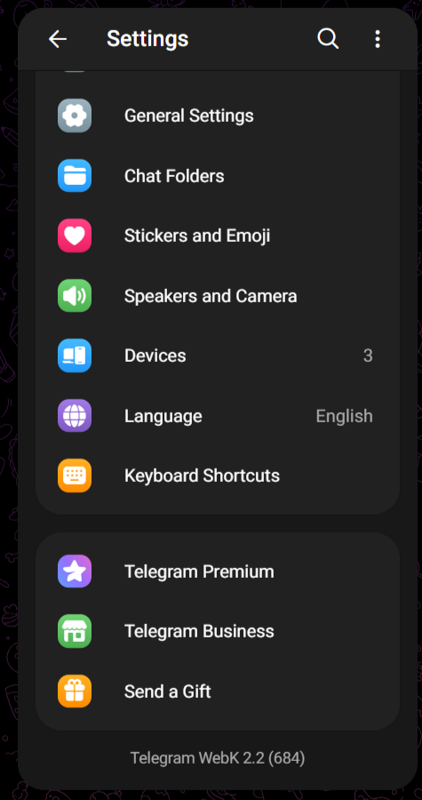
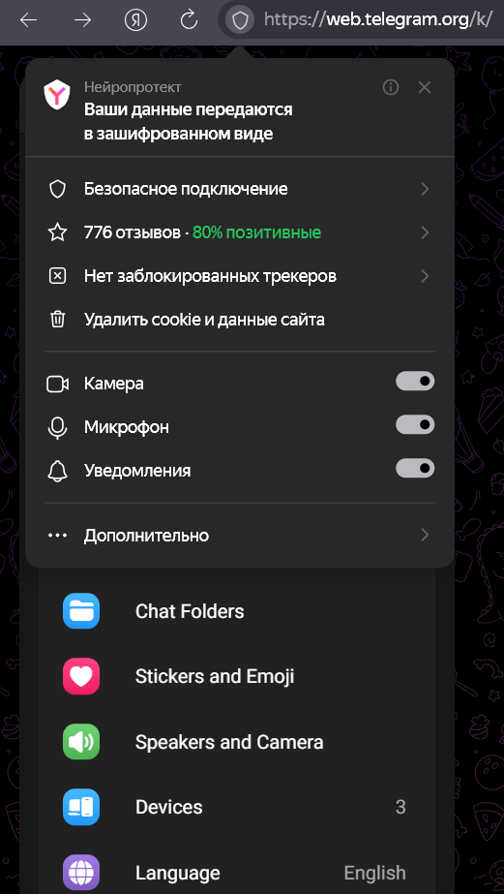
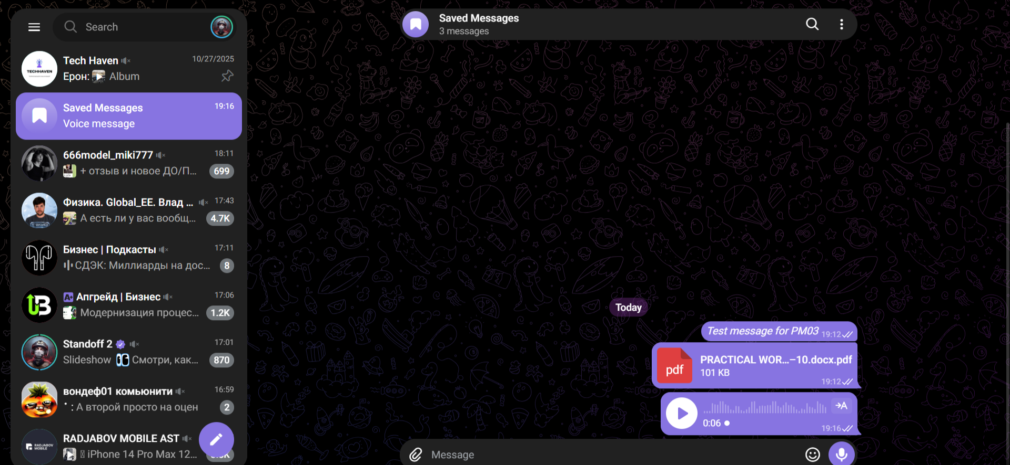

4. Task 3. Database software — MySQL

Software and purpose
MySQL is a free, open-source relational database management system (DBMS) developed by Oracle. It stores data in tables and is managed with the SQL language. MySQL Workbench is the official graphical tool used to connect to the server, write SQL queries and view tables.

System requirements
Parameter | Requirement | This computer
Operating system | 64-bit Windows only | Windows 11, 64-bit
Additional software | Microsoft Visual C++ 2019 Redistributable (installed before the server) | Installed
RAM | No strict official minimum; about 1–2 GB is enough for study databases | 16 GB
Disk space | About 1 GB for the server, Workbench and small databases | 1tb free
Rights and network | Administrator rights for installation; free port 3306 | Port 3306 used by MySQL

Main components
- MySQL Server — the database engine that runs as a Windows service.
- MySQL Configurator — sets up the service, port and root password after installation.
- MySQL Workbench — graphical tool for SQL queries and database design.
- MySQL Command Line Client / MySQL Shell — text tools for running SQL commands.
- Connectors (ODBC, .NET, Java) — drivers that let other programs connect to MySQL.

Installation or verification
MySQL was already installed on the computer, so the installation was verified:
- Opened services.msc and checked that the MySQL service (named like MySQL80 or MySQL84) is in the Running state.
- Opened MySQL Workbench and connected to the local server: host localhost, port 3306, user root.
- Created a test database and a table with the SQL below.
- Ran a SELECT query to verify that the data can be accessed.

SELECT VERSION();

CREATE DATABASE test_db;
USE test_db;

CREATE TABLE students (
id INT AUTO_INCREMENT PRIMARY KEY,
name VARCHAR(50) NOT NULL,
course VARCHAR(10)
);

INSERT INTO students (name, course) VALUES
('Gabit Atazhan', 'PM03'),
('Test Student', 'PM03');

SELECT * FROM students;

Result: SELECT VERSION() showed the server version, and the last query returned 2 rows, so the database was created and can be accessed.
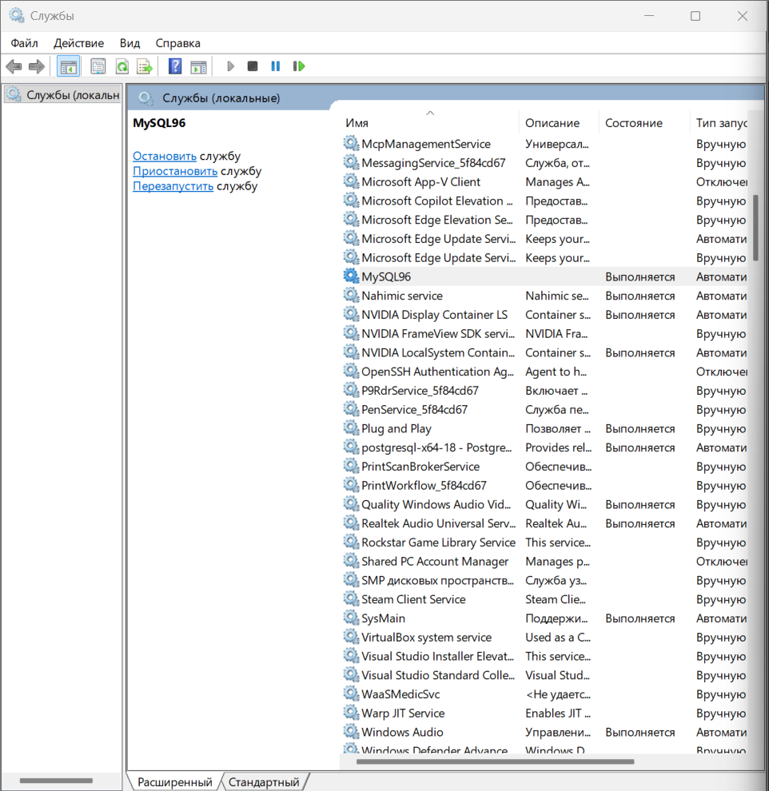
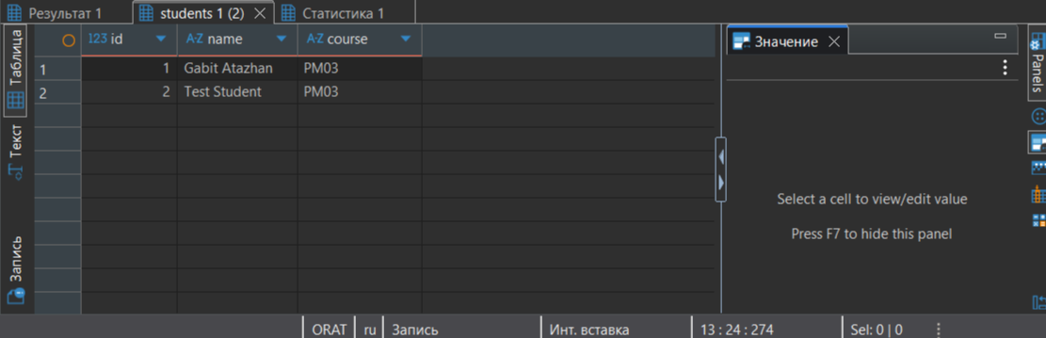

5. Task 4. Application configuration — Microsoft Edge
Edge was chosen because it is the main browser on this computer and is used every day for study. Each change was recorded with its reason.
Setting | Before | After | Reason for the change
Search engine | Bing | Google | More familiar search results for study
Download location | Downloads, saved automatically | Downloads\PM03, ask where to save | Keeps course files in one place and avoids clutter
On startup | Open the new tab page | Open tabs from the previous session | Saves time: study tabs reopen after a restart
Tracking prevention | Balanced | Strict | Blocks more trackers and protects privacy
Sleeping tabs | Off | On | Inactive tabs stop using memory, so the laptop works faster
User profile | One personal profile | Separate "Study" profile | Separates university favourites and history from personal ones

List of all configured settings:
- Microsoft Edge: search engine, download location, startup pages, tracking prevention, sleeping tabs, new Study profile.
- Telegram Web: notifications, muted groups, message preview off, microphone and camera permissions in Edge, profile name and photo, phone number privacy.
- MySQL: local connection in Workbench, test database test_db, table students.

6. Conclusion
In this work three types of application software were checked and configured: a web browser, a communication application and a database system. For each one the version was checked, the purpose and main features were described, and the most important settings were configured and tested.
I learned that correct configuration makes applications safer and more convenient: tracking prevention and privacy settings reduce risks, while notification and download settings make work more organised. Testing after each change, such as opening websites, sending a voice message and running an SQL query, confirmed that every application works correctly.

Sources
- MySQL 8.4 Reference Manual, Installing MySQL on Microsoft Windows — https://dev.mysql.com/doc/refman/8.4/en/windows-installation.html
- Telegram Web — https://web.telegram.org

