Practical Work 7–10: Sorting, Filtering, SQL Queries and JOIN
Oct 29, 2026 · GABIT ATAZHAN

Part 1. Sorting, Filtering and Searching (Topic 7)
All Part 1 operations were done on the Students table (30 records) in University_Database.xlsx. Each result is saved on its own sheet, so the original Students sheet stays unchanged. A group_name column was added to every result sheet with an INDEX/MATCH lookup from the Groups table.
Step | Sheet | How it was done in Excel | Result
1.2 Sort by last name | P1_Sort_LastName | Data → Sort → last_name, A to Z | 30 rows, from Abdrakhmanov to Zhunusov
1.3 Sort by group | P1_Sort_Group | Data → Sort → group_id, then last_name | 30 rows grouped from group 21 to 35
1.4 Filter one group | P1_Filter_Group | Data → Filter → group_id = 22 (IS-24) | 2 students: Serikov, Dosmukhamedov
1.5 Search by ID | P1_Search | INDEX/MATCH on student_id (also Ctrl+F) | 1017 → Adil Dosmukhamedov, group IS-24
1.5 Search by last name | P1_Search | INDEX/MATCH on last_name | Omarova → student 1014, group ECO-25
1.6 Two conditions | P1_Filter_2_Conditions | group_id from 21 to 23 AND birth_date ≥ 2006-01-01 | 3 students: Serikov, Abdrakhmanov, Ibrayeva
Sorting changes only the order of the rows; filtering hides rows that do not match, without deleting them.

Part 2. Introduction to SQL (Topic 8)
The nine tables from University_Database.xlsx were created in SQLite (file university.db) with primary keys, foreign keys and the CHECK constraints from Practical Work 1, then filled with the same data. The full script is University_SQL_Full.sql; the queries alone are in PW7-10_Queries.sql. Our database calls the subjects table Courses, so query 2.4 uses it.
# | Query | Rows returned
2.1 | SELECT * FROM Students; | 30
2.2 | SELECT student_id, first_name, last_name FROM Students; | 30
2.3 | SELECT * FROM Groups; | 15
2.4 | SELECT course_name FROM Courses; | 16

Part 3. SQL Queries and Aggregate Functions (Topic 9)
The database has 30 students in 15 groups (2 per group). The 75 grades range from 53 to 100, with an average of 81.93.
# | Task | Query | Result
3.1 | Students of one group (WHERE) | SELECT * FROM Students WHERE group_id = 21; | 2 rows: Nurlanova, Askarova (IS-23)
3.2 | Alphabetical order (ORDER BY) | SELECT * FROM Students ORDER BY last_name ASC; | 30 rows, first Abdrakhmanov
3.3 | Total students (COUNT) | SELECT COUNT(*) AS total_students FROM Students; | 30
3.4 | Students per group (GROUP BY) | SELECT group_id, COUNT(*) AS student_count FROM Students GROUP BY group_id; | 15 rows, 2 students each
3.5 | Maximum grade (MAX) | SELECT MAX(grade_value) AS max_grade FROM Grades; | 100
3.6 | Minimum grade (MIN) | SELECT MIN(grade_value) AS min_grade FROM Grades; | 53
3.7 | Average grade (AVG) | SELECT ROUND(AVG(grade_value), 2) AS average_grade FROM Grades; | 81.93
The grade column in our Grades table is called grade_value (not grade), so the queries use that name.

Part 4. Joining Tables Using JOIN (Topic 10)
Three JOIN queries were run on four related tables. In our database, Grades is not linked to Students directly: a grade belongs to an enrollment, and the enrollment belongs to a student and a course. So queries 4.2 and 4.3 pass through Enrollments.
# | Tables joined | Result
4.1 | Students + Groups | 30 rows: each student with a group name (for example, Nurlanova — IS-23)
4.2 | Students + Enrollments + Grades | 75 rows: student name, grade_value, grade_date
4.3 | Students + Enrollments + Courses + Grades | 75 rows: student name, course name, grade_value
Query 4.3 (student names, subjects and grades):
SELECT s.first_name, s.last_name, c.course_name, g.grade_value
FROM Students s
INNER JOIN Enrollments e ON s.student_id = e.student_id
INNER JOIN Courses c ON e.course_id = c.course_id
INNER JOIN Grades g ON e.enrollment_id = g.enrollment_id
ORDER BY s.last_name, c.course_name;
Columns that connect the tables (primary key → foreign key):
Join | Primary key | Foreign key
Students → Groups | Groups.group_id | Students.group_id
Students → Enrollments | Students.student_id | Enrollments.student_id
Enrollments → Courses | Courses.course_id | Enrollments.course_id
Enrollments → Grades | Enrollments.enrollment_id | Grades.enrollment_id
Comparison with the original tables. In the Students table the group is only a number (group_id = 21); after the JOIN the result shows the readable group name IS-23. The Enrollments table has 90 rows, but the INNER JOIN with Grades returns 75, because 15 enrollments have no grade yet (14 current courses and 1 dropped course). A LEFT JOIN returns all 90 enrollments and shows NULL in grade_value for these 15 (query 4.4).

Individual Assignment: Answers
- What is the difference between sorting and filtering? Sorting changes the order of all rows (for example, A→Z by last_name) but shows every record. Filtering shows only the rows that meet a condition (for example, group_id = 22) and hides the rest without deleting them.
- What is SQL used for? SQL (Structured Query Language) is used to create database tables and to add, change, delete and retrieve data from them. With one query it can search, sort, count and combine thousands of records.
- What is the difference between WHERE and ORDER BY? WHERE chooses which rows are returned (WHERE group_id = 21 returns 2 of 30 students). ORDER BY does not remove rows; it only sets their order (ORDER BY last_name ASC).
- Why do we use GROUP BY and aggregate functions? Aggregate functions (COUNT, MAX, MIN, AVG, SUM) turn many rows into one summary value, such as an average grade of 81.93. GROUP BY calculates that value separately for each group, such as the number of students in every group.
- What is the purpose of JOIN? JOIN combines rows from related tables through matching key columns. It lets one query show data stored in different tables, such as a student's name, course name and grade.
- What is the difference between INNER JOIN and LEFT JOIN? INNER JOIN returns only rows that have a match in both tables: 75 enrollments with grades. LEFT JOIN returns all rows of the left table, and NULL where there is no match: all 90 enrollments, 15 of them without a grade.

Screenshots

Query 2.1 — All records from the Students table

Query 2.2 — Student IDs, first names and last names
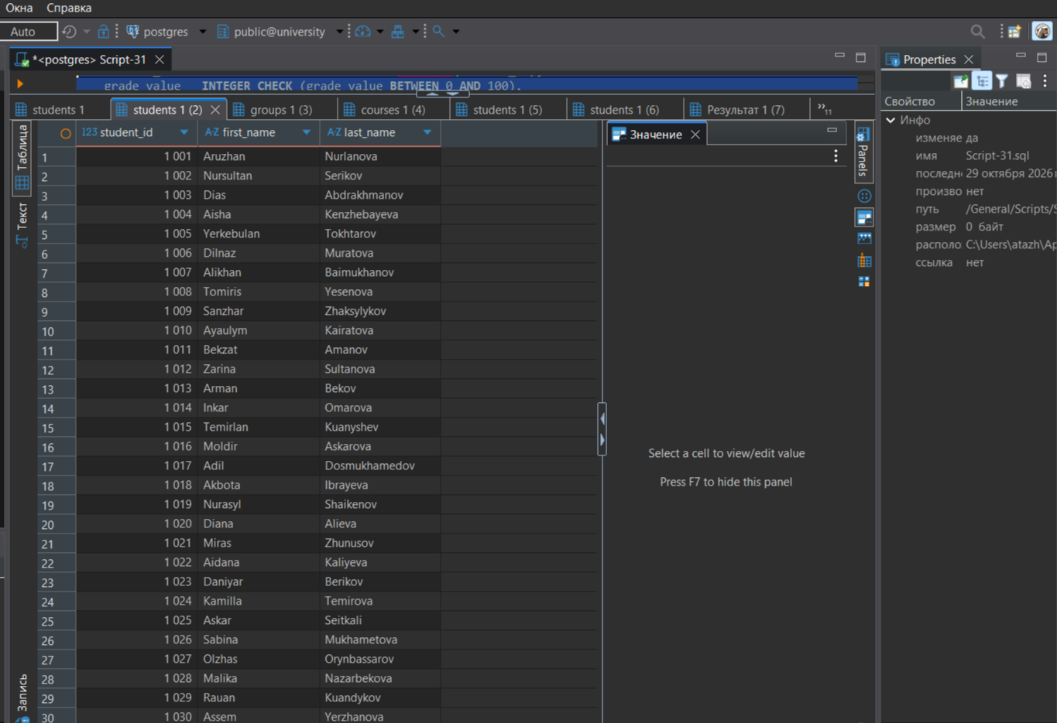

Query 2.3 — All records from the Groups table
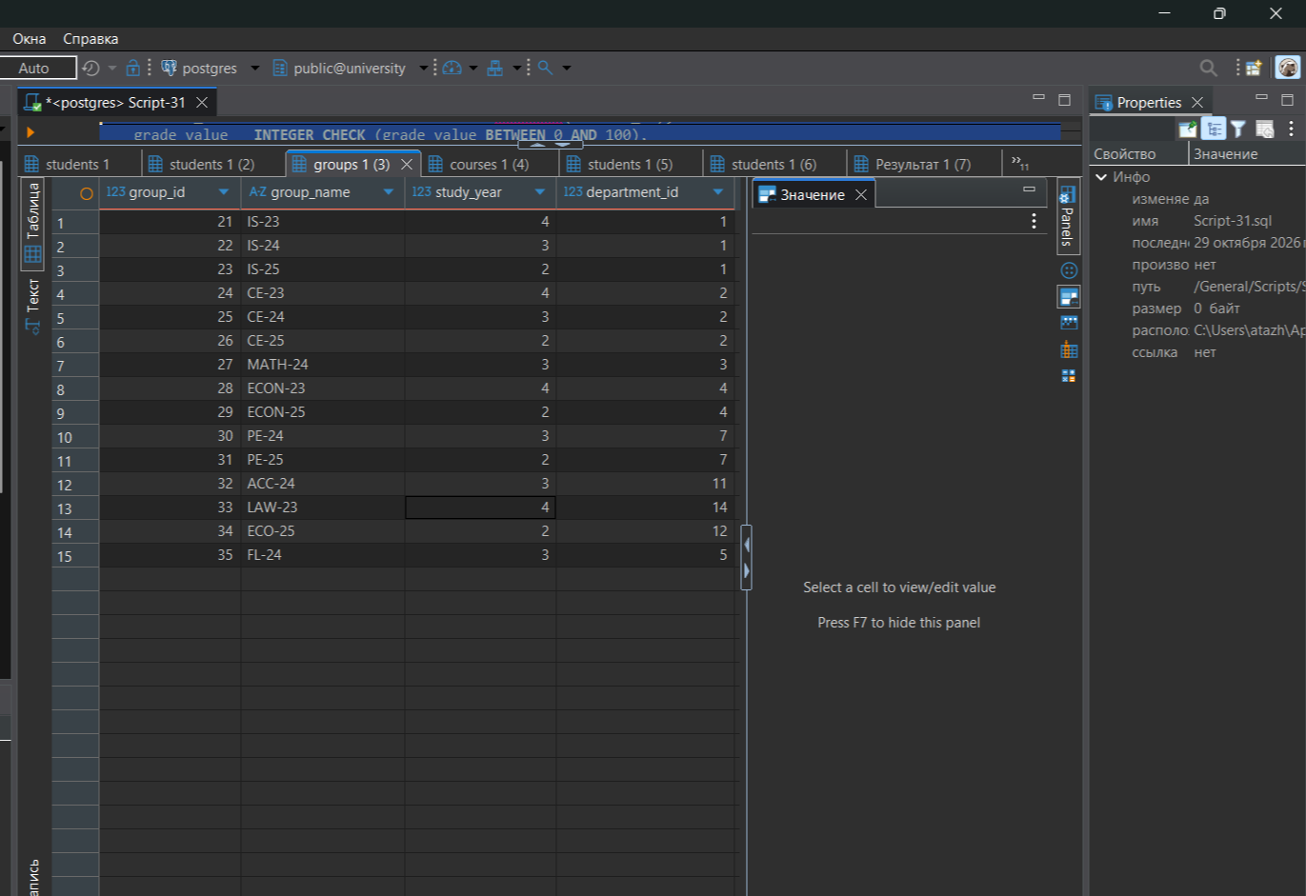
Query 2.4 — Names of all subjects (Courses table)


Query 3.1 — Students of group 21 (WHERE)

Query 3.2 — Students in alphabetical order (ORDER BY)


Query 3.3 — Total number of students (COUNT)

Query 3.4 — Number of students in each group (GROUP BY)


Query 3.5 — Maximum grade (MAX)

Query 3.6 — Minimum grade (MIN)


Query 3.7 — Average grade (AVG)

Query 4.1 — Students with group names (Students JOIN Groups)

Query 4.2 — Students and their grades (Students JOIN Enrollments JOIN Grades)


Query 4.3 — Student names, subjects and grades (JOIN of four tables)
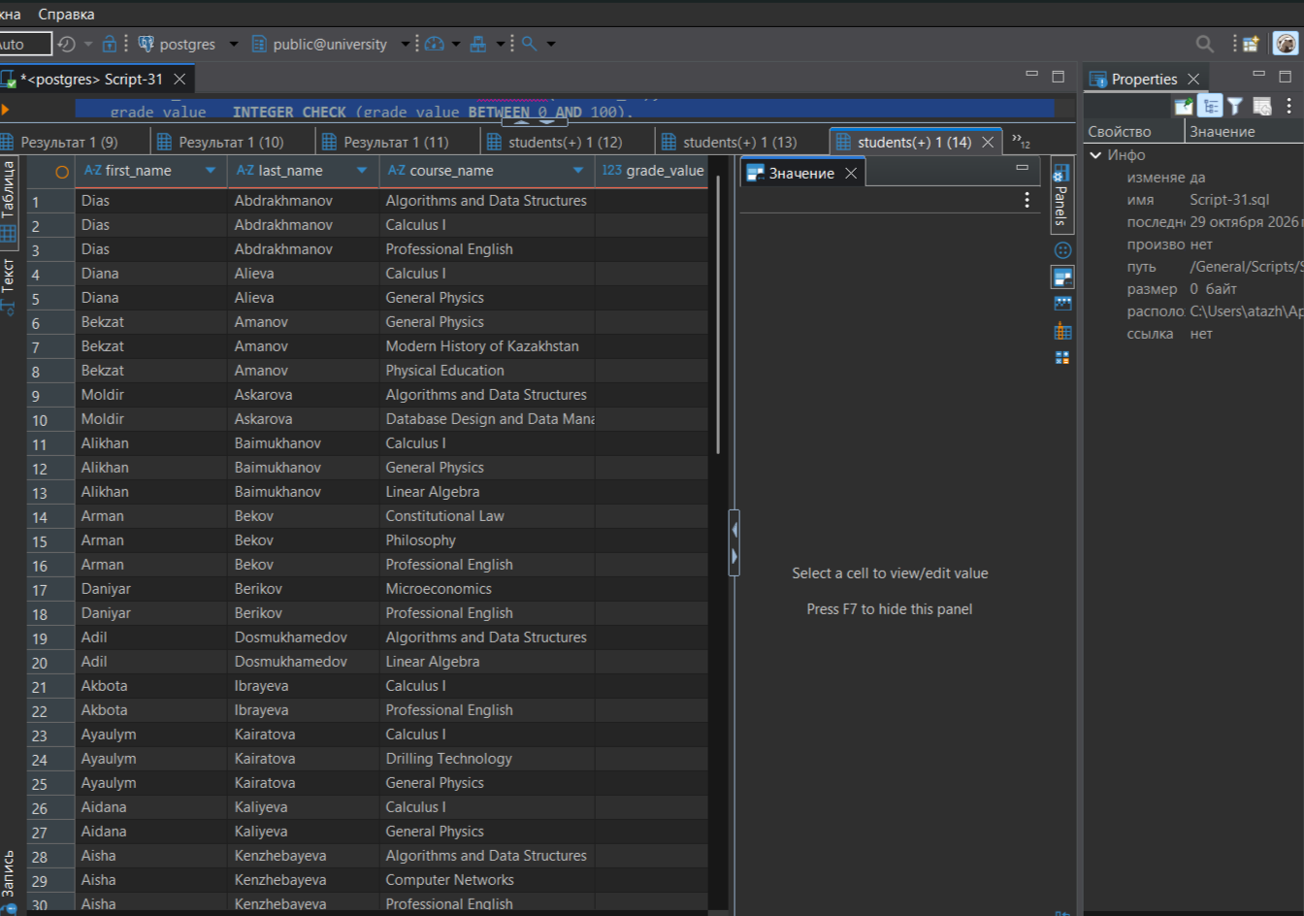
Query 4.4 — Enrollments without grades (LEFT JOIN)
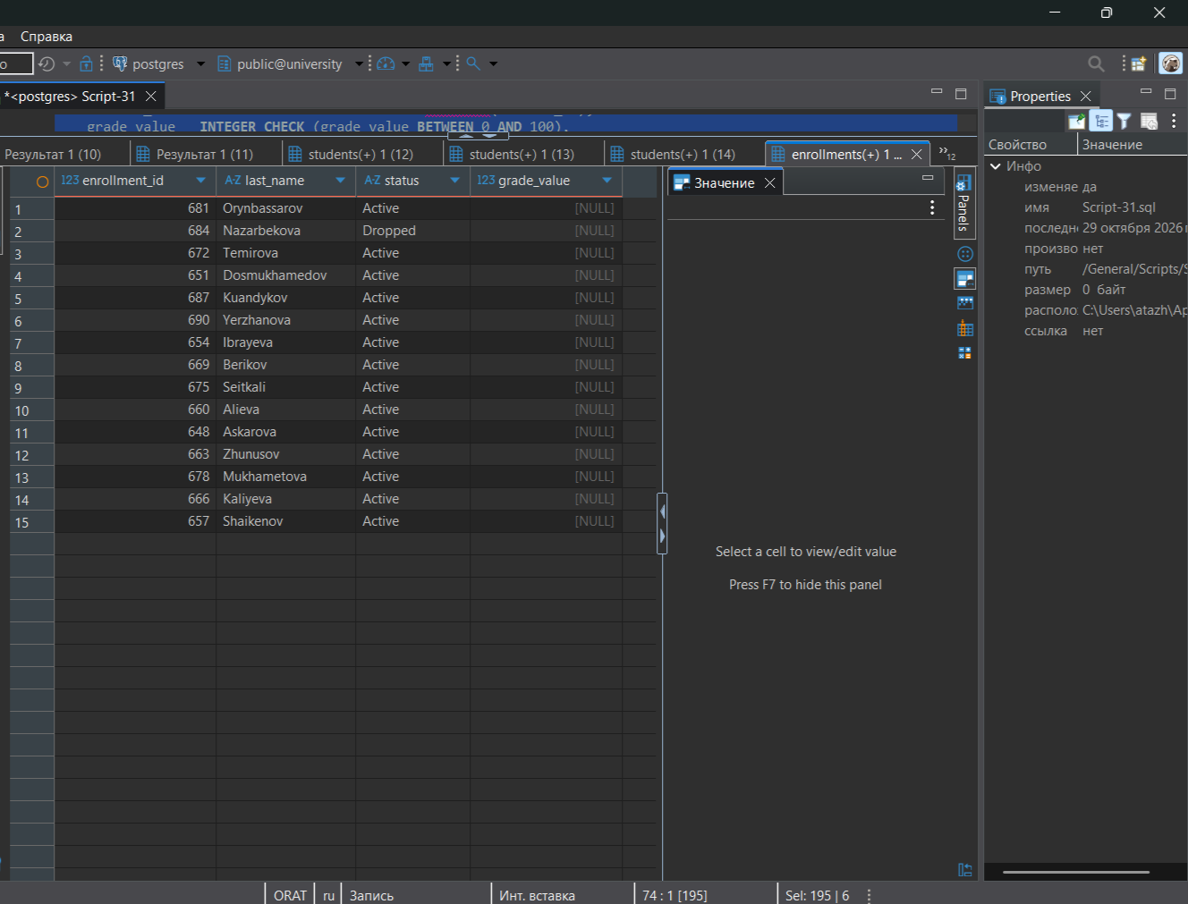
Query 4.5 — Row counts: original tables vs INNER JOIN and LEFT JOIN


Part 1.2 — Students sorted alphabetically by last name
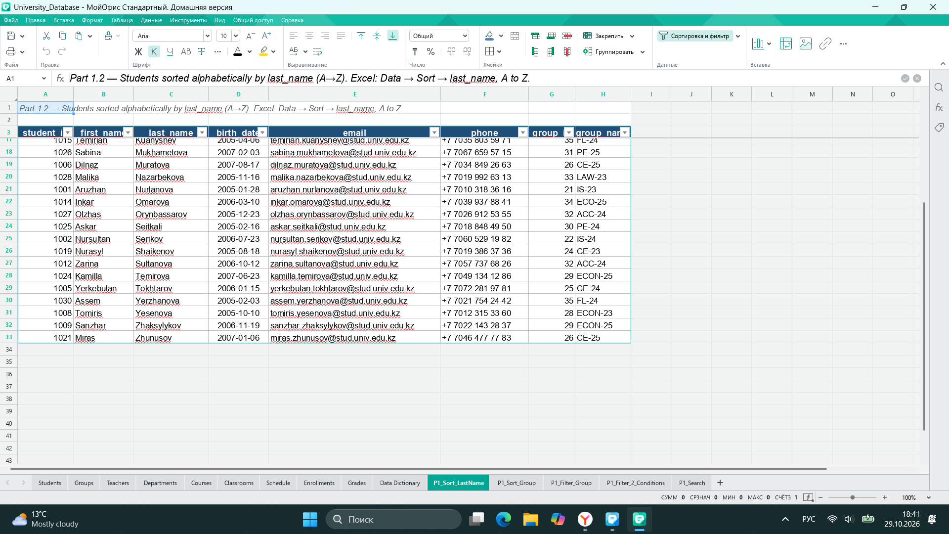
Part 1.3 — Students sorted by group
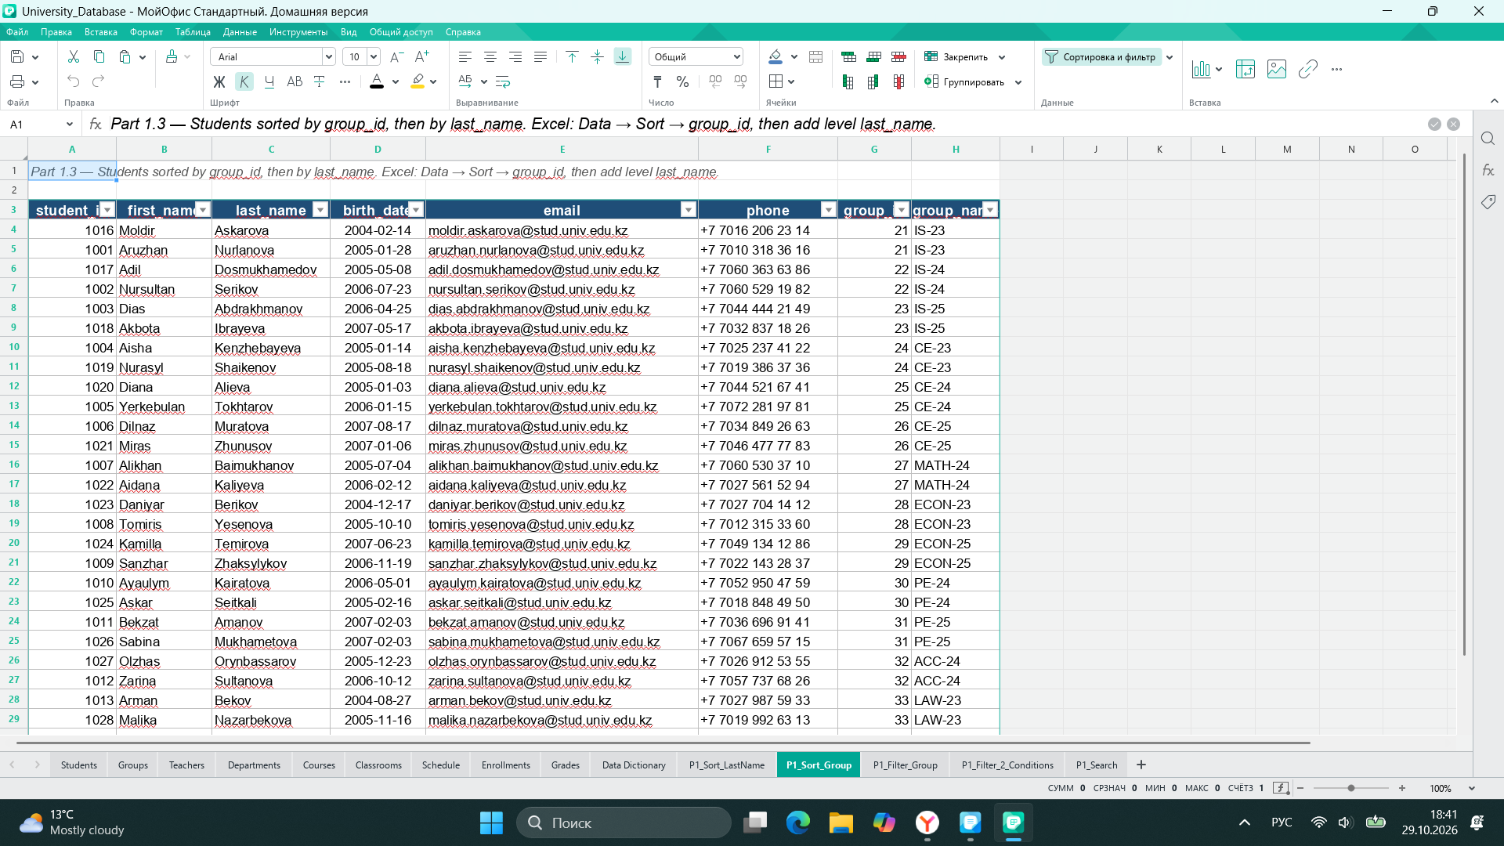
Part 1.4 — Filter: students of group 22 (IS-24)
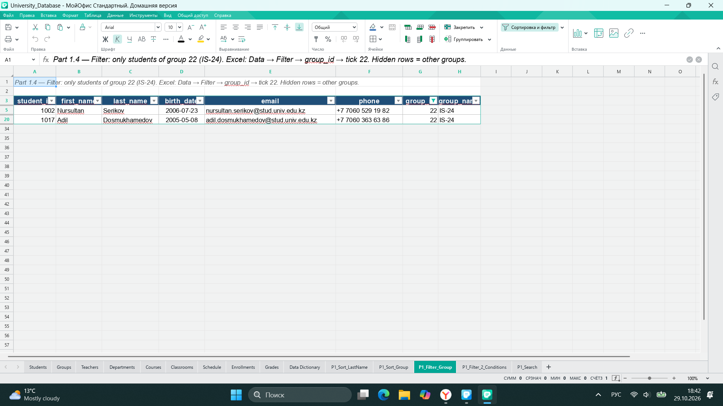
Part 1.5 — Search for a student by ID and by last name
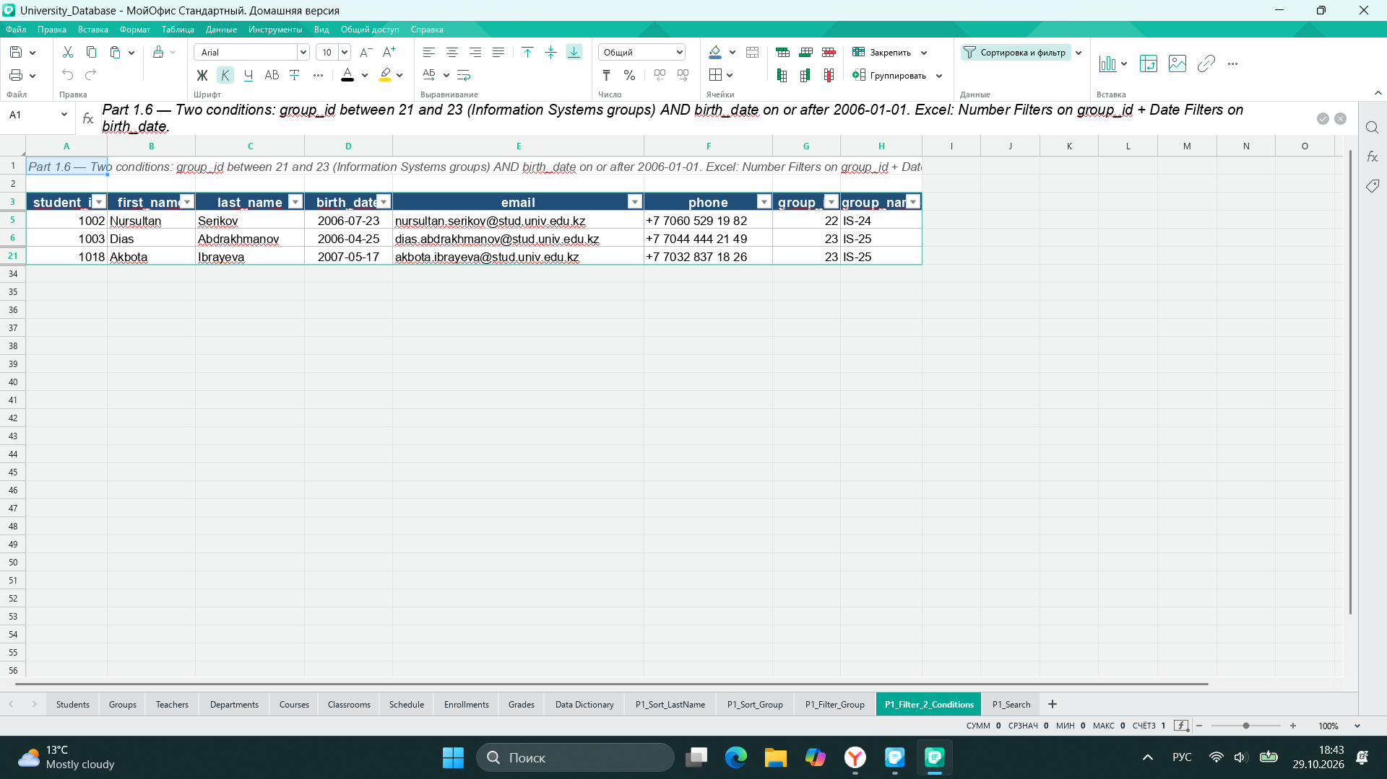
Part 1.6 — Filter with two conditions (group 21–23 and birth date from 2006)
