Data Analytics & Visualization — Take-Home Examination
Analytical Report: Pima Indians Diabetes Dataset (DS17)
Alabyekkubo Ssuubi Brian | Student No. 2500726334 | Dataset DS17

Introduction
This report analyses the Pima Indians Diabetes Database, a clinical dataset of 768 female patients of Pima Indian heritage, aged 21 and older, sourced from the UCI Machine Learning Repository via Kaggle (Smith et al., 1988). Each record contains eight diagnostic measurements (such as glucose, blood pressure, BMI, and insulin) and a binary Outcome indicating whether the patient developed diabetes within five years. The three main analytical questions investigated here are: (1) which diagnostic variables most strongly distinguish diabetic from non-diabetic patients; (2) how these variables relate to one another; and (3) what data-quality issues affect the reliability of the analysis.

Methodology
All analysis was performed in Python using pandas, NumPy, Matplotlib, Seaborn, SciPy, and scikit-learn within a single reproducible Jupyter notebook. Exploratory analysis first revealed that five columns (Glucose, BloodPressure, SkinThickness, Insulin, BMI) used the placeholder value 0 to represent missing measurements, since these values are physiologically impossible. These zeros were recoded as missing and imputed using the median, computed separately within each Outcome group, to preserve class-conditional distributions and remain robust to skew. Outliers in Insulin and BMI, identified via the IQR method, were capped (Winsorized) rather than removed, to retain clinically meaningful extreme cases. Categorical and ordinal encodings and two engineered features (a Glucose-to-Insulin ratio and binned Age Group) were added to support the visual and statistical analysis that followed.

Key Findings
Glucose emerged as the single strongest discriminator between diabetic and non-diabetic patients. Figure 2 shows diabetic patients have a markedly higher median glucose (~140 mg/dL) than non-diabetic patients (~108 mg/dL) with minimal overlap between interquartile ranges, a difference confirmed as highly statistically significant by a Welch's t-test (t ≈ -15.0, p < 0.001). The correlation heatmap (Figure 7) identified SkinThickness-BMI (r ≈ 0.57) and Pregnancies-Age (r ≈ 0.54) as the strongest positive relationships, both physiologically expected: skinfold thickness and BMI are two measures of the same underlying adiposity construct, while pregnancy count naturally accumulates with age. No strong negative correlations were found among the numerical variables, consistent with them broadly reflecting shared metabolic health rather than trade-offs. The BMI-Glucose scatter plot (Figure 5) showed a modest but statistically significant positive relationship (r ≈ 0.22, p < 0.001), reinforcing the clinical link between adiposity and glucose regulation without implying BMI alone drives glucose levels. The radar chart (Figure 13) demonstrated that the diabetic cohort's mean profile is elevated across every measured variable, not glucose alone, with the largest relative gaps in glucose and pregnancy count. Finally, the missing-value analysis (Section A3) showed that Insulin (48.7% missing) and SkinThickness (29.6% missing) were the most affected variables, likely reflecting that these tests are ordered less routinely than basic vitals — a data-quality issue of Missing Not At Random (MNAR) character that shaped the group-aware imputation strategy used throughout the cleaning pipeline.

Conclusion and Limitations
This analysis confirms glucose, BMI, and insulin as the most informative variables for distinguishing diabetes outcome in this cohort, with glucose being the dominant single predictor. Two key limitations should be noted. First, 48.7% of Insulin values and 29.6% of SkinThickness values were originally missing and required imputation; because imputed values were set to the group median rather than observed measurements, any correlation or effect size involving these two variables (including the Glucose-Insulin correlation reported above) is somewhat compressed toward the group average and should be treated as a conservative, not exact, estimate. Second, the dataset is drawn from a single, demographically narrow population of 768 adult female patients of Pima Indian heritage, so the specific thresholds identified here (e.g. the ~140 mg/dL vs ~108 mg/dL glucose split) should not be assumed to generalize to other sexes, age ranges, or ethnic groups without independent validation. A natural direction for future work would be to build and validate a predictive classification model using stratified sampling to address the roughly 65:35 class imbalance, and to compare its performance against simple threshold-based screening on glucose alone.

Embedded Figures
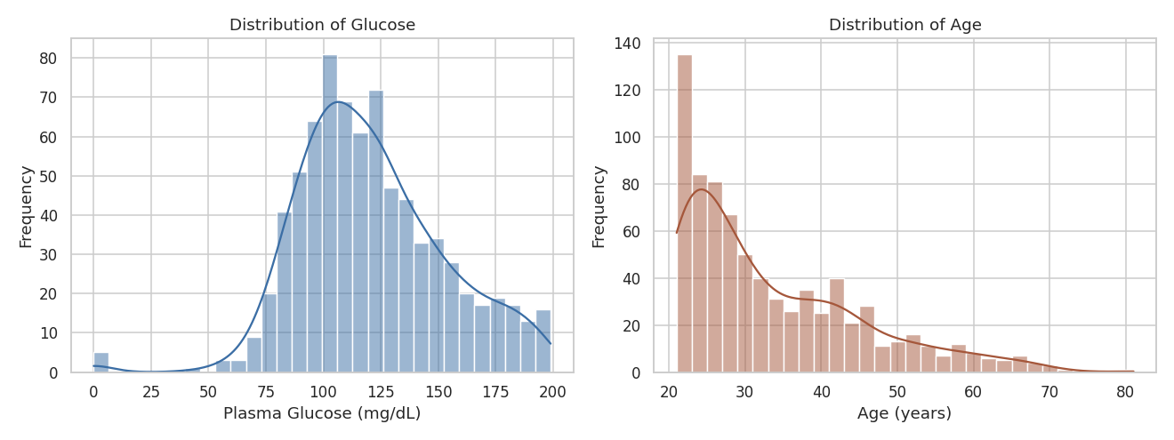
Figure 1: Distribution of Glucose and Age across all 768 patients, with KDE overlay. Age is strongly right-skewed toward younger adults.
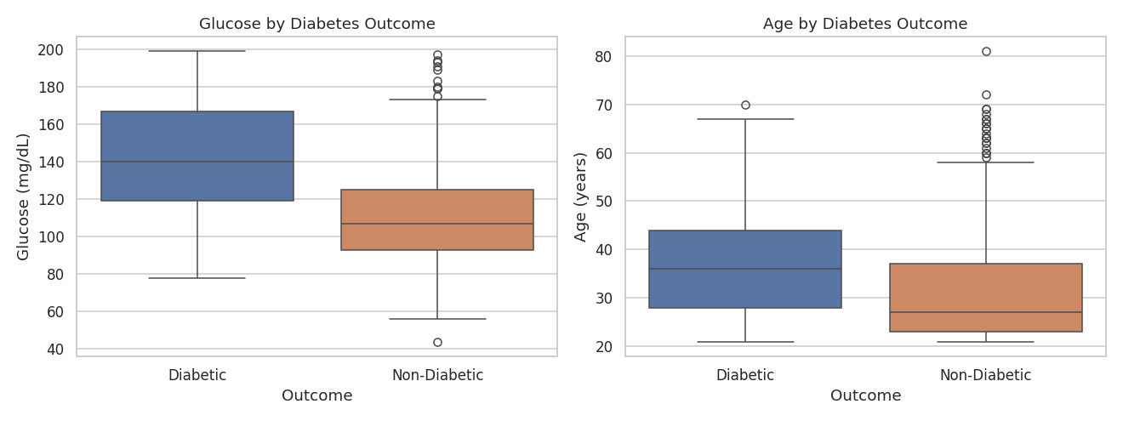
Figure 2: Glucose and Age distributions grouped by diabetes Outcome. Glucose shows minimal interquartile overlap between groups.
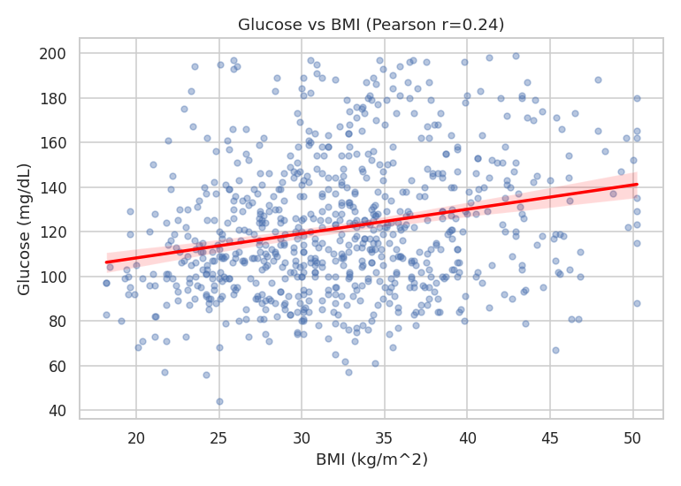
Figure 5: Scatter plot of Glucose vs BMI with linear regression line (Pearson r ≈ 0.22, p < 0.001).
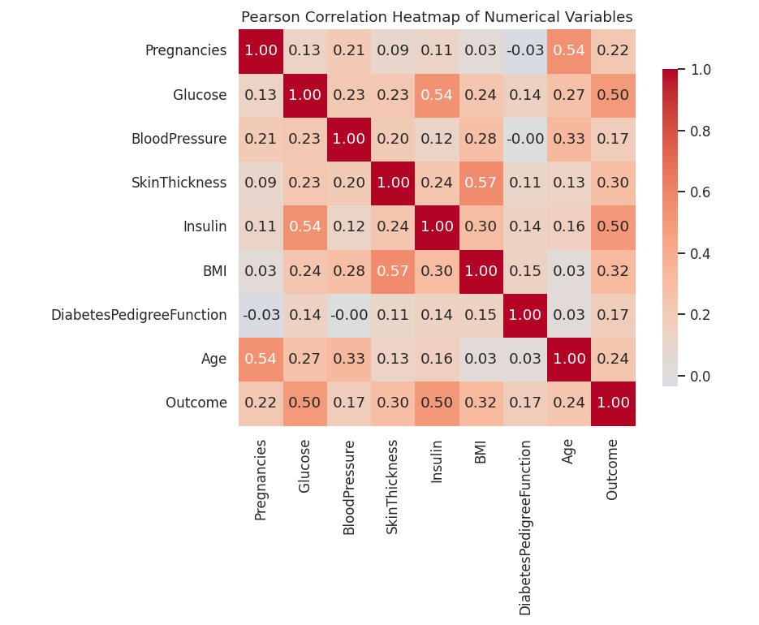
Figure 7: Pearson correlation heatmap of all numerical variables and Outcome, annotated with coefficients.
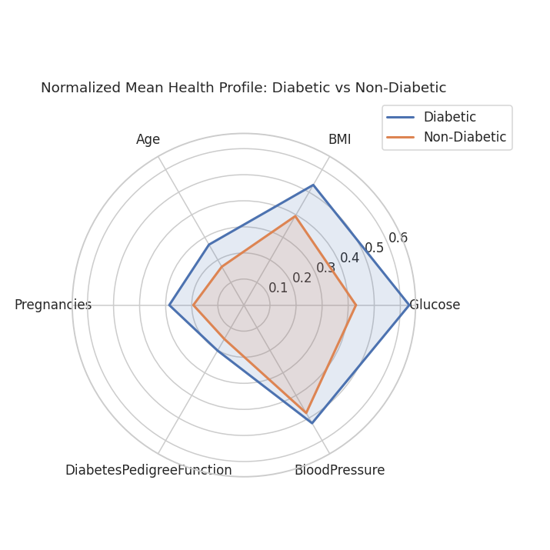
Figure 13: Normalized mean health profile (Glucose, BMI, Age, Pregnancies, DiabetesPedigreeFunction, BloodPressure) for diabetic vs non-diabetic patients.

