Instructor: Dr. Craig W. Slinkman

Office: COBA 532

|  |  |
| --- | --- |
| My office hours will be held in the Central Library on the second floor of the library. Mu location will be on the south side of the library. This is the side of the library that is closest to Mitchel Street.  In addition, office hours are available by appointment. | |
| Office Hours  |  |  |  | | --- | --- | --- | | Day | Time | Location | | Monday | 8:30 – 9.50  19:00 – 21:30 | BA 532  Library | | Tuesday | 19:00 – 21:30 | Library | | Wednesday | 8:30—9:50  19:00 – 21:30 | BA 532  Library | | Friday | 8:30 – 21:30 | BA-532 | |  |
|  |  |

### Course description

**BSTAT 3321. BUSINESS STATISTICS I. 3 Hours.**

Application of statistical techniques to business and economic data. Descriptive statistics, probability distributions, estimation, inference, regression, correlation, and time series. Prerequisite: MATH 1316 or other calculus course.

### Time and Place of Class Meetings

|  |  |  |  |
| --- | --- | --- | --- |
| **Meeting Information** | | | |
| **Days & Times** | **Room** | **Instructor** | **Meeting Dates** |
| MoWeFr 1:00PM - 1:50PM | COBA349 | Craig W Slinkman | 01/19/2016 - 05/06/2016 |

### COURSE OBJECTIVE

The course introduces the student to the basic principles and applications of descriptive and inferential statistics. The course assists students to become knowledgeable consumers of statistical analysis, its applications and limitations.

### Grading

|  |  |
| --- | --- |
| **Requirement** | **Percent** |
| Quizzes 8 at 10 points per quiz | 70 |
| Final Exam | 30 |
| Total | 100 |

1. To learn data analysis and applied statistics you must do applied statistics.
2. There are five homework assignments.
3. The homework with the minimum grade will be dropped.
4. The final homework which will be collected during final week counts twice.
5. A homework may have a potential bonus question which will add points to your homework score.
6. Since there are 5 homework assignments and one will be dropped and the final homework counts twice, then there are 4 possible grades. Each homework counts 100 points so there are 500 possible homework points. The homework counts 10% of your grade.
7. Class attendance will be taken and constitutes 10% of your grade. One unexcused absence is allowed. Anyone who arrives after the first 10 minutes will be given an unexcused absence. The US Department of Education now requires this because of fraudulent student loans. So if I have to carry out this task I might as well count it in your grade. If you must miss a class you need to tell me prior to missing the class.
8. If you come to class and get up and leave and do not return this counts a missed class.
9. There are three two exam plus a final exam. The exams are count 80% of your grade. The exams during the semester are worth 25% of your grade and the final exam is worth 30% of the grade.

## Letter grades



**Textbook**

The text book is shown on the next page. You need not purchase. If you wish to purchase the book I would suggest you get the Kindle edition.

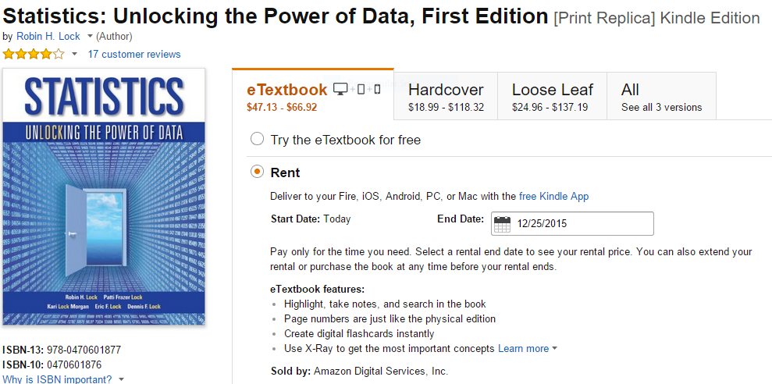

You can purchase the book [here](http://www.amazon.com/Statistics-Unlocking-Power-Data-First-ebook/dp/B00AZP83CC/ref=sr_1_1?s=books&ie=UTF8&qid=1440694506&sr=1-1&keywords=statistics+unlocking+the+power+of+data+kindle). I would recommend the Kindle edition.

**Web Resources**

|  |  |
| --- | --- |
| **Resource** | **Html** |
| Basic statistics notes | <https://github.com/utaSlinkman/BusinessStatistics> |
| Data | <https://github.com/utaSlinkman/utaStatisticsData> |

### Tentative Class Schedule

|  |  |  |
| --- | --- | --- |
| Date | Topic | Notes |
| 1/20/2016 | Data and Statistics | 01-Data and statistics |
| 1/22/2016 | Data and Statistics | 01-Data and statistics |
|  |  |  |
| 1/25/2016 | **Quiz 1** |  |
| 1/27/2016 | Summarizing and presenting data  Data collection and summarization | 02-Data collection and summarization  03-Data collection and summarization |
| 1/29/2016 | Data collection and summarization | 03-Data collection and summarization |
|  |  |  |
| 2/1/2016 | Data collection and summarization | 03-Data collection and summarization |
| 2/3/2016 | Confidence intervals | 04-Confidence intervals |
| 2/5/2016 | **Quiz 2** | 03-Data collection and summarization |
|  |  |  |
| 2/8/2016 | Confidence intervals | 04-Confidence intervals |
| 2/10/2016 | Confidence intervals | 04-Confidence intervals |
| 2/12/2016 | Hypothesis tests | 05-Hypothesis tests |
|  |  |  |
| 2/15/2016 | **Quiz 3** | 04-Confidence intervals |
| 2/17/2016 | Hypothesis tests | 05-Hypothesis tests |
| 2/19/2016 | Hypothesis tests | 05-Hypothesis tests |
|  |  |  |
| 2/22/2016 | Hypothesis tests | 05-Hypothesis tests |
| 2/24/2016 | Theoretical distributions | 07-Theoretical distributions |
| 2/26/2016 | **Quiz 4** | 05-Hypothesis tests |
|  |  |  |
| 2/29/2016 | Theoretical distribution | 07-Theoretcal distributions |
| 3/2/2016 | Classical statistical inference | Single population inference for proportions |
| 3/4/2016 | **Quiz 5** | Theoretical distributions |
|  |  |  |
| 3/7/2016 | Classical statistical inference | Single population hypothesis tests |
| 3/9/2016 | Classical statistical inference | Single population hypothesis tests |
| 3/11/2016 | **Quiz 6** | Single populations proportion |
|  |  |  |
| 3/14/2016 | Spring vacation |  |
| 3/16/2016 | Spring vacation |  |
| 3/18/2016 | Spring vacation |  |
|  |  |  |
| 3/21/2016 | Classical statistical inference | Single population mean |
| 3/23/2016 | Classical statistical inference | Single population mean |
| 3/25/2016 | Single populations proportion | Single population means |
|  |  |  |
| 3/28/2016 | **Quiz 7** | Single population mean |
| 3/30/2016 | Classical statistical inference | Difference in proportions |
| 4/1/2016 | Classical statistical inference | Difference in proportions |
|  |  |  |
| 4/4/2016 | Classical statistical inference | Difference in population means |
| 4/6/2016 | **Quiz 8** | Difference in population proportions |
| 4/8/2016 | Classical statistical inference | Difference in population means |
|  |  |  |
| 4/11/2016 | Classical statistical inference | Difference in population means |
| 4/13/2016 | Simple linear regression | Not yet posted |
| 4/15/2016 | **Quiz 9** | Difference in population means |
|  |  |  |
| 4/18/2016 | Simple linear regression | Not yet posted |
| 4/20/2016 | Simple linear regression | Not yet posted |
| 4/22/2016 | Logistic regression | Not yet posted |
|  |  |  |
| 4/25/2016 | **Quiz 10** | Simple linear regression |
| 4/27/2016 | Slack |  |
| 4/29/2016 | Slack |  |
|  |  |  |
| 5/2/2016 | Review |  |