Name: Atchaya S EX NO: 1
Roll No: 25BAD016 Date: 17/07/26
Slot: A 10
Experiment: Implementation of Linear Search Using Array ADT
AIM:
To write a C program to implement Linear Search using an array and find the index of a given element.
PSEUDO CODE:
- Start.
- Read the number of elements n.
- Read n array elements.
- Read the element to be searched (e).
- Initialize flag = 0.
- Traverse the array from i = 0 to n - 1.
- If arr[i] == e:
- Store i in index.
- Set flag = 1.
- Break the loop.
- If flag == 1, display the index.
- Otherwise, display "Element not found".
- Stop.

CODE:
#include <stdio.h>
int main() {
int n;
printf("Enter the number of elements: ");
scanf("%d", &n);
int arr[n];
printf("Enter array elements: ");
for(int i = 0; i < n; i++) {
scanf("%d", &arr[i]);
}
int e;
printf("Enter an element to be found: ");
scanf("%d", &e);
int flag = 0;
int index;
for(int i = 0; i < n; i++) {
if(arr[i] == e) {
index = i;
flag = 1;
break;
}
}
if(flag == 1)
printf("Element found at index %d", index);
else
printf("Element not found");
return 0;
}
OUTPUT:
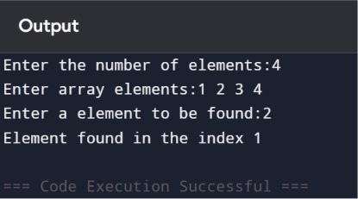
RESULT:
Thus, the C program to implement Linear Search using an array was executed successfully, and the required element was found and its index displayed.

Experiment: Implementation of Binary Search Using Array ADT
AIM:
To write a C program to implement Binary Search using an array and find the index of a given element.
Pseudo Code:
- Start.
- Read the number of elements n.
- Read the sorted array elements.
- Read the element to be searched (e).
- Initialize low = 0 and high = n - 1.
- Repeat while low <= high:
- Calculate mid = (low + high) / 2.
- If a[mid] == e, print the index (mid) and stop.
- If e < a[mid], set high = mid - 1.
- Otherwise, set low = mid + 1.
- If the element is not found, print "Element Not Found".
- Stop.
CODE:
#include <stdio.h>
int main()
{
int n;
int low, high, mid;
int e;
printf("Enter the number of elements: ");
scanf("%d", &n);
int a[n];
printf("Enter the array elements (sorted): ");
for(int i = 0; i < n; i++)
{
scanf("%d", &a[i]);
}

printf("Enter the element to be searched: ");
scanf("%d", &e);
low = 0;
high = n - 1;
while(low <= high)
{
mid = (low + high) / 2;
if(e == a[mid])
{
printf("Element Found at index %d", mid);
return 0;
}
else if(e < a[mid])
{
high = mid - 1;
}
else
{
low = mid + 1;
}
}
printf("Element not found");
return 0;
}

OUTPUT:

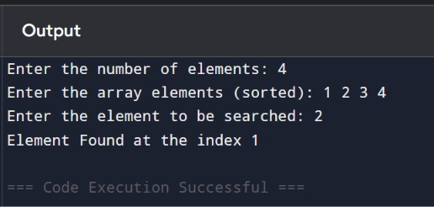

RESULT:
Thus, the C program to implement Binary Search using an array was executed successfully, and the required element was found and its index was displayed.

Experiment: Implementation of List Using Array ADT (Insert, Delete, Update)
AIM:
To write a C program to implement a List using Array ADT and perform Insert, Delete, and Update operations.
PSEUDO CODE:
- Start.
- Read the number of elements n.
- Read the array elements.
- Display a menu:
- Insert
- Delete
- Update
- Read the user's choice.
- Perform the selected operation:
- Insert: Read position and element, shift elements to the right, and insert the new element.
- Delete: Read position, shift elements to the left, and delete the element.
- Update: Read position and new value, replace the existing element.
- Display the updated list.
- Stop.
CODE:
#include <stdio.h>
int main()
{
int a[100], n, i, choice, pos, value;
printf("Enter number of elements: ");
scanf("%d", &n);
printf("Enter elements:\n");
for(i = 0; i < n; i++)
scanf("%d", &a[i]);
printf("\n1.Insert\n2.Delete\n3.Update\n");
printf("Enter your choice: ");
scanf("%d", &choice);
switch(choice)
{
case 1:
printf("Enter position and value: ");
scanf("%d%d", &pos, &value);
for(i = n; i > pos; i--)
a[i] = a[i - 1];
a[pos] = value;
n++;
break;
case 2:
printf("Enter position to delete: ");
scanf("%d", &pos);
for(i = pos; i < n - 1; i++)
a[i] = a[i + 1];

n--;
break;
case 3:
printf("Enter position and new value: ");
scanf("%d%d", &pos, &value);
a[pos] = value;
break;
default:
printf("Invalid Choice");
return 0;
}
printf("Updated List: ");
for(i = 0; i < n; i++)
printf("%d ", a[i]);
return 0;
}
OUTPUT:
FOR INSERT:
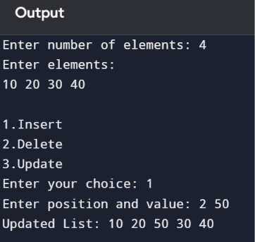

FOR DELETE:
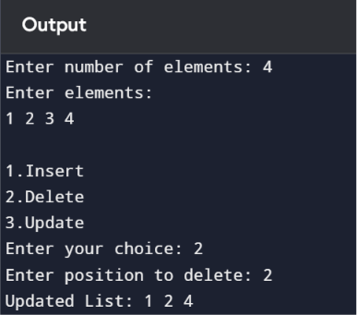
FOR UPDATE:
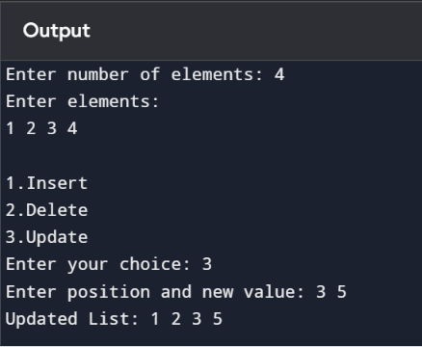
RESULT:
Thus, the C program to implement a List using Array ADT with Insert, Delete, and Update operations was executed successfully.

