Department of computer science Engineering

Course code – CS257

Database and Information System

MINOR PROJECT

MESS MANAGEMENT

SYSTEM

ATCHE SRAVYA - 170001013

B RUSHYA SREE REDDY - 170001014

PROJECT REPORT –

A database in the most general case is an organised collection of data. Now a days these are widely used in every field.

One of it ’s best use is in the MESS MANAGEMENT SYSTEM in hostels, offices etc… The main aim behind this minor project is to manage details regarding the student info, employee info, stock details, mess menu,

coupons bought by students etc… It will have a positive impact on the mess proceeding, making it more organised. Amount of food wasted will decrease as the mess staff will have a prior estimate of the student count.

BACK END -

The database includes the entity sets -

-> Student info

Attributes : student_id ,

student_name, password ,

date_of_birth , room_no ,

block_name , wallet_money

- Stores the details of the

students who are registered for

the mess

-> Employee details

Attributes : Emp_id , first_name , last_name , designation_id , date_of_birth , email_id , hire_date , no_of_leaves , house_no , street_no , street_name , city , state , pincode , gross_salary

* Stores the details of the employees

who work in the mess

-> Admin details

Attributes : admin_id , password

* Stores the details of the employee who can perform the following functionalities -

- View student details

- Register and deregister a

Student

- view employee details

- Register and remove an

Employee

- View and update job details

- View and update mess menu

- Get info of the coupons bought

and used by students

- View and update stock details

-> Designation details

Attributes : designation_id , job , working_days , salary

* Stores the available job details

-> Mess Menu

Attributes : meal_courses_offered , cost , Monday , Tuesday , Wednesday , Thursday , Friday , Saturday , sunday

- Stores info regarding the food items

served

-> Coupons registered

Attributes : student_id , date , breakfast , used_breakfast , b_used_time , lunch , used_ lunch , l_used_time , high_tea , used_ high_tea , h_used_time , dinner , used_dinner , d_used_time

- Stores the info of coupons bought

by students

- Stores the info about every

particular coupon used by student

at a particular time, on a

particular day

-> New stock details

Attributes : item_name cost_per_unit , unit , quantity_bought , date

- stores the details of the stock that

is newly bought

-> Used stock details

Attributes : item_name , unit ,

item_used ,

quantity_left,date

- stores the details of the stock that

is used daily

ER DIAGRAM

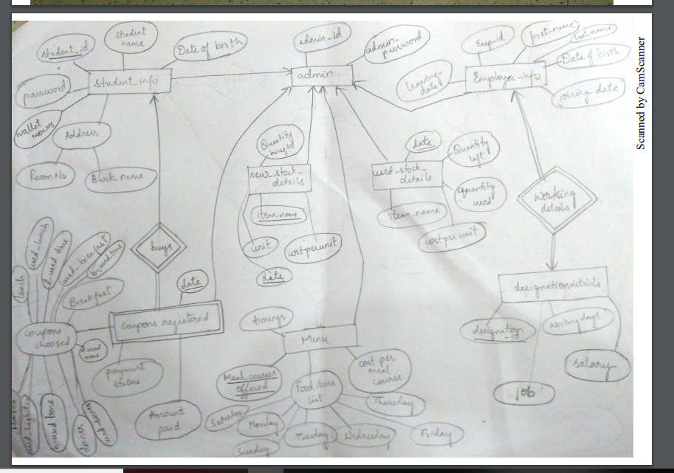

USER INTERFACE

1. Login page

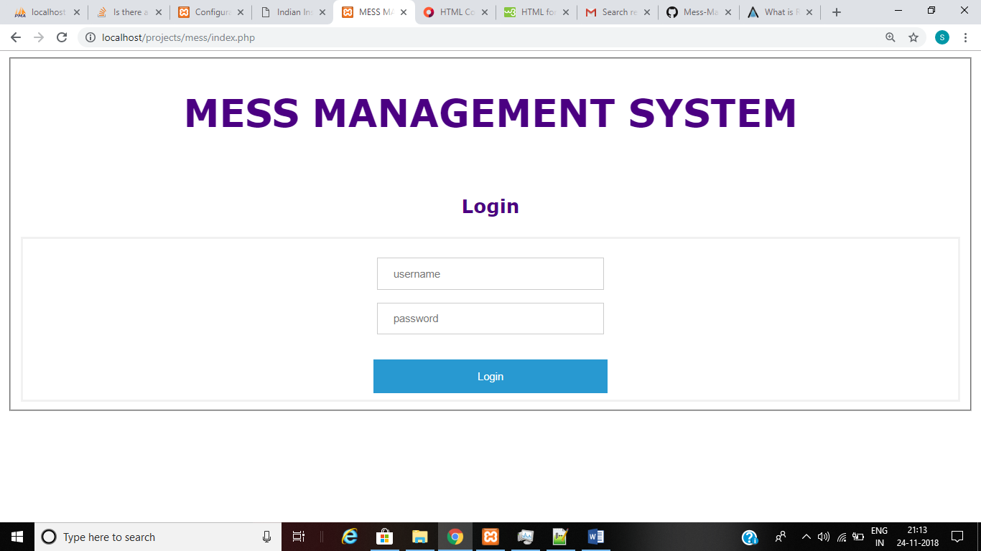

- if a registered student logins and wants

to buy coupons for next day

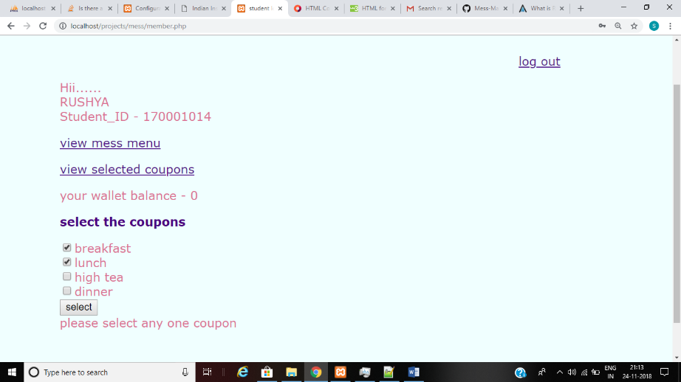

-payment (including adding money to wallet)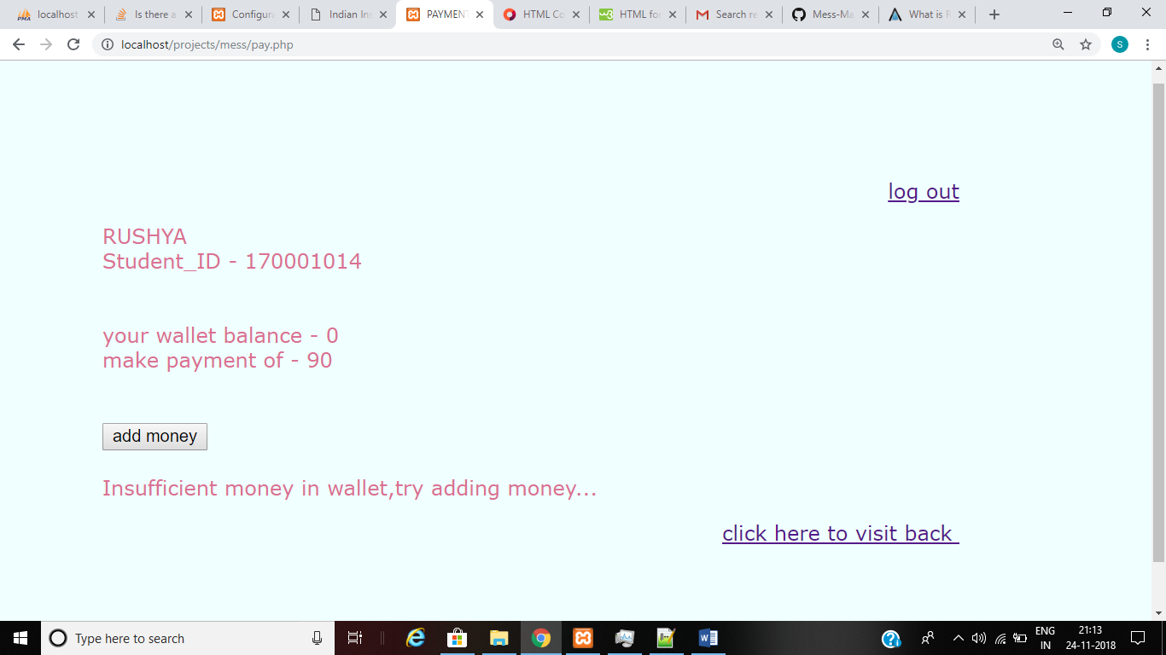

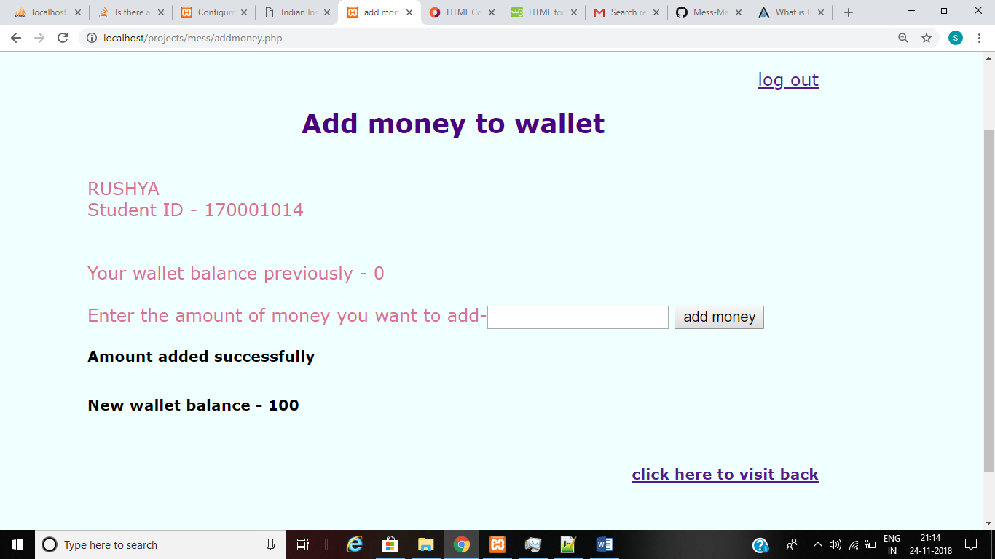

-coupons bought after successfull payment

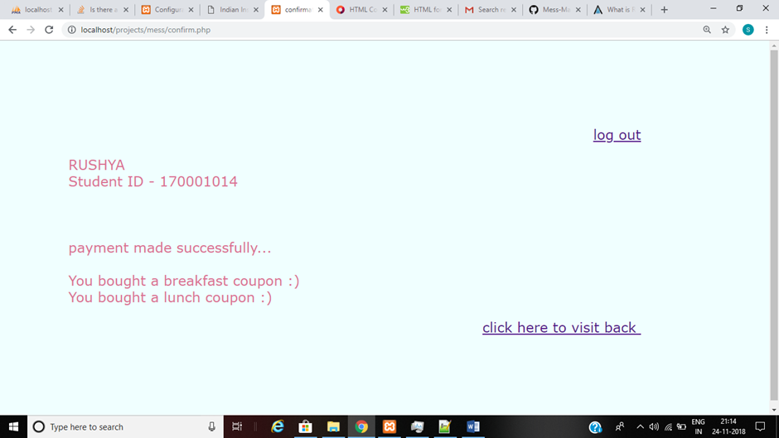

- after clicking on ‘view selected coupons’Now, to use them, select the use coupon option, it stores the date and time at which you select the coupon.

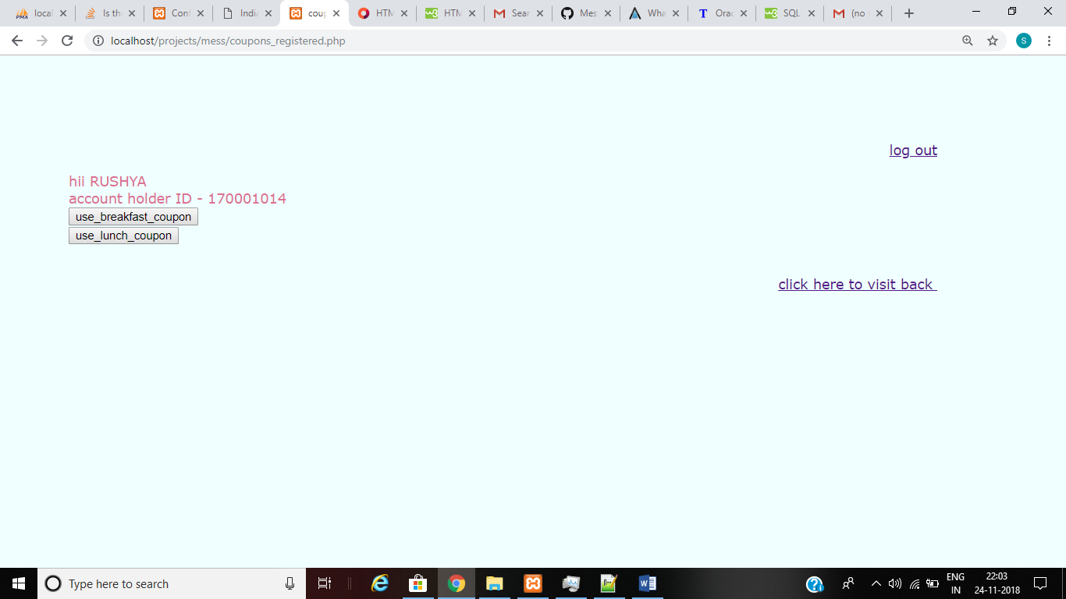

- if we select the use coupon option after the coupon is already used, it displays the time at which the coupon of the corresponding day is used for the first time(to restrict students from using a coupon more than once)

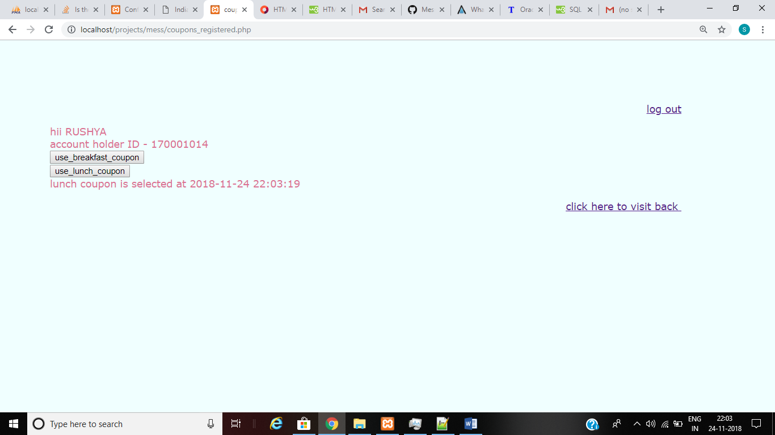

-to view mess menu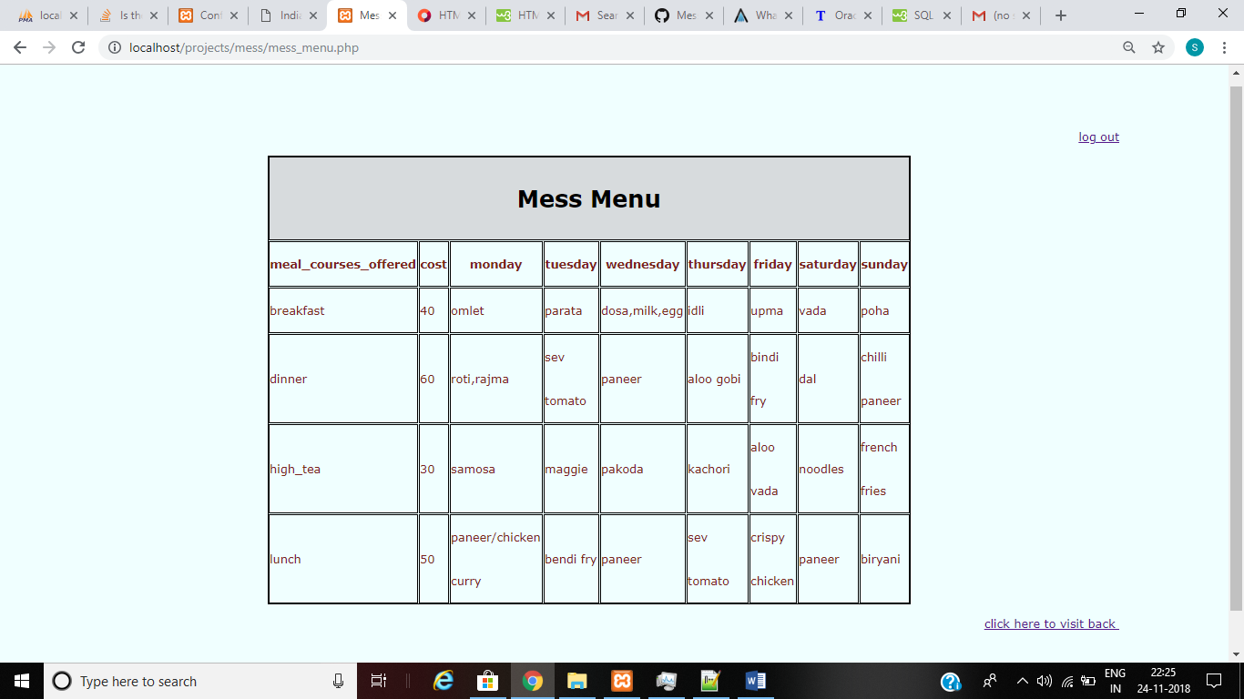

Functionalities of admin

After the admin logins ,he can perform the

following operations

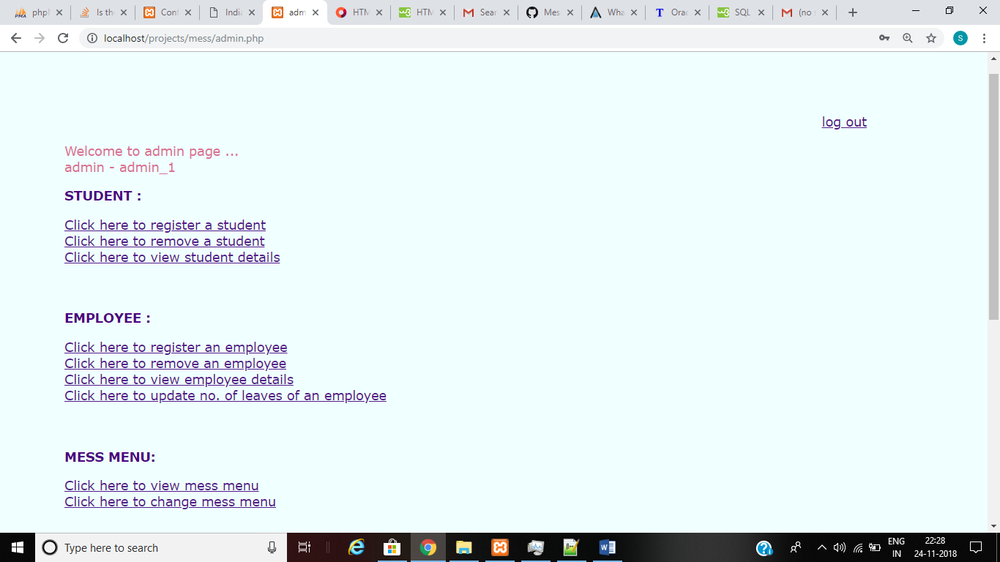

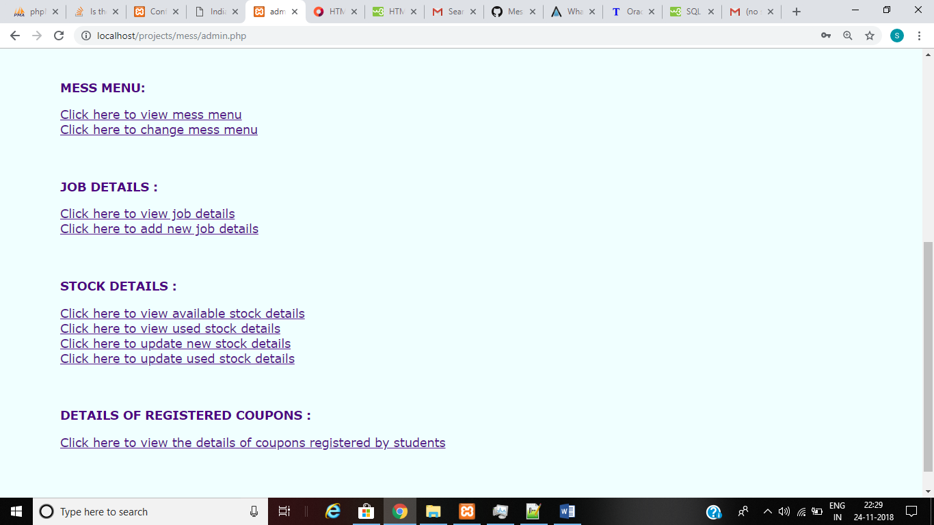

SOFTWARES USED:

Front end – HTML,php

Back end – MYSQL

Web server platform - Xampp

------------------END-----------------