Hayden Atchley

Lab 2 – NDVI Classification

CE 414

9 September 2022

**Project Requirements**

The project was to identify irrigated land based on NASA’s Landsat data and the Normalized Difference Vegetation Index (NDVI) that can be calculated therefrom. The Landsat data is obtained by measuring the intensity of light reflected from Earth’s surface in a given band of wavelengths. The program uses seven such bands, but only the red and near-infrared (NIR) bands are used in the calculations for this project.

**Model**

The intensities of red and NIR light were measured separately, producing two raster datasets, one for each band. The raster data I used covered much of Utah County. The process of calculating the NDVI from these datasets was fairly straightforward. The intensity values were originally reported as an integer ranging from 0–255, so I first converted that data to a float so that the subsequent arithmetic would be accurate. Then, it was a matter of combining the values from the red and NIR bands in order to calculate the NDVI. The equation for NDVI is given as:

so I separately added and subtracted the red to/from the NIR raster, then divided the two. The reason for this equation having the form it does is that vegetation tends to give off a significant amount of NIR radiation as heat, but there is hardly any red in most vegetation. (Failing to subtract the red would include *all* surfaces that give off heat and/or are reflective.) The denominator is simply used to normalize the values to the total amount of light from both bands.

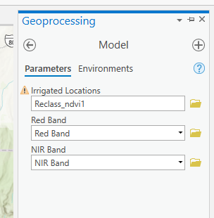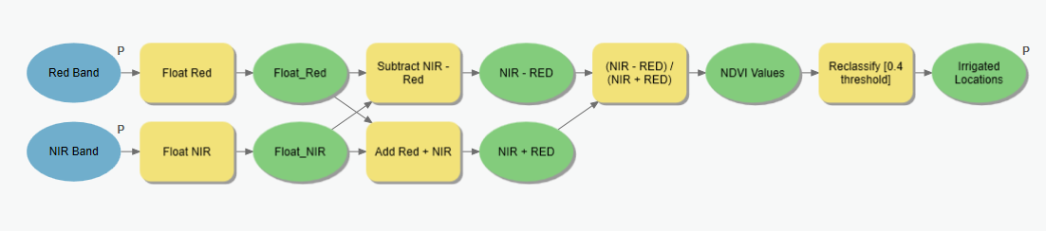

After calculating this combined raster, I classified the values into two groups. An NDVI of less than 0.4 was considered non-irrigated, and above 0.4 was considered irrigated. A map of my findings is given on the next page.

**Conclusions**

Many of the smaller areas of irrigation, especially in/near populated areas, are crop fields. However, there is also a large section of “irrigated” land that is natural vegetation, such as in the Uinta National Forest. This makes sense, as the forest and other flora would have basically the same characteristics with respect to red and NIR light as human-irrigated crops would. There is nothing particularly surprising about these results; they seem to match intuition.

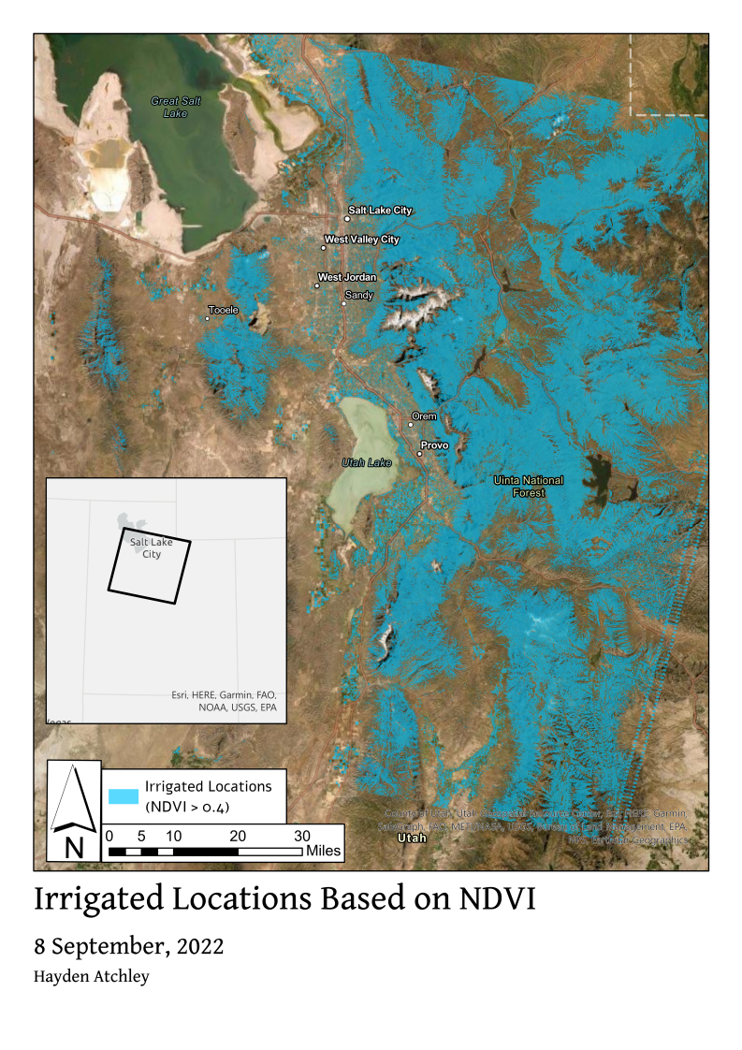

## Rubric for Classifying Land based on the NDVI

|  |  |
| --- | --- |
| **Item** | **Points** |
| Assignment Title, Name, Date, Course | 1/1 |
| Brief report on the requirements of the project | 5/5 |
| Describe your model   * List each of the tools used: (1 pt.) * List tool settings applied for the analysis (could someone repeat the lab using your report?): (1 pt.) * List all input, intermediate, and output datasets: (1 pt.) * Describe each input dataset including type (point, line, polygon, raster) and the source of the data: (1 pt.) * Describe each output dataset (point, line, polygon, raster): (1 pt.) | 5/5 |
| * One or more full pages (8.5 x 11) showing your model (5 pts.) * All text is readable (10pt. font minimum) (2 pts.) * All tools and data sets are shown (2 pts.) | 9/9 |
| * What locations within Utah County are most irrigated? (3 pts.) * Are your results as expected or did you find anything interesting or different than expected? (2 pts.) | 5/5 |
| Make a full page (8.5 x 11) map showing the results of your NDVI classification for Utah County.   * Map Title: (1 pt.) * Neat Line: (1 pt.) * North Arrow: (1 pt.) * Scale Bar: (1 pt.) * Text box with author name, date, map projection: (1 pt.) * NDVI classification image: (5 pts.) * Irrigated land versus non-irrigated land clearly symbolized: (1 pt.) * Polygon of Utah County: (1 pt.) * Labeled points indicating locations of a few large cities: (1 pt.) * Zoomed to an appropriate scale for viewing analysis results: (1 pt.) * All text is legible on printed map: (1 pt.) | 13/15 |
| * Create a Toolbox Interface for your model and include a screen capture of it including input and output data parameters. | 10/10 |
| **Bonus Task:** Repeat the lab exercise with a different dataset. Include in your report what data you used, how you acquired it, and what you may have changed to complete the exercise. Include an additional full-page map showing your results. | Instructor’s  Discretion |